

Managing Personal Information
Employees

Contents
For employees looking to learn how to add or manage their personal information on their Workday Profile, this document will guide you through the following tasks and processes.
Updating Contact Information
How to view and add contact information (e.g. home address, phone number, email, etc.)

Updating Personal Information
How to view and add personal information (e.g. date of birth, marital status, etc.)

Updating Emergency Contacts
How to view and add emergency contact information.

Updating Your Profile Photo
How to upload your profile photo to Workday.

Updating Your Legal Name
How to view and add your legal name.

Updating Your Preferred Name
How to view and add your preferred name (what employees will see when they search you in Workday).

Viewing / Editing Government IDs
How to view and add government IDs (e.g. Social Insurance Number).

Updating Contact Information
- To get started, click on the Personal Information application from the applications Menu at the top left-hand corner of your Workday Homepage.

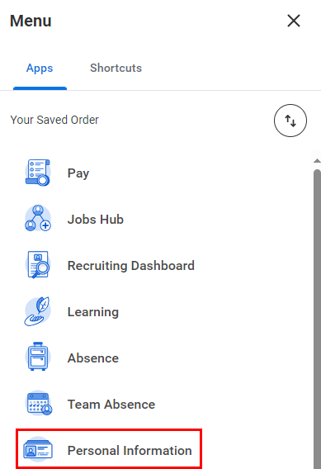
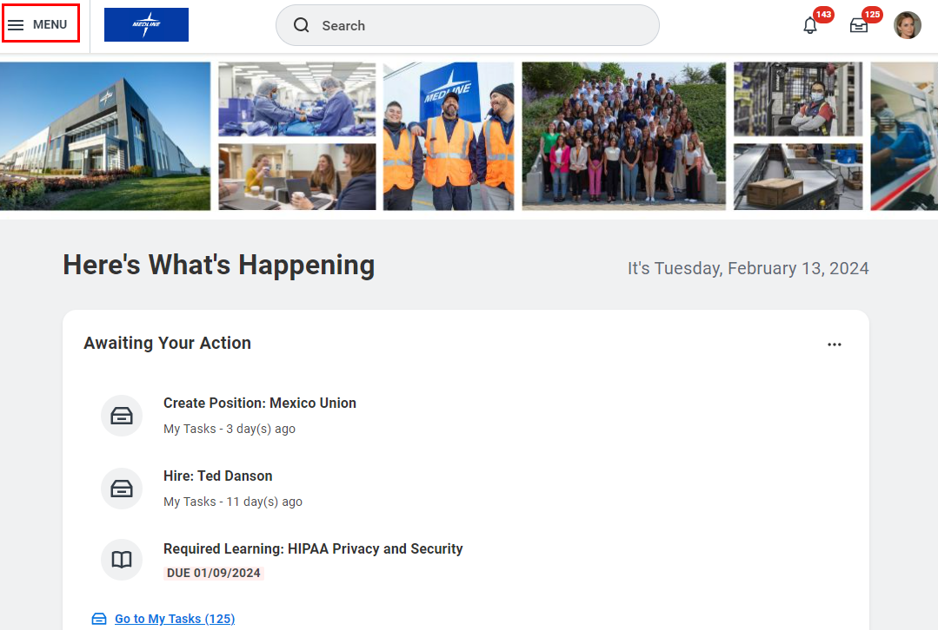

- Under the Change column, select Contact Information.

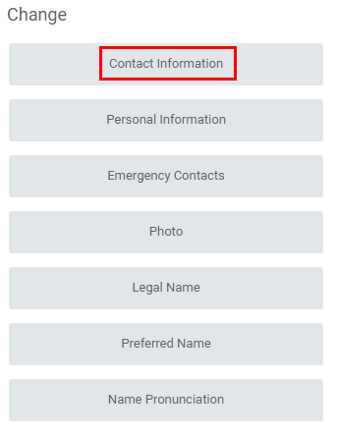

- On the following page, you can update your Home Contact Information (Addresses, Phones and Email Addresses). To update your information, click Edit at the top of the page.

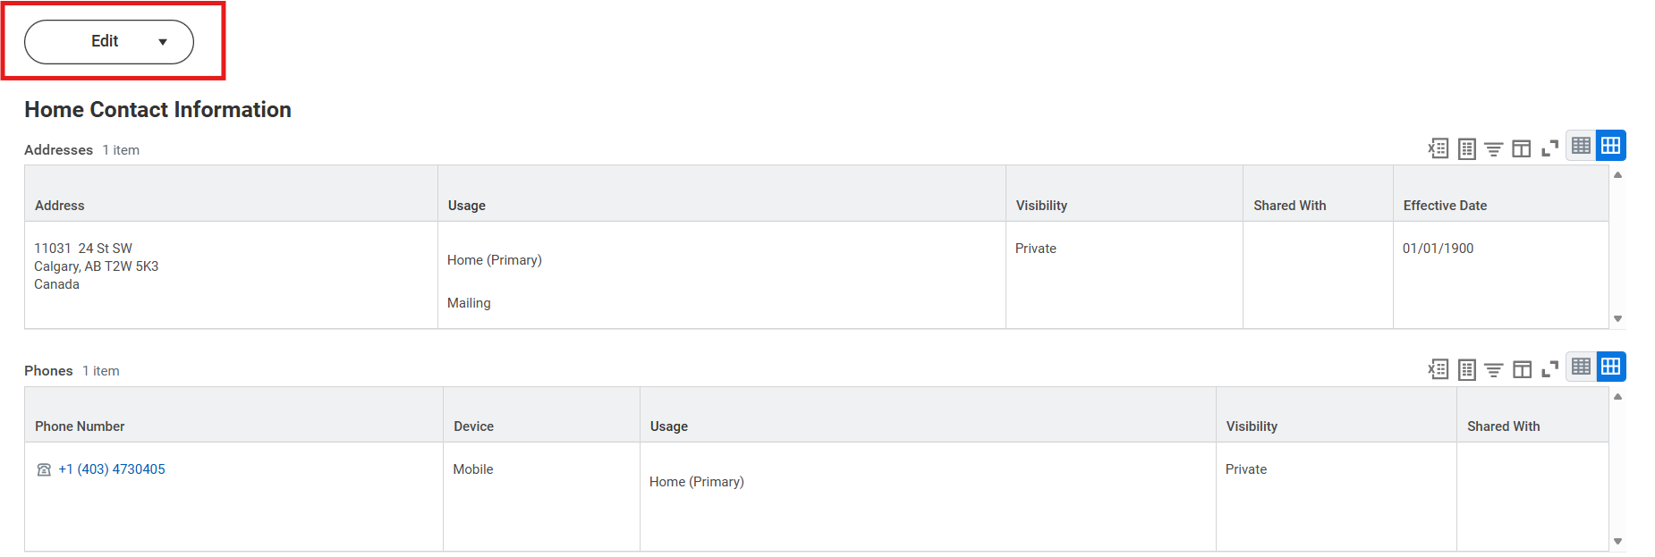

- On the following page, click the Edit icon () or the Add button to update your information. Note that Address, Email and Phone Number are required.

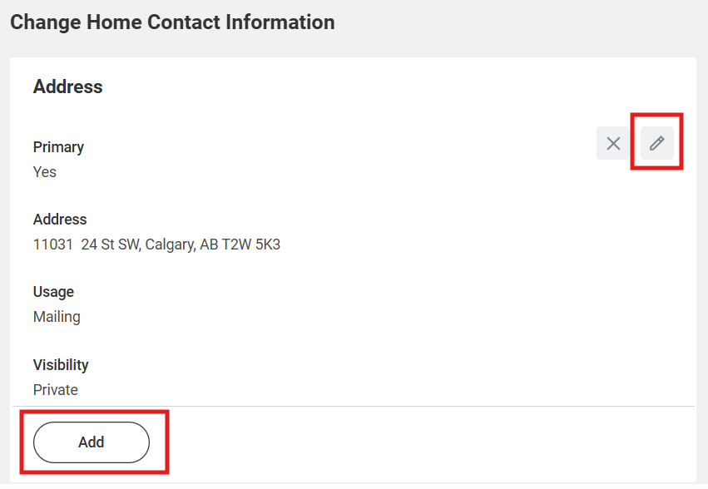

- Fields marked with a red asterisk are mandatory to fill out. If you leave one of these fields blank, you will not be able to submit your updates.

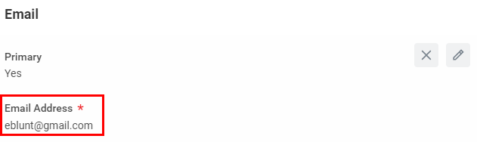

- Click the Checkmark icon to save your changes.

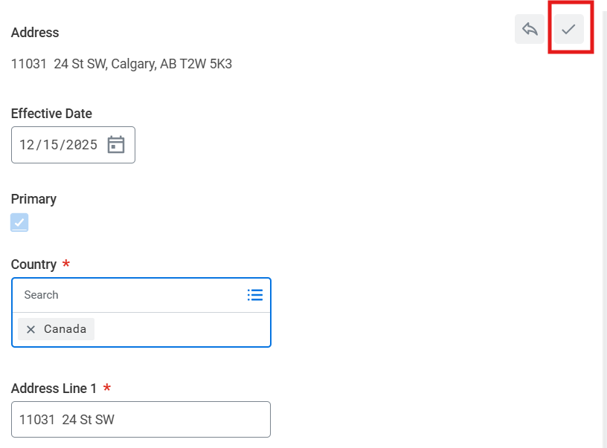

- Your changes will be reflected on the page.

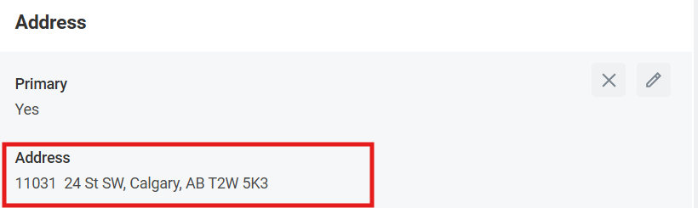

- Click Submit at the bottom of the page to save your changes. Note that if you change your Address you may receive a task in your My Tasks Inbox to complete your state and local withholdings within CICplus.



Updating Personal Information
- To get started, click on the Personal Information application from the applications Menu at the top left-hand corner of your Workday Homepage.

- Under the Change column, select Personal Information.

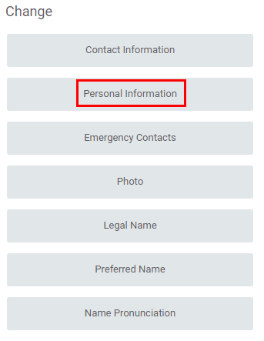

- On the following page, you can update your Personal Information. To update your information, click the Edit icon () in that particular section.

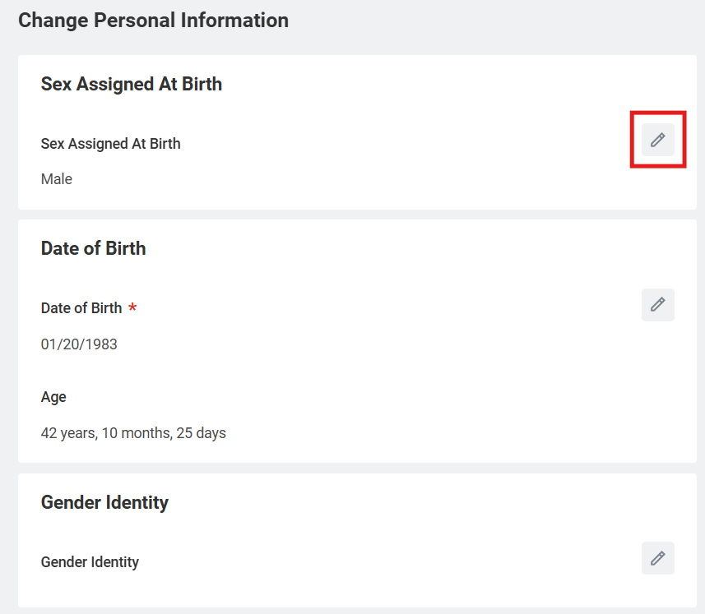

- Fields marked with a red asterisk are mandatory to fill out. If you leave one of these fields blank, you will not be able to submit your updates.

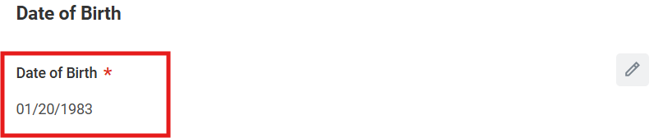

- Once you have clicked the Edit icon (), you can update your information via the drop-down menus. Click the Checkmark icon to save your changes.

- Click Submit at the bottom of the page to save your changes.

Updating Emergency Contacts
- Emergency contacts registered in Workday are visible to your manager and upper management.
- To prepare for emergencies, employees are encouraged to register emergency contact information in Workday so that their manager can access it when needed.
- If you prefer not to disclose emergency contact details, please enter a dummy phone number (0000000000 – ten zeros) in the phone number field.
- If you would like to update only the emergency contact information submitted to HR at the time of hire, please contact HR directly.
- To get started, click on the Personal Information application from the applications Menu at the top left-hand corner of your Workday Homepage.

- Under the Change column, select Emergency Contacts.

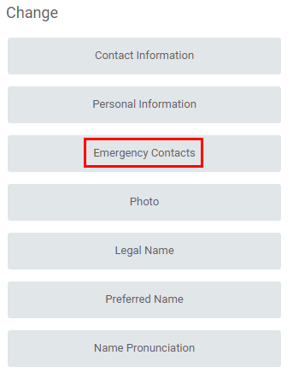

- On the following page, your current Emergency Contacts will be listed. Click Edit to make updates.
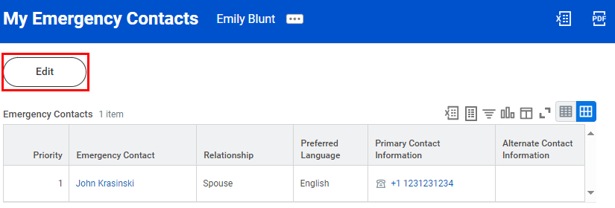
- You must provide at least one Primary Emergency Contact. Mandatory information includes their Legal Name, Relationship to you and either their Primary Phone Number.

- To update existing information, click on the Edit icon (). Once you have completed updates for that section, click on the Checkmark icon.
- To add information, click Add and fill in the prompted fields. Fields marked with a red asterisk (*) are mandatory.
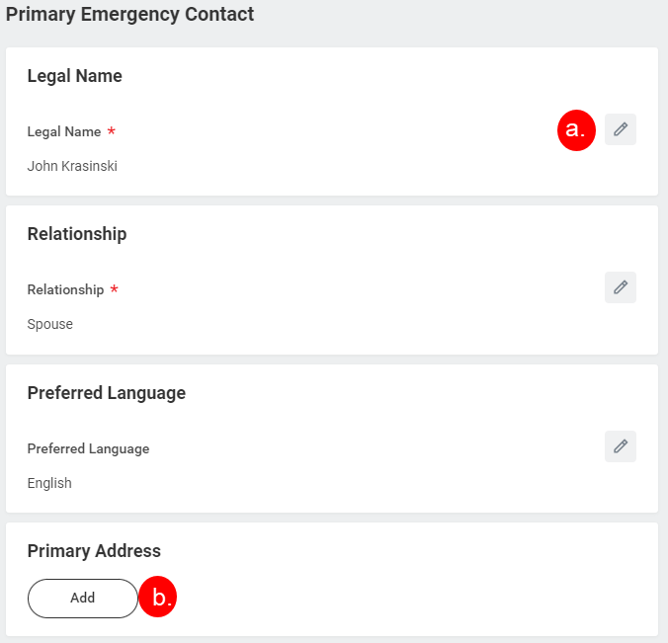

- Click Submit at the bottom of the page to save your changes.

Updating Your Profile Photo
- To get started, click on the Personal Information application from the applications Menu at the top left-hand corner of your Workday Homepage.

- Under the Change column, select Photo.

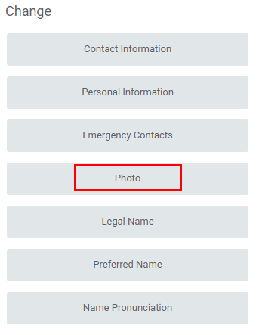

- On the following page, your current photo will be displayed. If you would like to update it, you can drag and drop the new photo into the grey section or click Select Files. Then, browse and select the applicable photo.

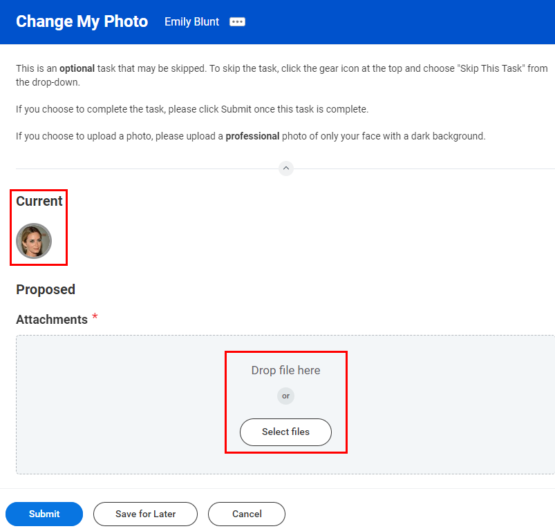

- Once you upload your photo, crop how you would like it to appear then click OK.

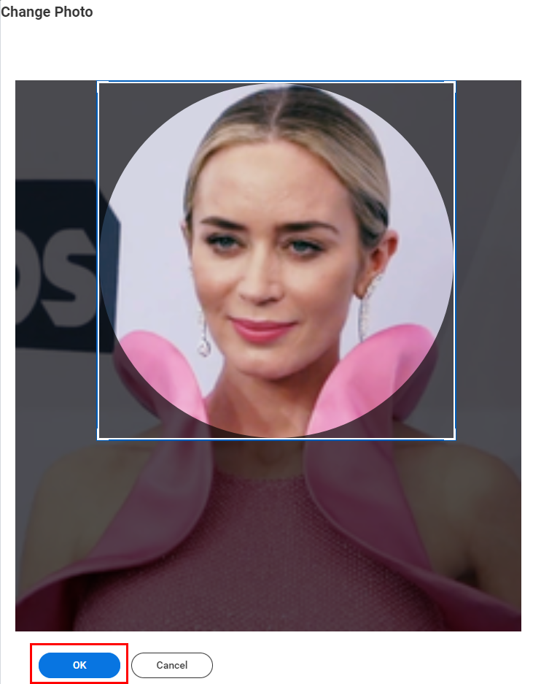

- Your new photo will be reflected on the page. Click Submit to save your changes.

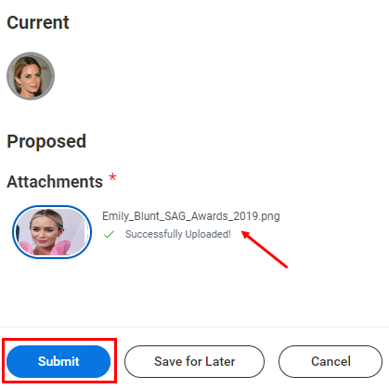

Updating Your Legal Name
- To get started, click on the Personal Information application from the applications Menu at the top left-hand corner of your Workday Homepage.

- Under the Change column, select Legal Name.

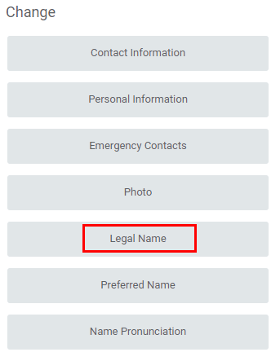

- On the following page, you can update your legal name information by typing it into the applicable fields. The Effective Date will be automatically populated to today’s date, but you can change it.
Please enter all kanji, furigana, and Western script.

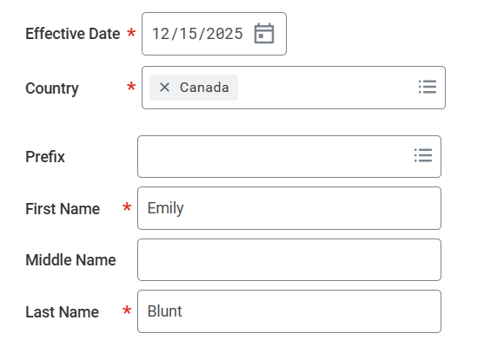

- You must attach documentation to verify your legal name change. To do so, drag or drop the new documentation into the grey section or click Select Files.
Example: Certificate of Residence, Driver's License, Family Register Extract, etc.

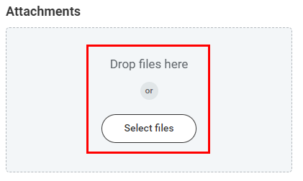

- Once you upload the document, select the Category it falls under.
If there is no appropriate category, please select “Personal Information”.

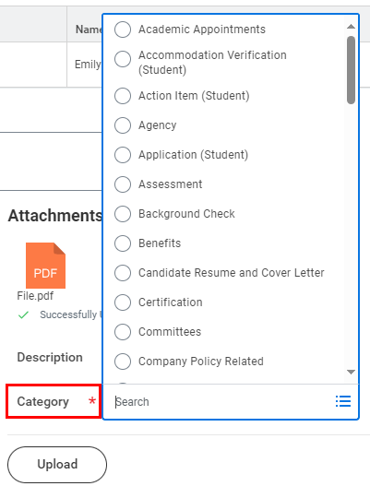

- You can enter a Description of the document, but it is not mandatory.

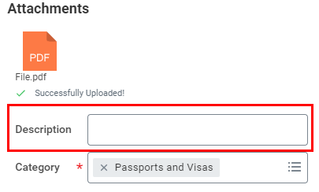

- Click Submit at the bottom of the page.



Updating Your Preferred Name
Fill in only if you wish to use your maiden name at work.
- Your preferred name is what appears in the Workday Search Bar, Org Chart and Workday Profile. To get started, click on the Personal Information application from the applications Menu at the top left-hand corner of your Workday Homepage.

- Under the Change column, select Preferred Name.

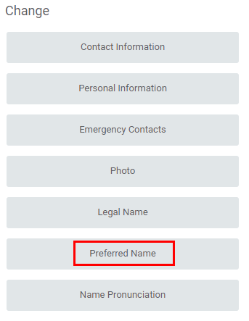

- On the following page, uncheck the Use Legal Name box.



- Update your First Name and Last Name as preferred.
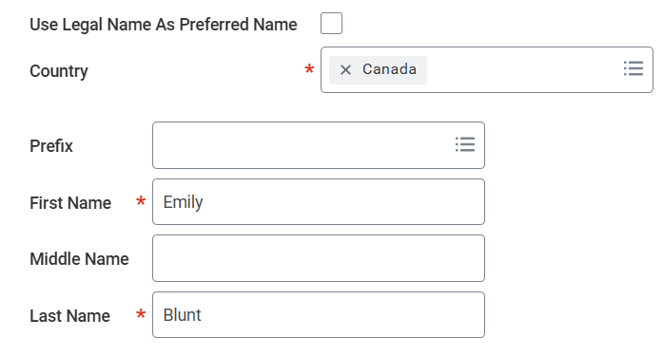
- Once you are done, click Submit at the bottom of the page to save your changes.

Viewing / Editing Government IDs
- Click on your Workday Profile located in the top right-hand corner of the page.

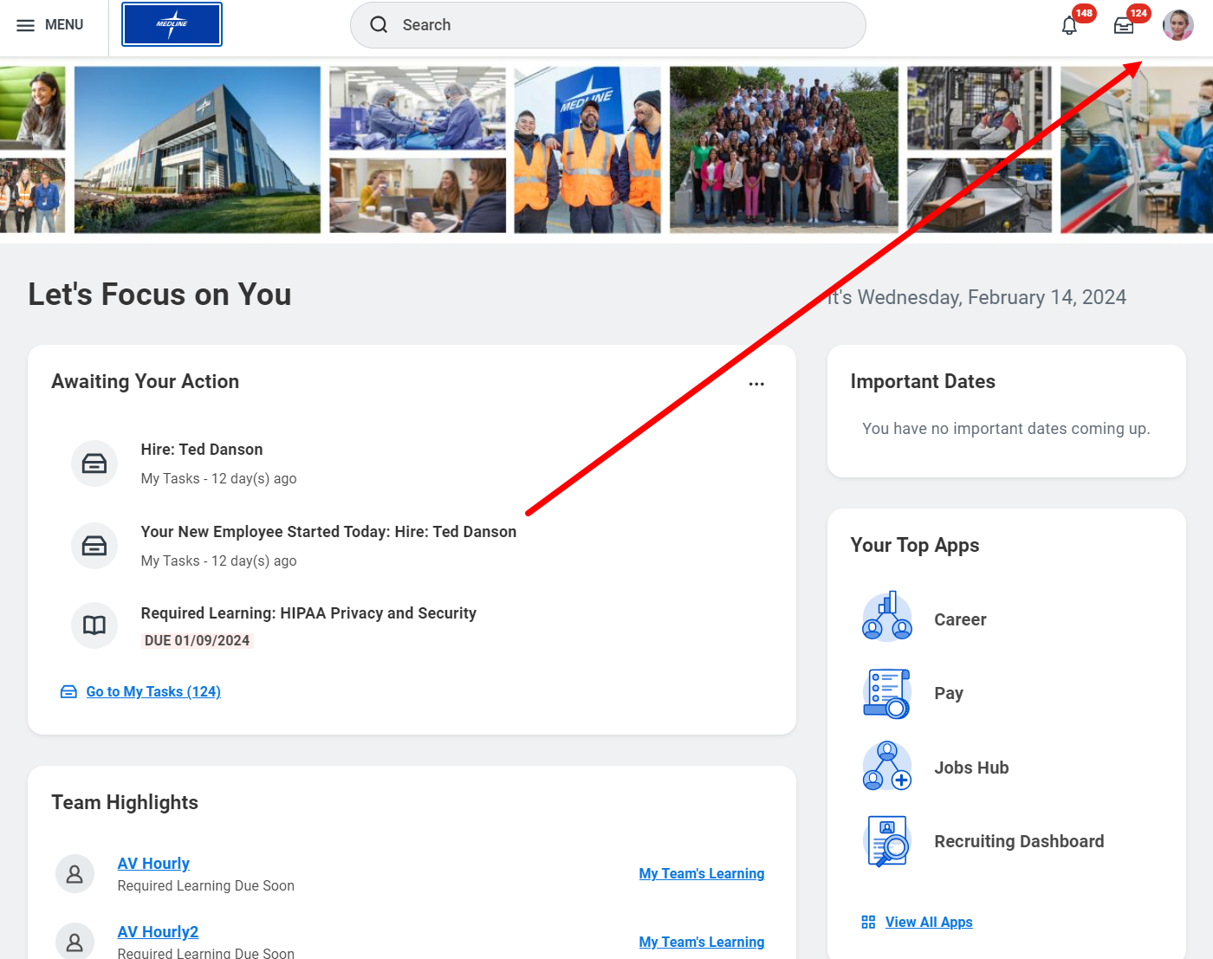

- From the drop-down menu, select View Profile.
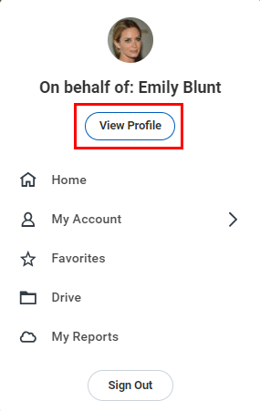

- Underneath your name, click on the Personal button.

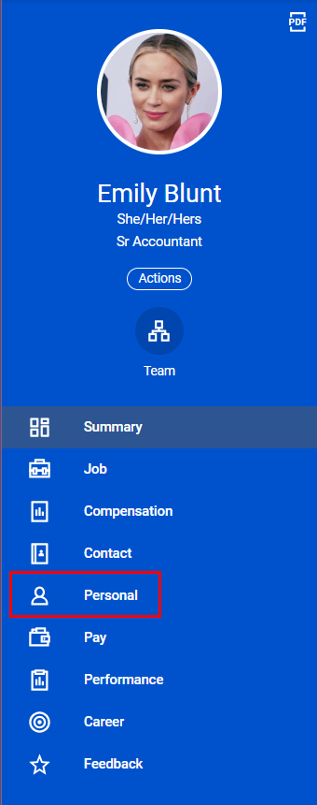
- On the right-hand side of the page, select IDs from the top bar.

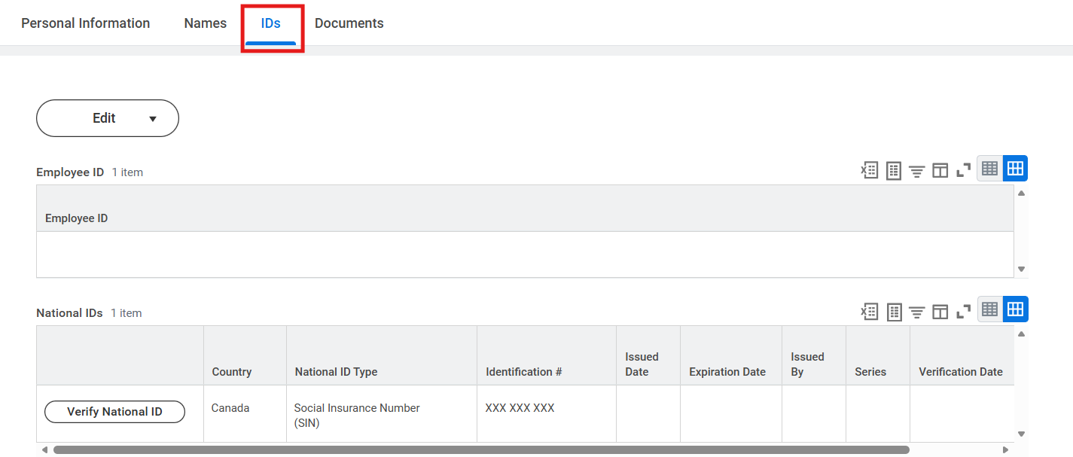

- Then, click Edit. From the drop-down menu, select Change My Government IDs.

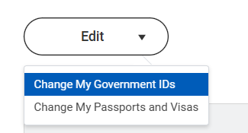

- To add a National ID, click the Add icon (+). Then, select the Country, Type of National ID, ID Number, Issued Date, and Expiration Date of the bottom row. To edit an existing ID, find the ID you want to update. Then, update the necessary fields.

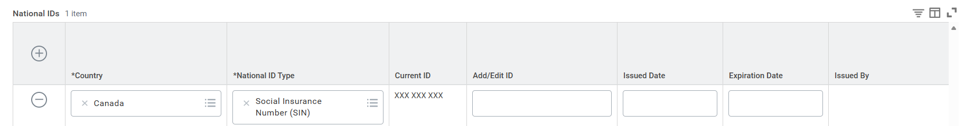

- You must attach documentation to verify your National ID change. To do so, drag or drop the new documentation into the grey section or click Select Files.

- Once you upload the document, select the Category it falls under.
If there is no appropriate category, please select “Personal Information”.

- You can enter a Description of the document, but it is not mandatory.

- Click Submit to save your edits.

