

Workday Basics
Managers

Overview of Business Processes in Workday
A Business Process includes tasks that must be completed for an event to occur, the order in which they must be completed, and who must complete them. All activity in Workday is organized by business process. Typically, a business process has someone who initiates, someone who approves, and someone who receives a notification.

Notifications may go to the initiator, approver, and/or others who may not have been directly involved in the process. Notifications help to ensure you never lose track of important tasks and deadlines.

As a Manager, you have direct access in Workday and play a central role in many business processes. Once a business process is initiated, Workday enforces security and business rules, and you may receive tasks in your My Tasks Inbox to complete.

Managing your Workday My Tasks Inbox
Your My Tasks Inbox includes tasks, approvals, due dates, and other items sent to you as part of a business process. Actions can be completed from your My Tasks Inbox, while notifications are purely informational.

- Once logged in to Workday, you will be taken to your Workday Homepage. You can navigate to your My Tasks Inbox by clicking on the main Inbox section on the left-hand side of the screen, or by clicking on the My Tasks Inbox icon in the top right-hand corner of the screen.

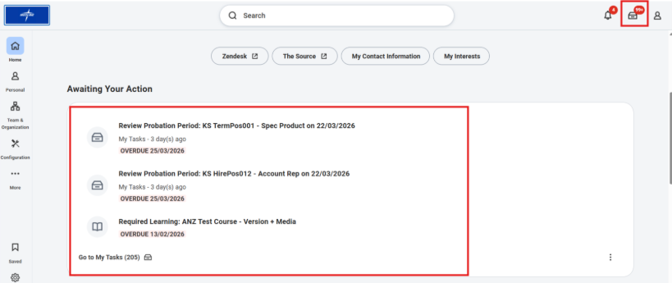

- Your My Tasks Inbox is made up of an Actions section and an Archive section. Each item in your Actions Inbox is a task you need to act upon to complete a business process. Think of it as a Workday “to-do list.” Once you complete a task from your Actions Inbox, the task will be moved to the Archive Inbox for your records.

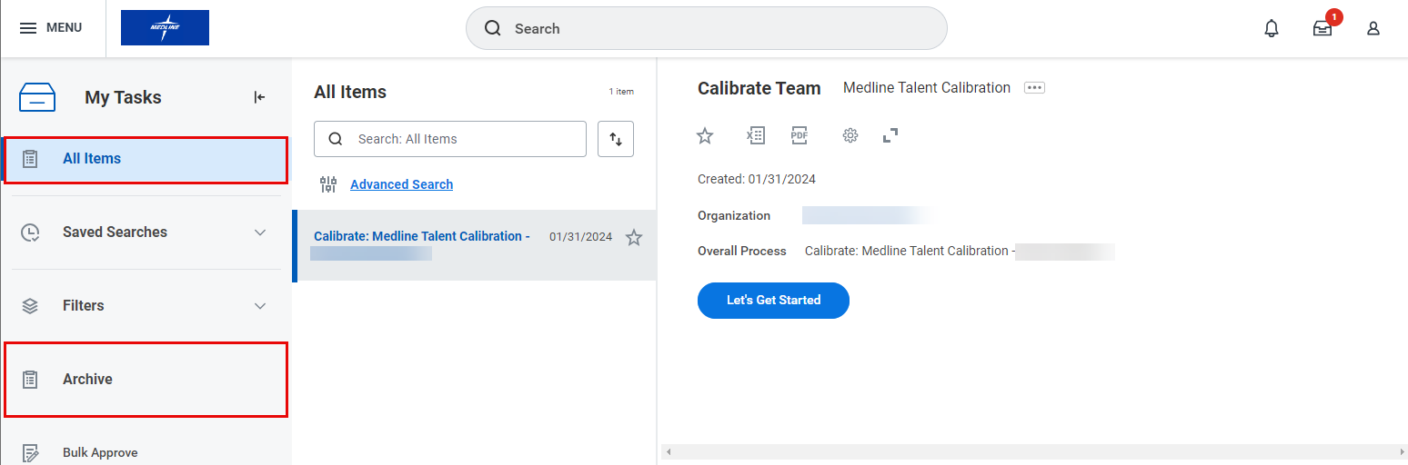

- To view and complete a task, click the task on the left-hand side of your My Tasks Inbox. The task will open on the right-hand side of the screen. Click on the Expand icon () in the top of the page for easier viewing. In the example below, you would click Let’s Get Started to begin the task.

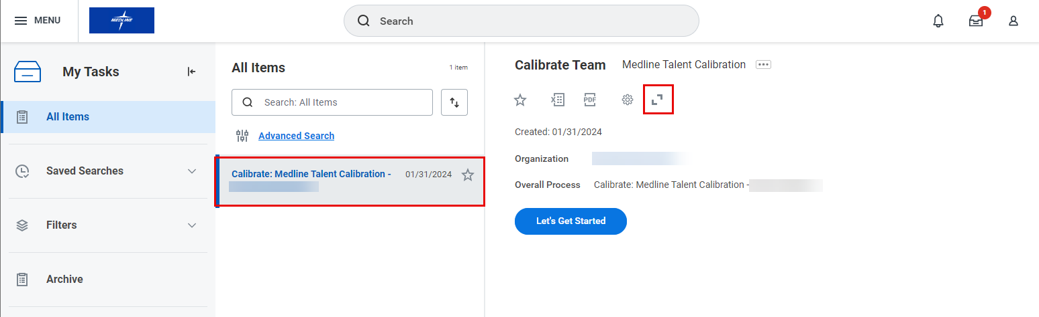

- Once you complete a task from your Actions Inbox, the task will be moved to the Archive Inbox for your records. To see your archived tasks, click the Archive tab.

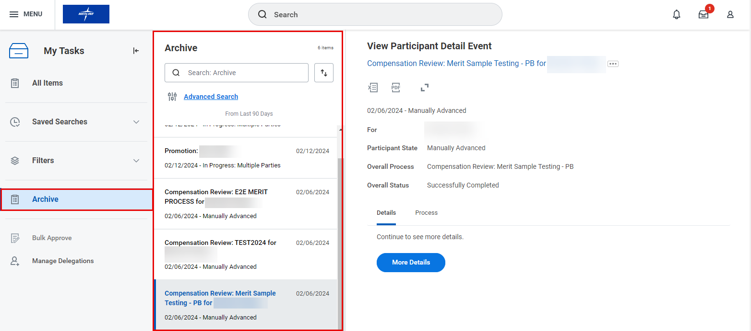

- To view an archived task, click the task on the left-hand side of the screen. It will open on the right-hand side of the screen. Again, you can click the arrows () to expand the screen. You can also see the overall status of various processes, for example if they are Successfully Completed or Canceled.

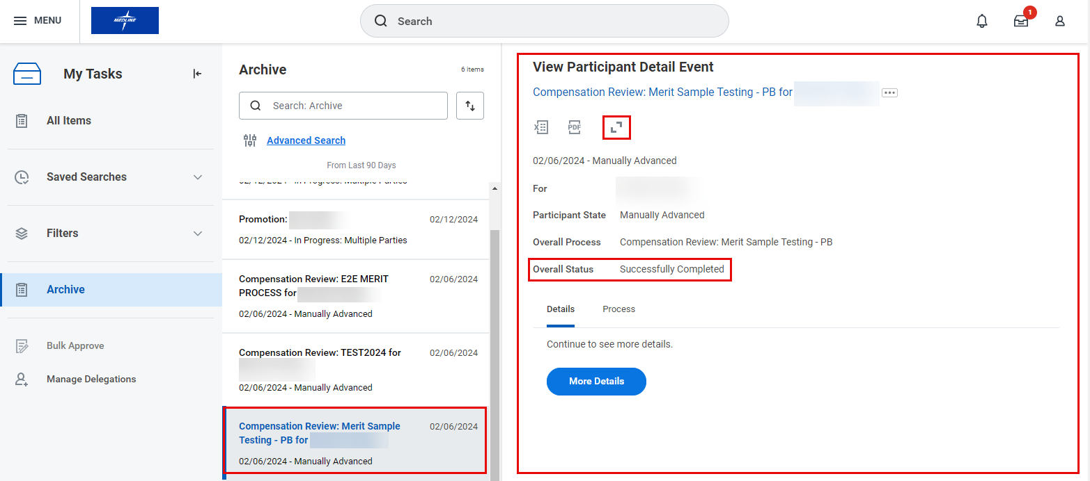

- You can also see the details of the request and the Process History under the Process tab. This function can be helpful for requests that are In Progress.

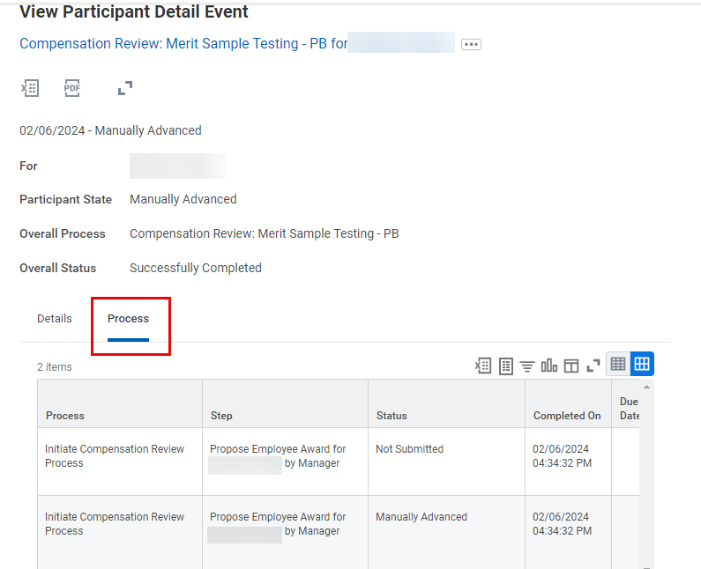

Viewing Your Org Chart
- Click the Avatar icon () in the top right-hand corner, then click View Profile.

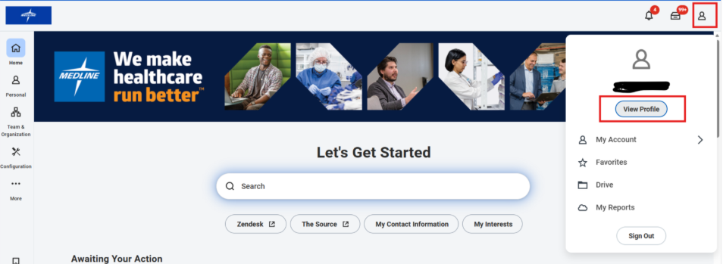

- From your Workday Profile, you can access an interactive organization chart by clicking on the Team icon at top of the sidebar.

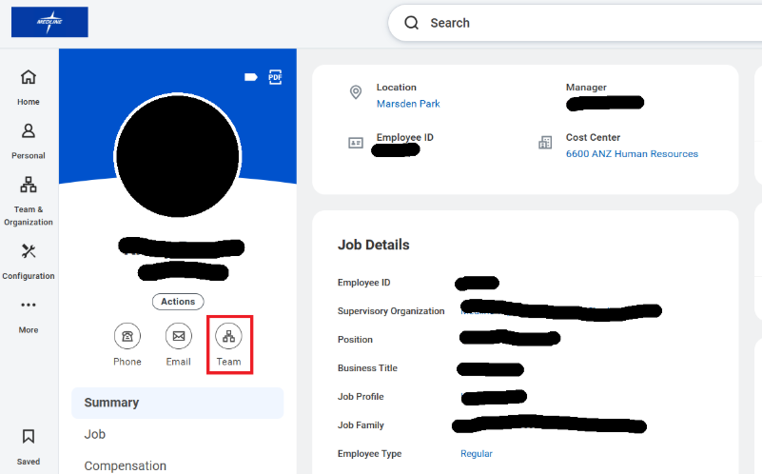

- Once selected, the Org Chart will show you a hierarchical overview, including your direct reports, peer colleagues and supervising Manager.
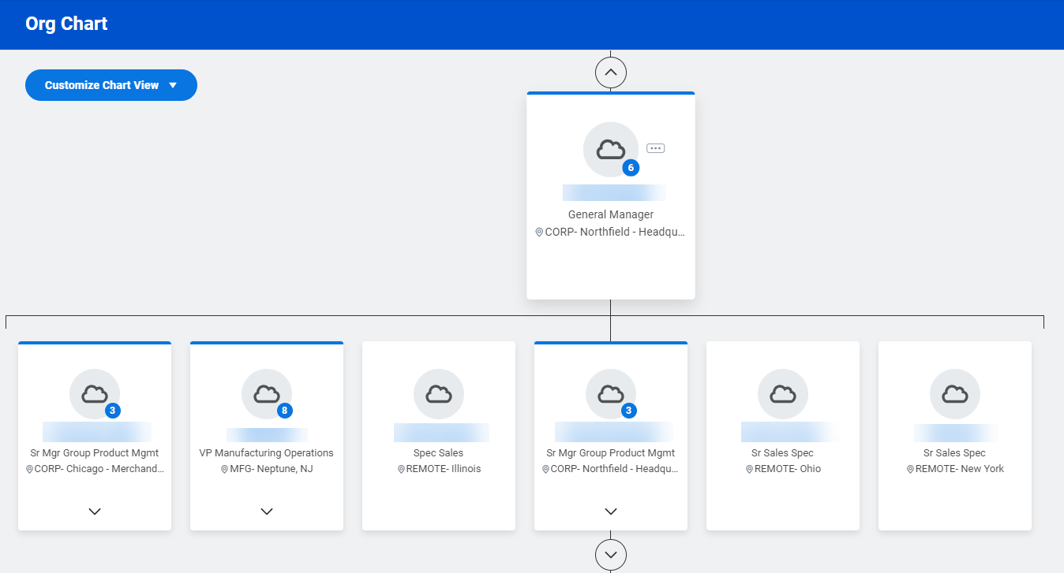
Please note that you can scroll up and down to see the full reporting structure. Managers have a blue circle showing the number of direct reports on their team.

Finding Supervisory Organizations
Workday is organized by Supervisory Organizations that group employees into a management hierarchy based on reporting relationships. Additionally, Managers have special access to view information, approve requests, and initiate actions for employees in their Supervisory Organization.

- For example, if you were going to search for a particular Manager’s supervisory organization, you would type in “org:” followed by the name of the Manager and hit Enter on your keyboard.

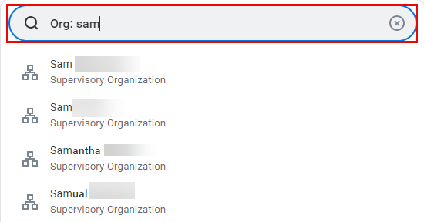

- Select the name of the Supervisory Organization from the Search Results page to view additional information.
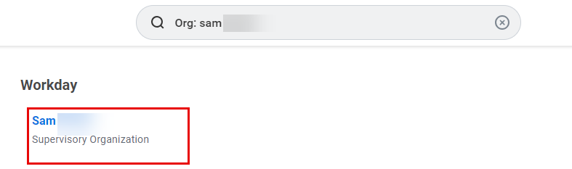
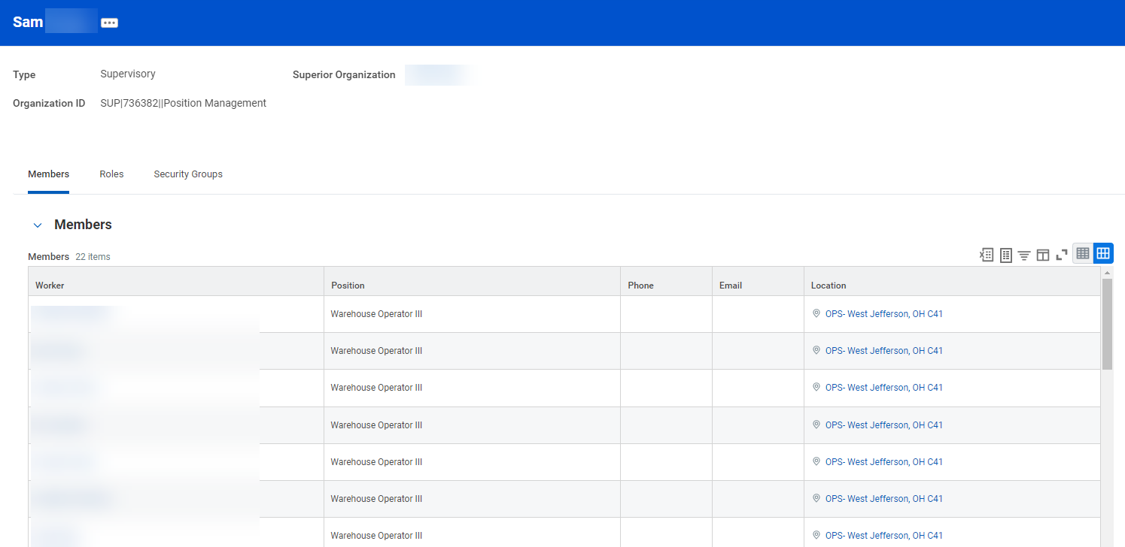
Viewing Employee Data
- To get started, type the name of an employee in the Search Bar and select the employee from the drop-down menu. This will take you to their Workday Profile.

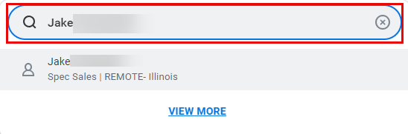

- On the Workday Profile, you can view information specific to that employee. The information you will be able to see depends on your relationship with the employee. For example, if you manage that employee, you will be able to see Job, Compensation, Contact, Personal, Performance, Career and Feedback information related to them. However, if you navigate to your Manager’s Workday Profile, for example, you will only be able to see their Job information.

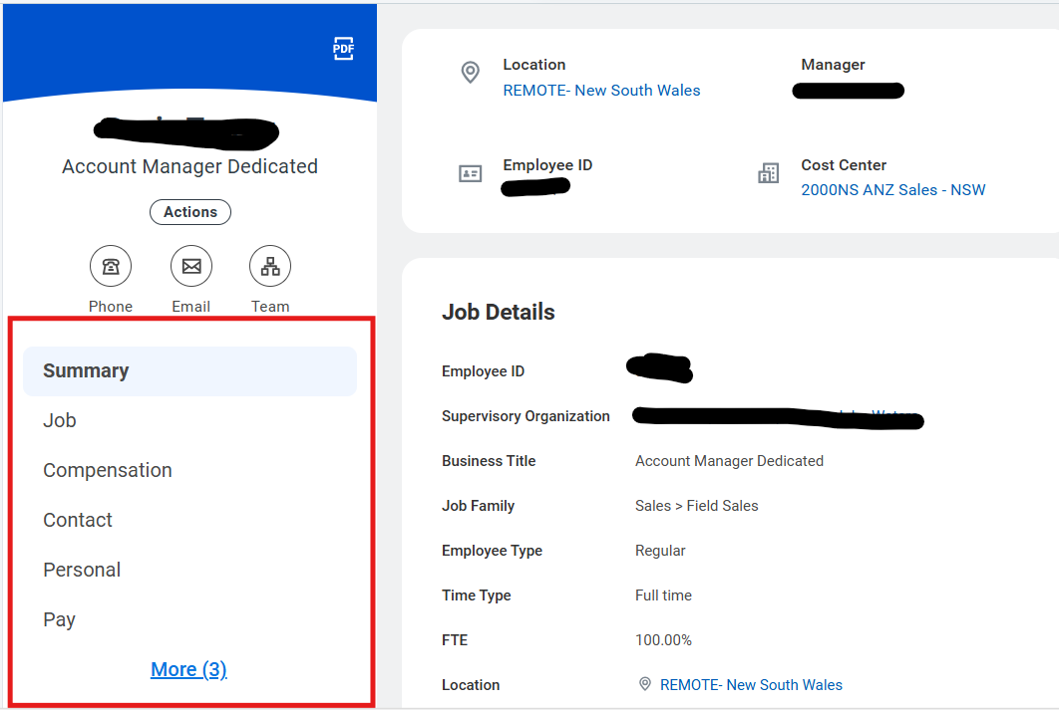
Delegating Tasks
Tasks in Workday may be delegated from one employee to another employee. This allows the delegate to initiate, approve, review, and execute tasks on behalf of the delegating employee.

- To get started, type Delegations into the Search Bar and select My Delegations from the drop-down menu.

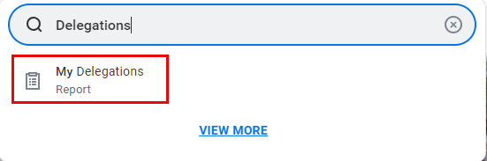

- On the My Delegations page, select Manage Delegations.

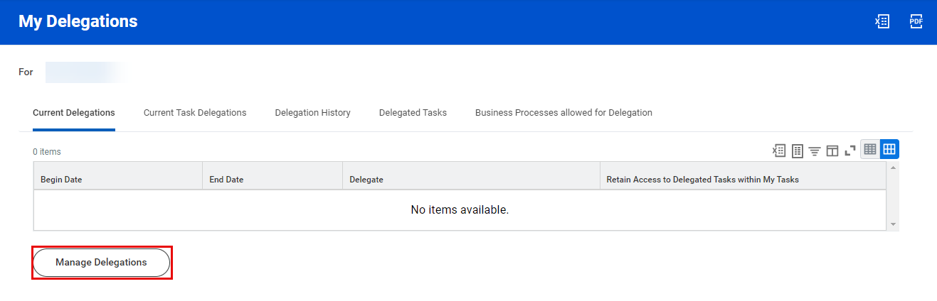

- Delegations may be modified from the Manage Delegations page. From this page, enter the following information:
  - Select a Begin Date that is today’s date or a date in the future. You cannot select a date in the past.
  - End Date
  - Your Delegate must be a peer or superior. You may only delegate to a direct report under special circumstances (e.g. Executive assistants) and you must contact HRIS to do so.
  - Start On My Behalf indicates the list of business processes that may be initiated on behalf of the delegator
  - Do Inbox Tasks On My Behalf specifies the business processes which the delegate may approve and review on behalf of the delegator
  - You have the option to keep track of your delegated tasks in your My Tasks Inbox by checking the box under Retain Access to Delegated Tasks in Inbox
  - A Delegation Rule may be specified, if applicable

Please note that the End Date is a required field.

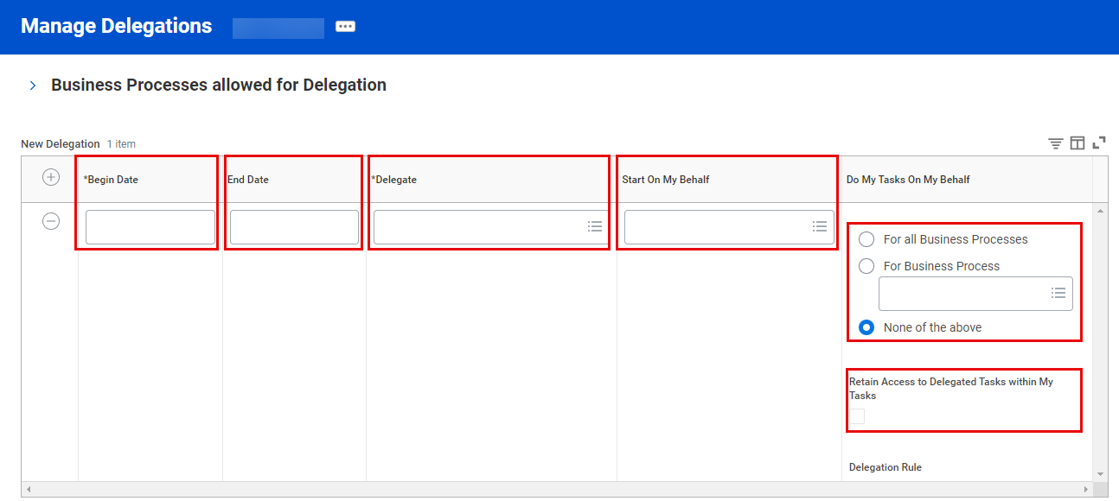

- Once you have entered this information, click Submit.



