

Workday Basics
Employees

Accessing Workday
- To navigate to Workday, click the Workday link

- Once you have successfully logged in, select either Skip or Remember this device to continue to your Workday Homepage.

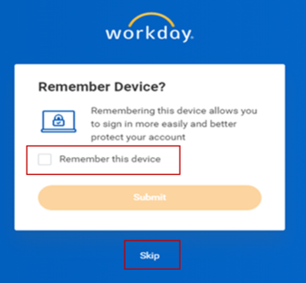

Common Workday Terms
Here are some of the common terms you will encounter as you start to use Workday.
- Actions are indicated with an Ellipses icon with three dots (), or an Actions button 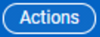 . The Ellipses icon appears when you hover over an object highlighted in blue to indicate a hyperlink, such as a name or a job title. Both the Ellipses icon and the Action button provide navigational shortcuts to activities you can complete without having to return to your Workday Homepage.
- The Search function operates like your favorite search engine.
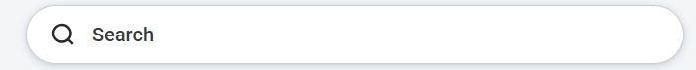
- A Mandatory Field – indicated by a red asterisk (*) – indicates a Workday field that cannot be skipped or excluded when entering data.
- Applications are the icons that appear on your Workday homepage. Each application provides a gateway to a different area of Workday, such as Talent and Performance or Personal Information. Applications are sometimes referred to as Worklets.

- Errors and Alerts help guide you through Workday processes by appearing on-screen when required information is missing. Depending on the type of missing content, you may or may not be able to continue the process until you have fixed the issue.
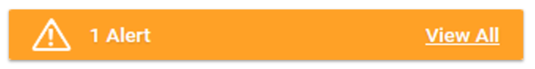 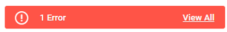

Workday Navigation Overview

Search Function

You can use the Search field to find information in Workday.
- Locate the Search field at the top of your screen.

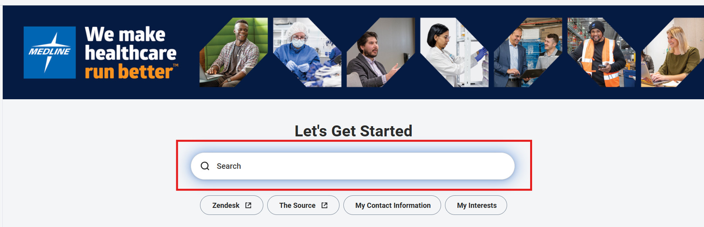

- Type the topic you are looking for into the Search field. As you type, Workday will filter your request and offers several of the most common search results in a drop-down menu.

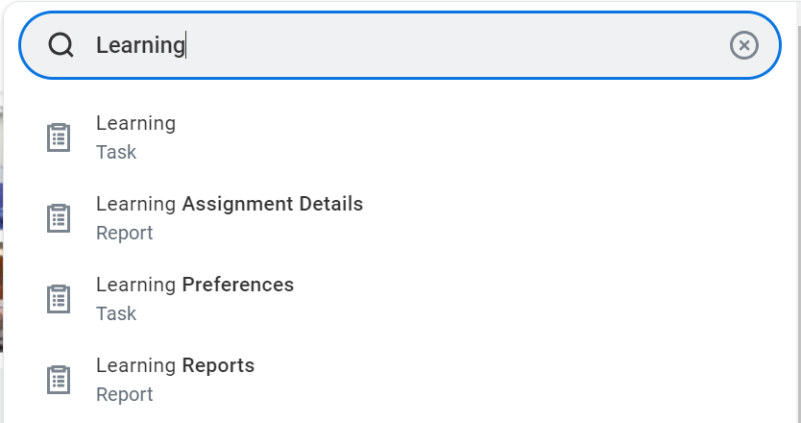
Please note that you will not need to type the whole word or phrase, but you will still need to spell your entries correctly.

- Select one of the results from the drop-down menu, or press Enter on your keyboard to display the search results in a separate window. You can use the Edit Categories list in the top menu to narrow the focus of your search. Note, the information you see in Workday is based on your role and data that is useful and relevant to you.

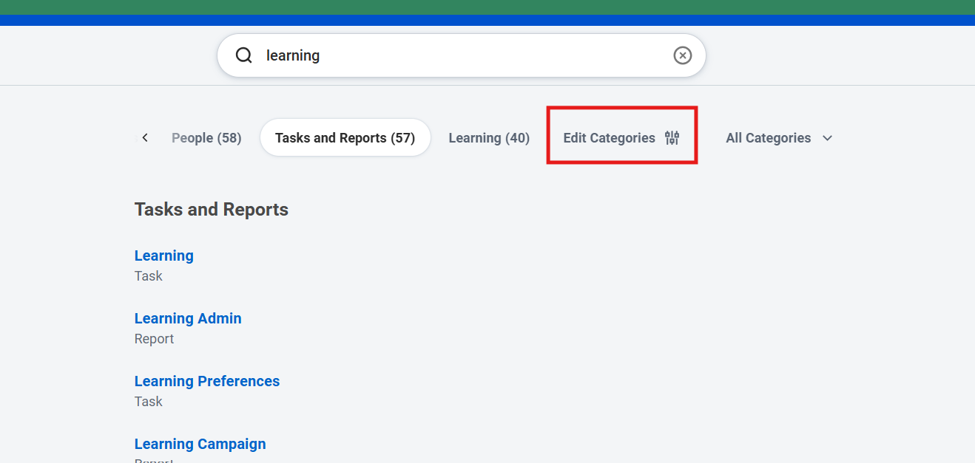
Please note that there are many ways to find the same information in Workday, depending on what you prefer. You can use Applications, your Workday Profile, the Actions icon, or the Search field.

Remember, if you get lost at any time, you can always return to your Workday Homepage from any page by clicking the Workday Logo in the upper left-hand corner of your screen.

Applications

An Application is a compact report displayed as a “tile” on a Workday page, providing easy access to tasks and information you use on a regular basis. You can think of an application like the icons on your computer, tablet, or smartphone that you use to load a program or application.

- When you log in to Workday, you will automatically be directed to your Workday Homepage. The menu on the left-hand side of the Homepage will show your applications. You can choose to personalize your Homepage to display the applications you want – similar to the way you would display apps on your phone.

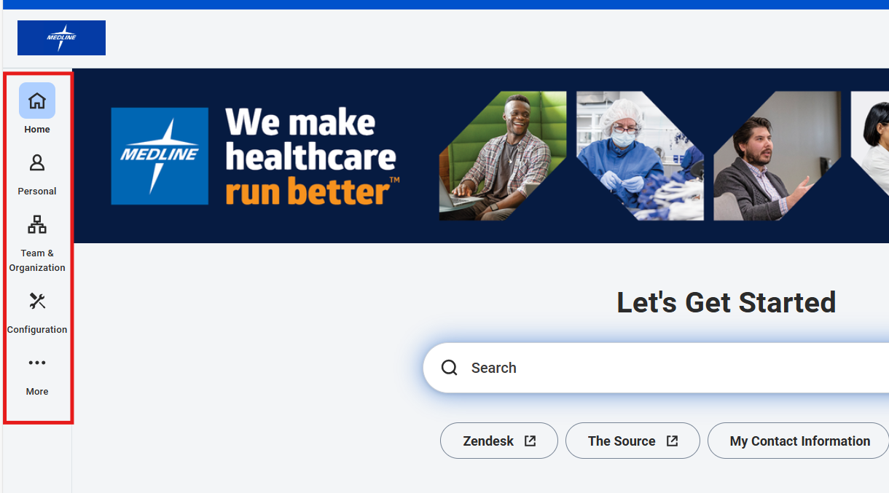

Managing Your Workday My Tasks Inbox

Your Workday My Tasks Inbox includes tasks, due dates, and other items sent to you as part of a business process. Actions can be completed from your Workday My Tasks Inbox, while notifications are purely informational.

- Once logged in to Workday, you will be taken to the Homepage. You can navigate to your My Tasks Inbox by clicking Go to My Tasks on the left-hand side of the screen, or by clicking on the My Tasks Inbox icon in the top right-hand corner of the screen.

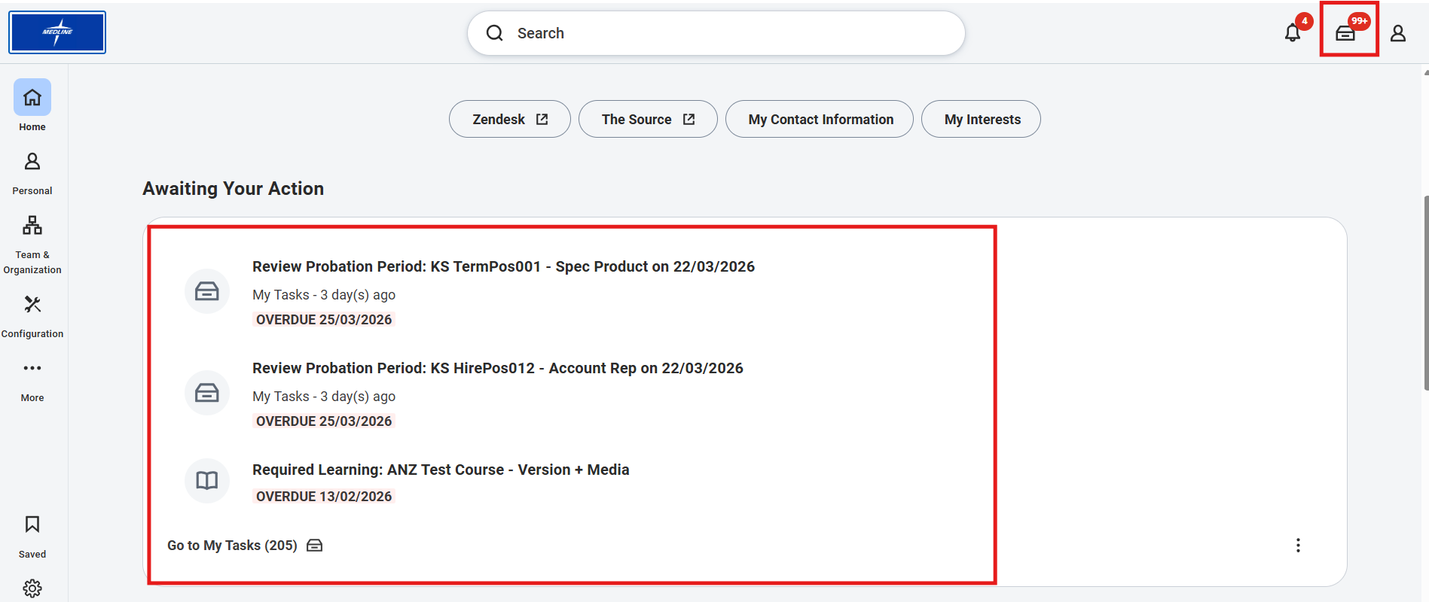

- Your My Tasks Inbox is made up of an Actions section and an Archive section. Each item in your Actions Inbox is a task you need to act upon to complete a business process. Think of it as a Workday “to-do list.” Once you complete a task from your Actions Inbox, the task will be moved to the Archive Inbox for your records.

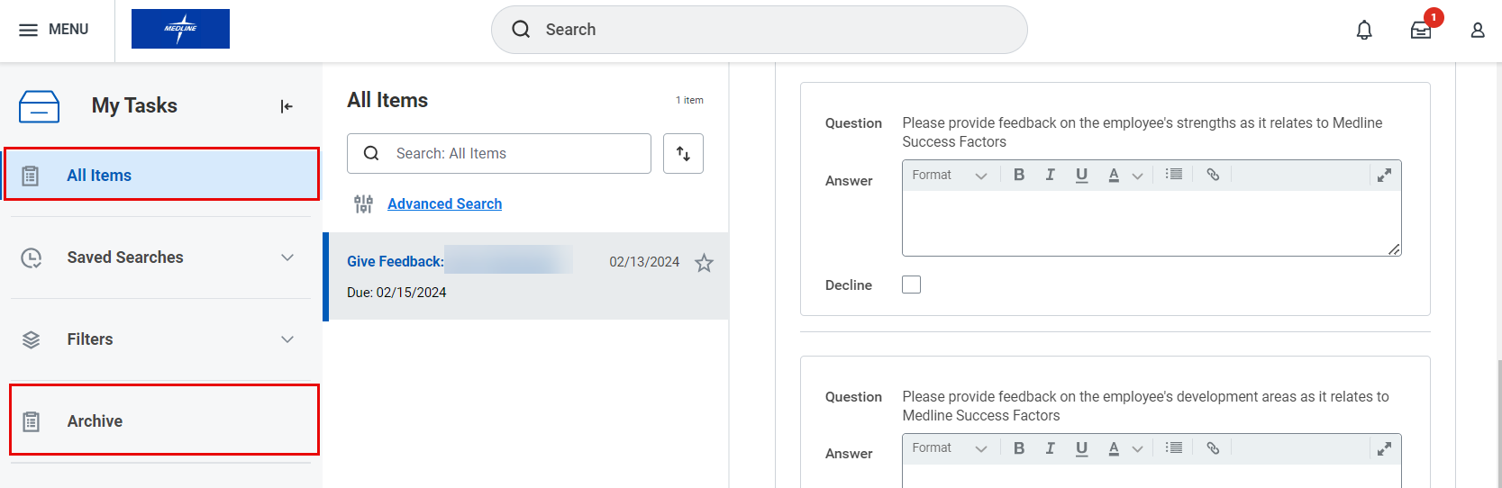

- To view and complete a task, click the task on the left-hand side of your My Tasks Inbox. The task will open on the right-hand side of the screen. Click on the Expand icon () in the top of the page for easier viewing. In the example below, you would type your feedback directly in the prompted fields to complete the task.

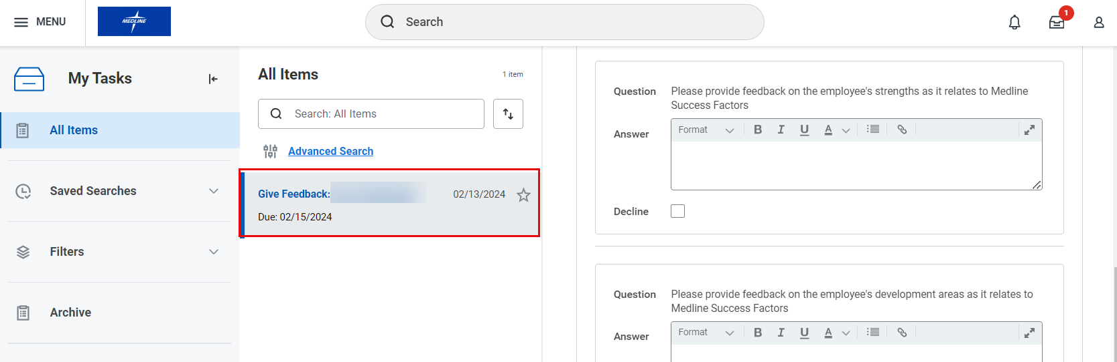

- Once you complete a task from your Actions Inbox, the task will be moved to the Archive Inbox for your records. To see your archived tasks, click the Archive tab.

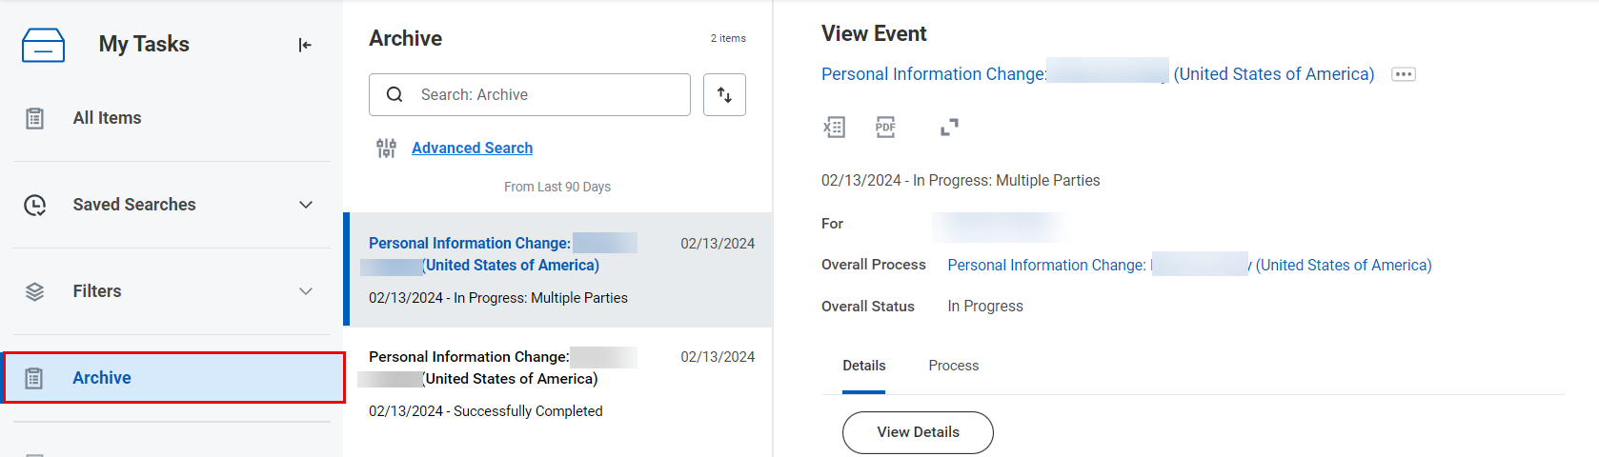

- To view an archived task, click the task on the left-hand side of the screen. It will open on the right-hand side of the screen. Again, you can click the arrows () to expand the screen. You can also see the overall status of various processes, for example if they are Successfully Completed, In Progress or Canceled.

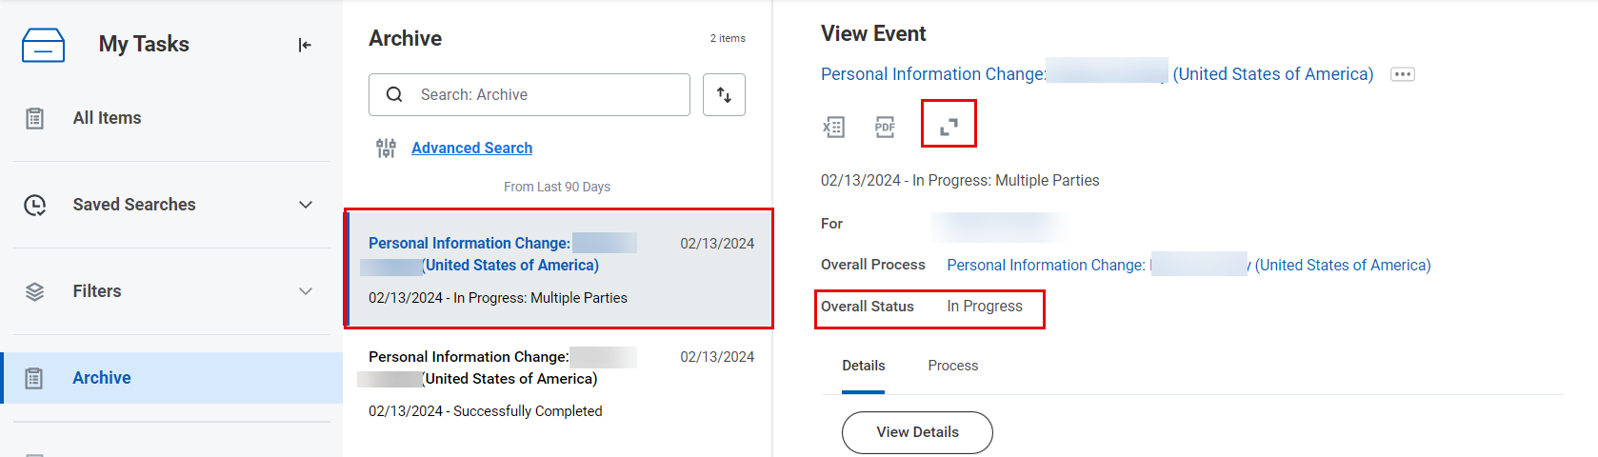

- You can also see the details of the request and the Process History under the Process tab. This function can be helpful for requests that are In Progress.

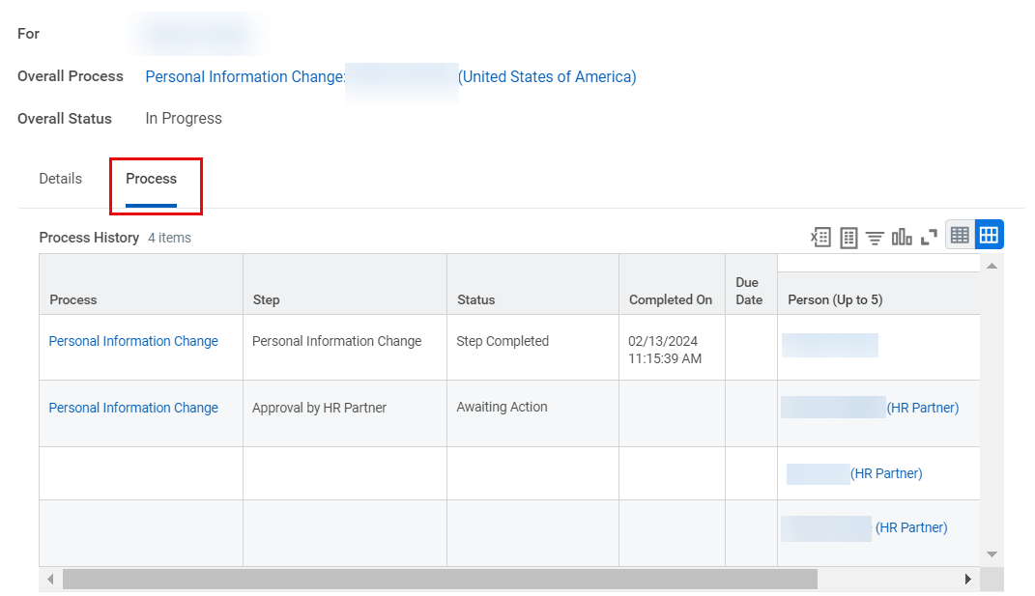

Managing your Workday Notifications

As noted above, actions can be completed from your My Tasks Inbox, while Notifications are purely informational. Workday Notifications will update you on the status of a business process.

- From your Workday Homepage, locate and click on the bell-shaped Notifications icon in the top right-hand corner of the screen.

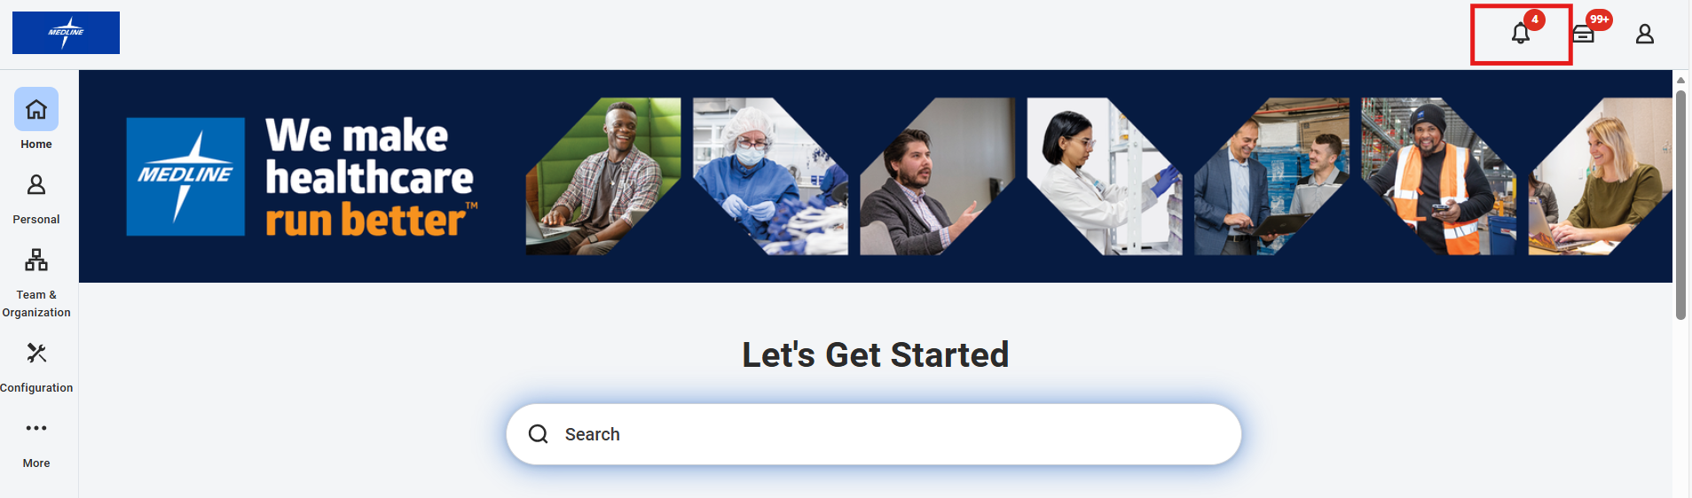

- You will be brought to the Notifications page. From here, you can view your notifications on the left-hand side of the screen. Click the notification to open it on the right-hand side of the screen.

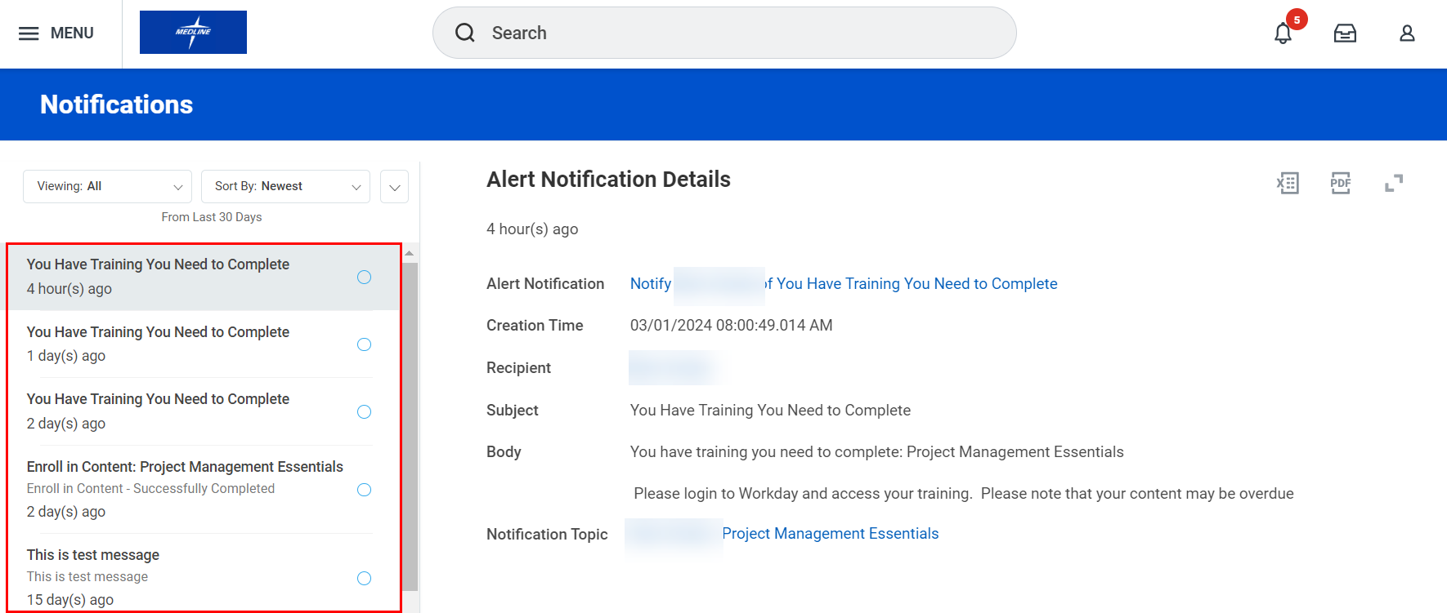

Viewing Your Org Chart
- Click the Avatar icon () in the top right-hand corner, then click View Profile.

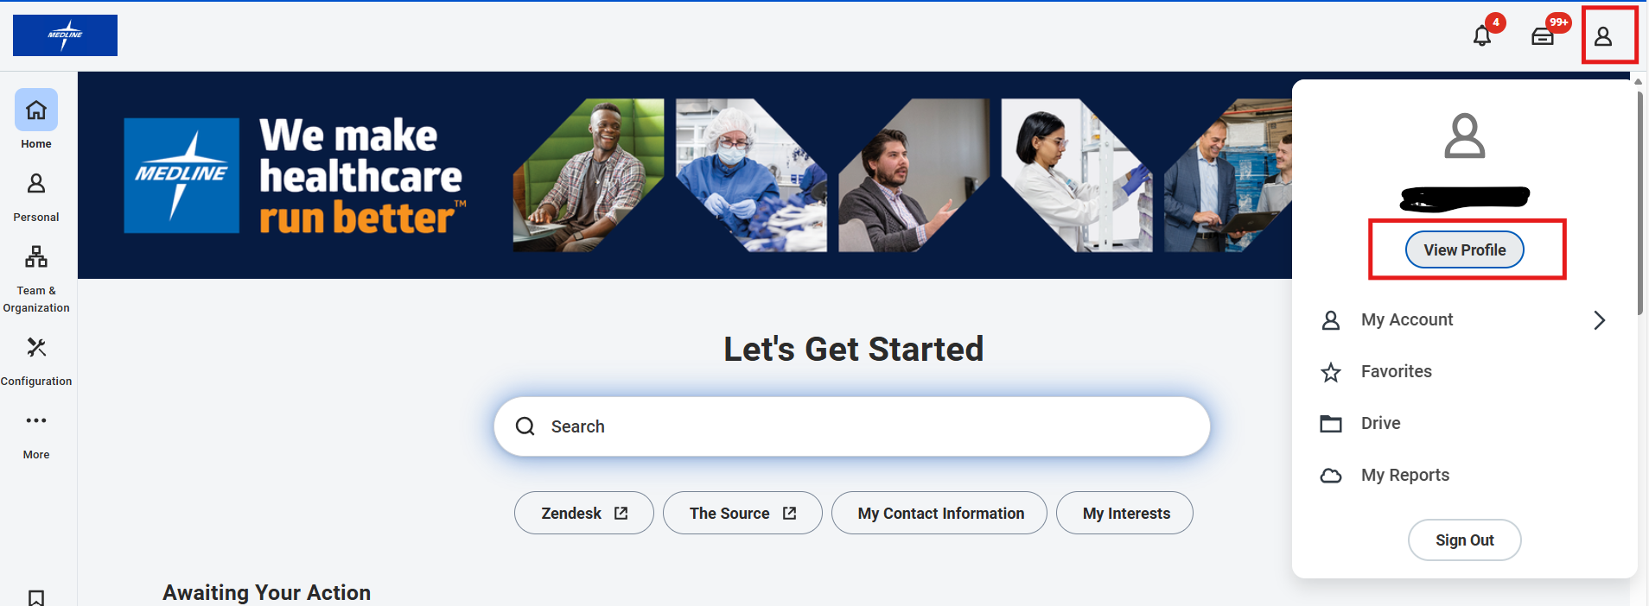

- From your Profile page, you can access an interactive organization chart by clicking on the Team icon at top of the sidebar.

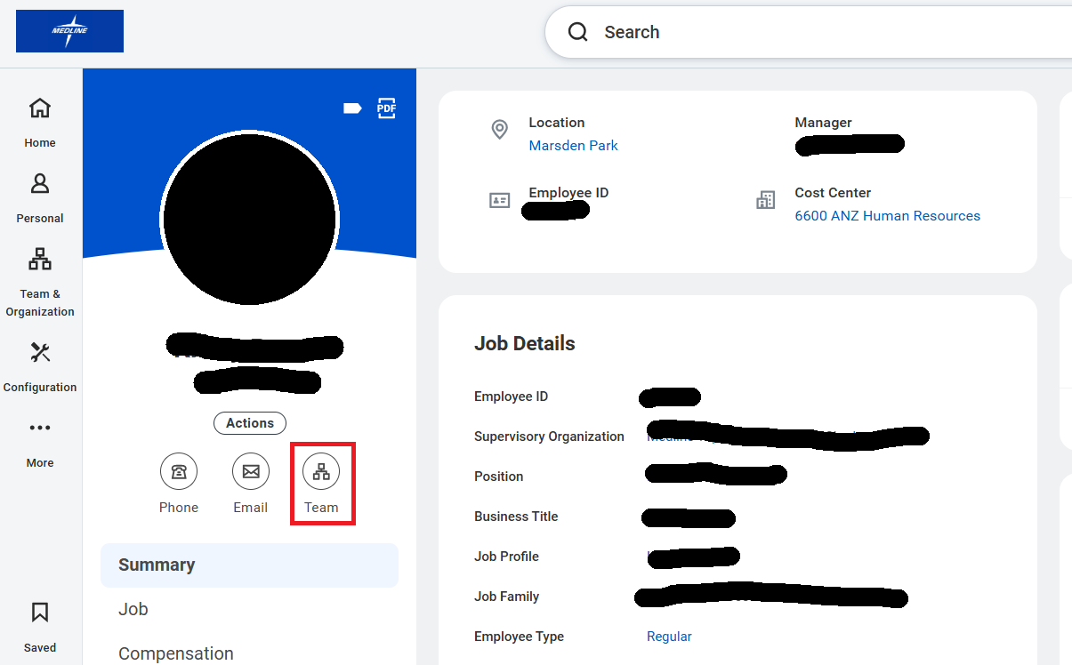

- Once selected, the Org Chart will show you a hierarchical overview, including your direct reports (if any), peer colleagues and supervising manager.
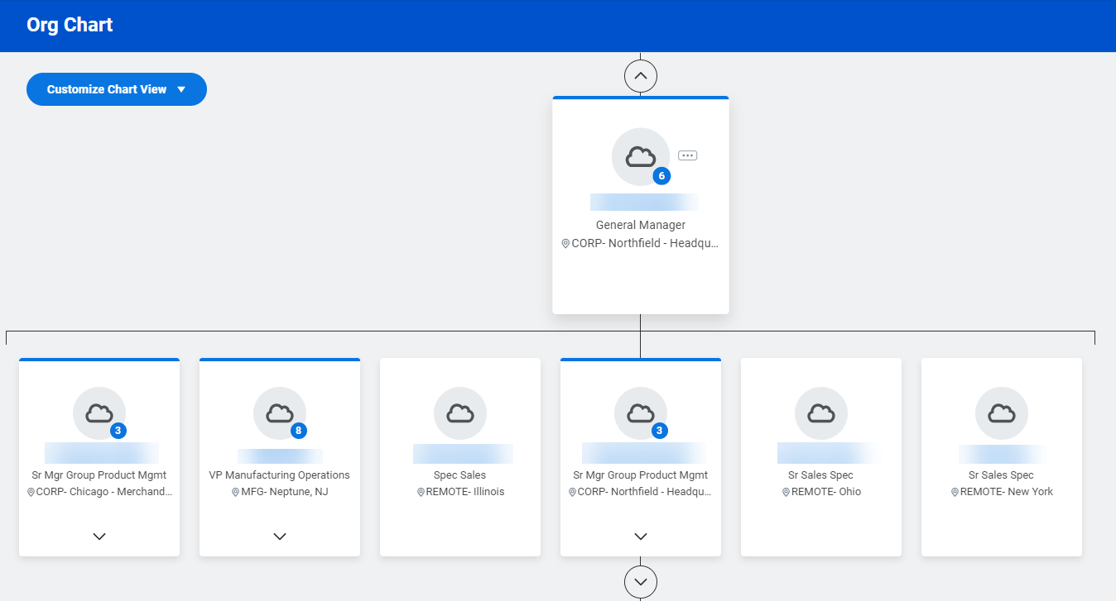
Please note that you can scroll up and down to see the full reporting structure. Managers have a blue circle showing the number of direct reports on their team.

