

Delegating Tasks
Managers and Employees

Tasks in Workday may be delegated from one employee to another employee. This allows the Delegate to initiate, approve, review and execute tasks on behalf of the delegating employee. Delegating tasks in Workday can be useful if you are on extended leave.

- To get started, type Delegations into the Search field and select My Delegations from the drop-down menu.

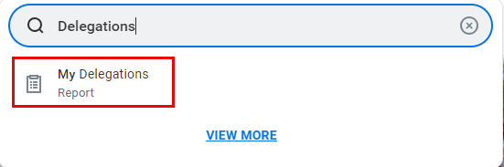

- On the My Delegations page, select Manage Delegations.

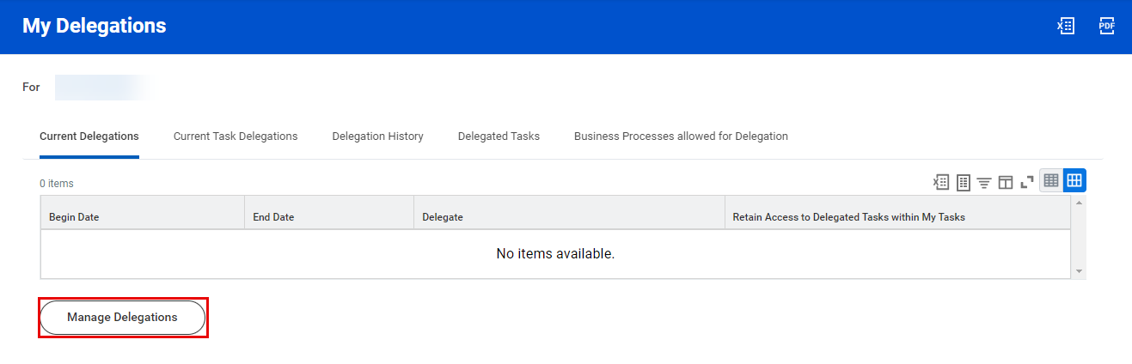

- Delegations may be modified from the Manage Delegations page. From this page, enter the following information:
  - Select a Begin Date that is today’s date or a date in the future. You cannot select a date in the past.
  - End Date.
  - Your Delegate must be a peer or superior. You may only delegate to a direct report under special circumstances (e.g. executive assistants) and you must contact HRIS to do so.
  - Start On My Behalf indicates the list of business processes that may be initiated on behalf of the Delegator.
  - Do Inbox Tasks On My Behalf specifies the business processes which the Delegate may approve and review on behalf of the Delegator.
  - You have the option to keep track of your delegated tasks in your My Tasks Inbox by checking the box under Retain Access to Delegated Tasks in Inbox.
  - A Delegation Rule may be specified, if applicable.

Please note that the End Date is a required field.

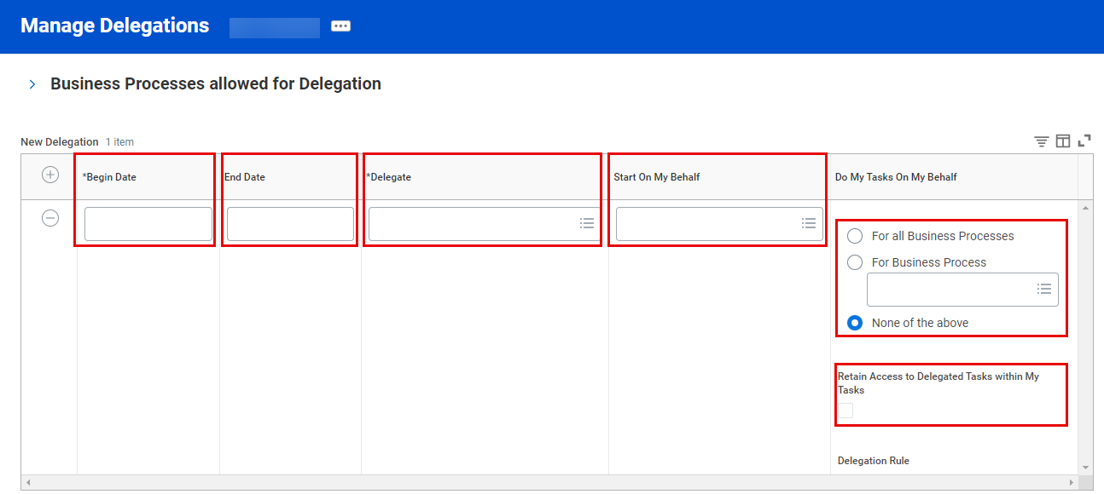

- Once you have entered this information, click Submit.



