

Candidate Tracking
Managers

For Managers looking to manage candidates through the recruitment process for a job requisition you initiated and to learn how to provide an offer, this document will guide you through the following tasks and processes:
Reviewing Candidates
How to review candidates that have applied to one of your job requisitions.

Reviewing Candidates
- From your Workday Homepage, select the Recruiting Dashboard application from the Applications Menu. Alternatively, you can click the Recruiting Dashboard app directly on your Workday Homepage below Your Top Apps if it appears there.

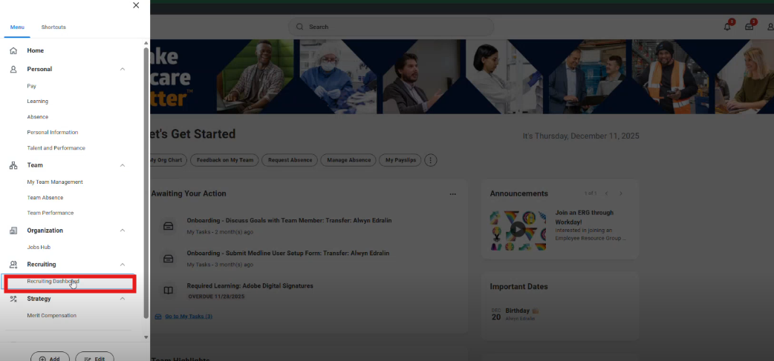

- Under the Reports column, select My Open Job Requisitions.

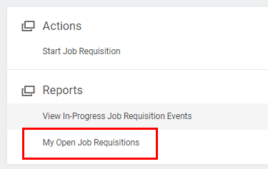

- If you are the Manager on the job requisition, it will automatically populate. Then, click OK.

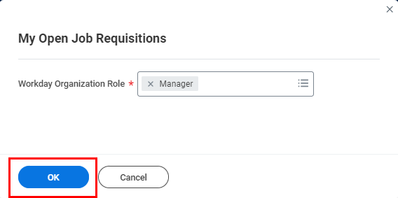

- Select an Open Job Requisition from the list to view candidates for.

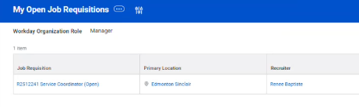

- Then, click Candidates or Review Candidates, which will take you to the same tab.

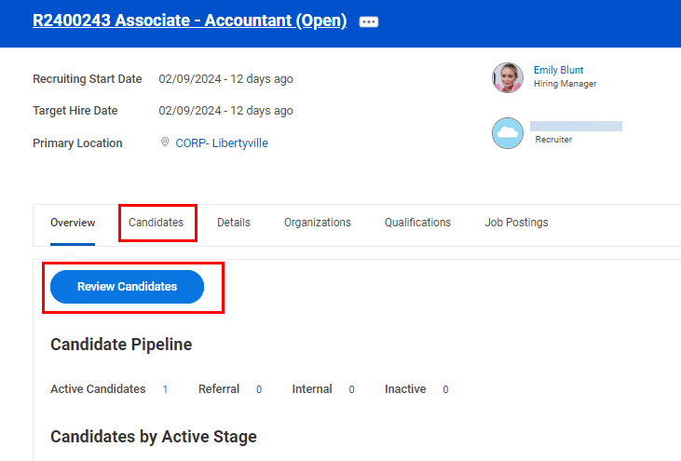

- From this page, you can view candidates for the job requisition.
- View the number of Active Candidates, Active Referrals, Active Internal Candidates, or Converted Prospects.
- Filter candidates by ones Awaiting Action.
- View all in the table.

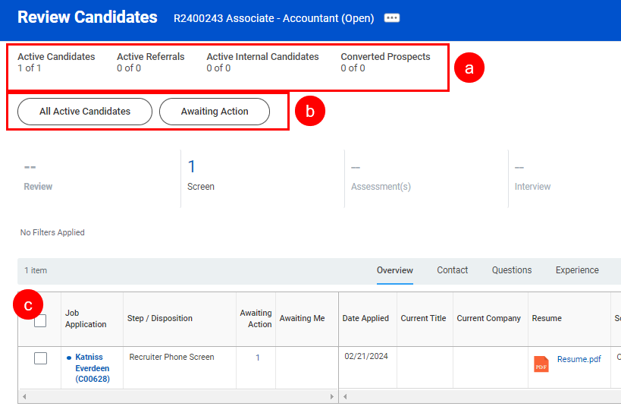
- Click on a candidate’s Name in the table to review their application.

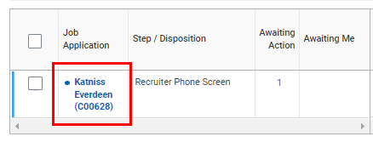

- You will be directed to the candidate’s Profile, where you can view their Work History Experience, Education, Resume / Cover Letter, Languages, Websites and more.

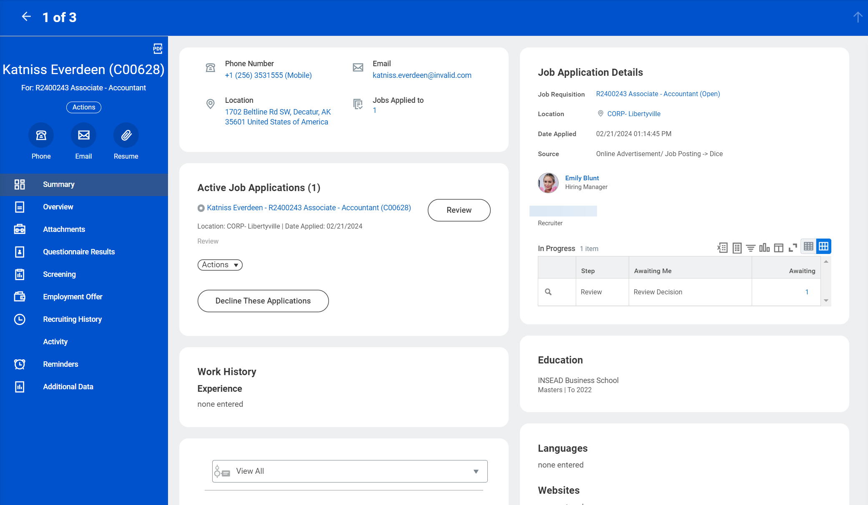

- You may be asked to screen the candidate’s application if the Recruiter chooses to send it over to you. In such case, you will receive a task in your Workday My Tasks Inbox titled Hiring Manager Submission with the candidate’s name. Review their application, then select Move Forward and Proceed with Interview.

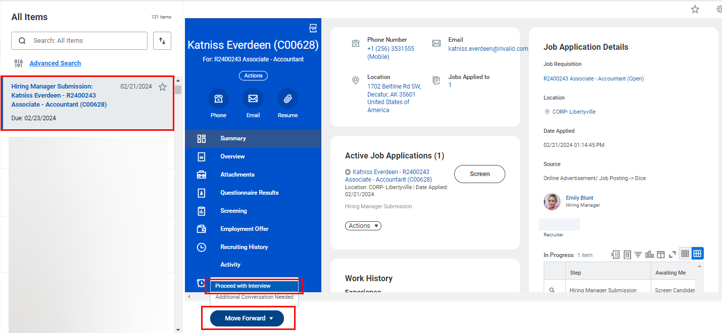

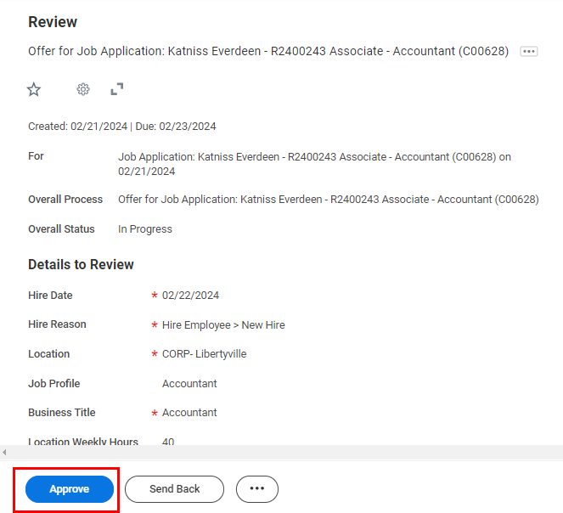

- If approved, the offer will be routed to a superior in your organization for approval. The name will be mentioned in the confirmation notification.



- They can choose to either Approve or Send Back. If they approve, the next step will route to the recruiter to generate a document for offer.

