

Candidate Tracking
Managers

For Managers looking to manage candidates through the recruitment process for a job requisition you initiated and to learn how to provide an offer, this document will guide you through the following tasks and processes:

Offer Approval Process
How to initiate an offer for a candidate that has applied to a job opening on your team in Workday.

Offer Approval Process
- After the recruiter submits the offer details, it will be routed to you for your approval before it is sent to the candidate. Select the task in your Workday My Tasks Inbox titled Offer for Job Application with the candidate’s name.

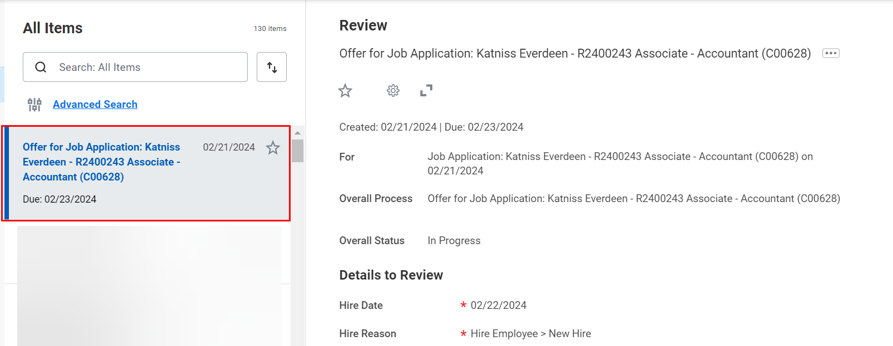

- On the right-hand side of the screen, review the details of the offer. Then, you can either select Approve or Send Back. If you choose to send back, please provide a reason for the recruiter to make the necessary modifications.

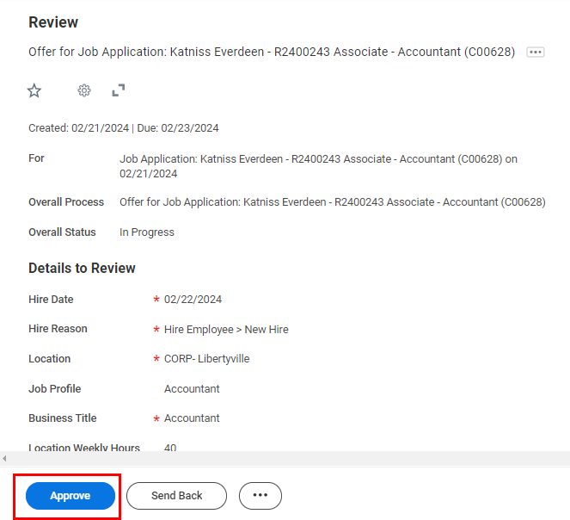

- If approved, the offer will be routed to a superior in your organization for approval. The name will be mentioned in the confirmation notification.



- They can choose to either Approve or Send Back. If they approve, the next step will route to the recruiter to generate a document for offer.

