

Agency

For processing the candidates via agency, this document will provide a proper guideline to recruiters and agency users on how to process a candidate via agency.

Recruiters:

- Navigate to the requisition and post the job tp the agency.
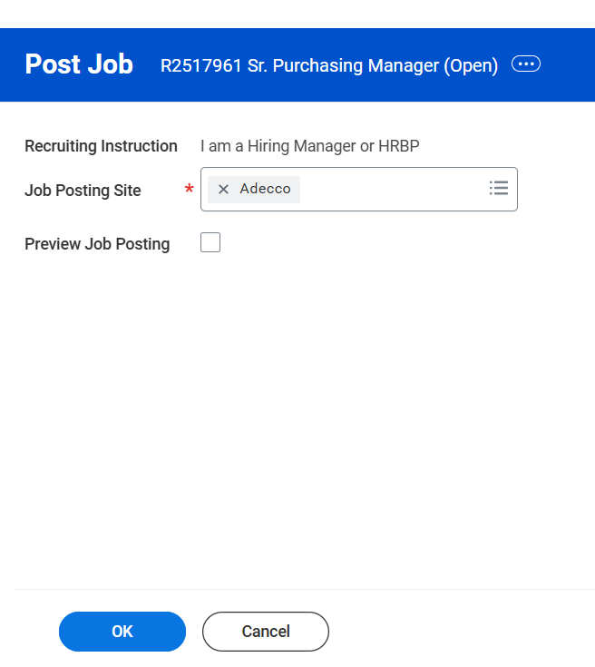

Once the job is posted, the agency users can submit the candidates.

Agency Users :

- The agency and agency users are created in the system and the agency users have been provided access to login into the system.
- The Agency user can login into the system and view the current job postings posted to the agency.


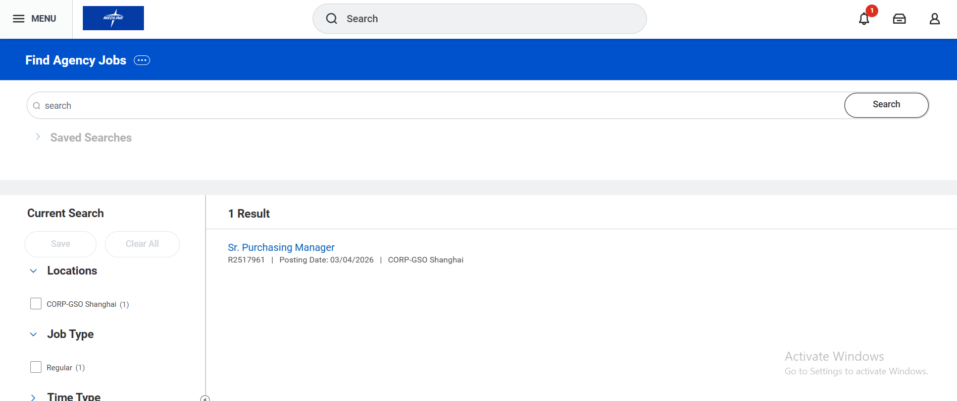

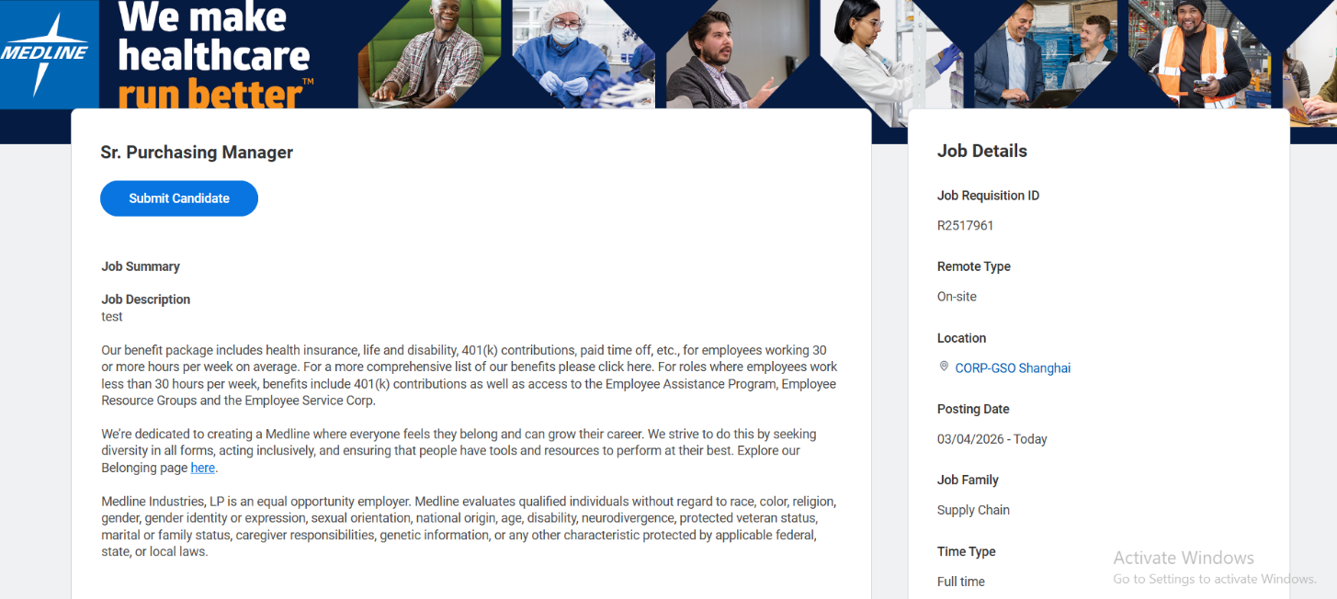

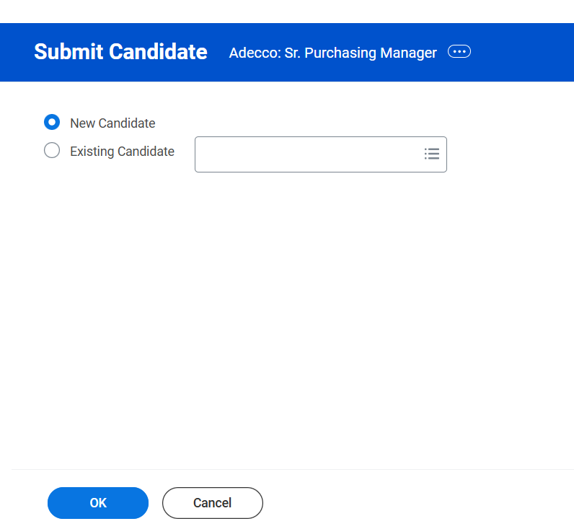
- Give basic and required information of the candidate and submit to the candidate, the candidate lands in the job requisition.

