New employees will have default Probation details based on the rule setup
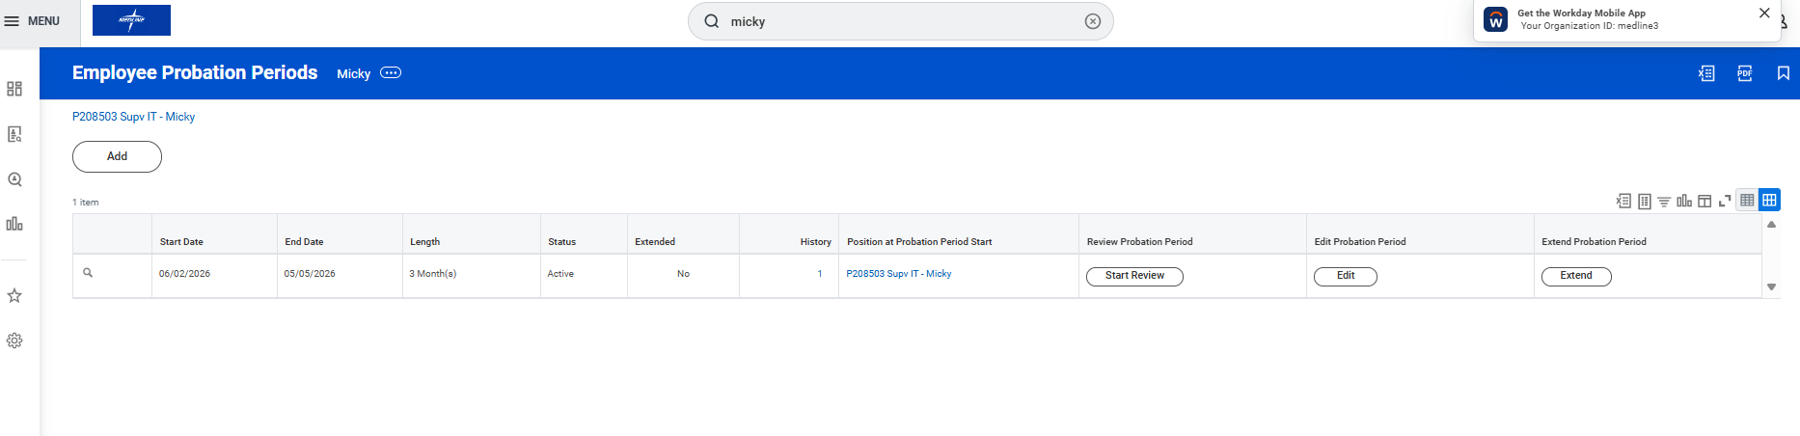

HR Partner will Trigger the Probation Goals to Employee based on the Review Template. Access Start Performance Review for Employee->Select Employee->Select Review template” Goal Based Probation Performance Review-APAC”


3.Once Submitted by HR Partner->Employee self


Complete Self Evaluation Task with the Employee -> Click Get started

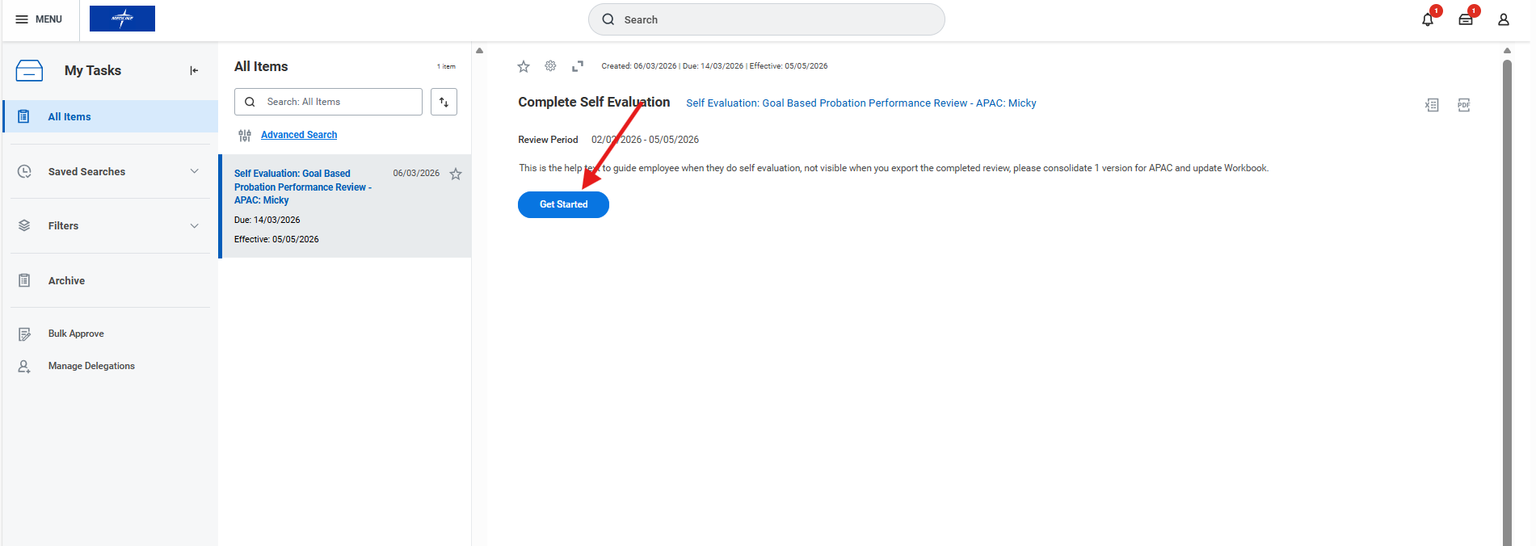

Click Add for performance Goals
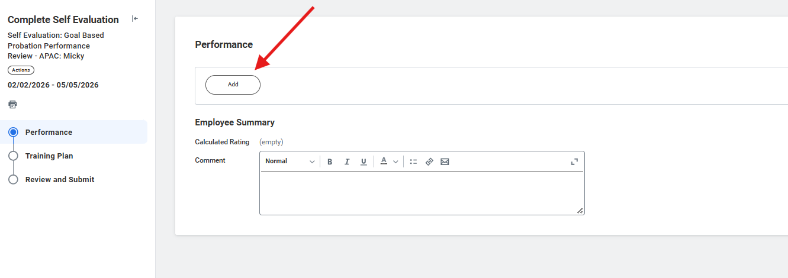

Add performance Goals
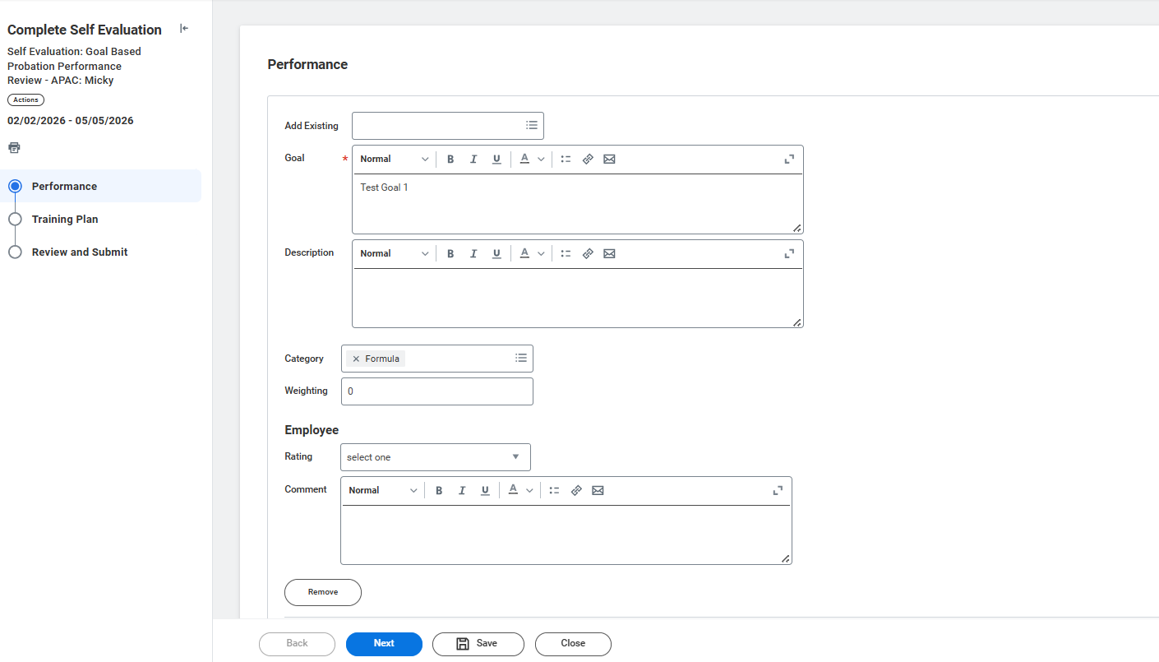

6.Add Training Plans
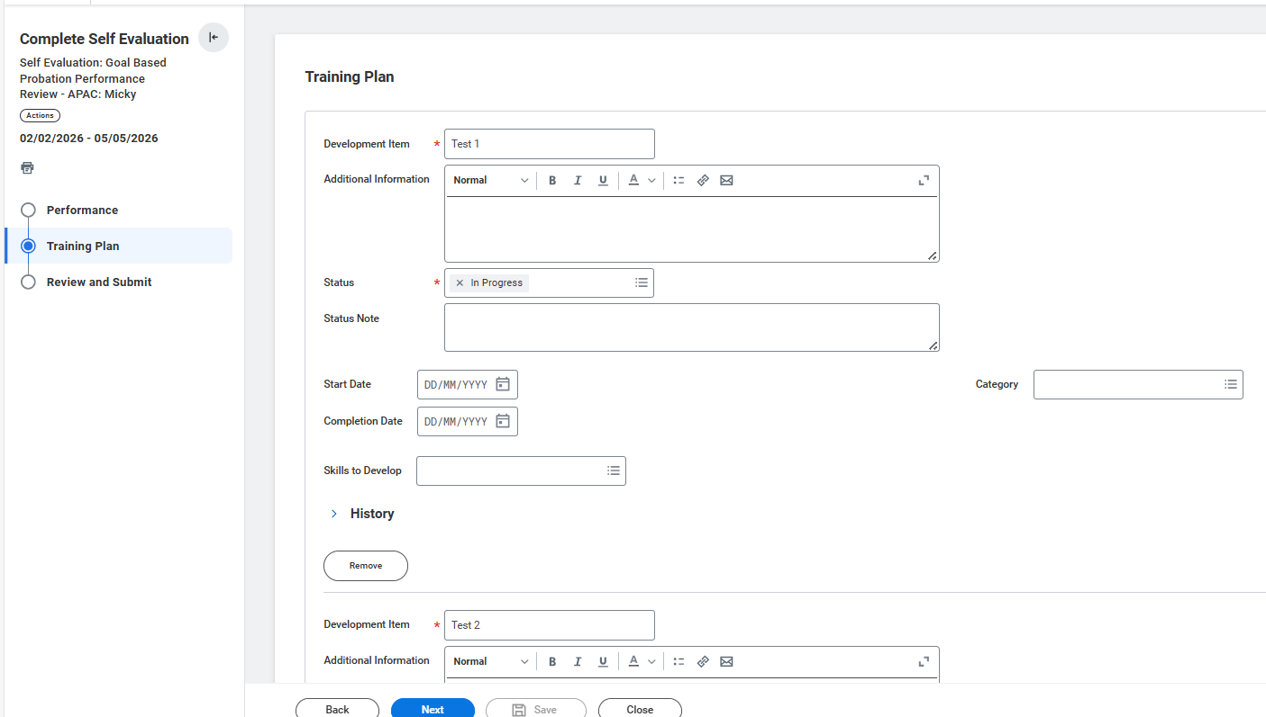
Review and Submit the Task
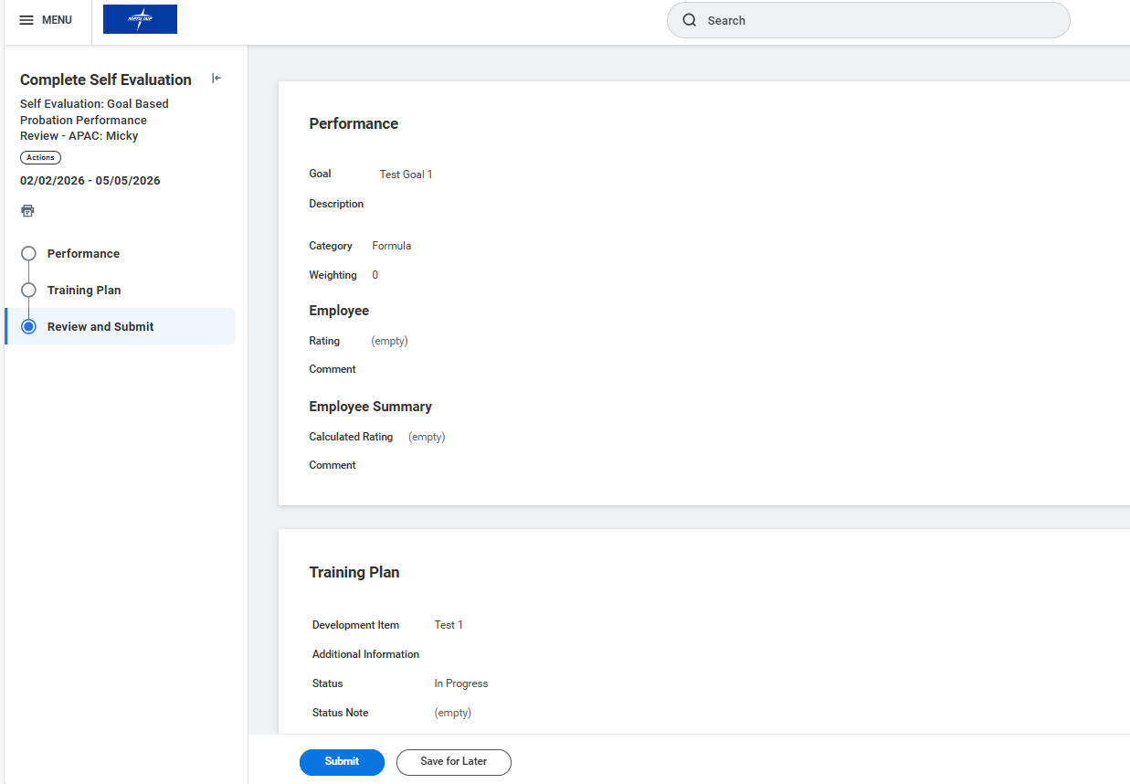

Manager Review.
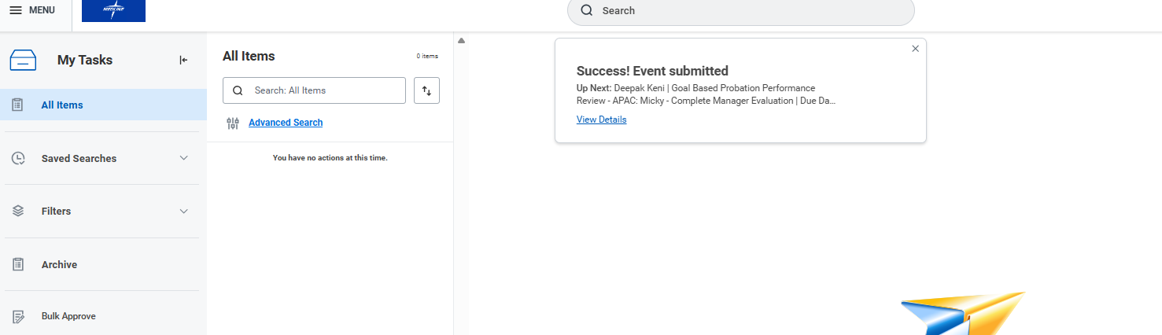

Manager to Click “ Get Started”
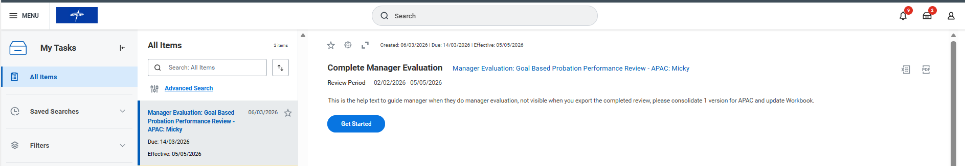

Review the Goals and Sumit
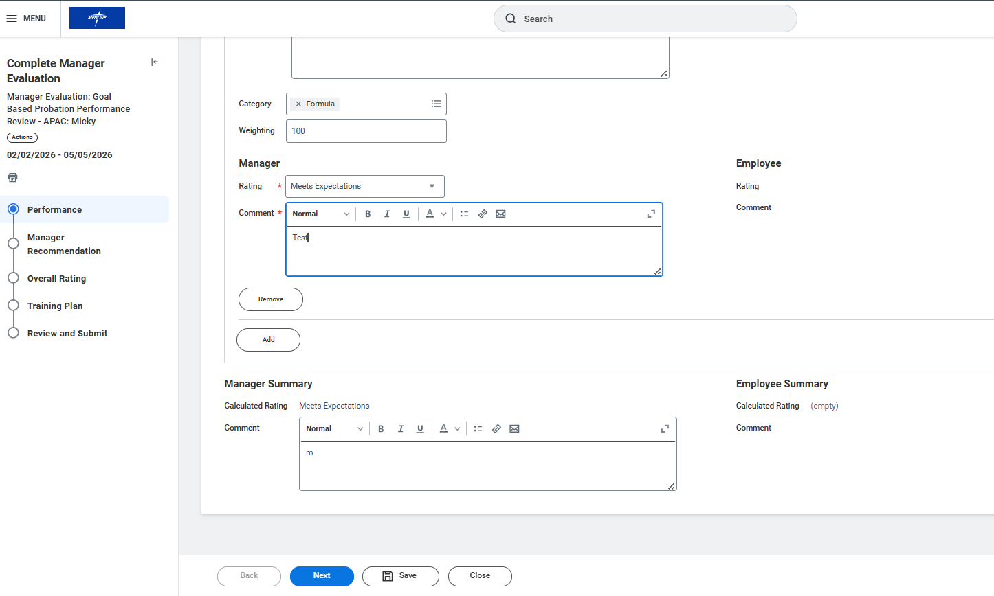

Provide Manager Recommendation:
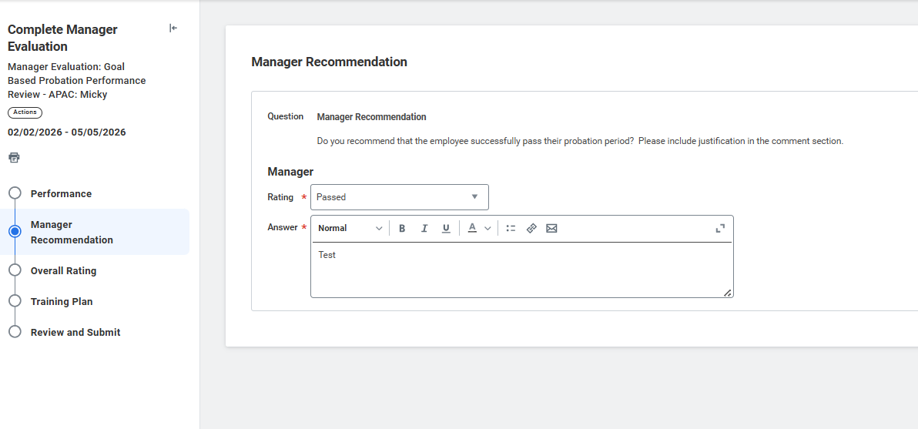

Complete Overall Rating:
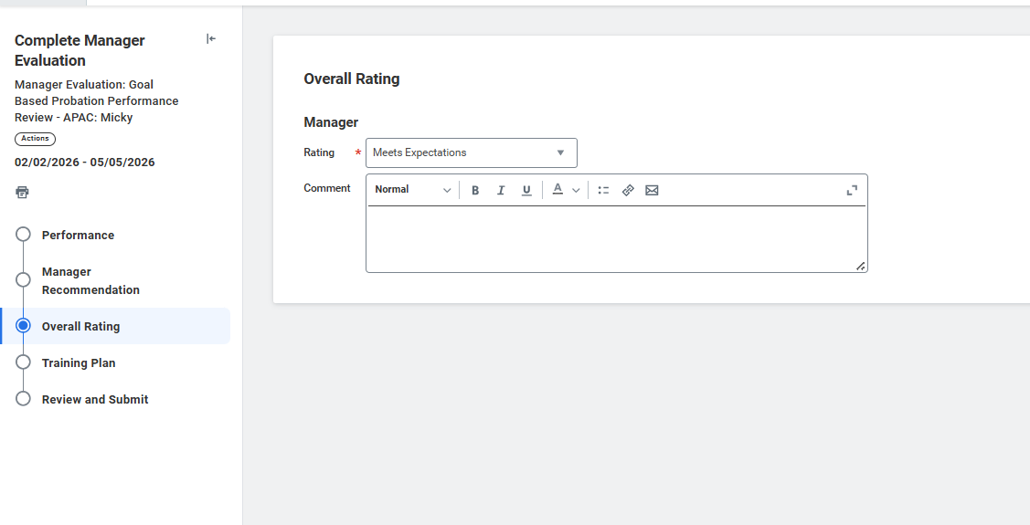

Click Submit and Completed the Probation Review
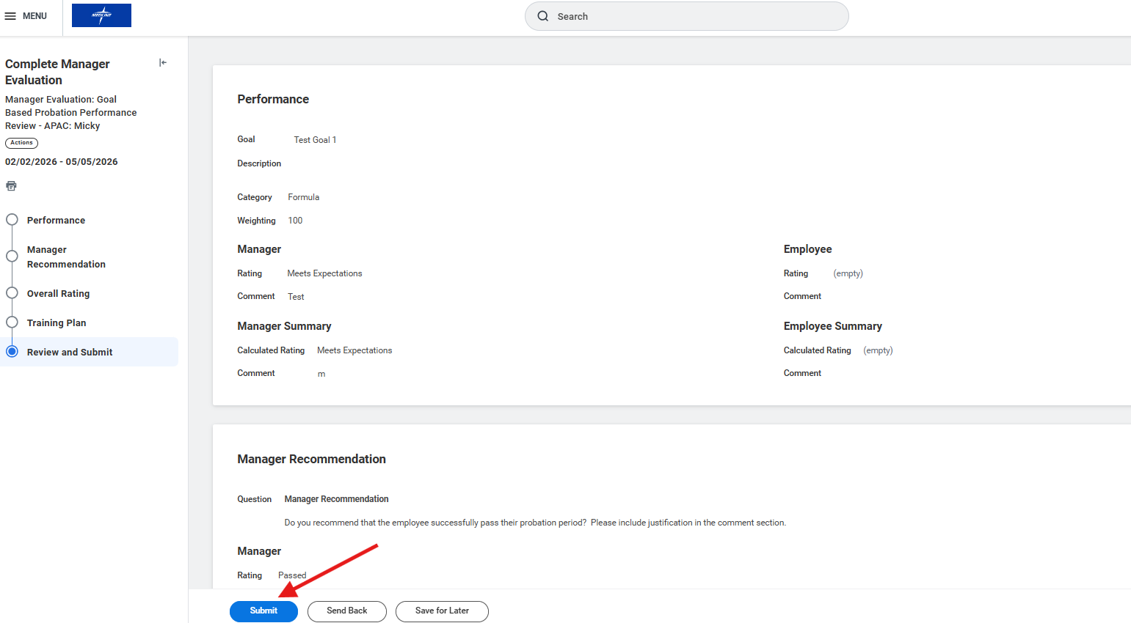

Provide Review Comments
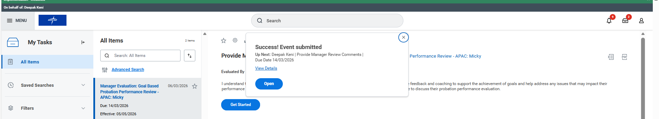

Manager Acknowledgement:
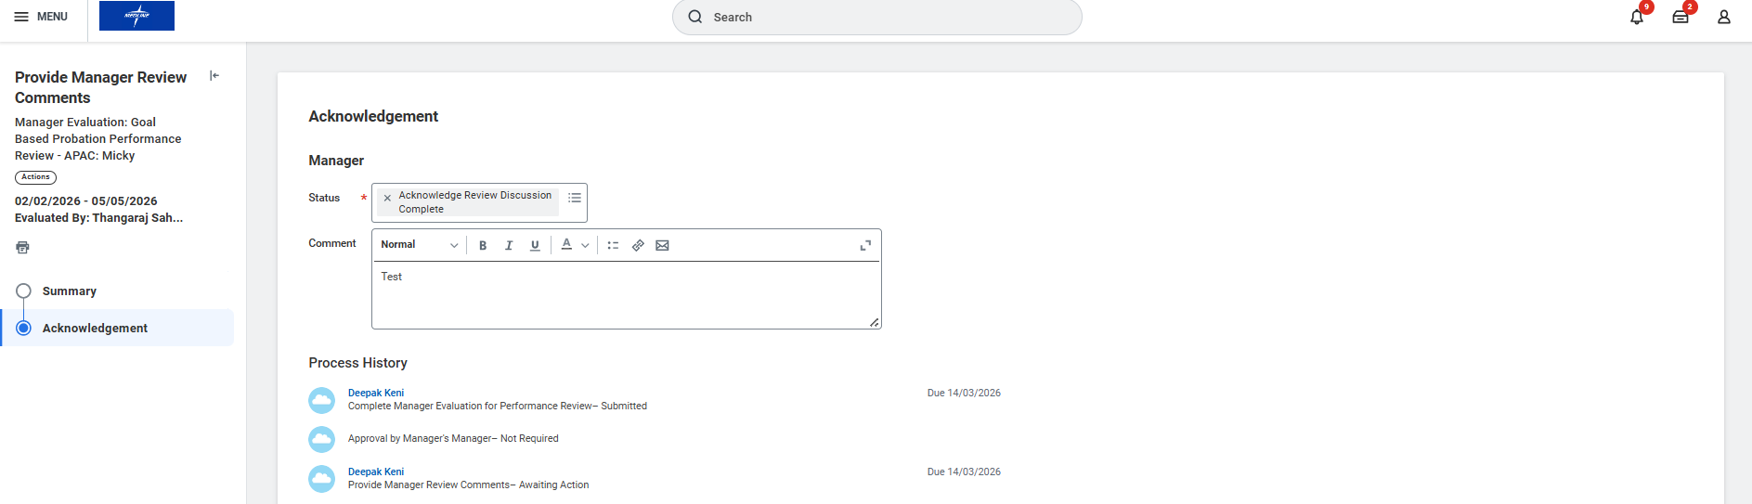

ESS Acknowledgement:
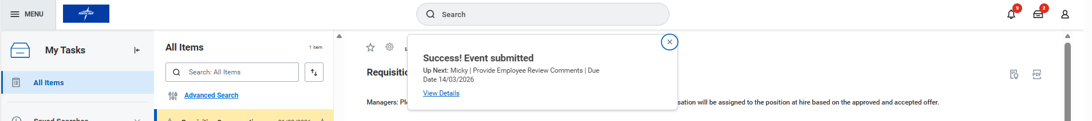

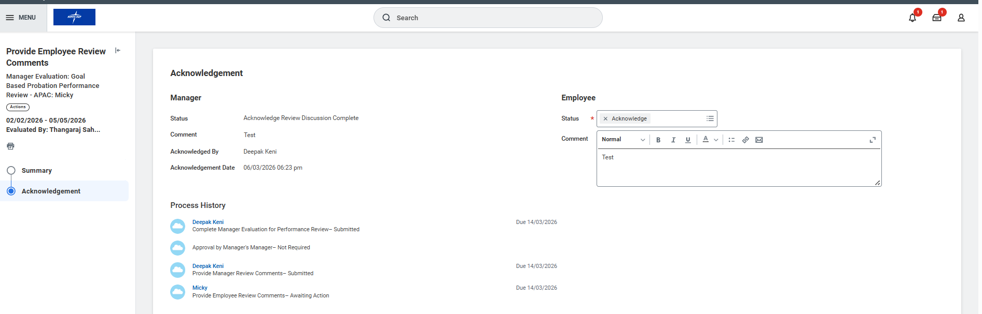

Probation Review successfully completed and Triggered to HR partner to launch the outcome:
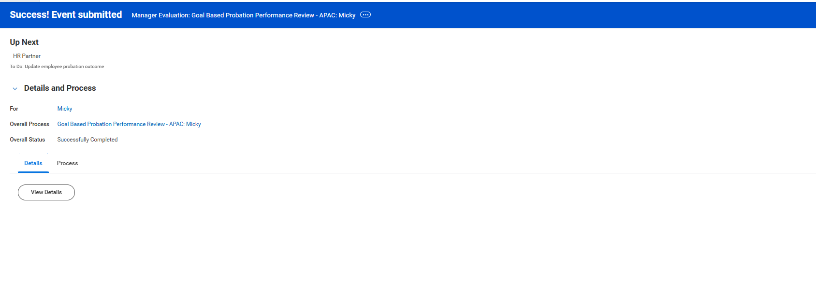

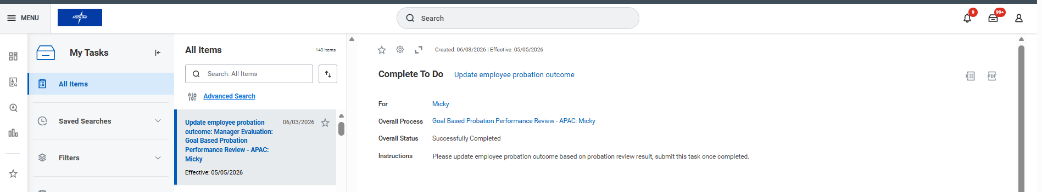

Probation Outcome:
Access Job change->Manager Probation Periods
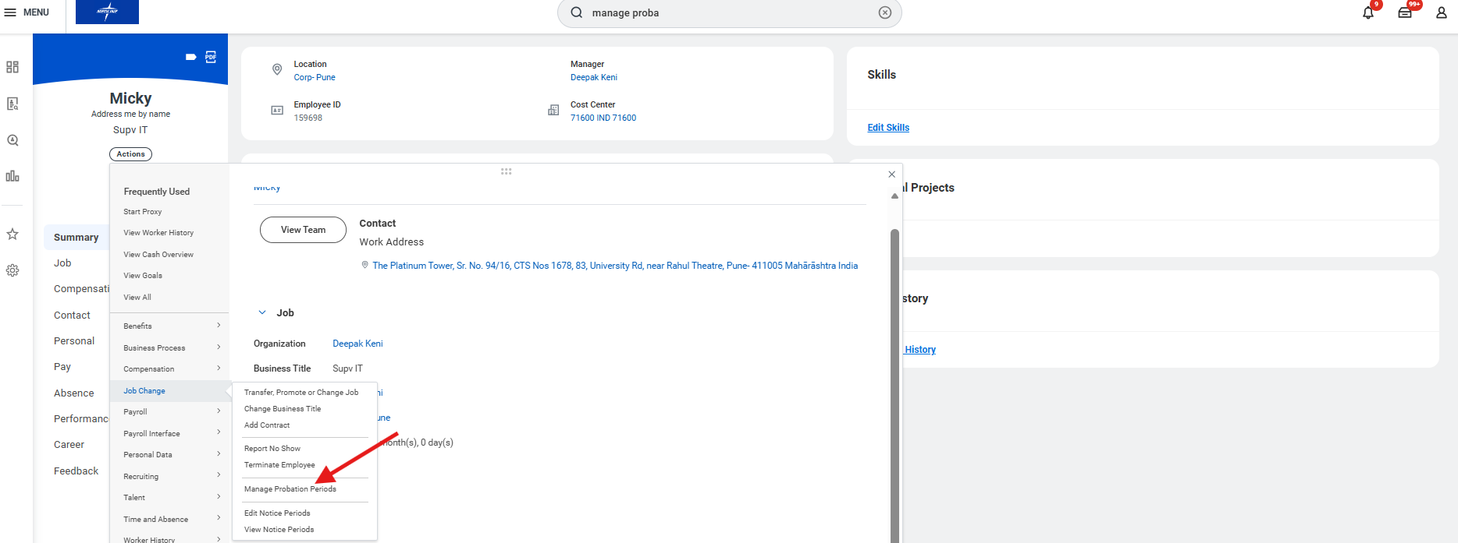
Click Start Review to Launch the Probation outcome
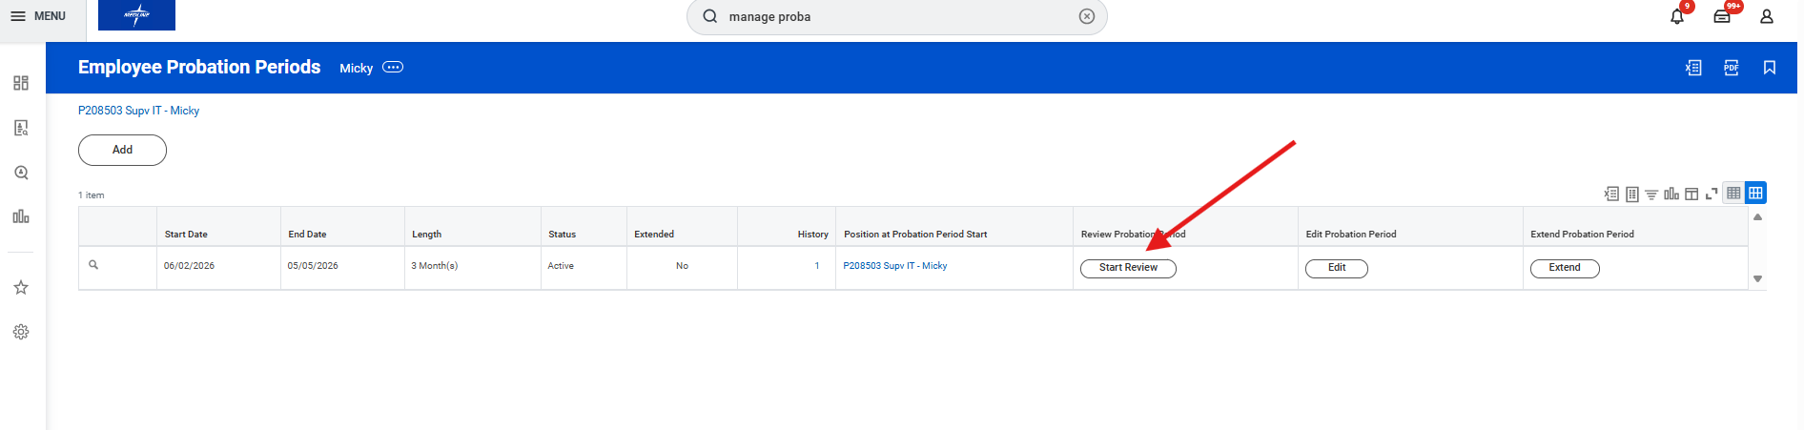

Update the Probation Outcome from the Dropdown list:
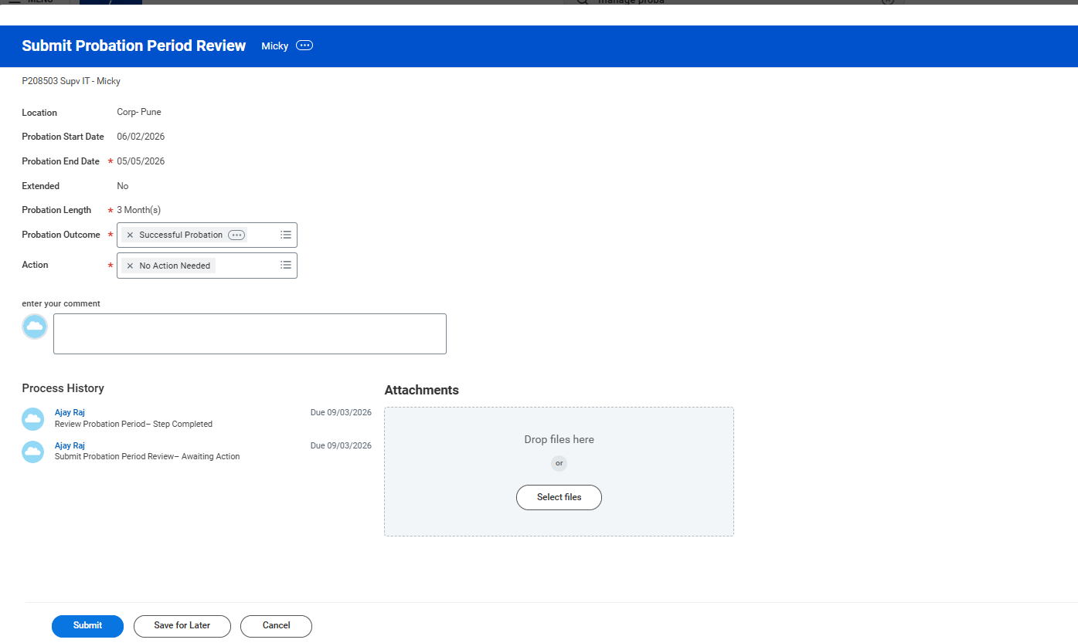

Outcome successfully submitted
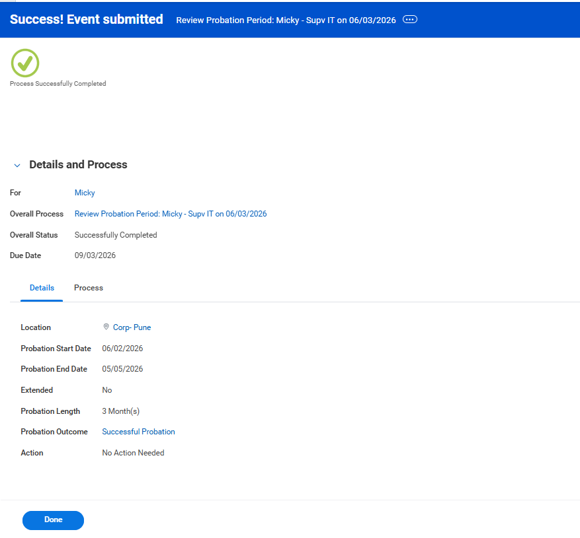

Submit the TODO Employee Probation outcome:
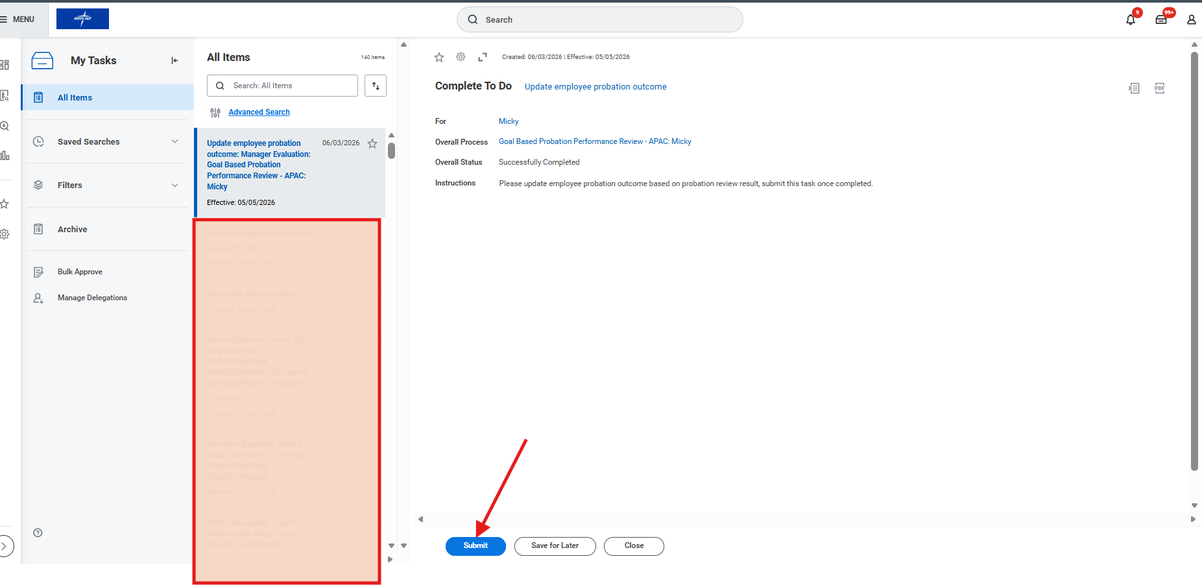

Goal based Probation Performance Review:
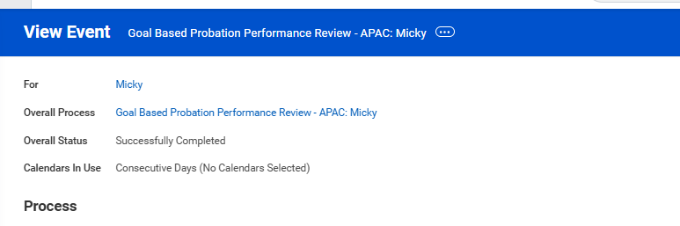

Notification triggered to Employee for the Successful Probation:
