Resignation Process for India:
1.Employee accesses the Job change -> Resign task
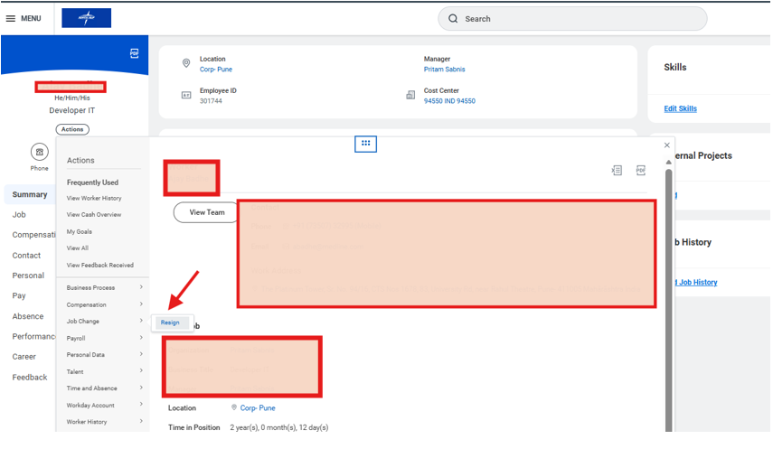

2.Submit Resignation will default the dates and Employee should select the Resignation Reason and if any attachments.
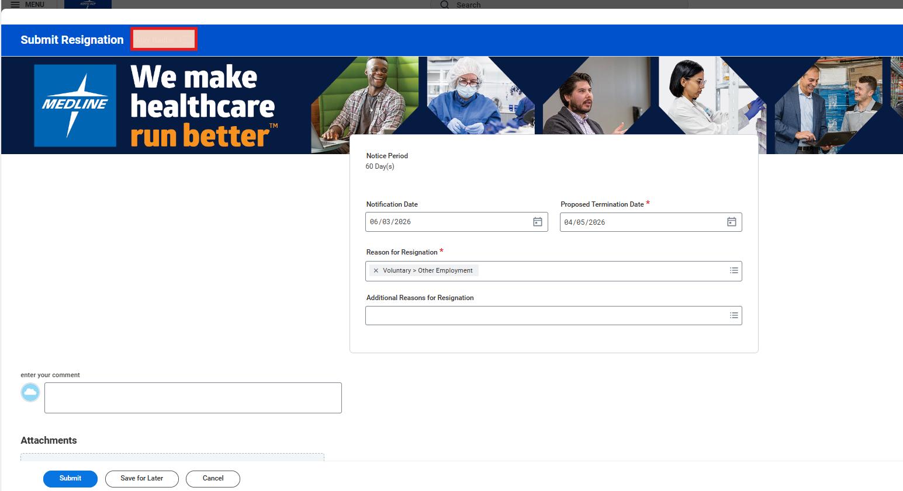
3. Next Step-> Manager Approval
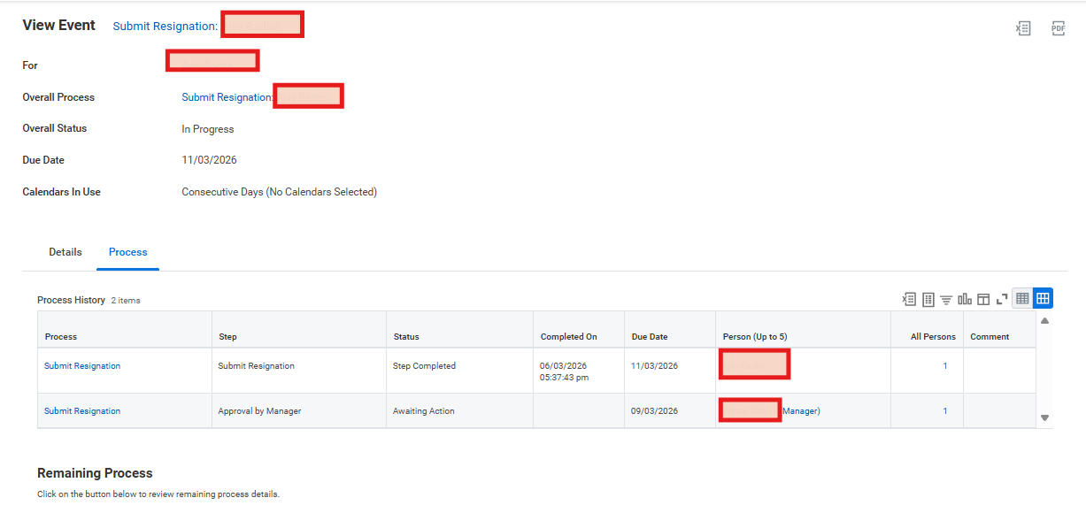

MSS: Manager can Approver OR Send back

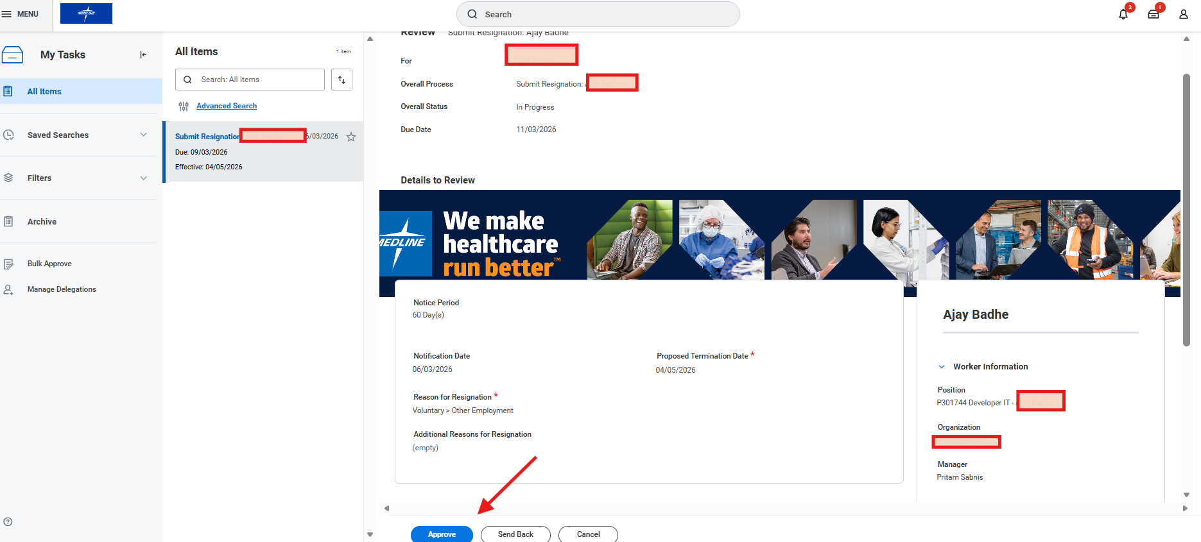

4. Once Manager Approved-> HR Partner will Approve.
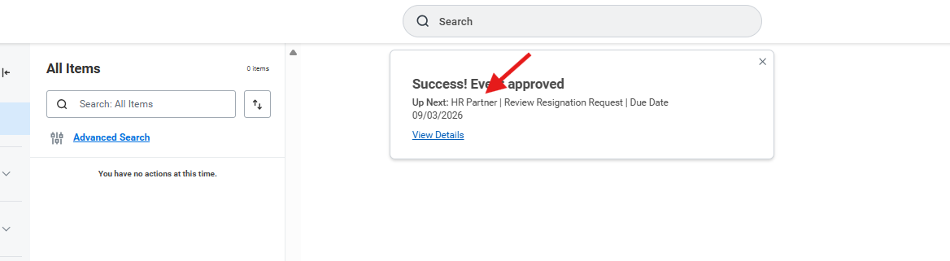

HR Partner can Approve or Send back:
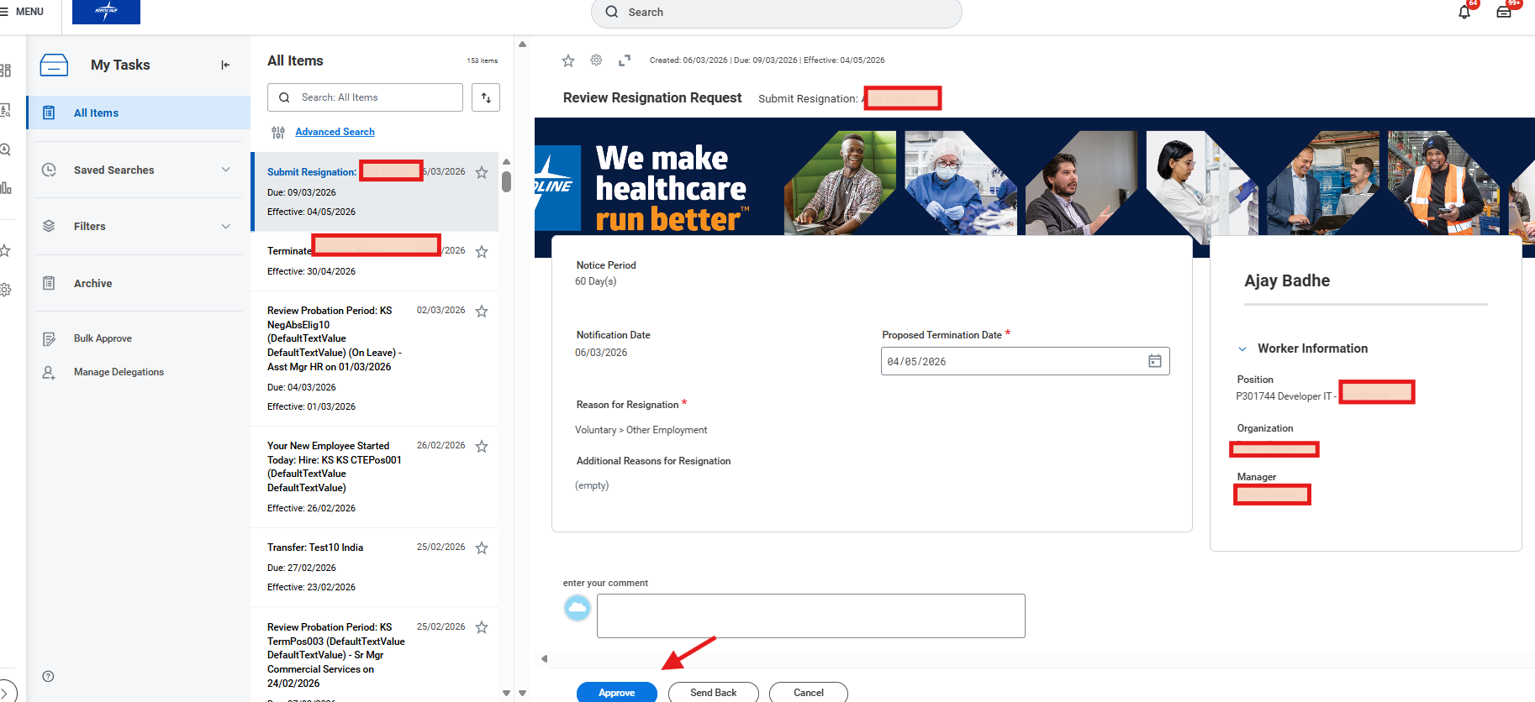

HR Partner approved -> Submit Resignation Completed.
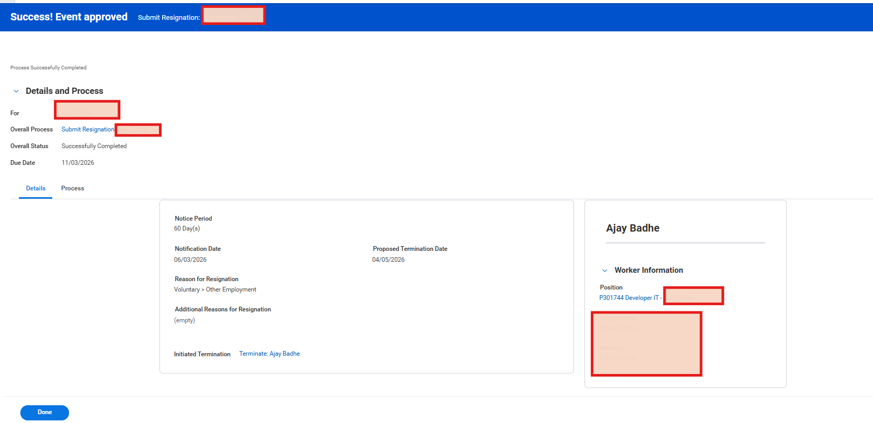

HR Partner Received the Termination Task with Resignations Details:
