

Lateral Move
Managers and HR Partners

Lateral Move (Initiating Manager)
- Access the task called Start Job Change
- Select the employee, choose the “Lateral Move” template, and click Ok.
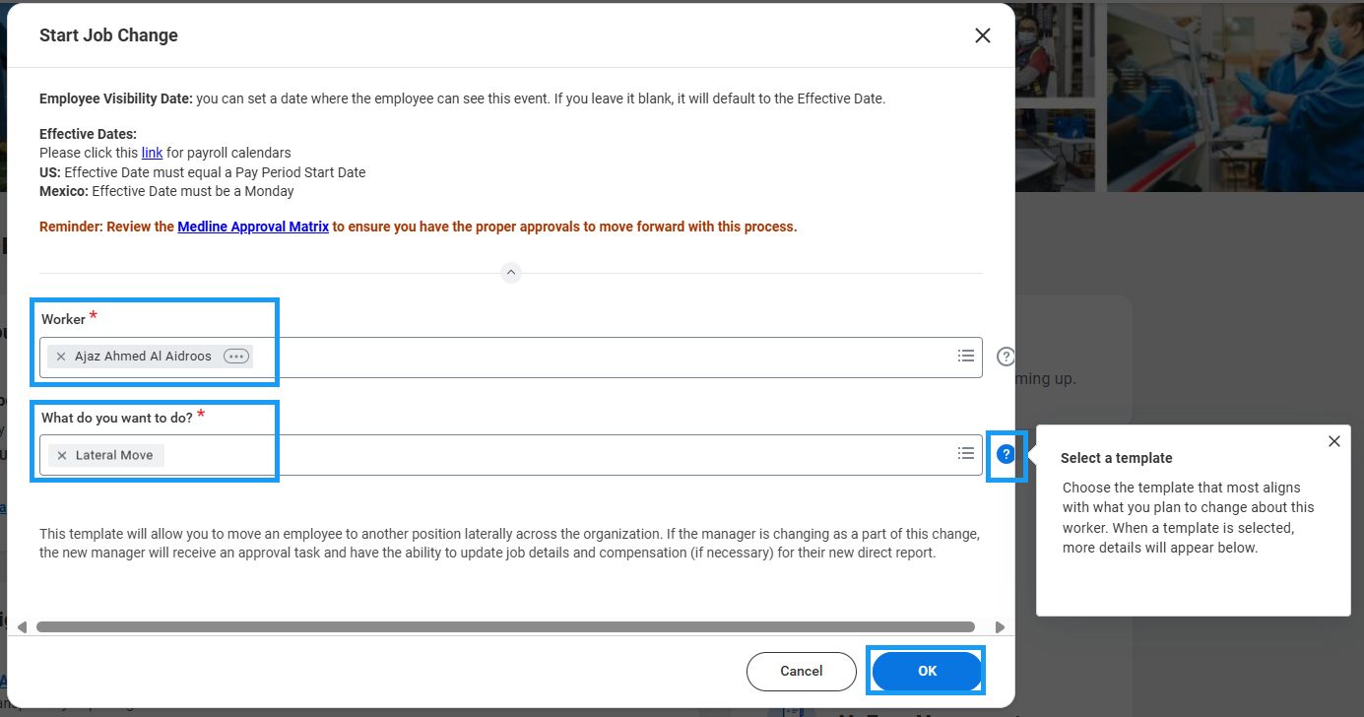
- Choose the desired Effective Date – it must be the beginning of a pay period.
- Select the team that the person will be moving to.
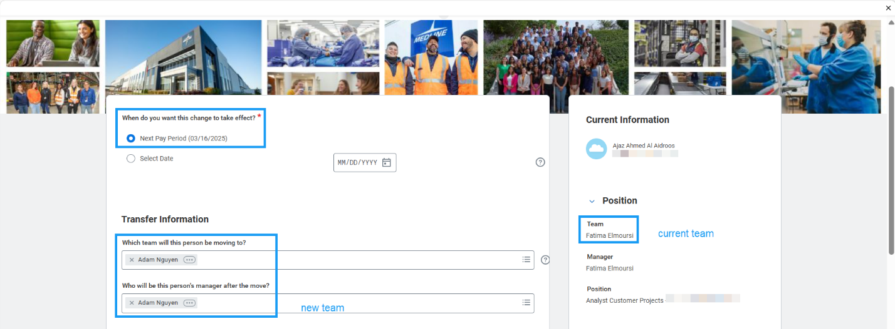

- If the position is moving WITH the employee, check the box that says, “Is this person’s position moving with them?”

Please note that checking this box means you will not be able to backfill this position on your team.

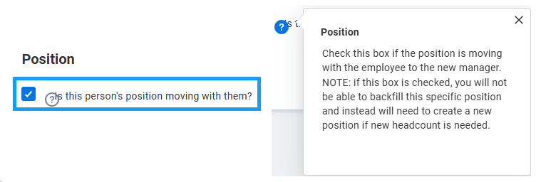

- If the box is left unchecked and you plan to backfill the position, select the radio button that says, “Keep open for backfill” under “What do you want to do with this person’s current position?”
- If the box is left unchecked and you do NOT plan to backfill the position, select the radio button that says “Close” to close the position after the employee vacates it.
- It is recommended that you check the box “Should the current position be available for overlap?”
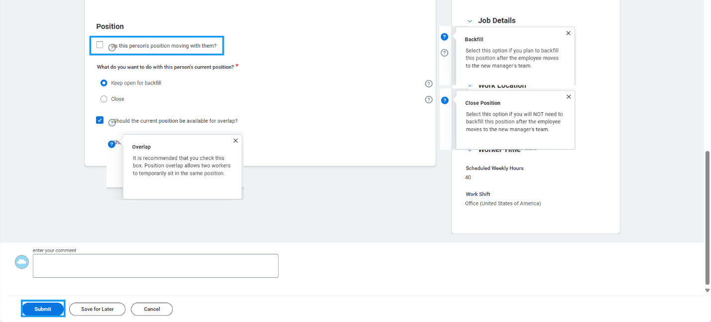
- Review changes and click Submit to route to the Receiving Manager.

Lateral Move (Receiving Manager)
- Open the task for the Lateral Move in your My Tasks inbox.
- Review the data entered by initiating manager.

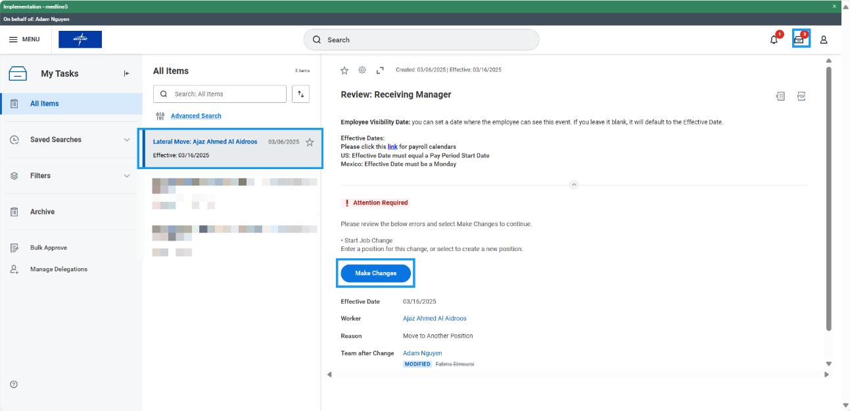

- If the initiating manager has elected to keep the employee’s position open on their team for backfill, you must select another position for this employee to complete the transfer. Click the “Make Changes” button at the top of the task to enter edit mode.
  - If you already have a position open and available for this employee, select that position in the dropdown under “Select a position for this change.”
Please note that you may not select a position that is tied to an open or future job requisition.

  - If you do not have a position open and available for this employee, you may select the box that says, “Do you want to create a new position?”
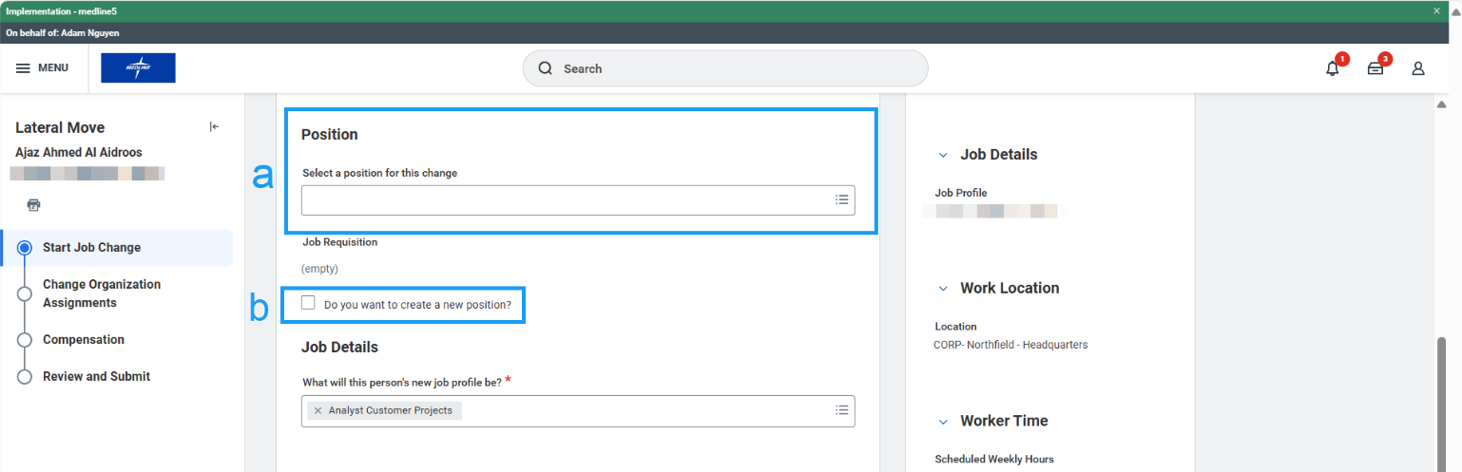
- Confirm that the Job Profile, Location, Scheduled Hours, and Work Shift are correct and click Next.

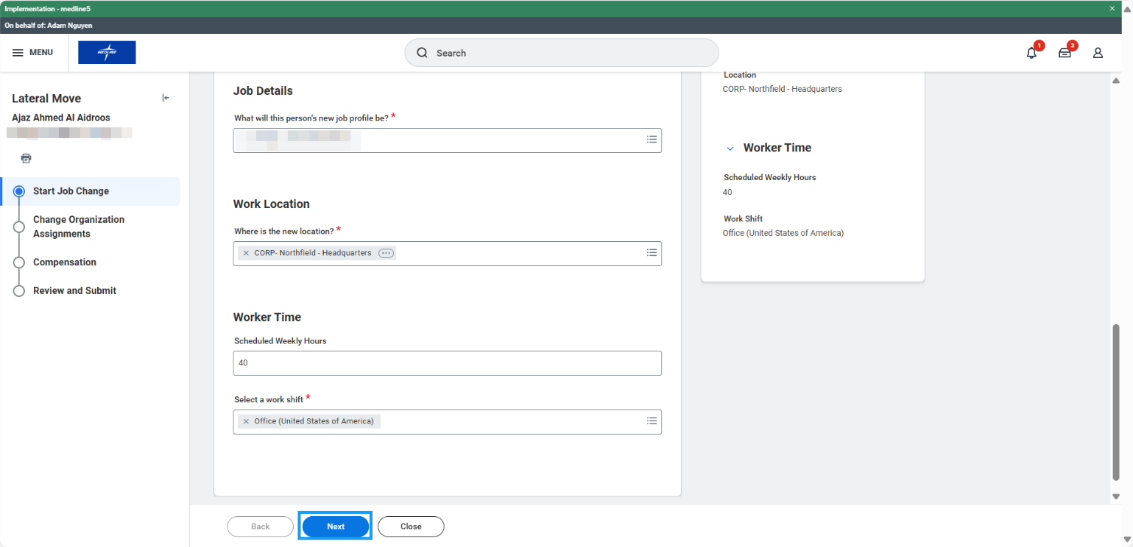

- Confirm that the Company, Cost Center, Department, and other organizations are correct and click Next.

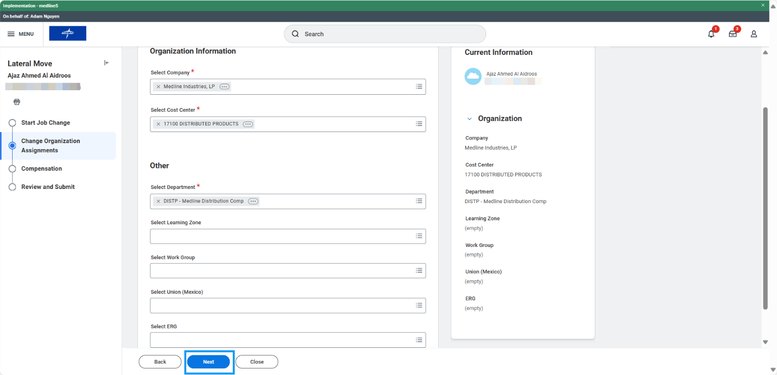

- Confirm that the Compensation is correct. If changes are needed, click the three dots on the right side of the form to Edit. Click Next.

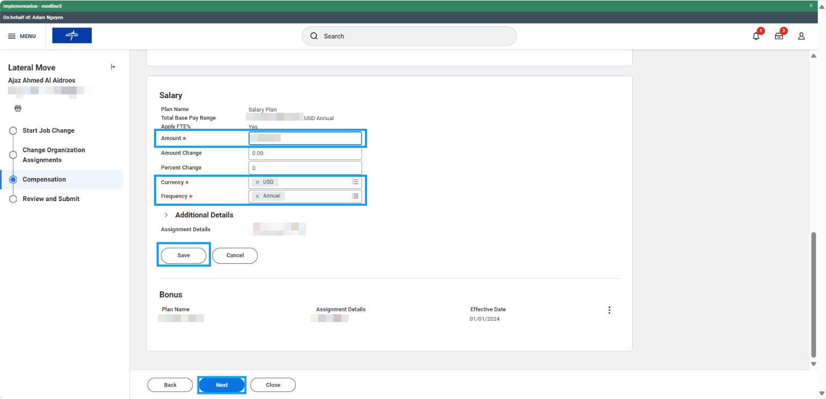

- Review all details and click Approve to route to HR Partner.
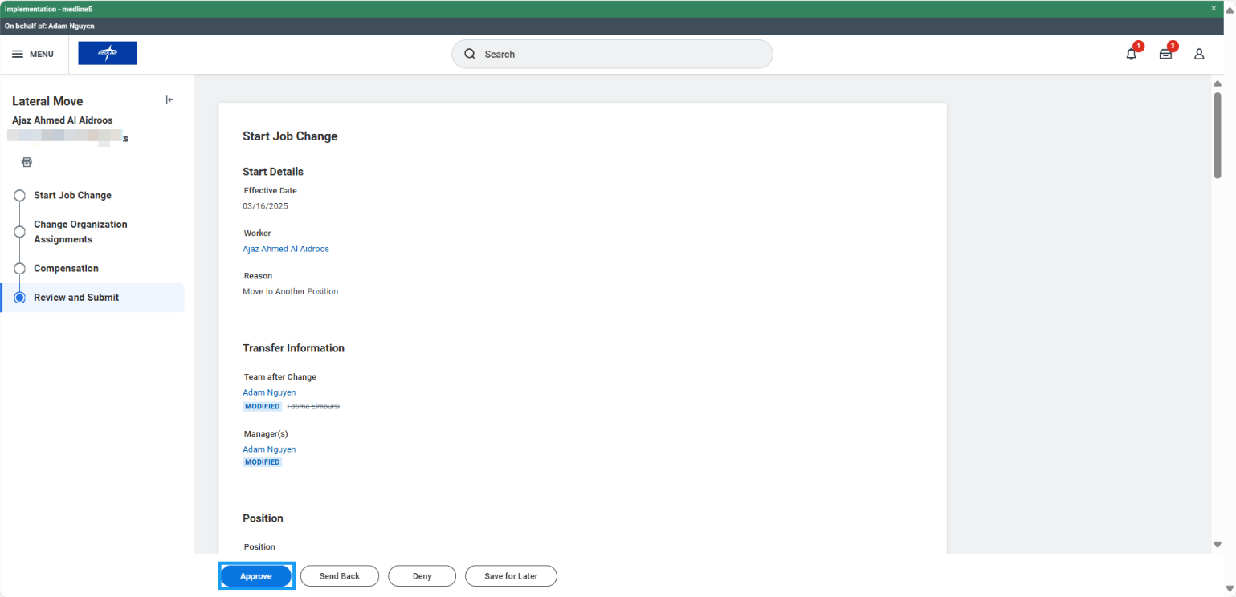

Lateral Move (HR Partner)
- Open Lateral Move task in your My Tasks inbox and review the form. If changes are needed, click the blue “Make Changes” button at the top of the form to enter edit mode.
- After reviewing, click Approve to route to the next approver (if applicable).

