

Transfer Employee to Another Manager – Move Position with Employee
Managers and HR Partners

Transfer Employee to Another Manager – Move Position with Employee (Initiating Manager)
- Access the task called Start Job Change
- Select the worker, choose the template called Transfer Employee to Another Manager, and click Ok.
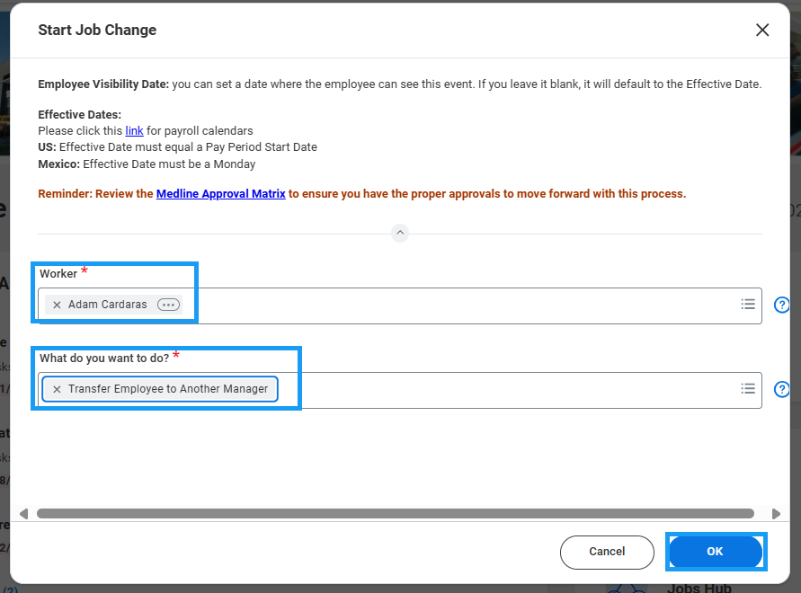
- Choose the desired Effective Date – it must be the beginning of a pay period.
- Select the new manager in the field “Which team will this person be moving to?”
- Select the check box next to “Is this person’s position moving with them?”
- Click Submit to route to the Receiving Manager for review and approval.

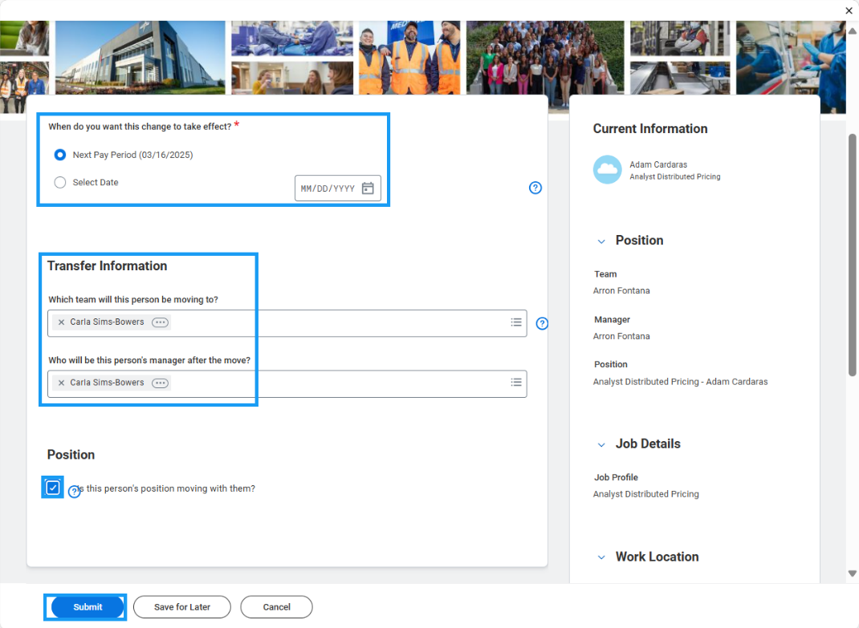
Transfer Employee to Another Manager – Move Position with Employee (Receiving Manager)
- Access the Transfer task in your My Tasks inbox.
- Review the change submitted by the initiating manager. If changes are needed, click the blue “Make Changes” button at the top of the form to enter edit mode.
- Confirm accuracy of the change and click Approve to route for HR approval.

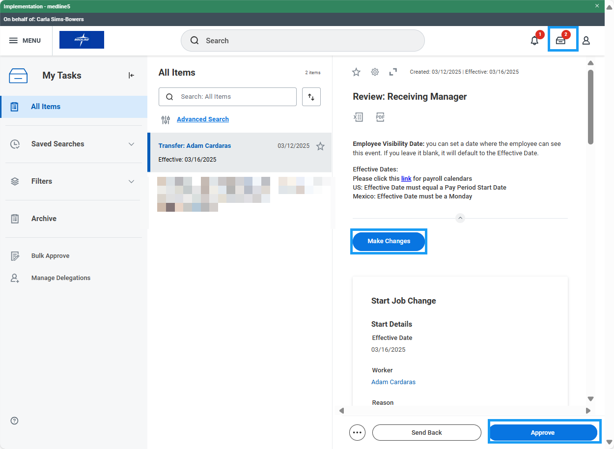

Transfer Employee to Another Manager – Move Position with Employee
(HR Partner)
- Access the Transfer task in your My Tasks inbox and review the proposed changes. If edits are needed, click the blue “Make Changes” button at the top of the task to enter edit mode.
- Review accuracy of the change and click Approve.
