

In-Line Promotion with Manager Change – Move Position with Employee
Managers and HR Partners

In-Line Promotion with Manager Change – Move Position with Employee (Initiating Manager)
- Access the task called Start Job Change
- Select the worker, choose the template called In Line Promotion, and click Ok.

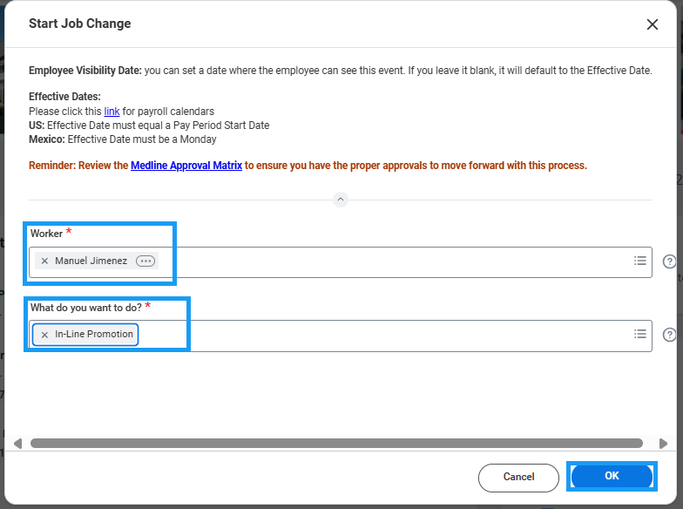

- Choose the Effective Date – it must be the beginning of a pay period.
- Enter the new manager’s name where it says, “Which team will this person be moving to?”
- Select the check box next to “Is this person’s position moving with them?”
- Click Submit to route to the Receiving Manager for review and approval.
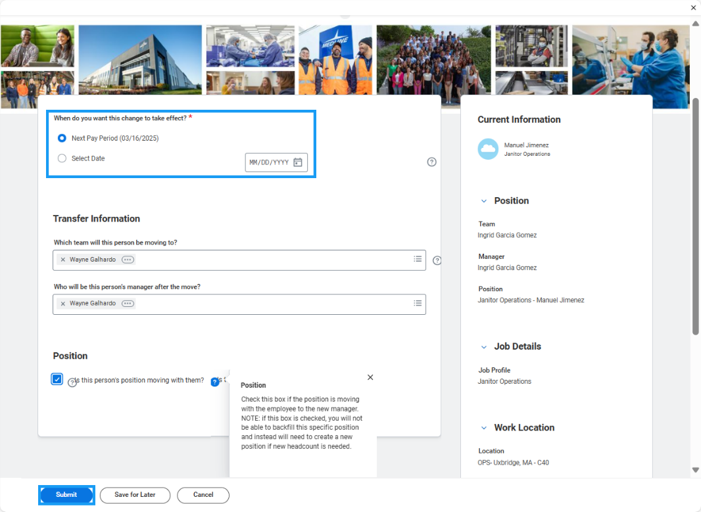

In-Line Promotion with Manager Change – Move Position with Employee (Receiving Manager)
- Access the Promotion task in your My Tasks inbox.
- Click the blue “Make Changes” button at the top of the task to enter edit mode.

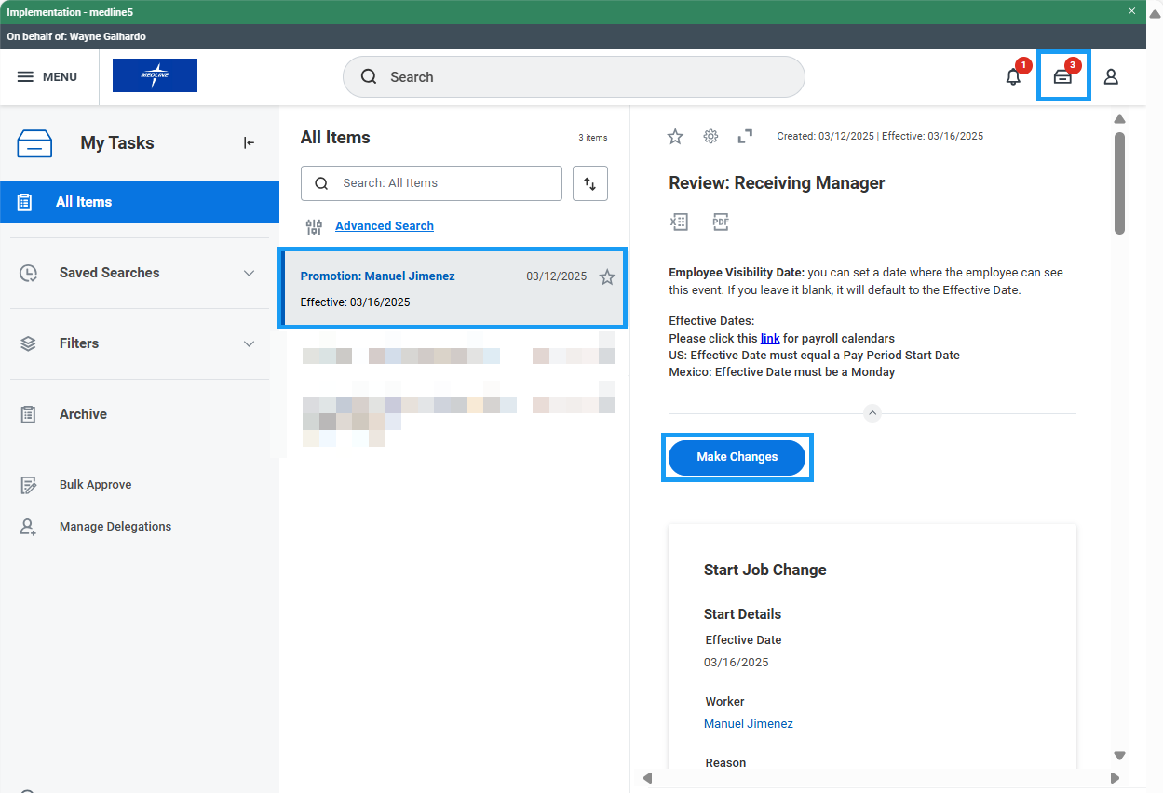

- Under Job Details, select the new job profile. If the job profile you are looking for does not show up in the drop-down list, please reach out to your HR Business Partner. A new job profile may need to be created before you can proceed.
- Work Location, Time Type, Scheduled Weekly Hours, and Work Shift can also be changed on this form if applicable. Click Next.
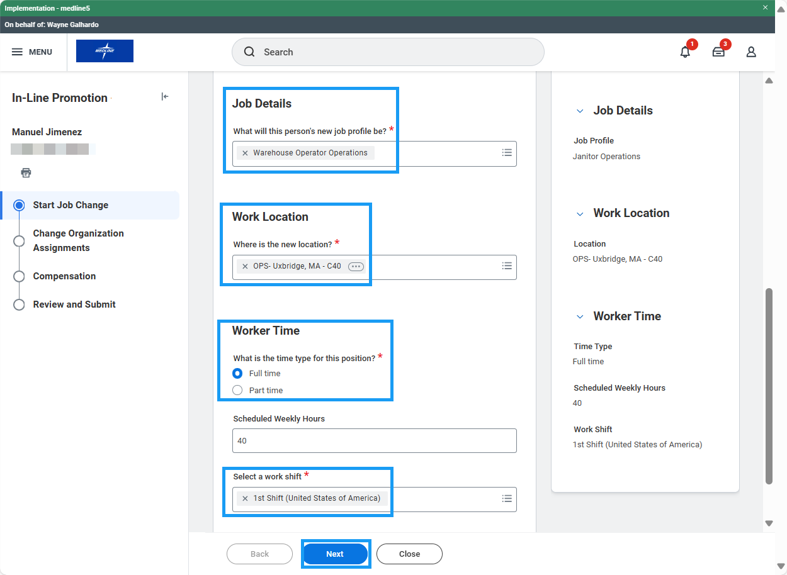
- Edit Company, Cost Center, Department, and other organizations if necessary. Click Next.
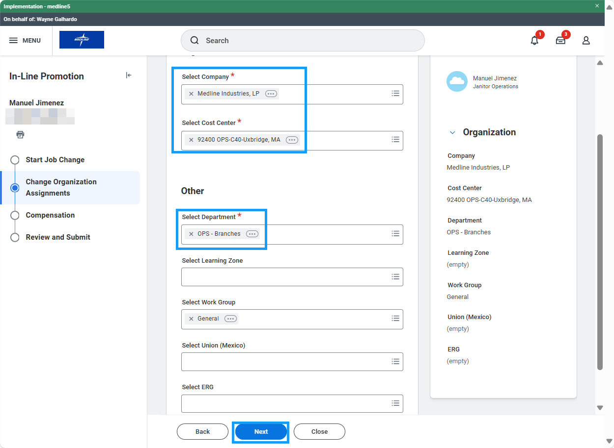
- On the Compensation screen, scroll down to review the Total Base Pay Range guidelines for the new job profile. If this is an hourly job, there will be an Hourly Plan assignment. Click the related actions button (three dots) and select Edit. Enter the proposed hourly rate and click Save. If this is a salary job, there will be a Salary Plan assignment. Click the related actions button (three dots) and select Edit. Enter the proposed annual rate and click Save. Click Next.

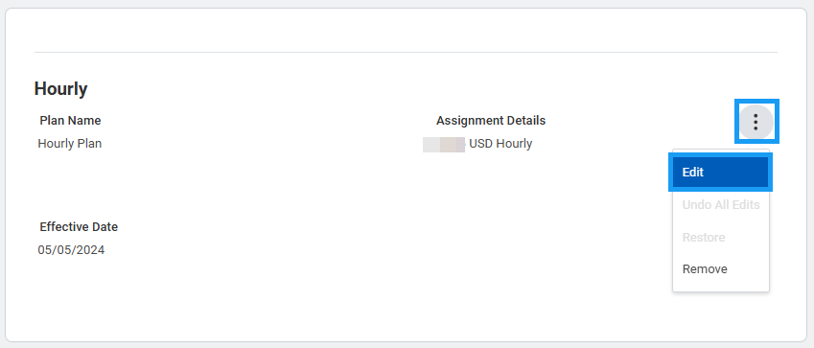
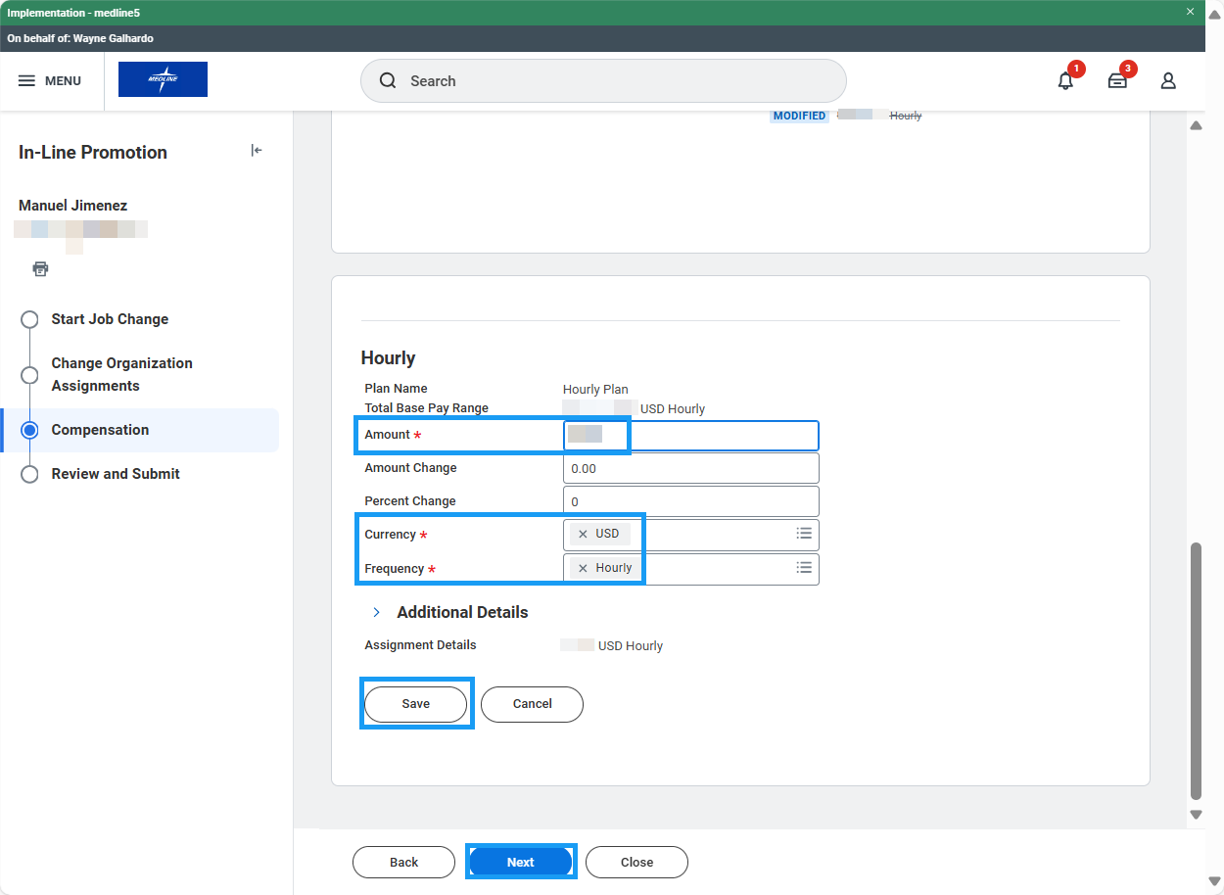
- Review the changes and click Submit to route to HR for approval.

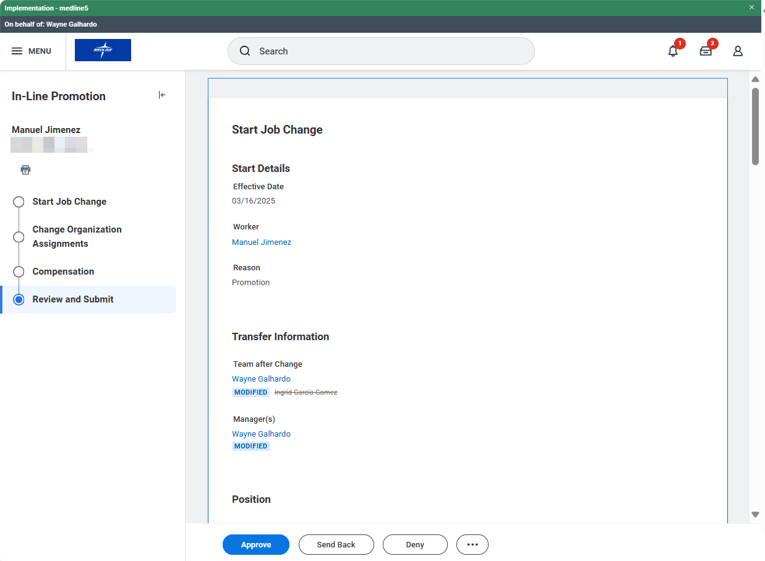
In-Line Promotion with Manager Change – Move Position with Employee (HR Partner)
- Access the Promotion task in your My Tasks inbox and review the proposed changes. If edits are needed, click the blue “Make Changes” button at the top of the task to enter edit mode.
- Review accuracy of the change and click Approve to route for approval if necessary. Approval flow is HR Partner > Manager’s Manager > 1st VP. Sometimes Compensation will be included in the approvals if certain criteria is met.

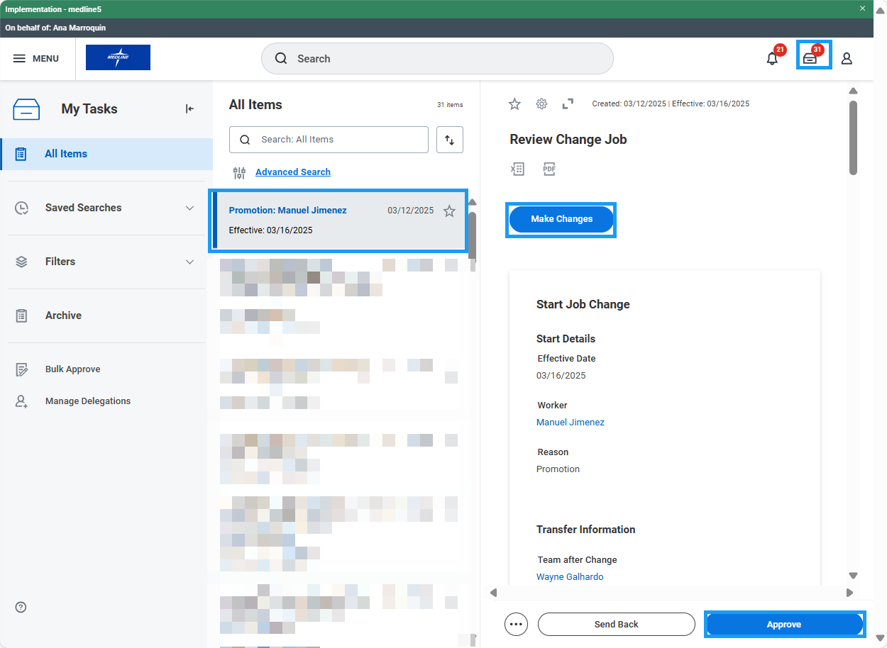

- The Promotion task is routed to the worker’s proposed manager’s manager for additional approval:

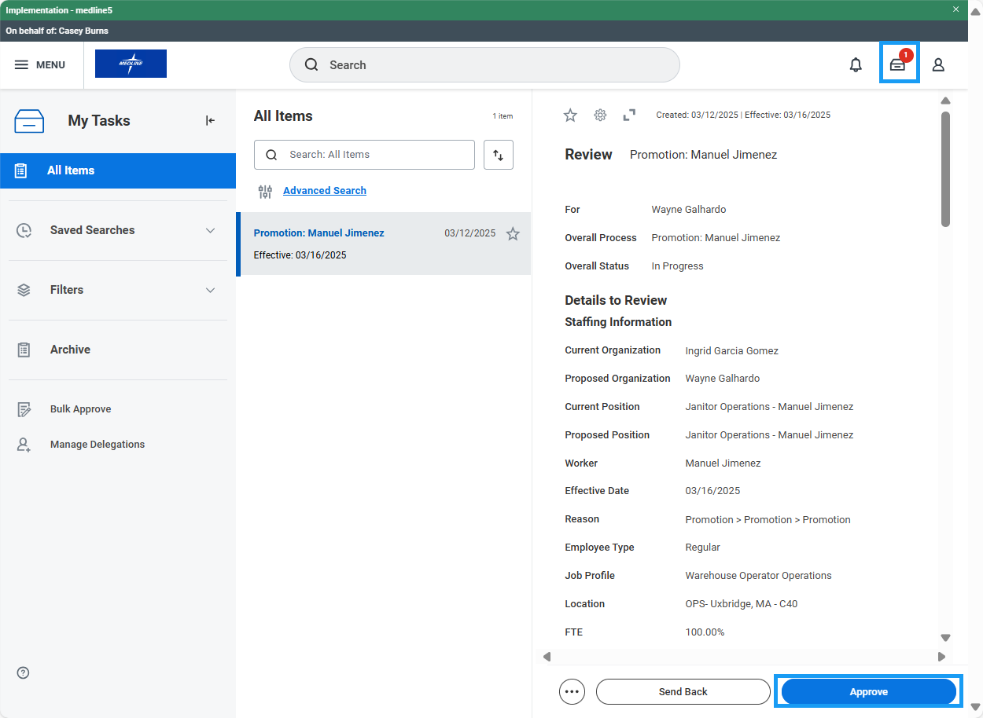
- The Promotion task is routed to the worker’s proposed manager for additional approval:
