

End Contingent Worker Contract
Managers and HR Partners

End Contingent Worker Contract (Initiating Manager)
- Access the task End Contingent Worker Contract
- Enter the Contingent Worker name and click Ok.

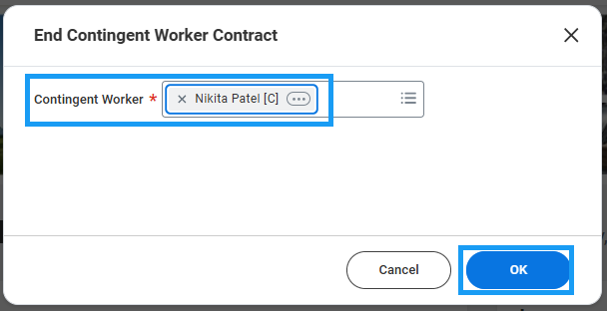

- Enter the Contract End Date and Reason.
- Check the Close Position box only if you do not plan to fill this position with another Contingent Worker in the future.
- Check the box to make the position available for overlap if applicable and click Submit to route to HR for approval.

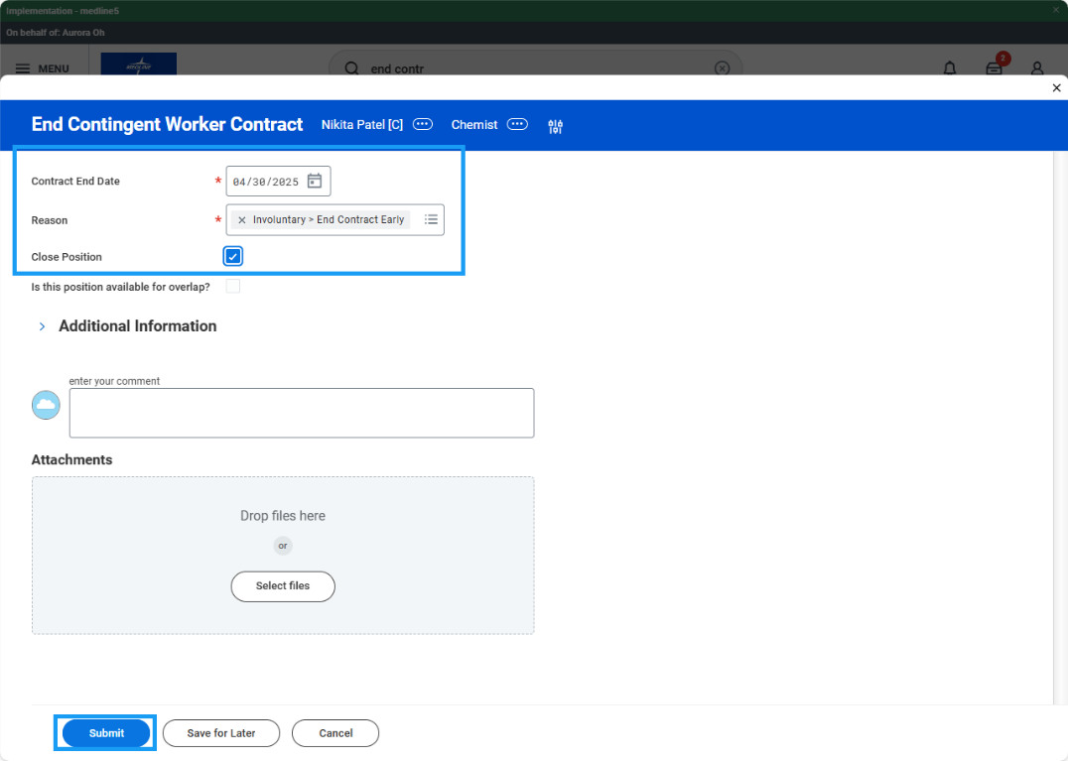
End Contingent Worker Contract (HR Partner)
- Access the End Contract task in your My Tasks inbox and review the proposed End Contingent Worker Contract event.
- Make changes if necessary and click Approve.

