

Change Work Location
Managers and HR Partners

Change Work Location (Initiating Manager)
- Access the task called Start Job Change
- Select the employee, choose the Change Work Location template, and click Ok.
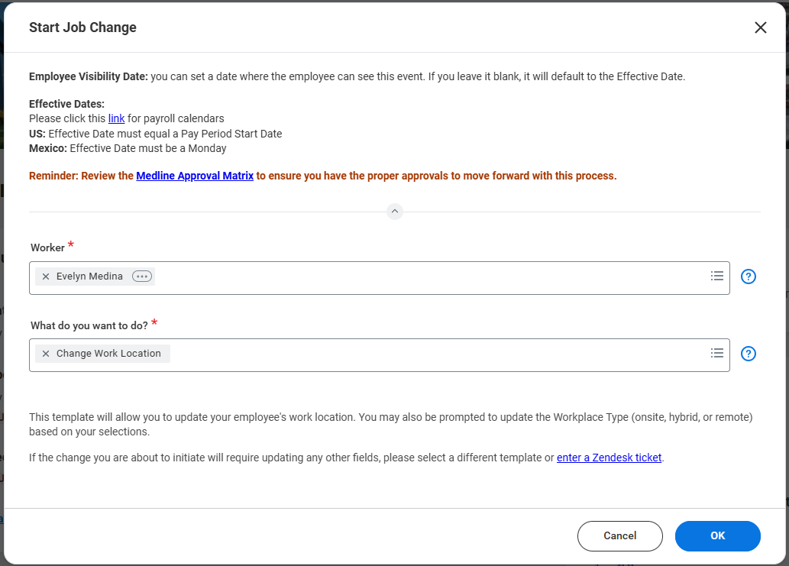
- Choose the desired Effective Date – it must be the beginning of a pay period.
- Select the new location and click Submit to route for HR Partner approval.

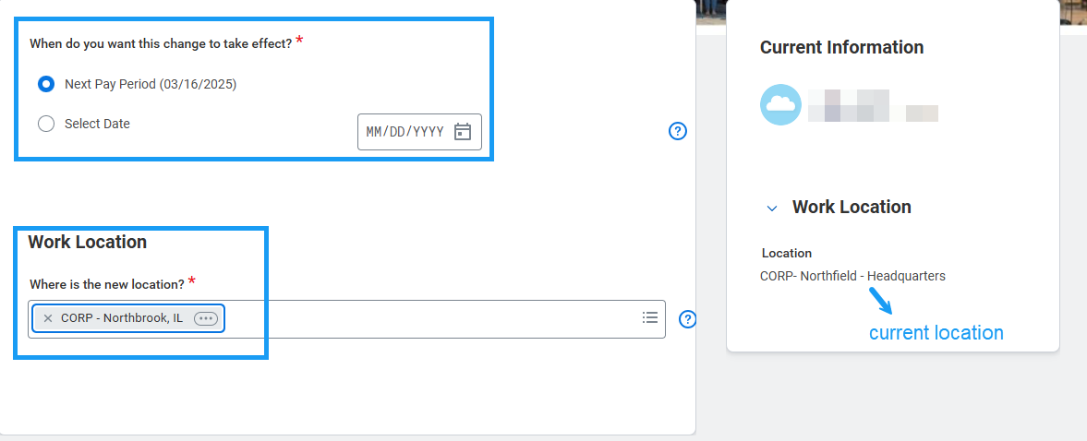
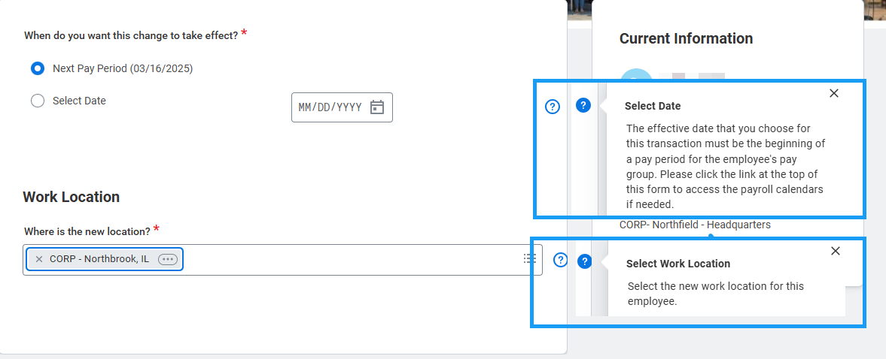

- Once HR Partner approves, check back in your My Tasks inbox for a task called “Edit Additional Data” and confirm that the Workplace Type is correct. Change if necessary and press Submit.

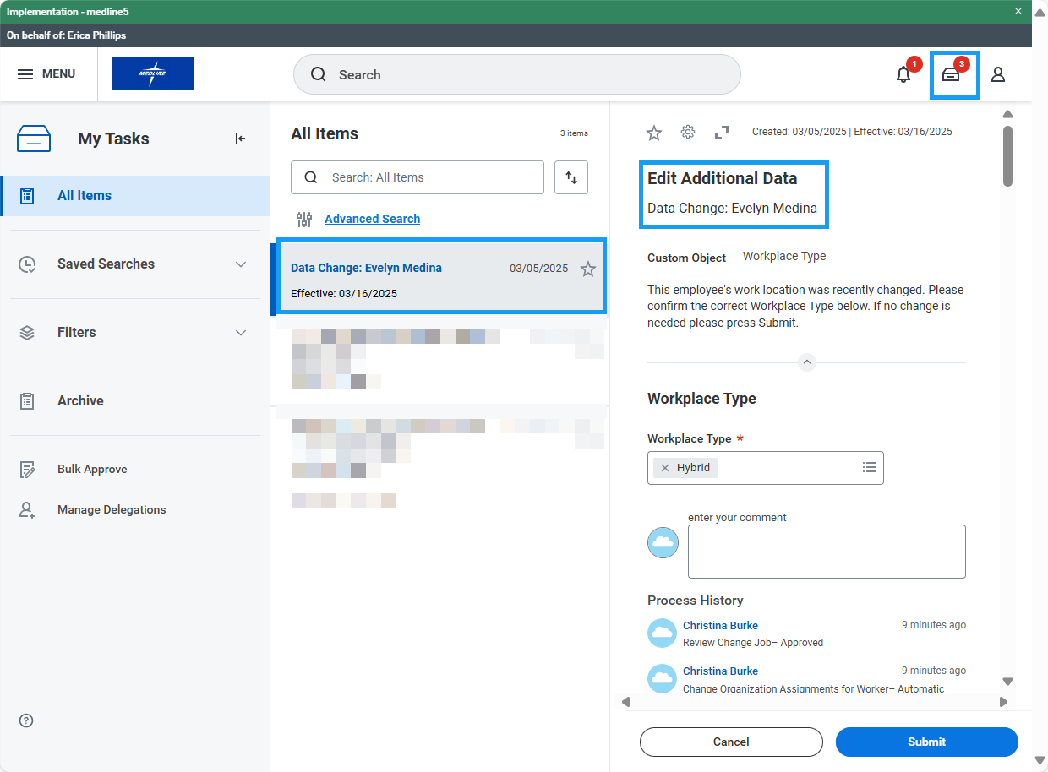

Change Work Location (HR Partner)
- Access the Data Change task in your My Tasks inbox.
- Review the location change submitted by the manager. If edits are required, click the blue “Make Changes” button at the top of the form.
- Confirm the accuracy of the change and click Approve.

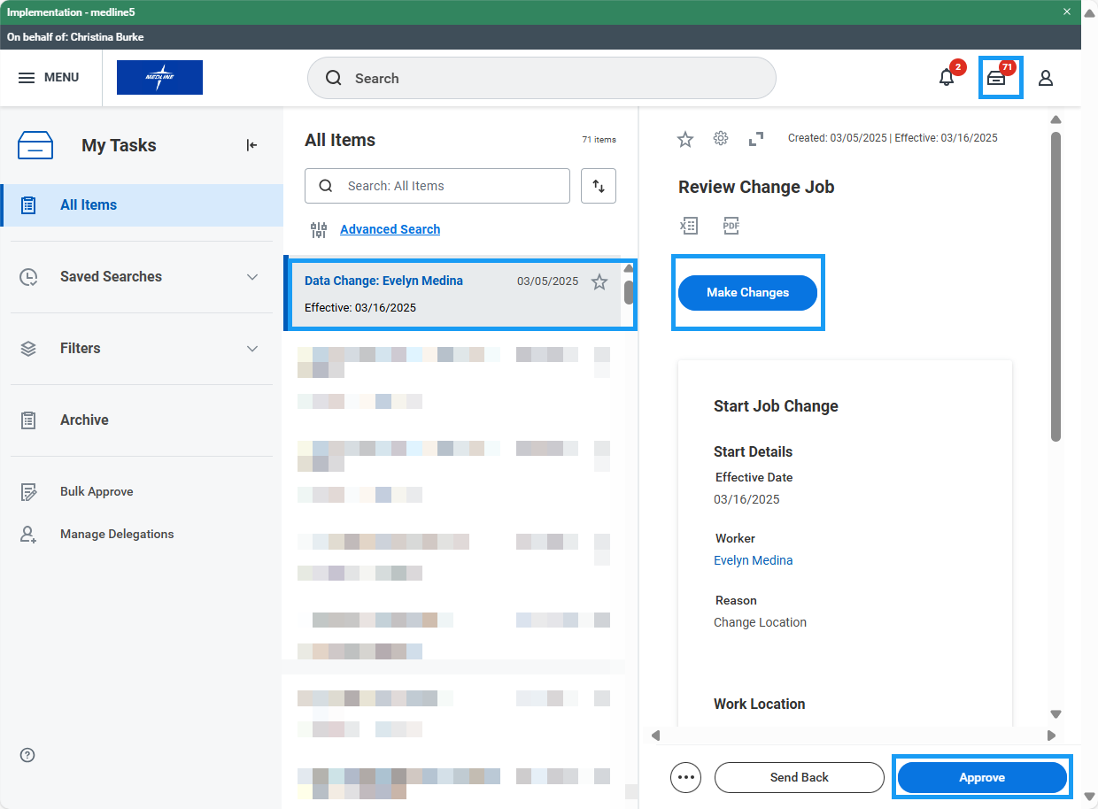

- If the employee is moving from an onsite location to a Remote location, HR Partner will immediately receive a task called “Update Remote Employee Work Address.”

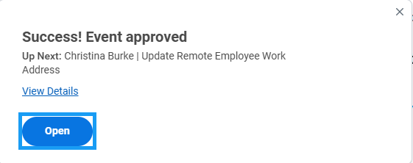
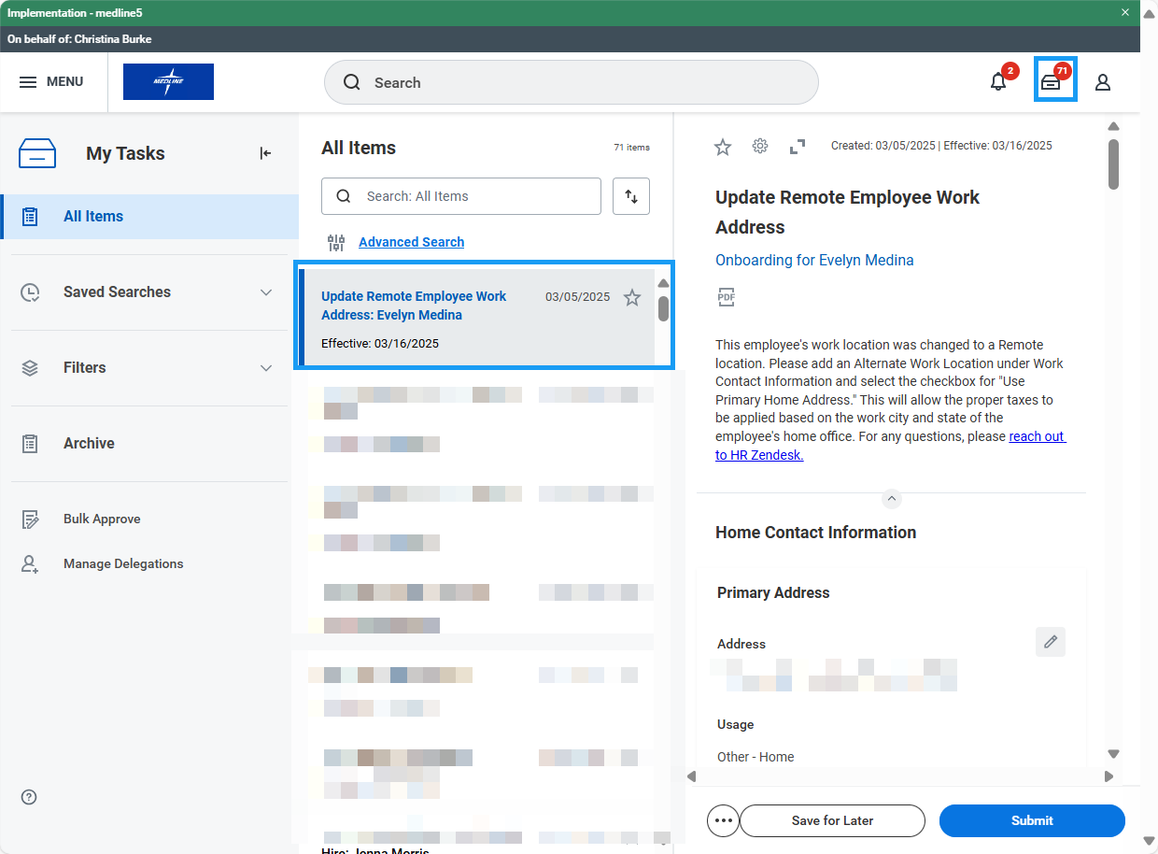
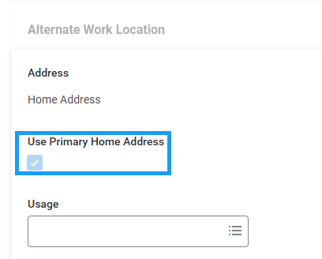

- Scroll down to the Work Contact Information section and under Alternate Work Location click Add. Select the check box next to “Use Primary Home Address” and click Submit.

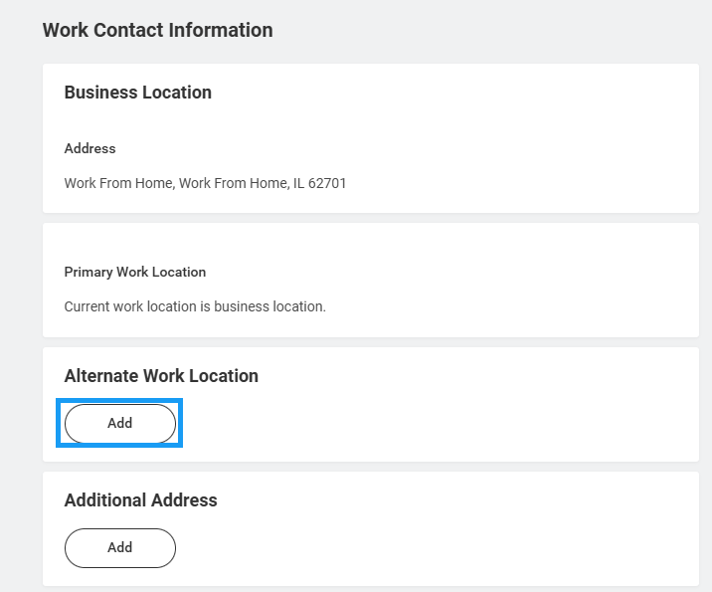

- The subject employee will receive a task to confirm their home address is accurate.

