

Change Scheduled Hours
Managers and HR Partners

Change Scheduled Hours (Initiating Manager)
- Access the task called Start Job Change
- Select the employee, choose the Change Scheduled Hours template, and click Ok.

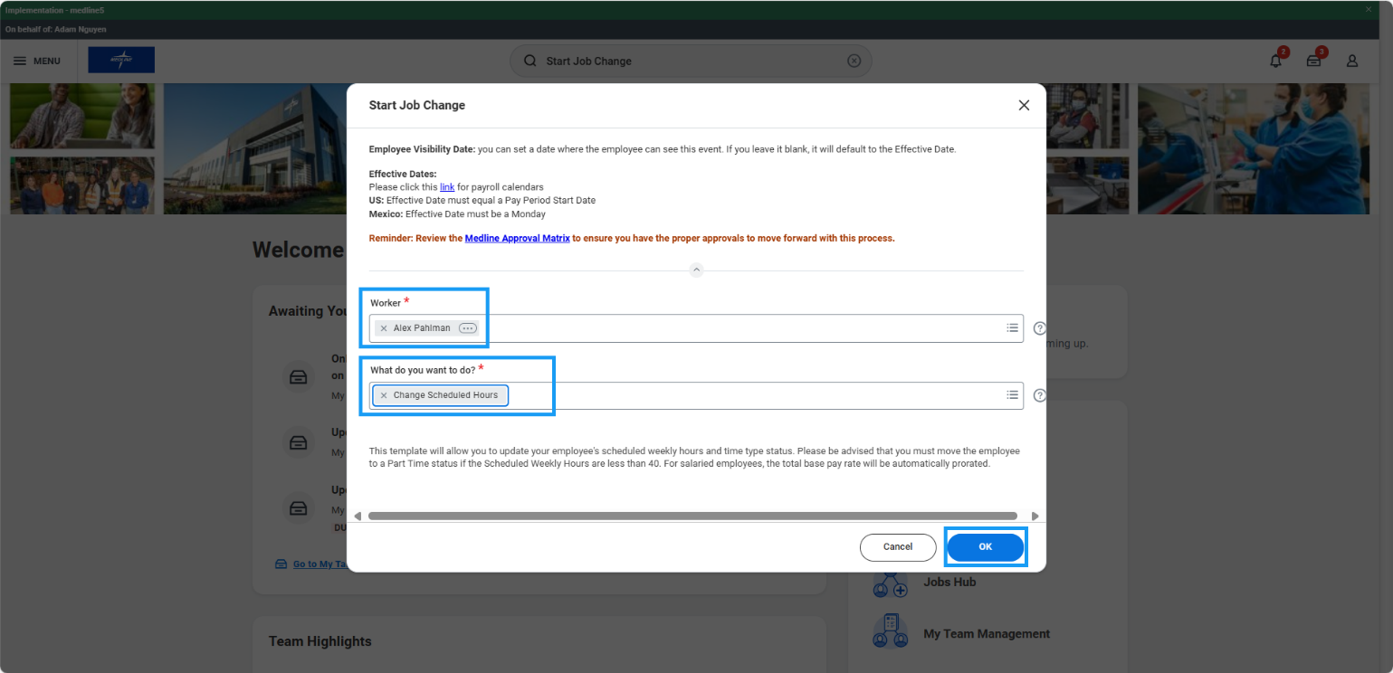

- Choose the Effective Date – it must be the beginning of a pay period.
- Choose the time type for the position.
- Enter the number of hours that the employee will be scheduled to work in a typical week. The FTE % will be automatically calculated. Click Submit.

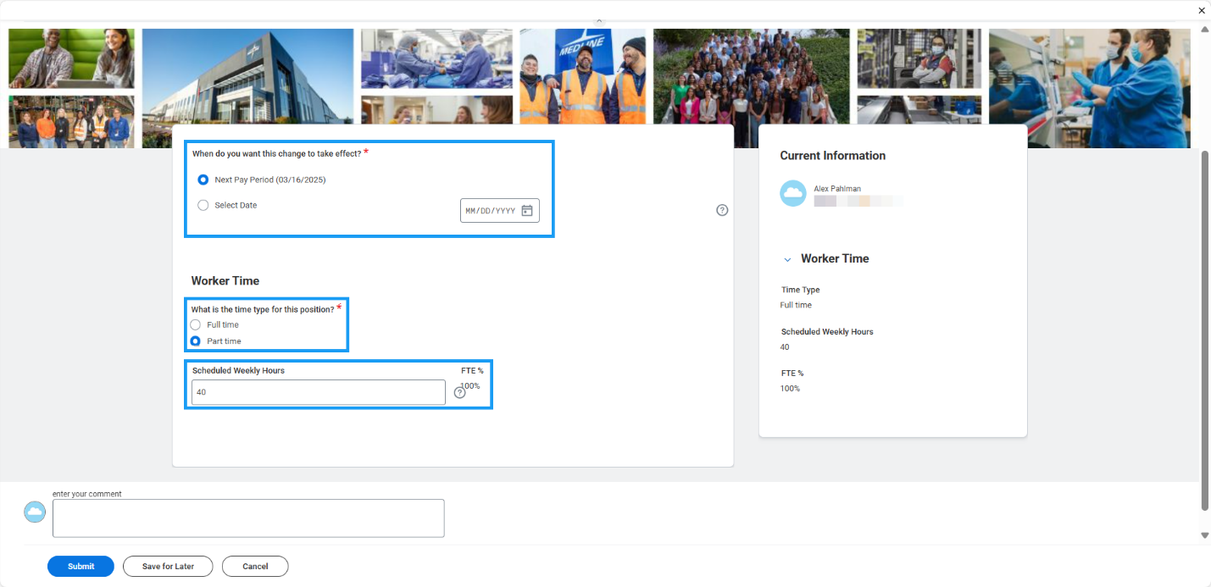

- For hourly employees whose base compensation rate will not be changing, managers can click Next on the Compensation screen, review the changes, and click Submit to route to HR Partner for approval.

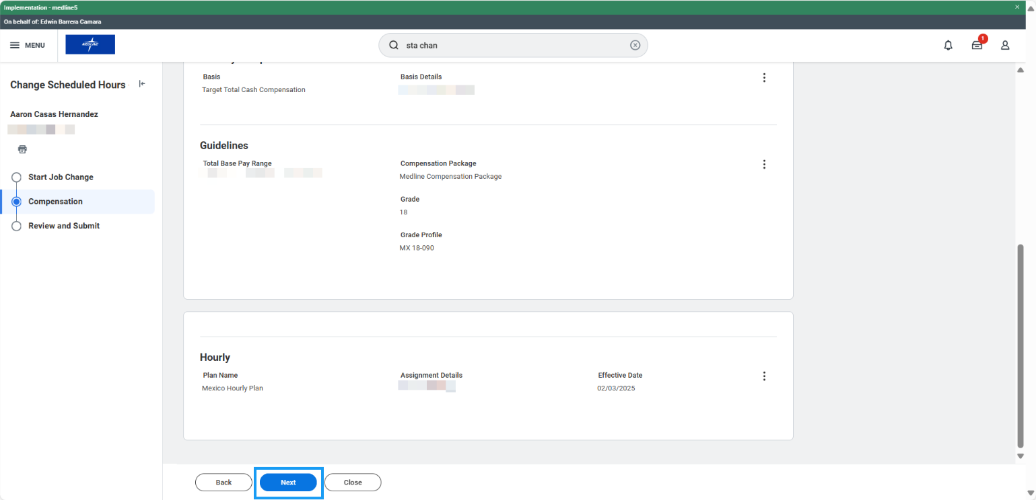

- For salaried employees, total base compensation will automatically be prorated based on the proposed scheduled weekly hours. Review the changes on the compensation screen and click submit to route to HR Partner for approval.

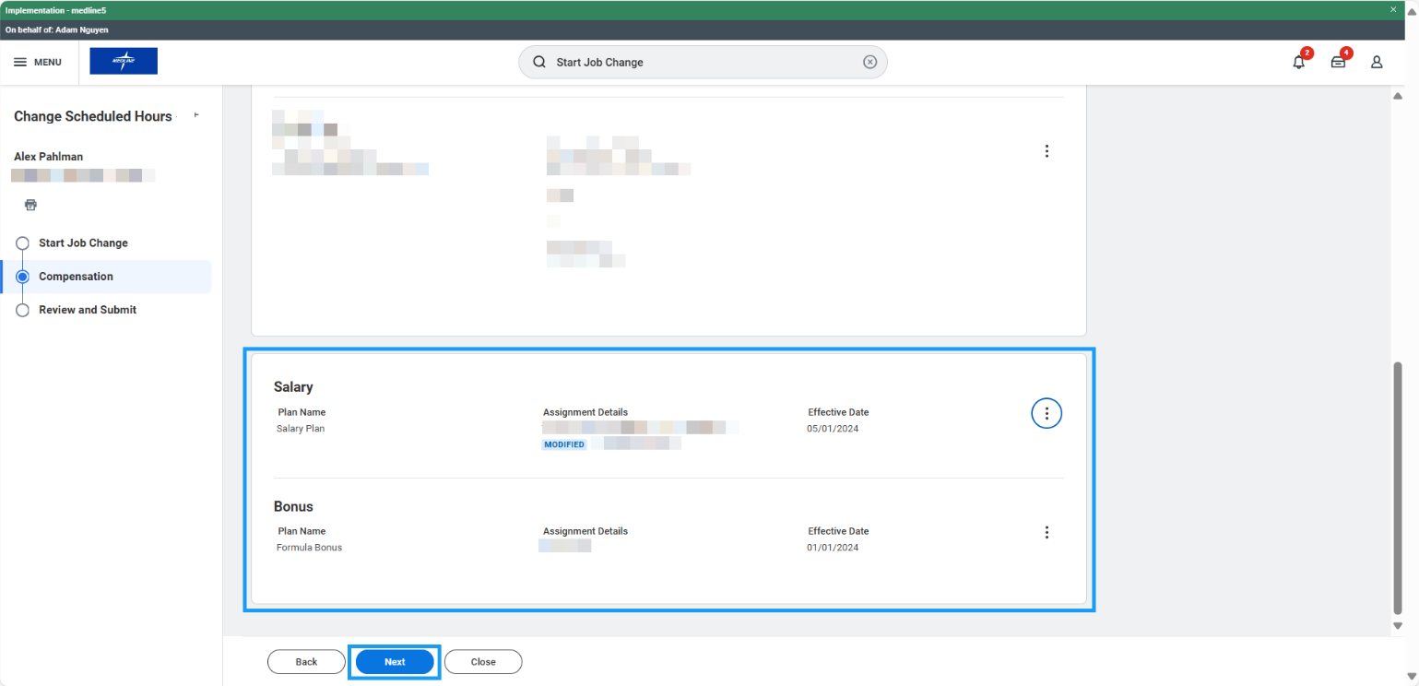

Change Scheduled Hours (HR Partner)
- Access the Data Change task in your My Tasks inbox.
- Review the changes submitted by the manager. If edits are required, click the blue “Make Changes” button at the top of the form to enter edit mode.
- Confirm accuracy of the change and click Approve to route for Manager’s Manager approval if required.

