

Learning
Managers

Contents
Assigning Courses 1
Accessing Learning History and Learning Transcripts 5
Approving Courses for your Direct Reports 5

Assigning Courses
- To get started, click on the Learning application from the applications Menu at the top left-hand corner of your Workday Homepage.

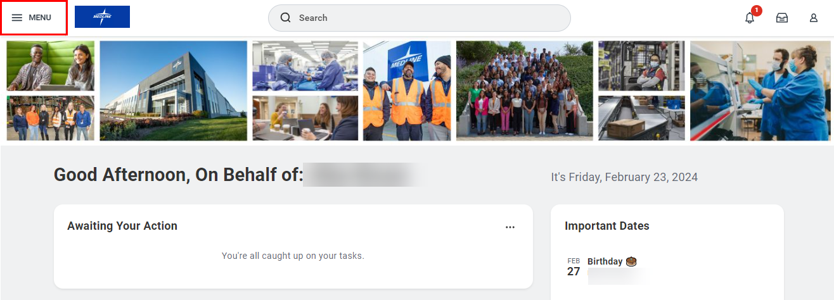
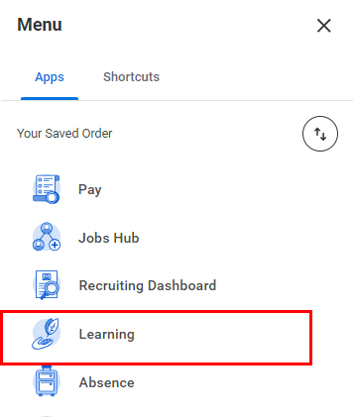

- Next, click Discover from the navigation panel on the left-hand side of your screen. To find a course to enroll in, you can Browse Learning or Browse Topics to find a wide range of learning content. You can also browse Most Popular or Recently Added courses.

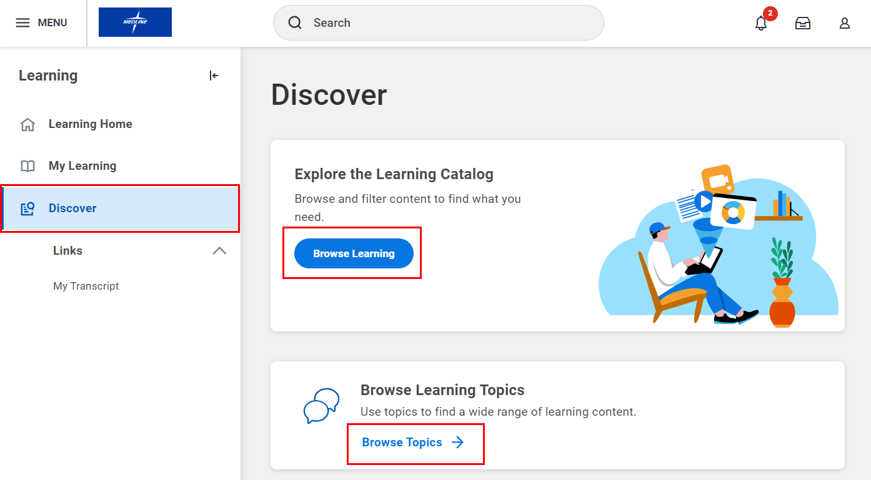

- Use the Search function to find a course to enroll your team in, or you can use the Filters on the left-hand side of the screen to find a course.

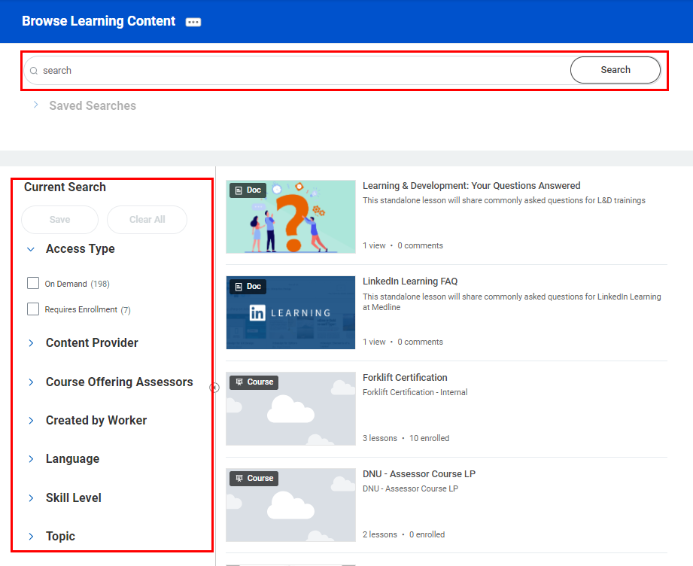

- Click on the Course name to see additional details and to enroll your direct reports. Once you have clicked on a course, you can enroll your direct reports by selecting Enroll My Team.

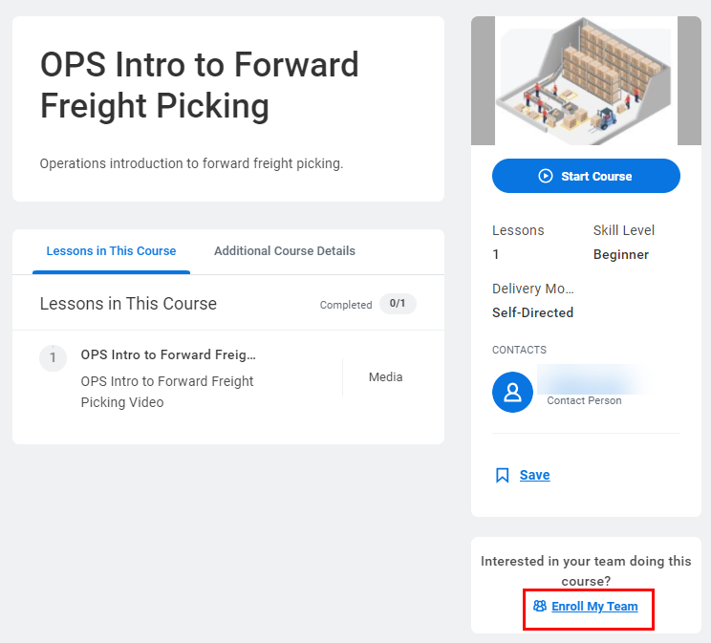

- Indicate whether the course is Assigned as Required Learning using the Yes/No buttons.

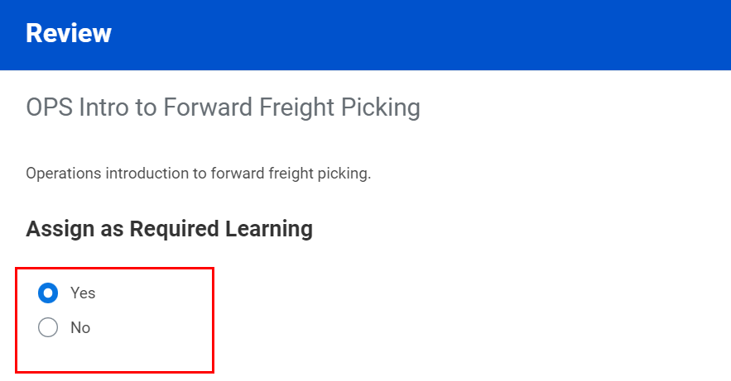

- If the course is Assigned as Required Learning, you will be prompted to set a required Due Date. A Due Date can be assigned using a specific Date, or a set Duration in Days, Weeks, Months or Years that the employee must complete the learning within.

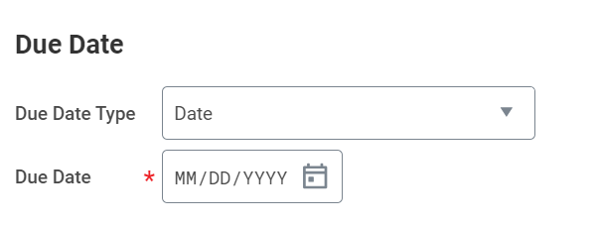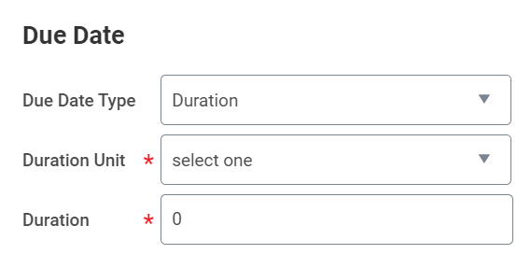

- Next, select which employee(s) you would like to assign the course to using the checkbox beside their name. You can also select all by checking on the first checkbox in the header of the table. Once you’re finished, click Submit to proceed.

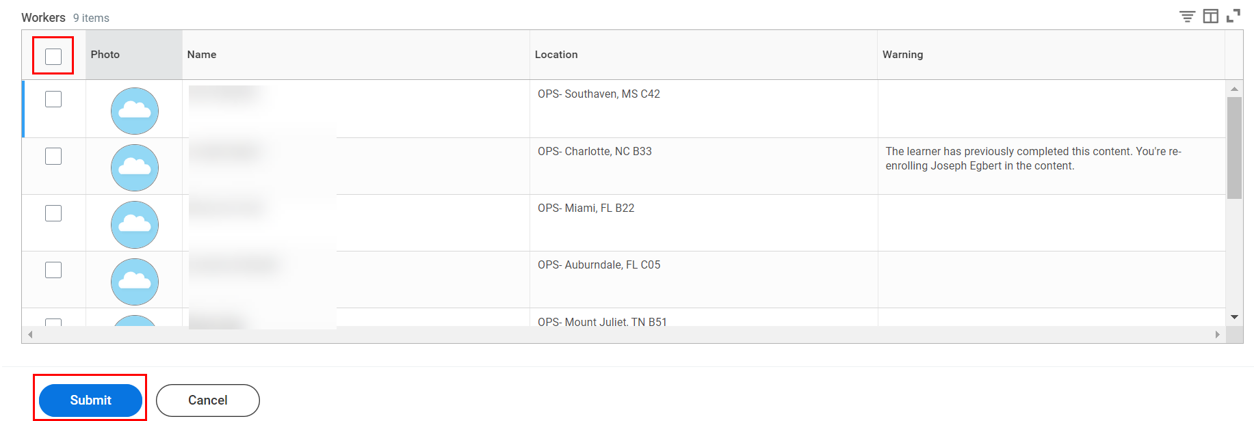

- A confirmation page acknowledging that the process has been successfully completed will pop up. Click Done to return to the course overview page.

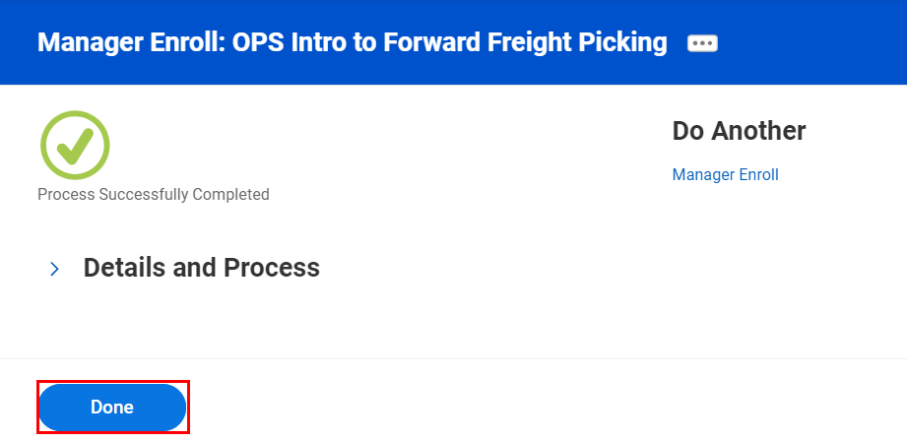

Accessing Learning History and Learning Transcripts
- To get started, type “My Team’s Learning” into the Workday search bar and click the My Team’s Learning Report from the search results.

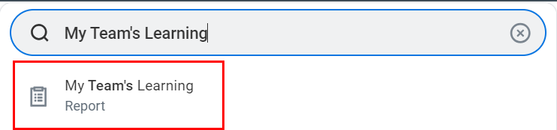

- Next, you will see a report that identifies which courses your direct reports are currently enrolled in or have completed. You’ll be able to the Grade and Score and additional information such as Registration Date and Attendance Status.

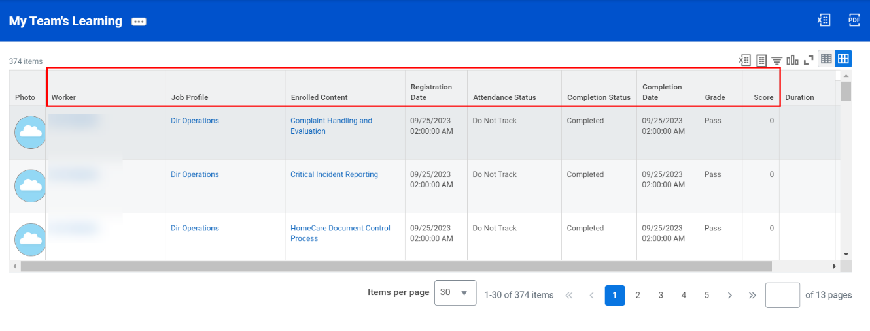

- Clicking the Enrolled Content (course name in blue) will bring you to that course’s details page.

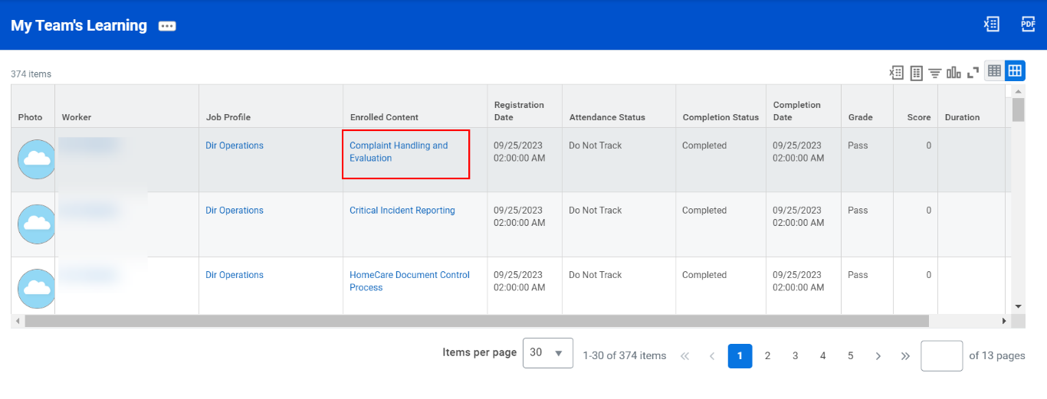

Approving Courses for your Direct Reports
- As a Manager, you may be required to provide approval for your direct reports to take certain courses. Navigate to your Workday My Tasks Inbox and select the task titled Enroll in Content.

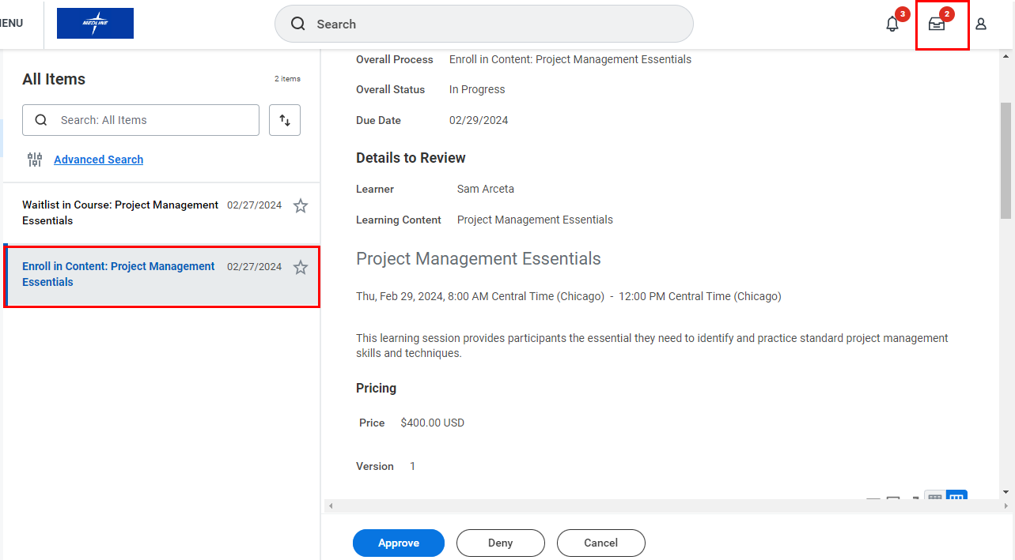

- Carefully review the details of the course, including the Price. To approve the course, click Approve.

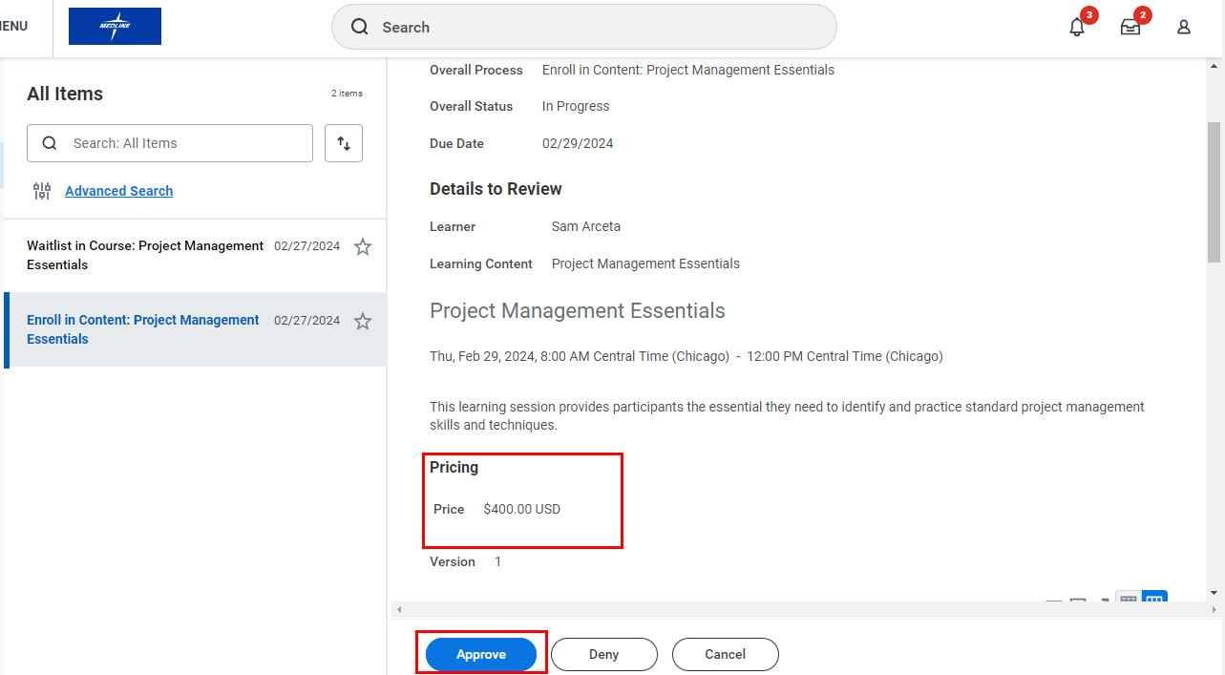

- If you Deny the course, you must provide a Reason for doing so. Click Submit when you’re done.

