

Learning
Employees

Contents
Navigating the Learning Dashboard 1
Enrolling in a Digital Course 3
Enrolling in a Blended Course 4
Dropping a Course 7
Viewing Learning History and Transcript 10
Creating a Learning Path 12

Navigating the Learning Dashboard
Workday offers a variety of digital and blended/instructor led learning courses for Employees to complete. Learning how to navigate the Learning Dashboard will make it easier to access required training and search for content that interests you.
Please note that the Learning application shown below is the standard interface in Workday. This interface may change in the future.

- To get started, click on the Learning application from the applications Menu at the top left-hand corner of your Workday Homepage.

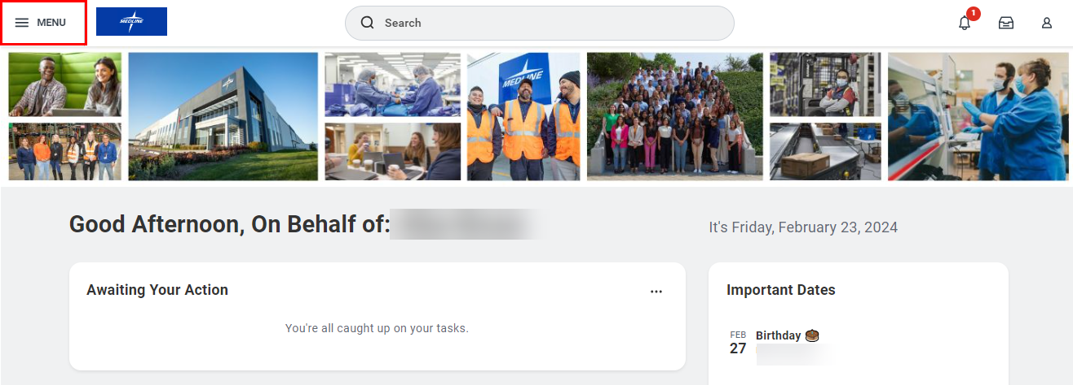
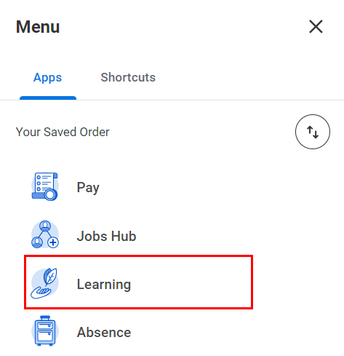

- Next, click Discover from the navigation panel on the left-hand side of your screen. To find a course to enroll in, you can Browse Learning or Browse Topics to find a wide range of learning content. You can also browse Most Popular or Recently Added courses.

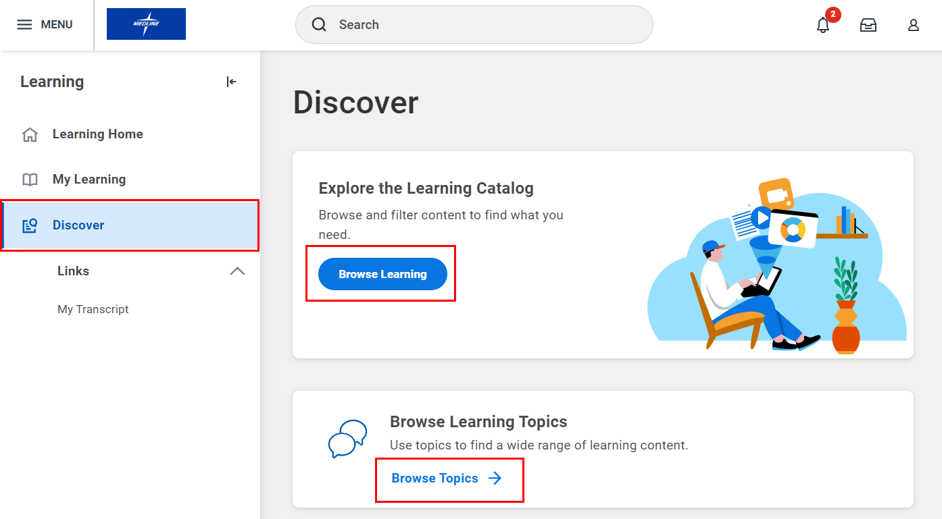

- You can use the Search function or you can use the Filters on the left-hand side of the screen to find a course.

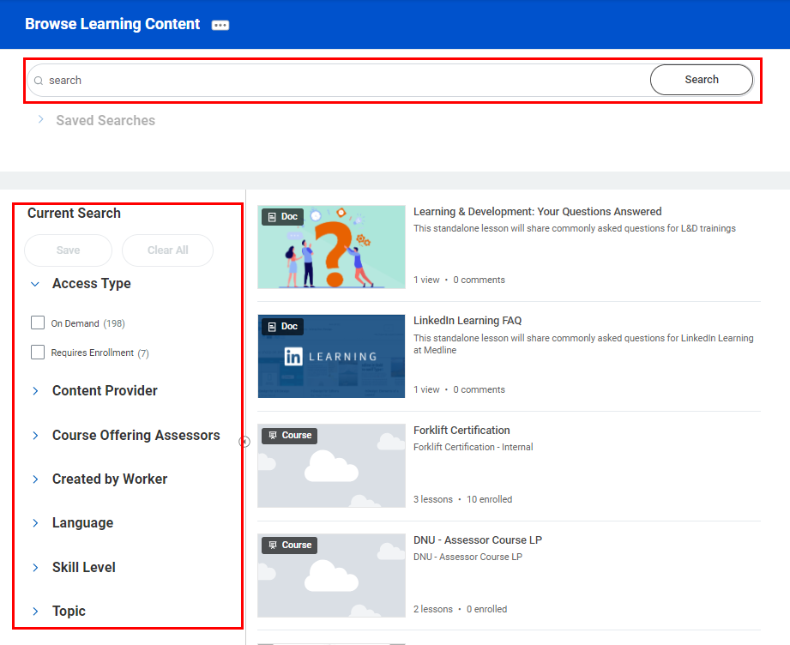

- Click on the Course name from the search results to see additional details about the course.

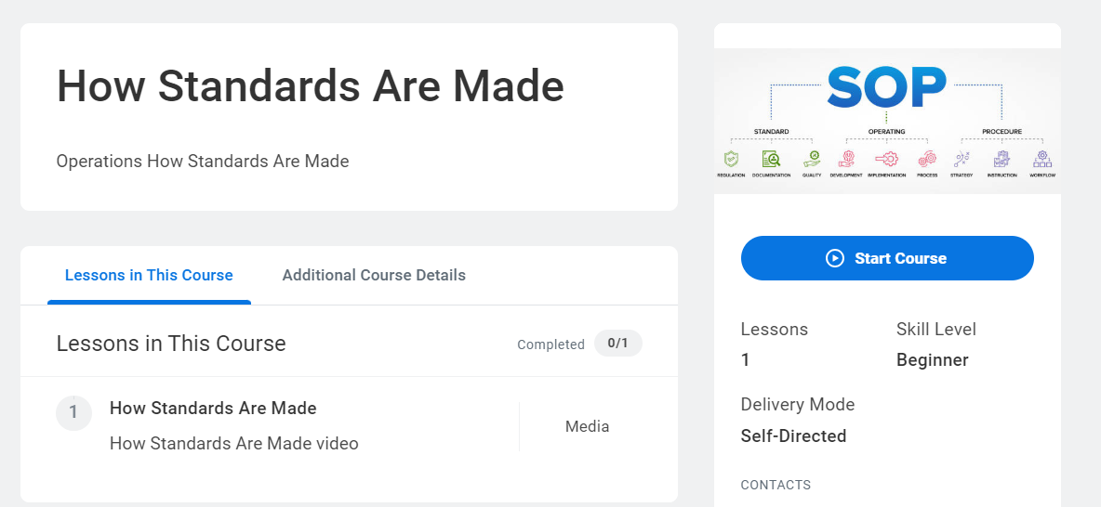

- To view a Required course, click on the Learning Home tab from the navigation panel on the left-hand side of your screen. Your required courses will show up under the Required for You section.

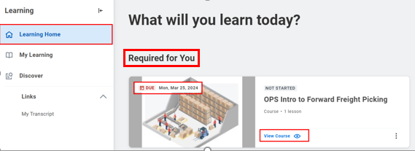

- The due date will show up at the top left-hand corner of the course. Click View Course for more information.

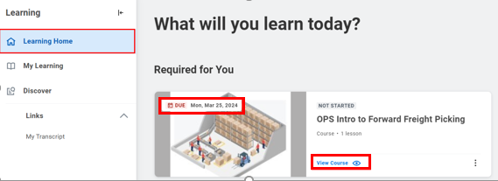

Enrolling in a Digital Course
- Once you are on the course overview page, click Start Course to enroll.

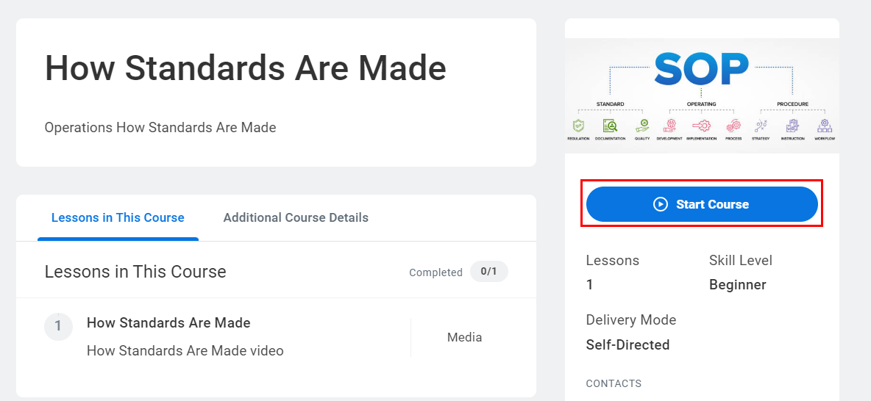

- You will see a pop-up message on your screen. Click Launch Content.

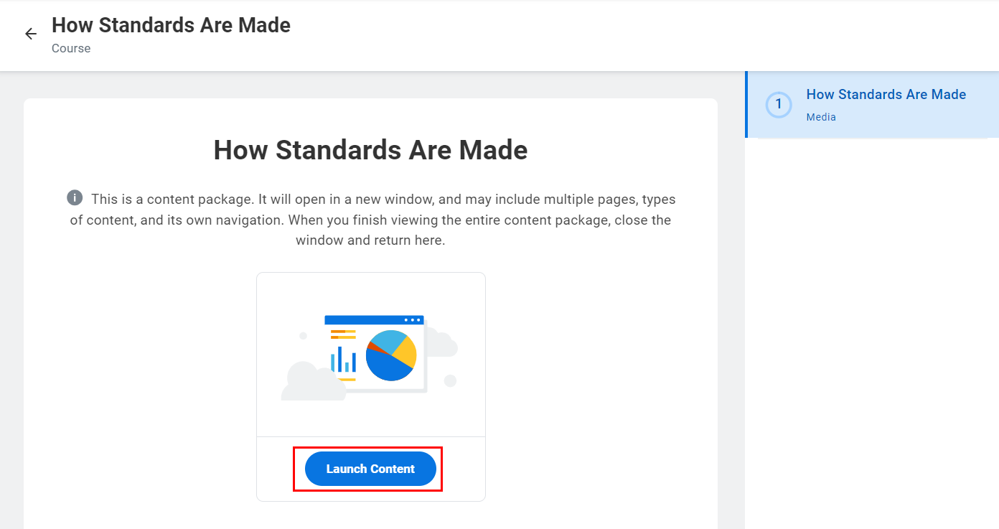

- Your learning content will open in a new tab.

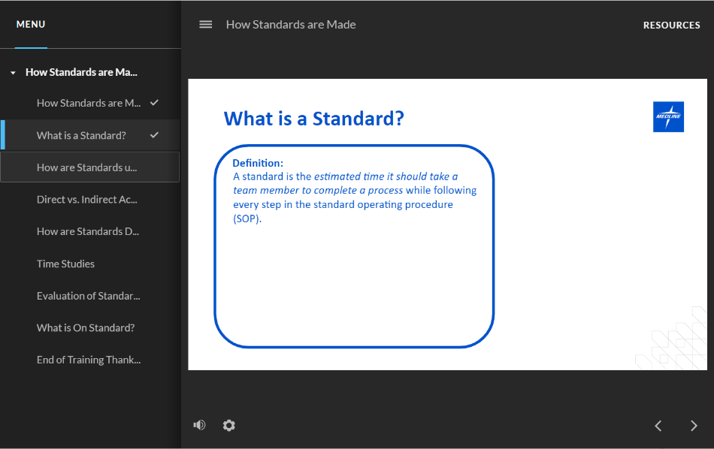

Enrolling in a Blended Course
- Once you are on the course overview page, click Select Offering to enroll.

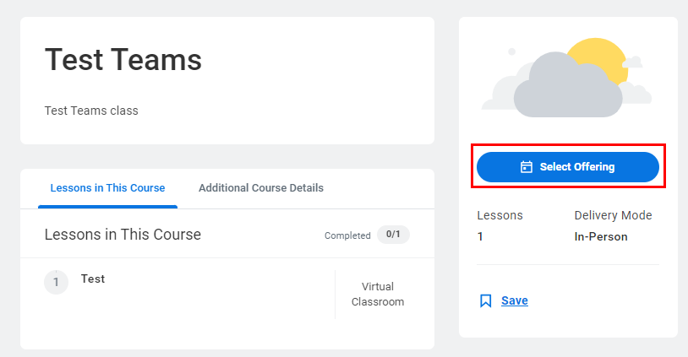

- In the pop-up window that appears, review the Open Offerings information such as the Start and End Date, the Attendance Type and Availability. Select a course offering by clicking on the checkbox and click OK.

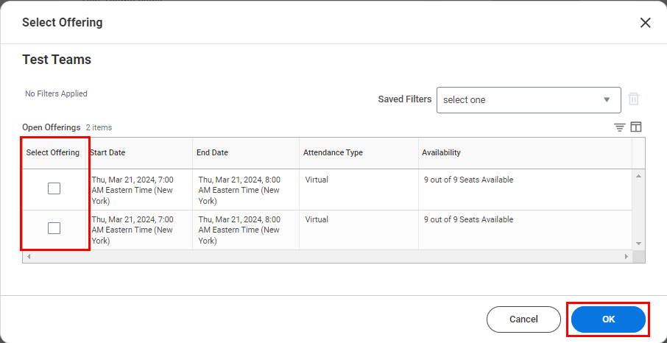

- Review the course details and click Submit.
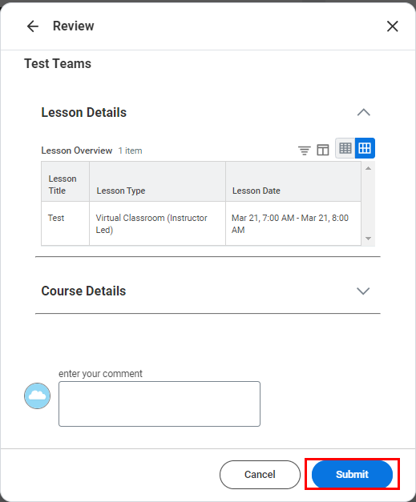

- You will automatically return to the course overview page. Click Add to Calendar to add the course to your calendar.

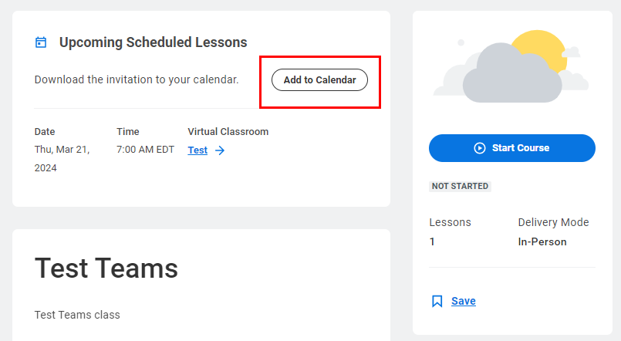

- Save the ICS file to your computer.
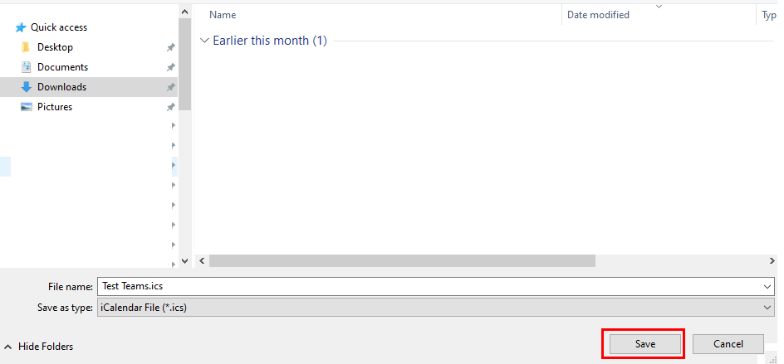

- Next, click the downloaded ICS file. In the invite that appears, click Save & Close to save the meeting invite to your calendar.

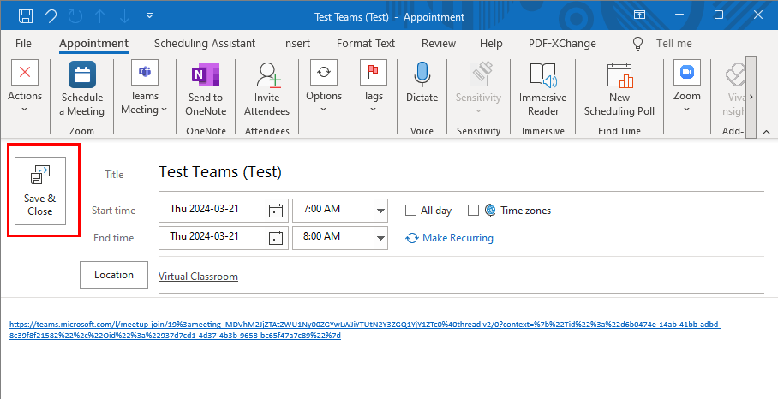

Dropping a Course
- If you accidentally enrolled in a course and want to drop it, navigate to the course overview page. Click Drop Course.

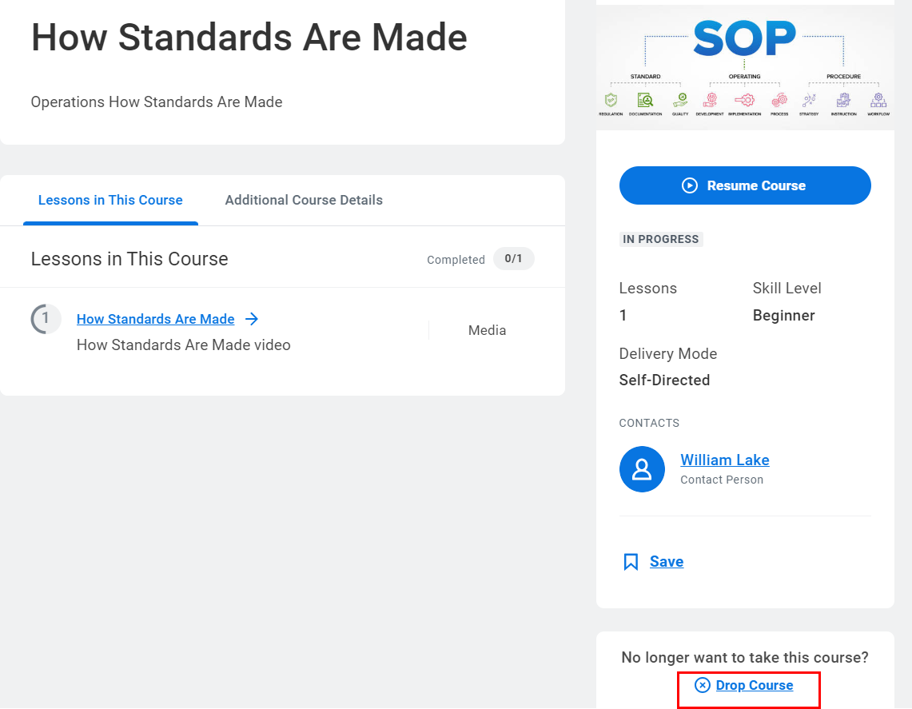

- Another way to drop a course is by clicking on the Learning application and then clicking My Learning from the navigation panel on the left-hand side of your screen.

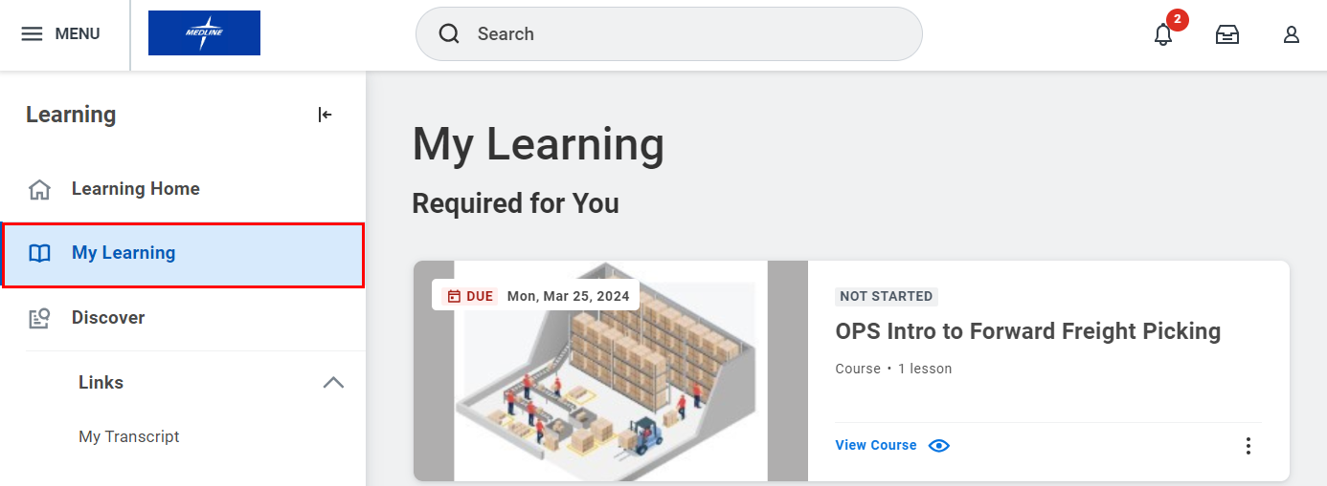

- Scroll down and select Drop Enrollment.

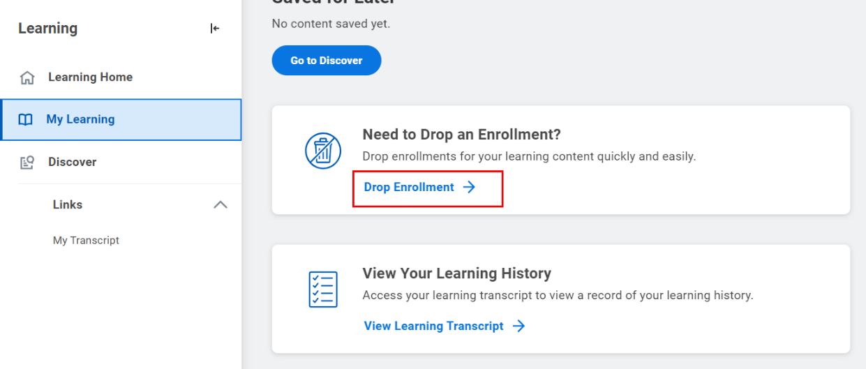

- Select the Program or Course you wish to drop from the drop-down menu. Click OK to continue.

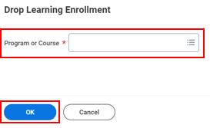

- Select a Drop Reason from the drop-down menu. Click OK to continue.

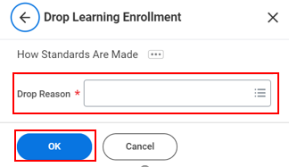

- Next, add any comments if applicable then click Submit.

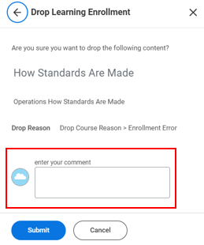

Please note that if a course is assigned as Required, you will not be able to drop it. If you wish to drop a required course, please contact a learning administrator.

Courses with a cost must be dropped at least 10 business days prior to the start date to avoid charges.

Viewing Learning History and Transcript
- From the Learning application, click My Transcript from the navigation panel on the left-hand side of your screen.

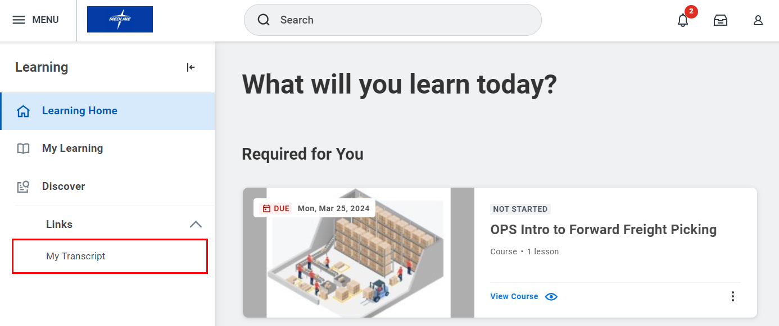
- Alternatively, you can click My Learning. Scroll down and select View Learning Transcript under View Your Learning History.

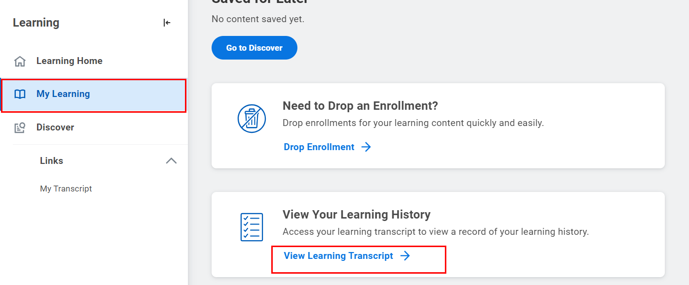

- You will be brought to another page that will show your transcript. Your transcripts show your courses that are Not Started, In Progress and your Learning History.

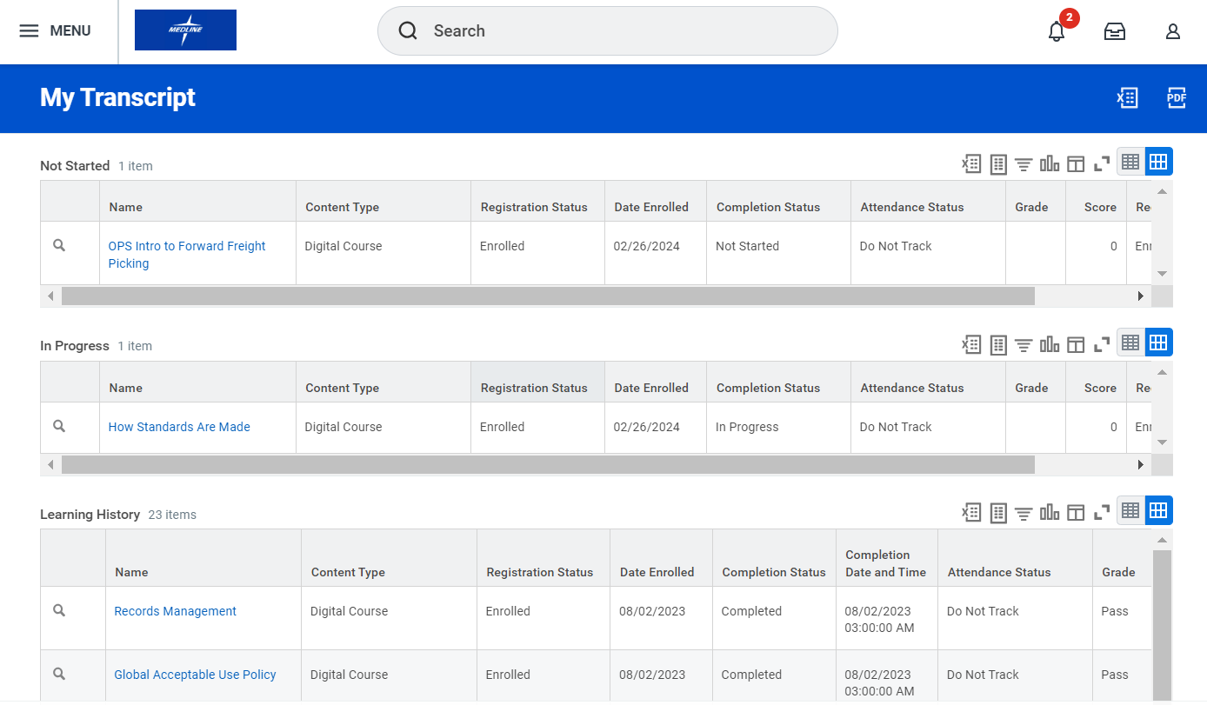

Please note that your Manager will also have access to your learning transcript.

Creating a learning path
You can create learning paths made up of several courses as you browse learning.

- To get started, click on the learning application from the applications menu at the top left-hand corner of your workday homepage.

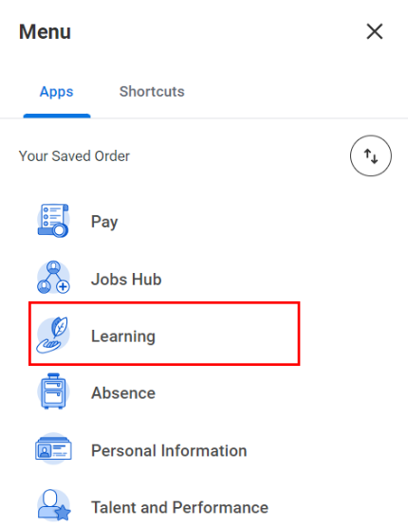

- Click discover from the navigation panel on the left-hand side of your screen. Use the browse learning feature to locate a course that interests you.

- Click a course name. To add it to a new learning path, click save then create learning path.

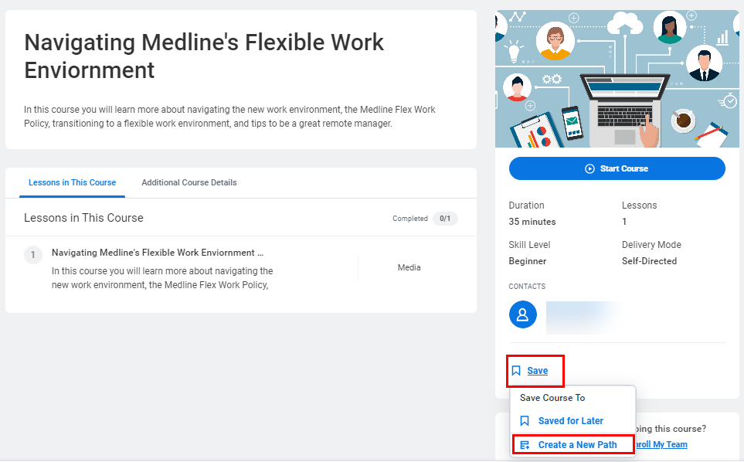

- Type a name for the learning path in the path title field and click create.

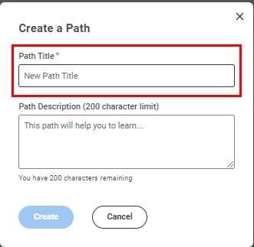

- You can add more courses to your existing learning path by clicking save and selecting the appropriate learning path from the drop down menu. You can also create new learning path as you go.

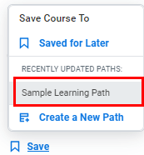

- View your learning path(s) by clicking my learning from the navigation panel on the left-hand side of your screen. Scroll down and selct your learning path.

