Login as Employee and Navigate to Absence Worklet
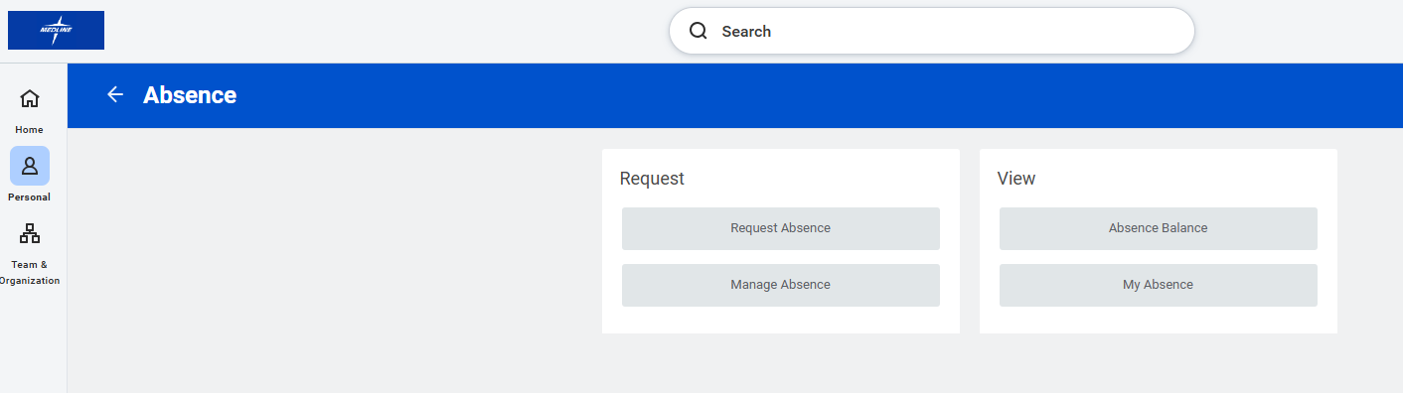

Click on Absence Balance to view Time off Balances:

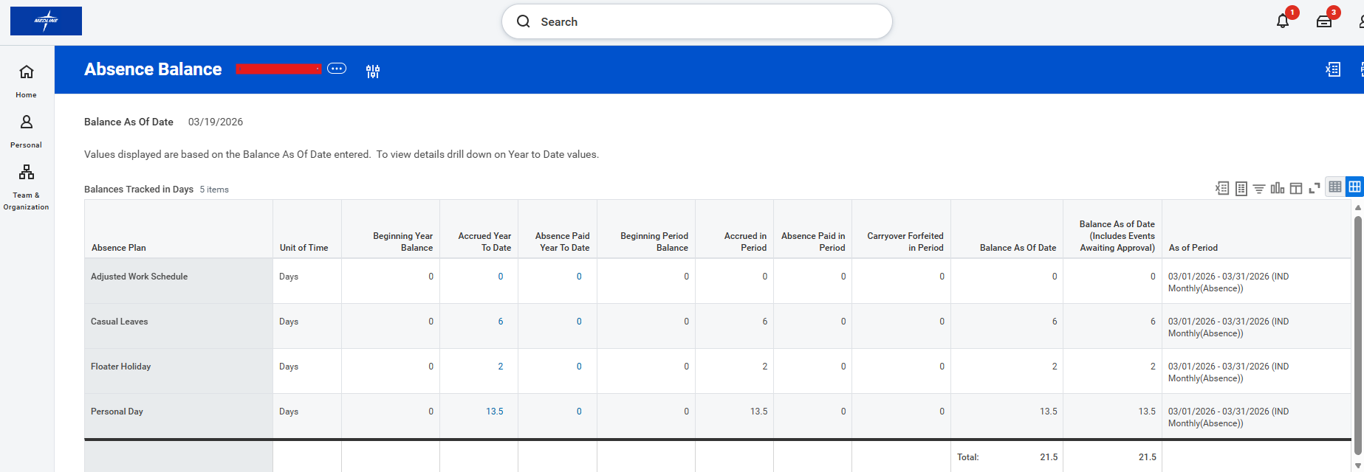
Request Time off/Absence:

Click on Request Absence to submit Time off Request:
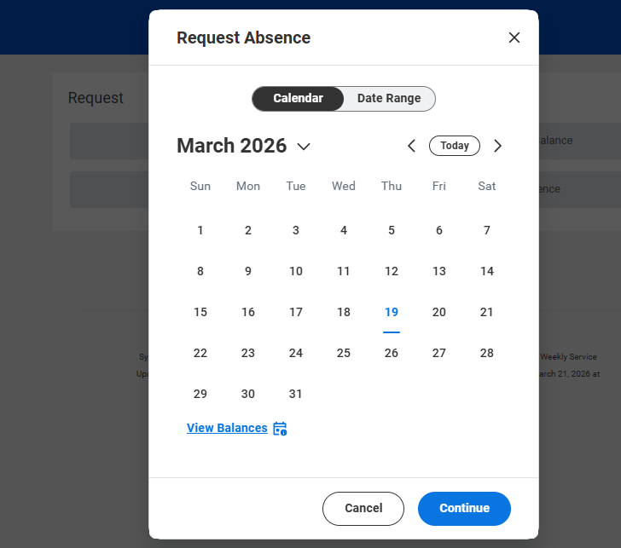
Select the Dates and click on Continue:
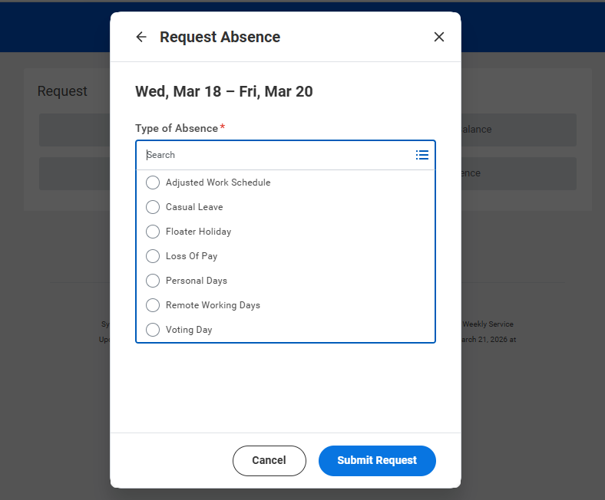
Select the Absence Type:
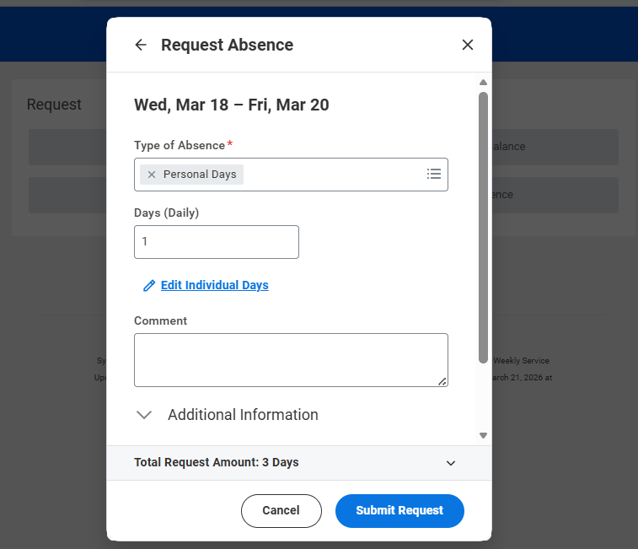
Click on Submit Request:
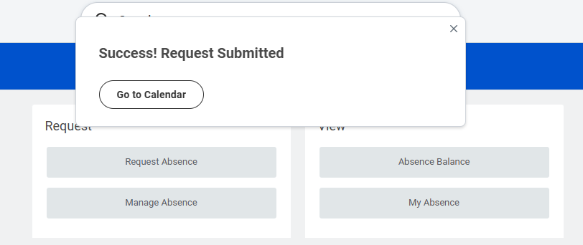
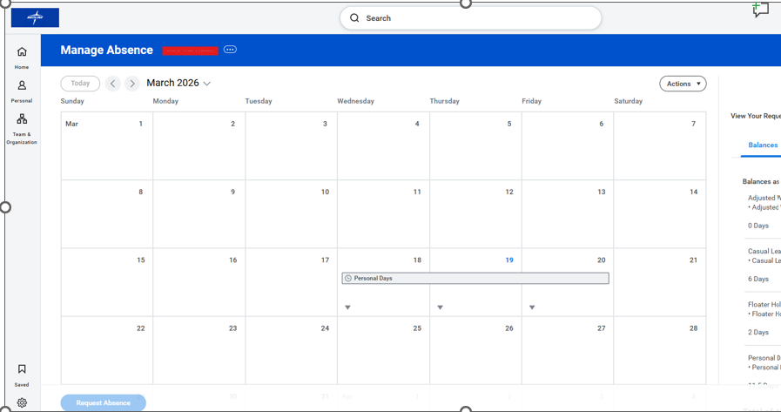

Time off Correction:
Click on Manage Absence:
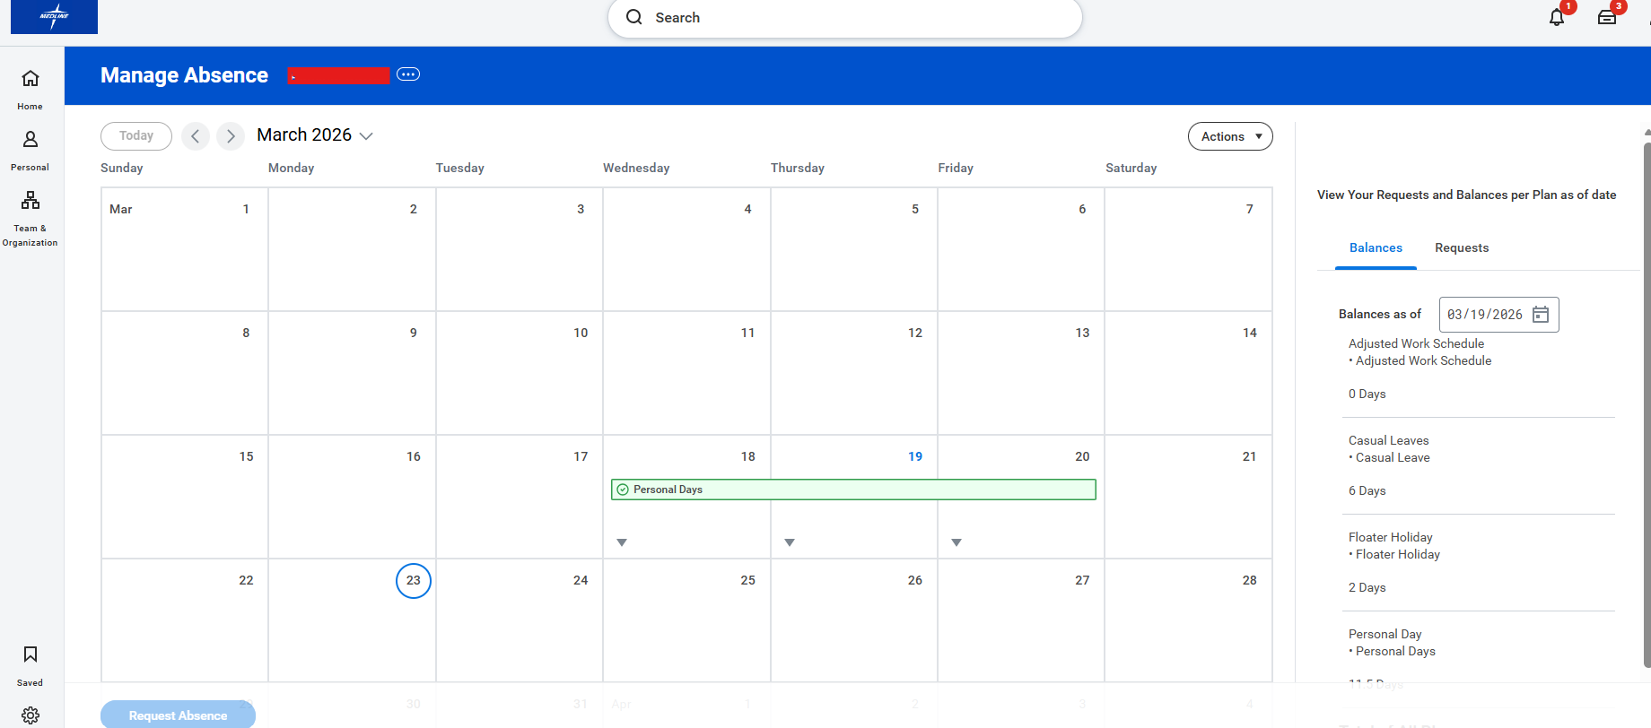
Select the Time off Request need to be corrected
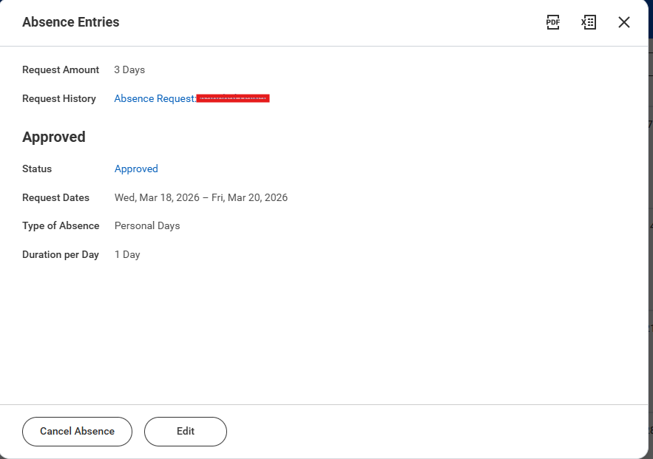
Click on the Edit Button to make correction:
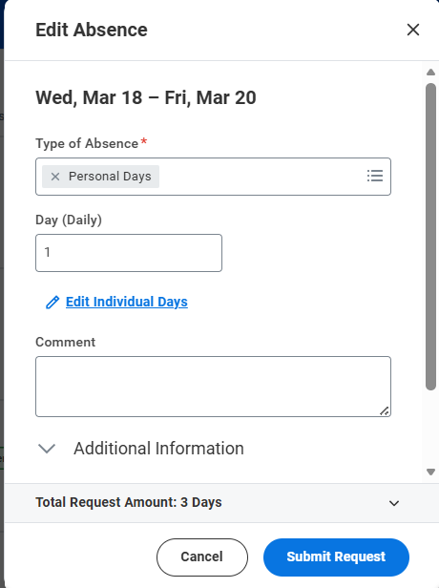
Click on Edit individual days:
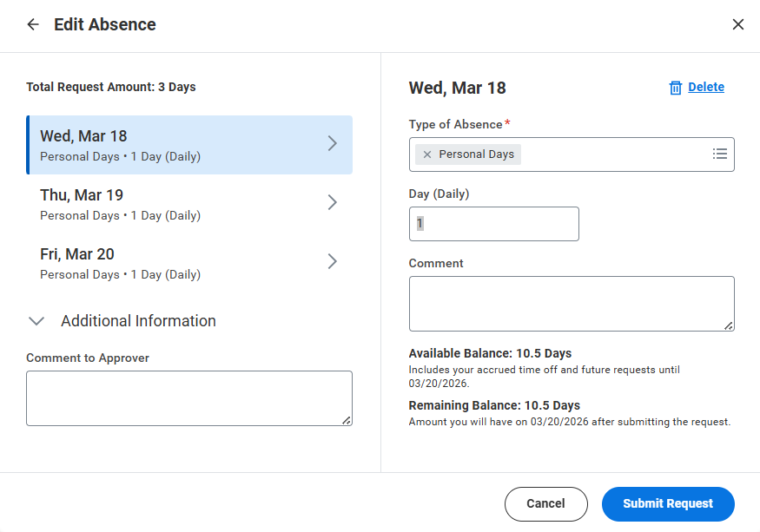
Time off corrections can be done on Individual days. Time off entry can be deleted or daily quantity can be adjusted
Make the correction and click on Submit Request:
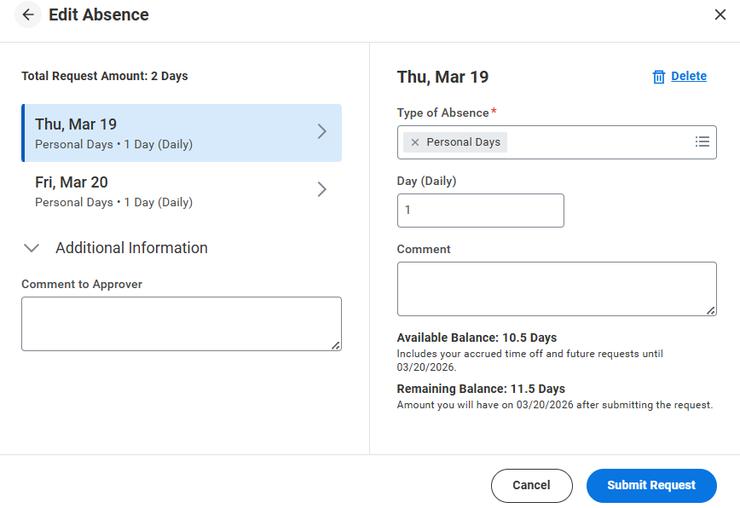
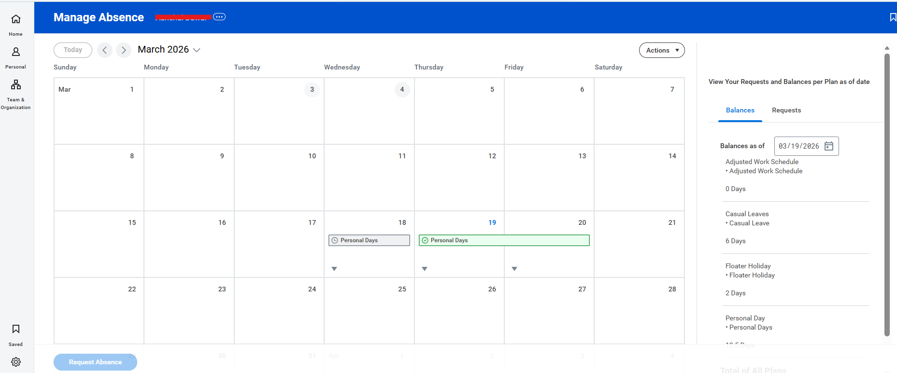
Approved Time off entry will be shown in green color and Pending for approval will be shown in grey color

