


Employees

View My Accruals
You can view your hourly balances for multiple accruals for any day directly on the My Accruals tile.

Navigation: UKG Home Page
On the My Accruals tile, click on the Balance as of Today dropdown arrow to select a past or future date. For instance, to view the annual balance, set the "Balance as of today" date to the last day of the year. Use the left and right arrows to move to the different accrual codes to view your balances.
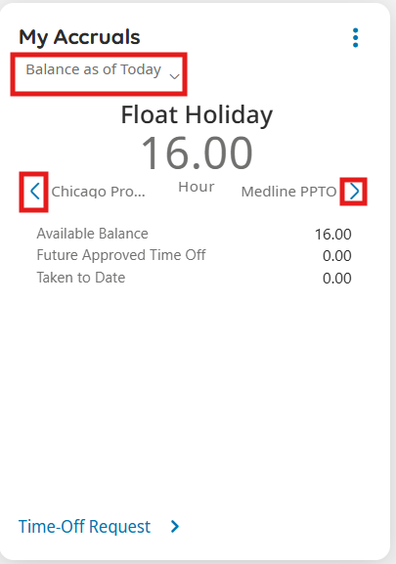
- Available balance = What you’ve accrued so far minus any future approved requests. Because of this, the amount you see may look lower than your actual accrual to date.
  - Floating Holiday: if eligible, is frontloaded on January 1
  - PTO: accrues based on your paygroup (weekly Sunday for hourly employees and the 1st and 16th for salaried employees)
    - If you have approved scheduled time off in the future – you may see a negative available balance. To check your remaining time for the year, simply adjust the date to year-end.
    - Employees can borrow up to 40 hours of PTO before it is earned with manager approval and if the hours will be earned within the same calendar year.
  - PPTO = accrues 1 hour for every 30 hours worked, up to the annual and overall limit, if applicable.
    - PPTO cannot be used in advance of accrual, unlike PTO. This means your PPTO balance cannot go negative.
    - Hourly employees: Changing the date will not update your Available Balance because PPTO accrues on hours worked. Check the Paid Time Away policy and supplement, if applicable, to see your PPTO eligibility.
  - Chicago Protected Sick = similar to PPTO, accrues 1 hour for every 30 hours worked, up to the annual and overall limit, if applicable.
- Future Approved Time Off = refers to any hours of absence that have been submitted and approved for upcoming dates.

- Taken to Date = refers to any absences recorded prior to the specified date.

