


Employees

Request Time Off
You can request time off for partial or full days using the My Time Off tile on the UKG Home Page.

Navigation: UKG Home Page
- From the My Time Off tile, select Reason for the type of time off.
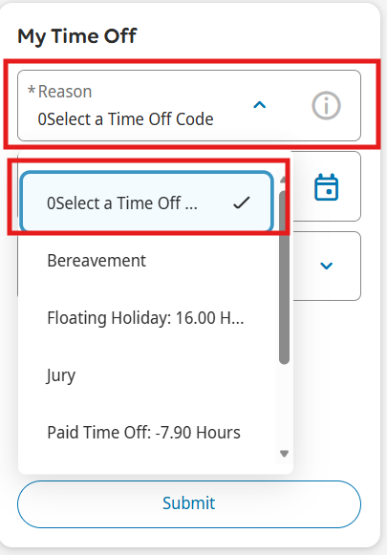
- Select Dates to access the calendar
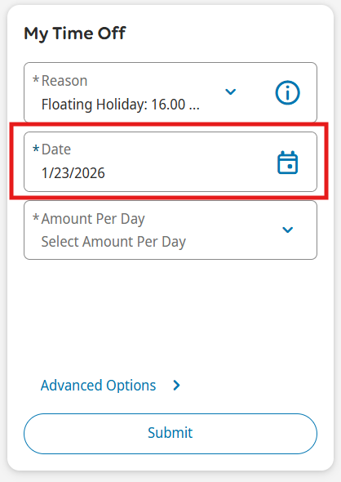

- In the calendar Date Range, input your desired start and end dates. Click Apply.
Only request time off for days you are scheduled to work. For example, if your time off spans two weeks and you don’t work weekends, submit separate requests to avoid using PTO on weekends. Don’t include company holidays unless you’re scheduled to work.

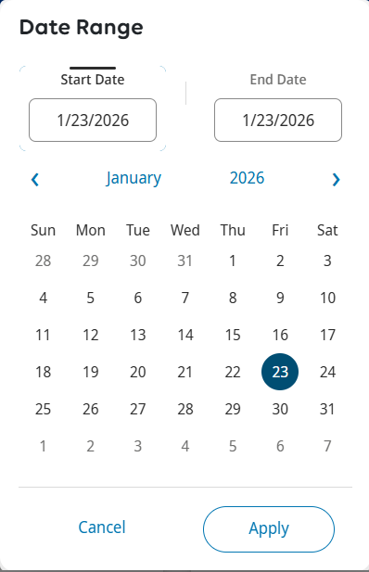

- Select Amount Per Day and in the dropdown options, select Full for a full day off or Hours for a partial day off.

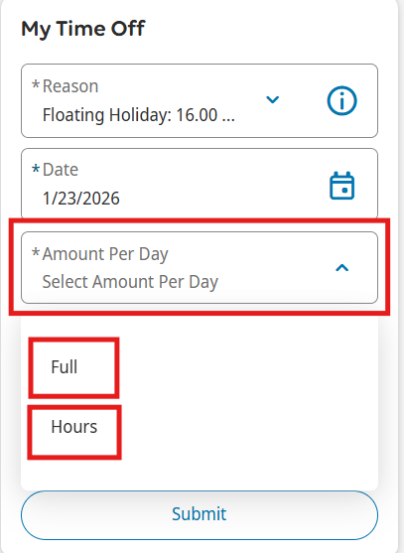

- If selecting Hours. Input the Start Time and the Duration (formatted as HH.MM), which is the number of hours requested. Review and click Submit.

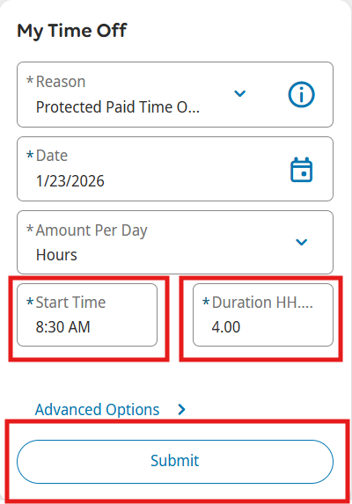

- The request will then be submitted to your manager, who should review and approve/deny within 72 hours. If you have UKG Mobile, you will receive notification once your manager has approved/denied. If you submit multiple requests without enough available balance, some may be rejected. To review the status from UKG. Go to My Notifications tile from the homescreen and click on My Requests.
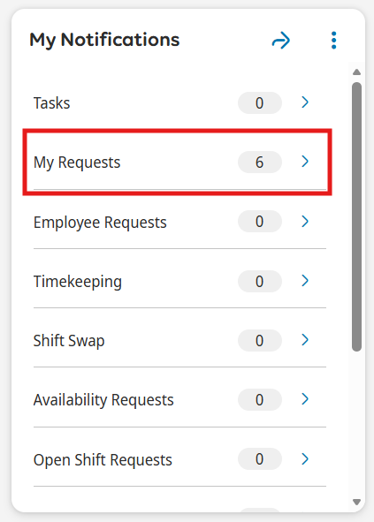
- Update the filter to All Status so you can see all requests, whether pending or approved. Or choose whichever status you are looking into.
