

In-Line Promotion with Manager Change – Plan to Backfill
Managers and HR Partners

In-Line Promotion with Manager Change – Plan to Backfill
(Initiating Manager)
- Access the task called Start Job Change
- Select the worker, choose the template called In Line Promotion, and click Ok.

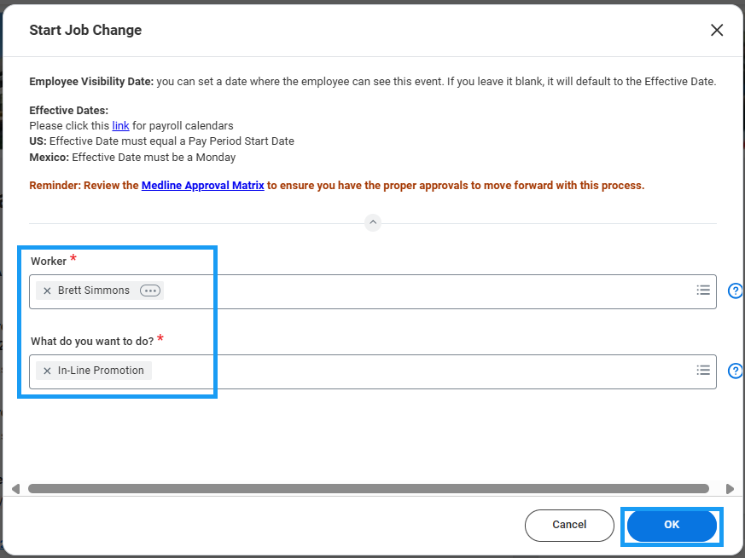

- Choose the desired Effective Date – it must be the beginning of a pay period.
- Select the new manager in the field “Which team will this person be moving to?”
- Ensure that the box next to “Is this person’s position moving with them?” is not checked.
- Select “Keep open for backfill”
- Select “Should the current position be available for overlap?”
- Click Submit to route to the Receiving Manager for review and approval.
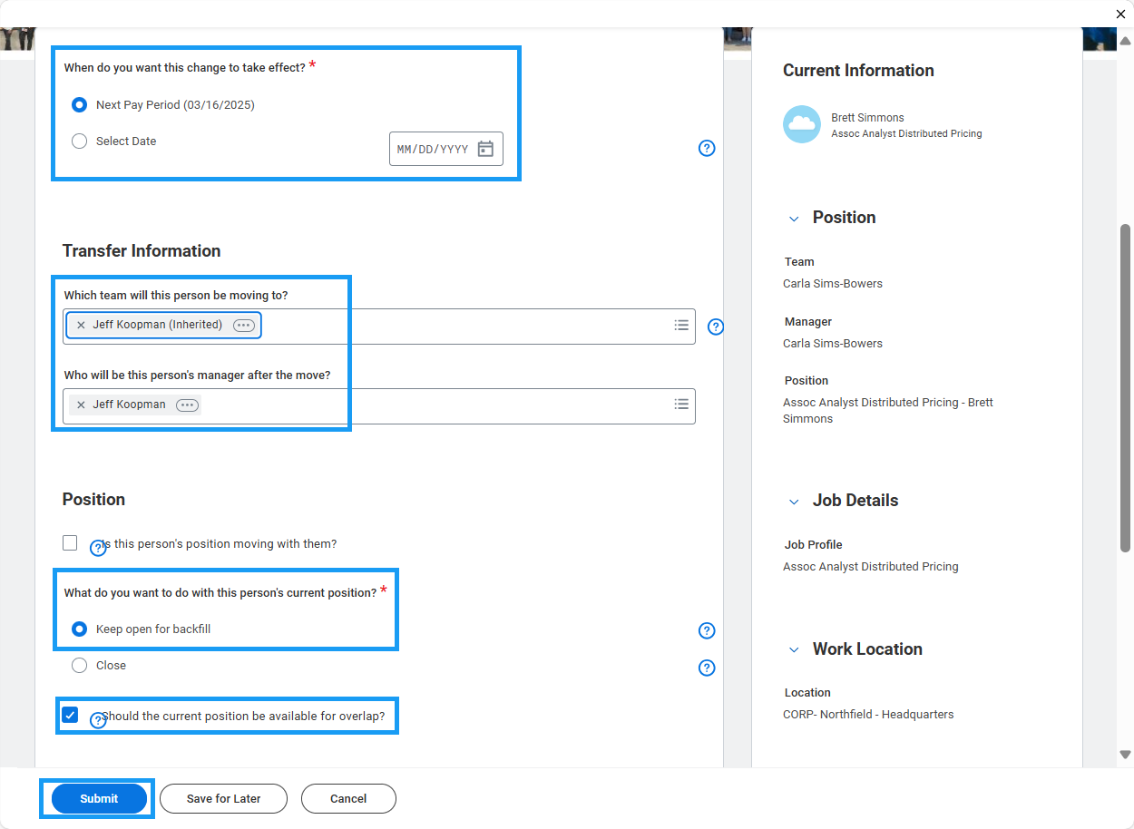

In-Line Promotion with Manager Change – Plan to Backfill
(Receiving Manager)
- Access the Promotion task in your My Tasks inbox.
- Review the change submitted by the initiating manager. You will see an “Attention Required” alert at the top of the form. Click the blue “Make Changes” button to enter edit mode.

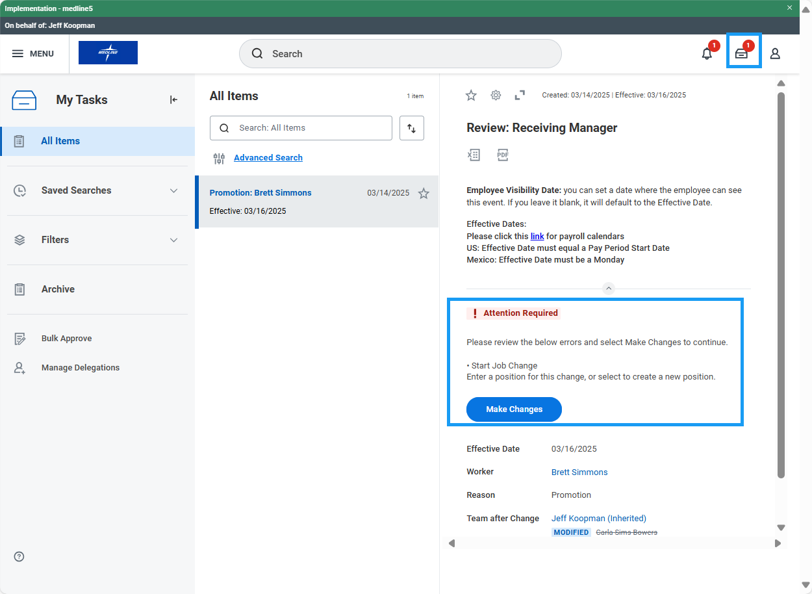

- Under the Position section, choose an open position for the transferring employee. If one is not available, you may check the box that says, “Do you want to create a new position?” Note: you will not be able to choose a position that is tied to an open job requisition.

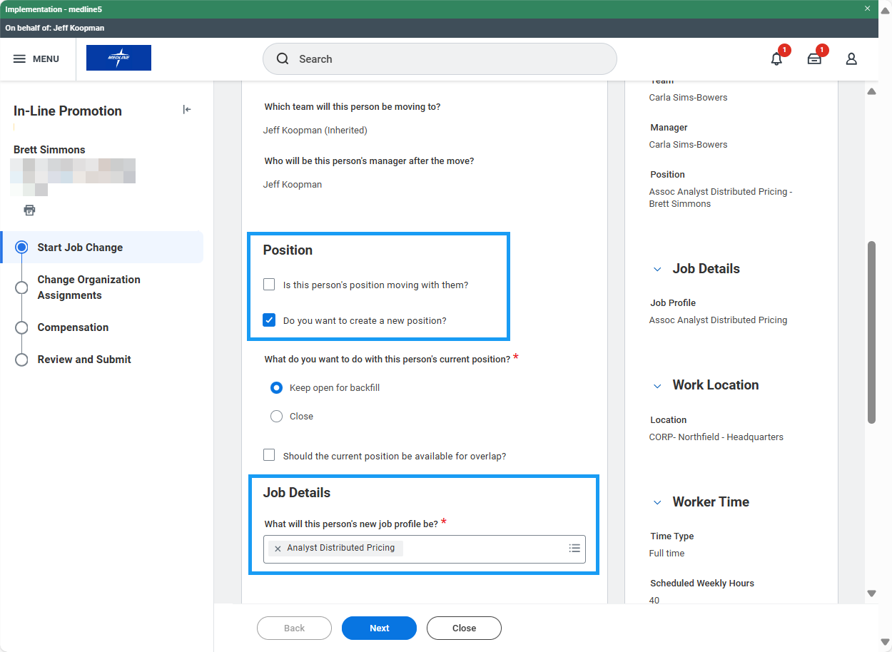

- Edit Job Profile, Work Location, Time Type, Scheduled Weekly Hours and/or Work Shift if necessary. Click Next.

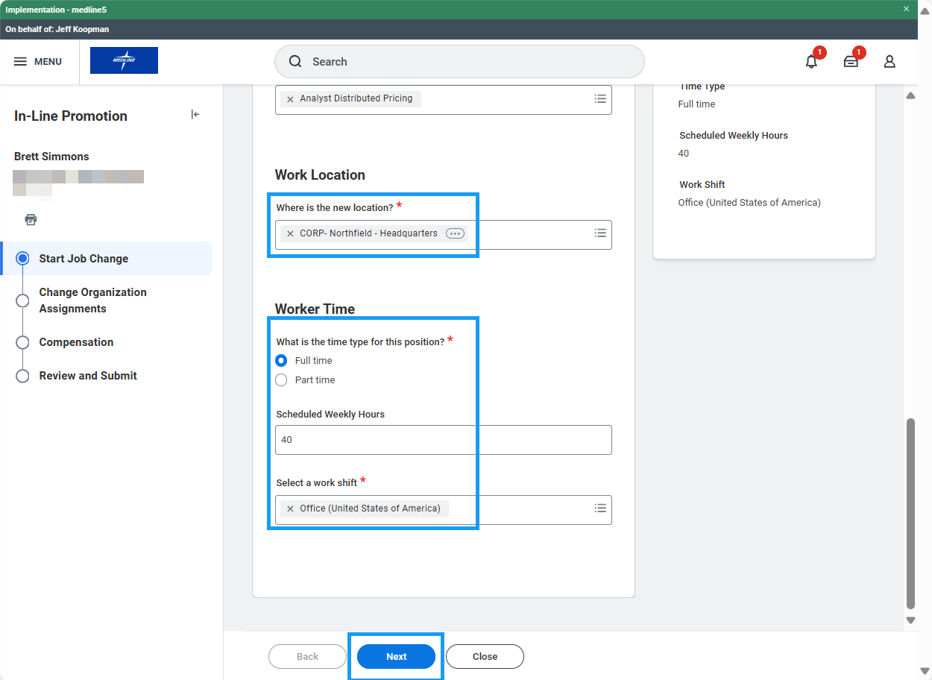

- Edit Company, Cost Center, Department, and other organizations if necessary. Click Next.

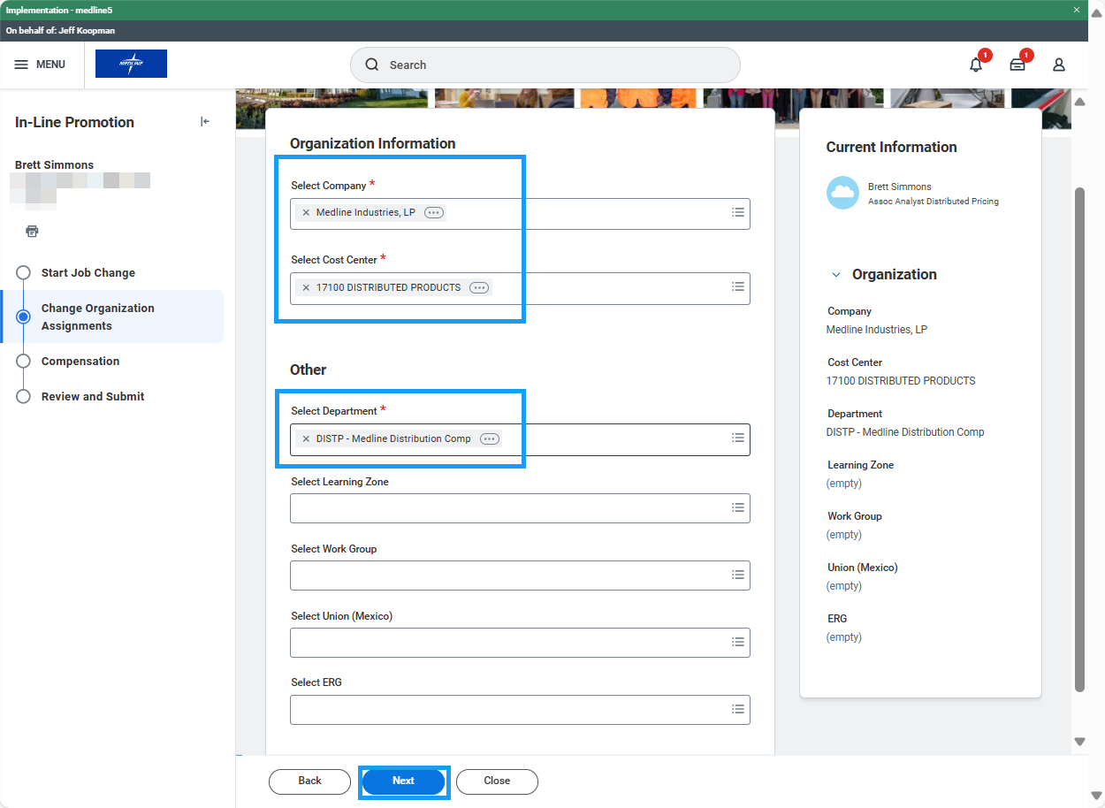
- On the Compensation screen, scroll down to review the Total Base Pay Range guidelines for the new job profile. If this is an hourly job, there will be an Hourly Plan assignment. Click the related actions button (three dots) and select Edit. Enter the proposed hourly rate and click Save. If this is a salary job, there will be a Salary Plan assignment. Click the related actions button (three dots) and select Edit. Enter the proposed annual rate and click Save. Click Next.

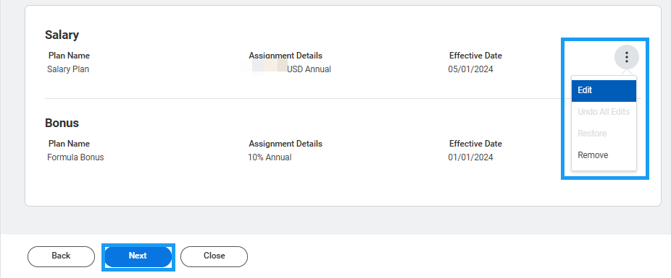

- Review the changes and click Approve to route to HR for further approval.

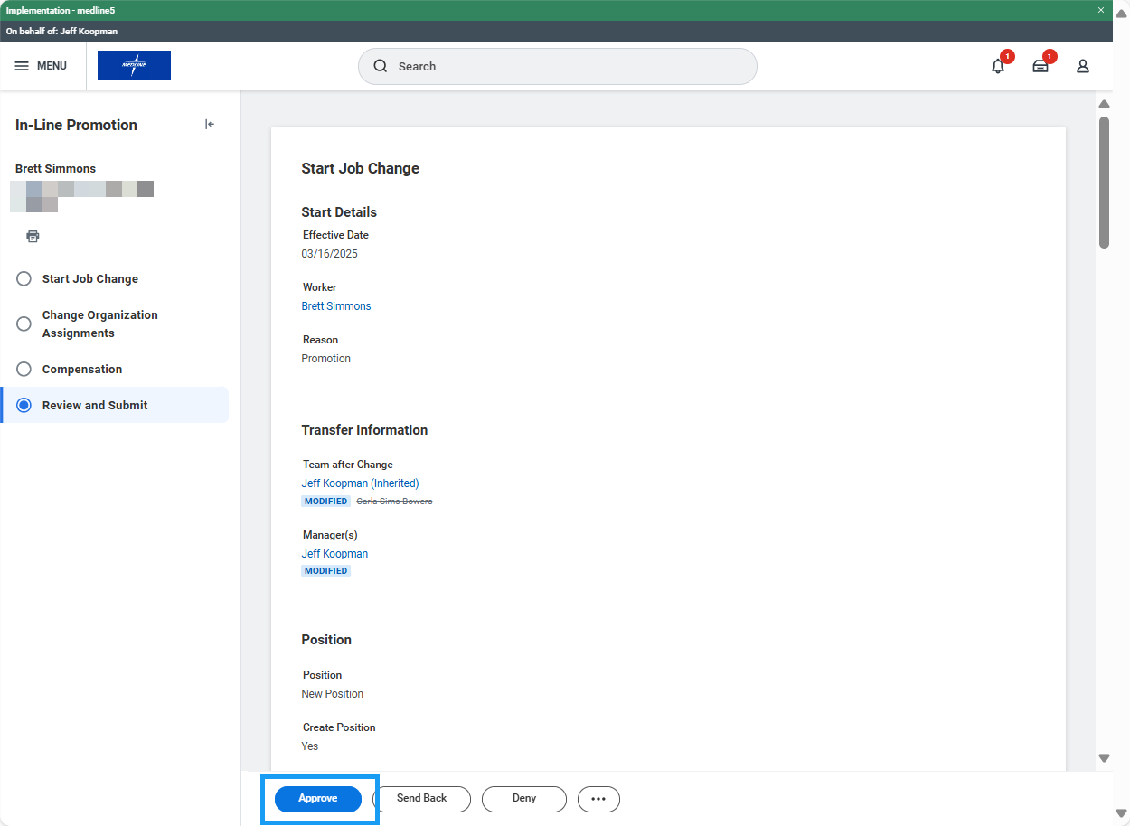
In-Line Promotion with Manager Change – Plan to Backfill (HR Partner)
- Access the Promotion task in your My Tasks inbox and review the proposed changes. If edits are needed, click the blue “Make Changes” button at the top of the task to enter edit mode.
- Review accuracy of the change and click Approve to route for further approval if necessary. Approval flow is HR Partner > Manager’s Manager > 1st VP. Sometimes Compensation will be included in the approvals if certain criteria is met.

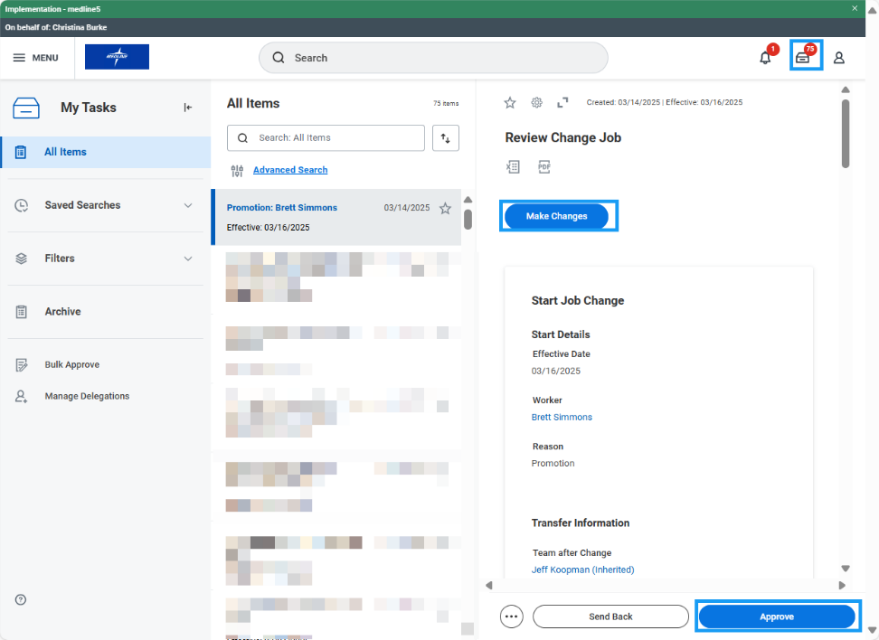

- The Promotion task is routed to the worker’s manager’s manager for additional approval:

