

Create Contingent Worker Position
HR Partners/HR Coordinator

Create Contingent Worker Position (HR Partner/HR Coordinator)
Creating contingent worker positions
- Access the task called Create Position.
- Enter the Supervisory Organization that the contingent worker position will sit in.

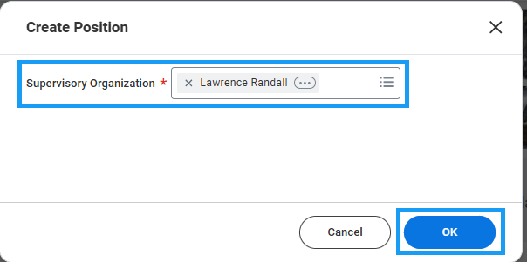

- Enter the required information. Note the following requirements:
  - Job Posting Title should just be an identifiable title – these positions will not actually be posted.
  - The Availability Date and Earliest Hire Date should be the earliest possible dates that the manager would fill the position. It’s recommended to use today’s date for these fields.
  - The Job Profile must be Contingent Worker.
  - The Worker Type must be Contingent Worker.
  - The Worker Sub Type determines whether or not system access is needed.

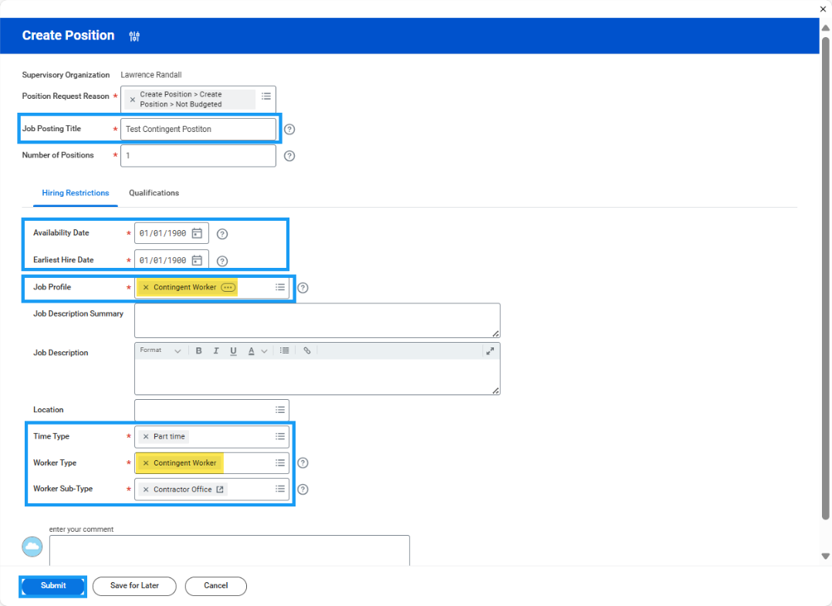

- Click Submit to route to the manager for approval. The approval flow is Manager > Manager’s Manager > First VP.
  - Manager Approval
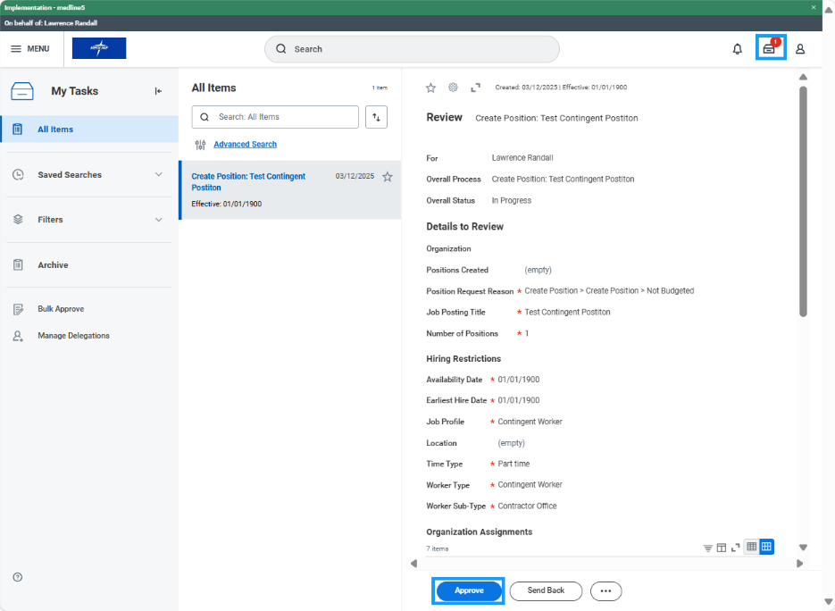

  - Manager’s Manager Approval:

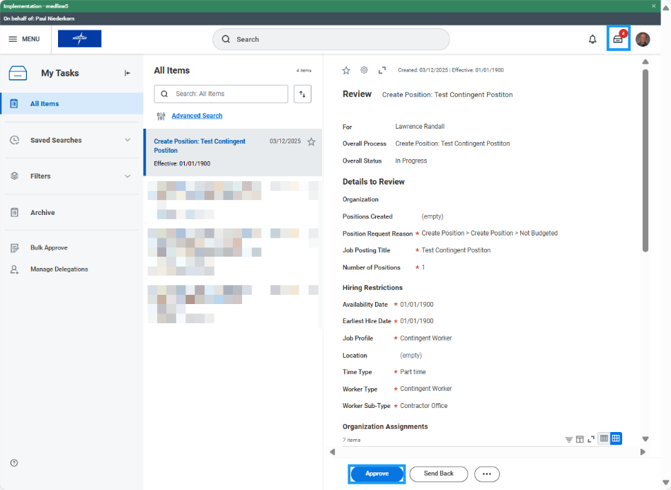

  - First VP Approval:

