

Contract Contingent Worker
Manager Only

Contract Contingent Worker (Manager)
Hiring contingent workers into open positions
- Access the task called Contract Contingent Worker
- If the Contingent Worker (CW) has been at Medline before, you can search for them under Existing Pre-Hire. If they are brand new, select Create a New Pre-Hire.

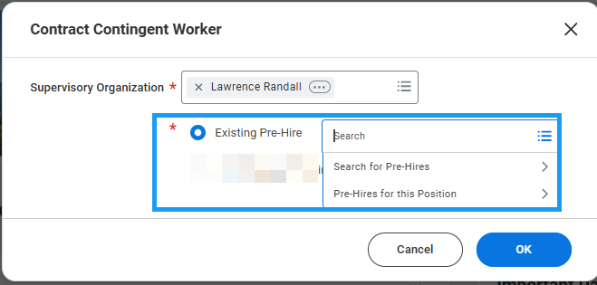
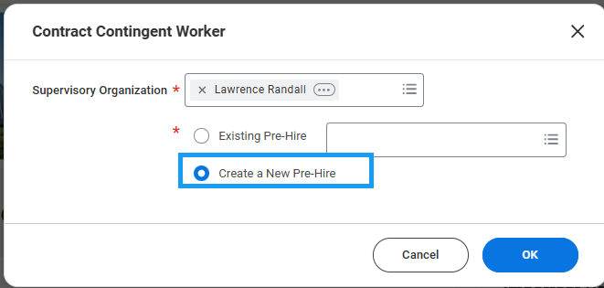

- Enter the CW’s legal name information.

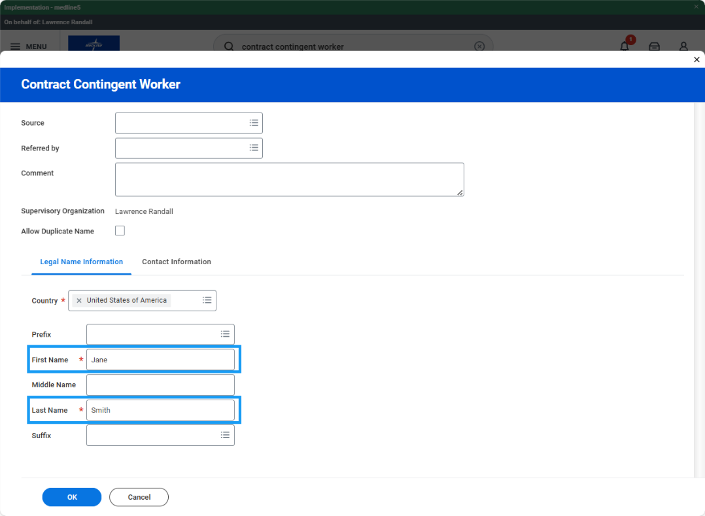

- Click the Contact Information tab and add their contact information. Note: at least 1 piece of contact information is required to proceed. Click Ok.

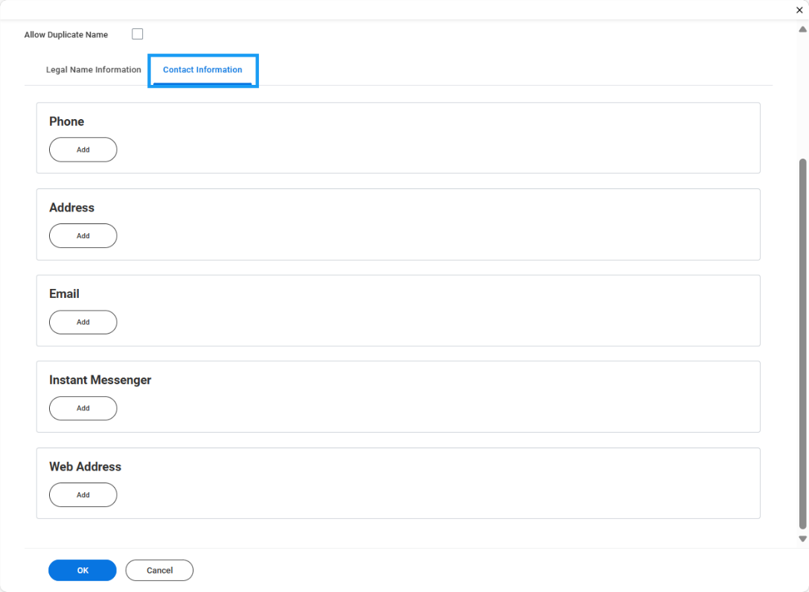
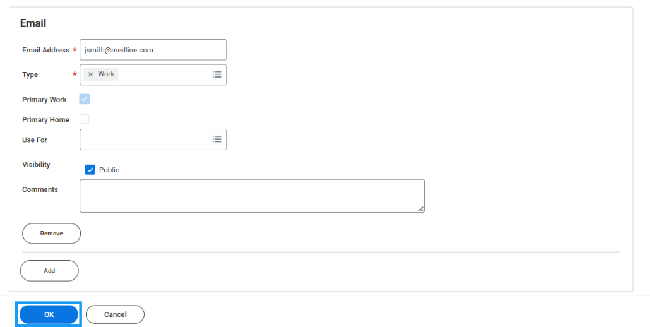

- On the Contract Contingent Worker form, enter the contract start date and reason.

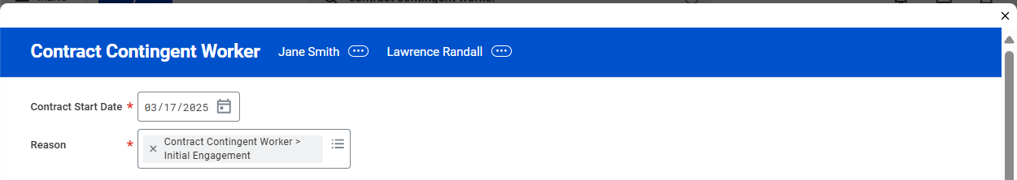
- Under Job Details, select the contingent worker position.
- Confirm that the defaulted information from the position is applicable and change if necessary. Add a location.

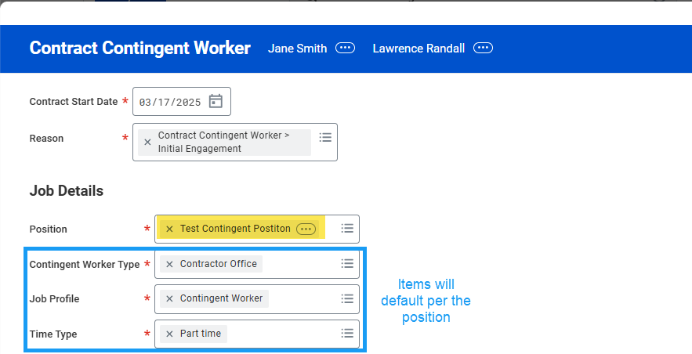
- Supplier is a required field. Enter the name of the organization that provided the contingent worker resource. If the Supplier does not exist, enter a Zendesk ticket to have it created before you proceed.
- The Contract End Date is required and can only be a maximum of 90 days from the Contract Start Date.

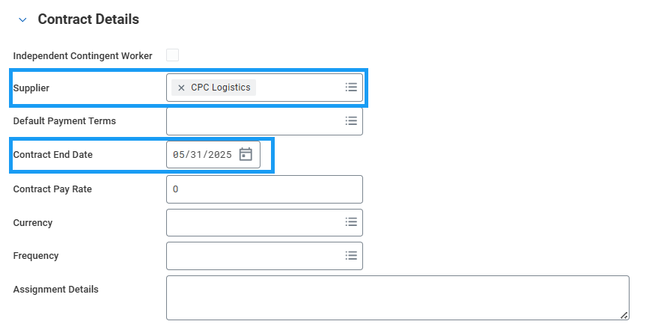

- Enter a Work Shift.

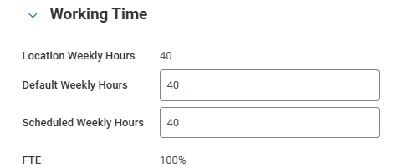

- Expand the Additional Information section. Job Title and Business Title will default to whatever was entered into the Job Profile. Change these fields to whatever the company-facing job title should be. It cannot be Contingent Worker.

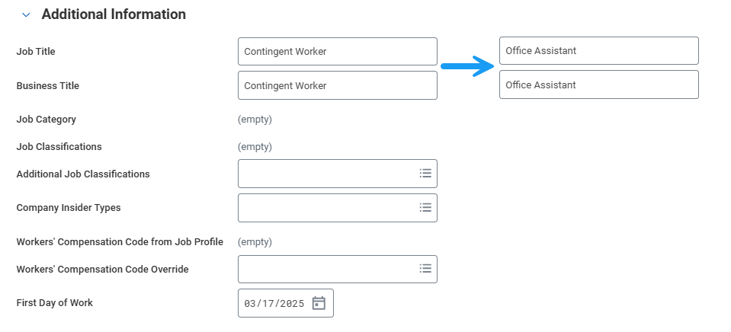

- Click Submit to route for HR Partner approval.

