

Change Work Shift
Managers and HR Partners

Change Work Shift (Initiating Manager)
- Access the task called Start Job Change
- Select the employee, choose the Change Work Shift template and click Ok.

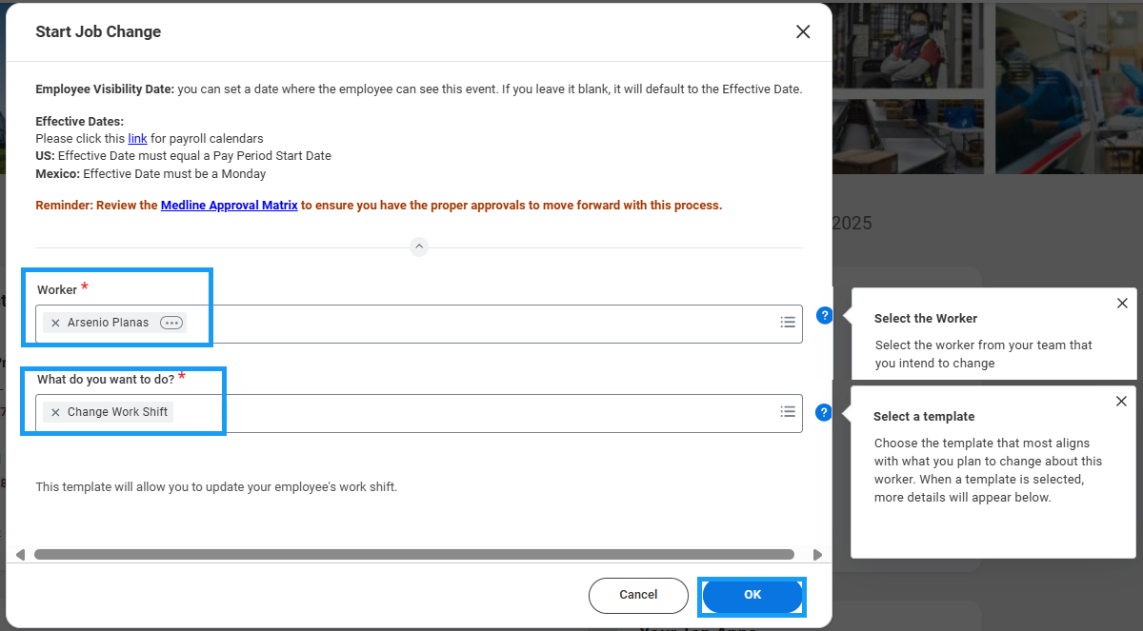
- Choose the Effective Date – it must be the beginning of a pay period.
- Select the new work shift value.
- Click Submit to route to HR for approval.

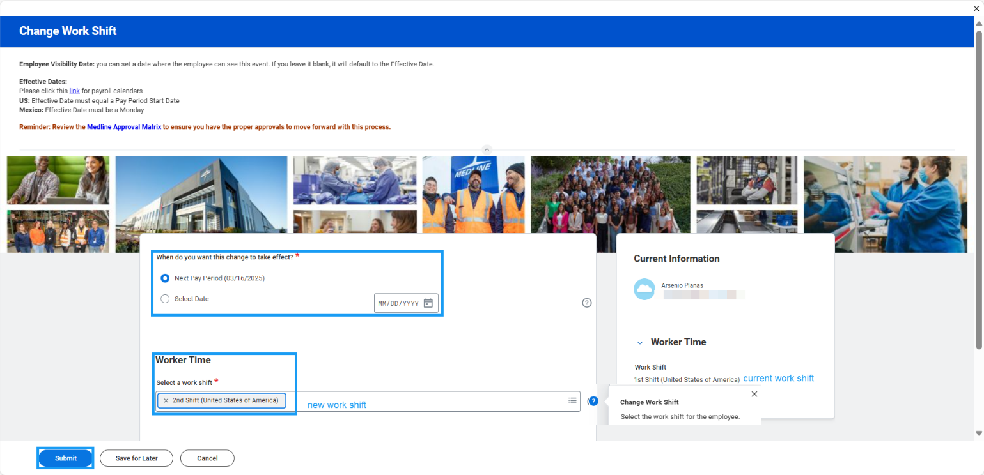
Change Work Shift (HR Partner)
- Access the Data Change task in your My Tasks inbox.
- Review the changes submitted by the manager. If edits are required, click the blue “Make Changes” button at the top of the form to enter edit mode.
- Confirm accuracy of the change and click Approve.
