

Change Organization Assignment
Managers and HR Partners

Change Organization Assignment (Initiating Manager)
- Access the task called Start Job Change
- Select the worker, choose the template called Change Organization Assignments and click Ok.

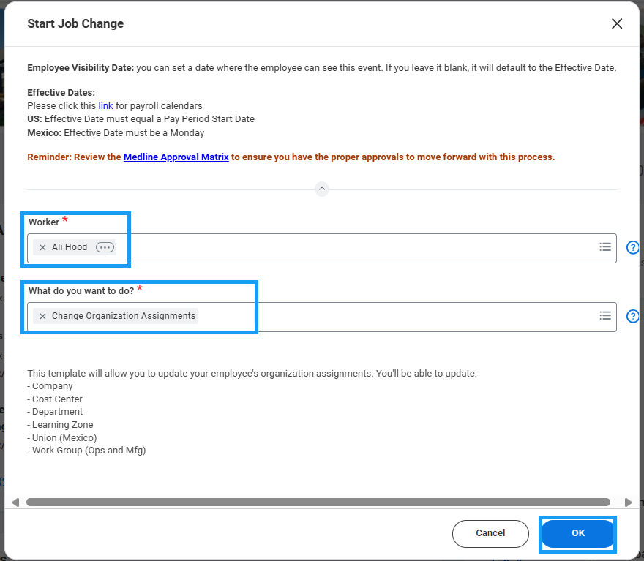

- Choose the Effective Date – it must be the beginning of a pay period – and click Submit.
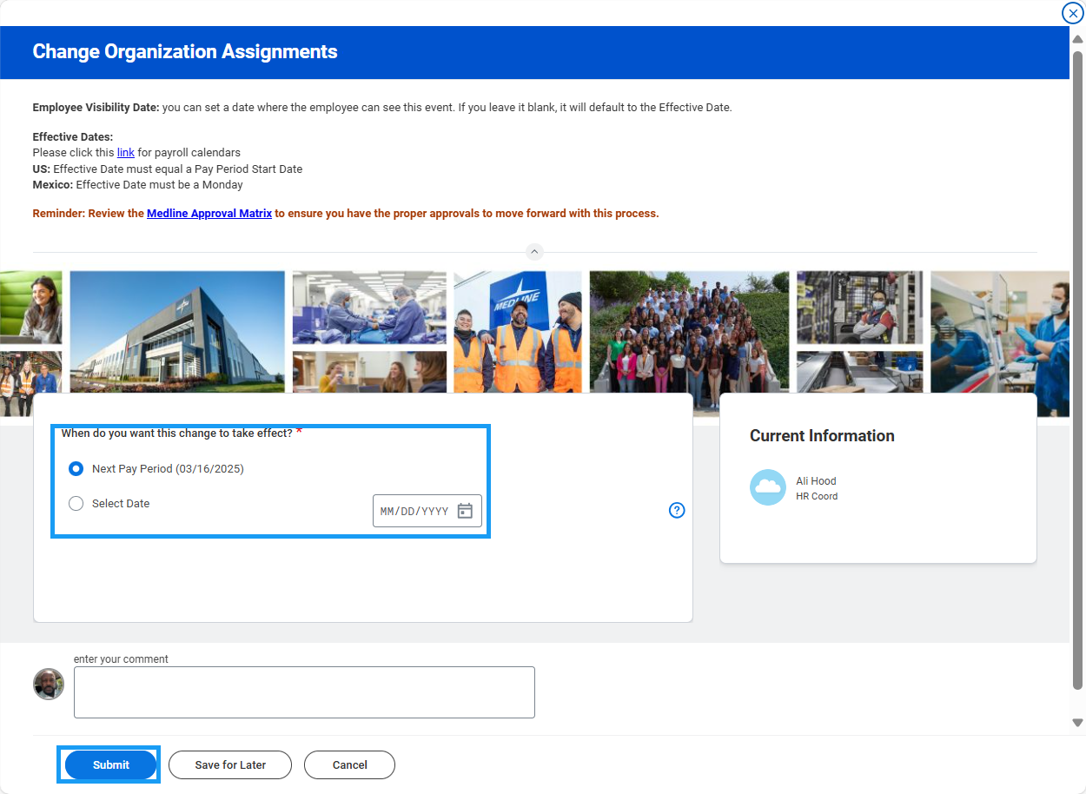

- On the next screen you will be able to change the organization(s). Click Next.
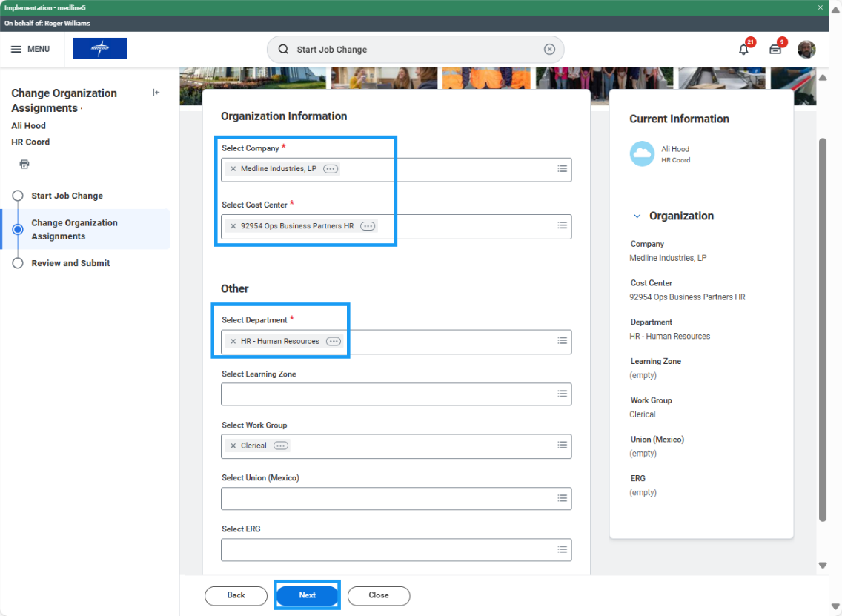

- Review changes and click Submit to route for HR Partner approval (if applicable).
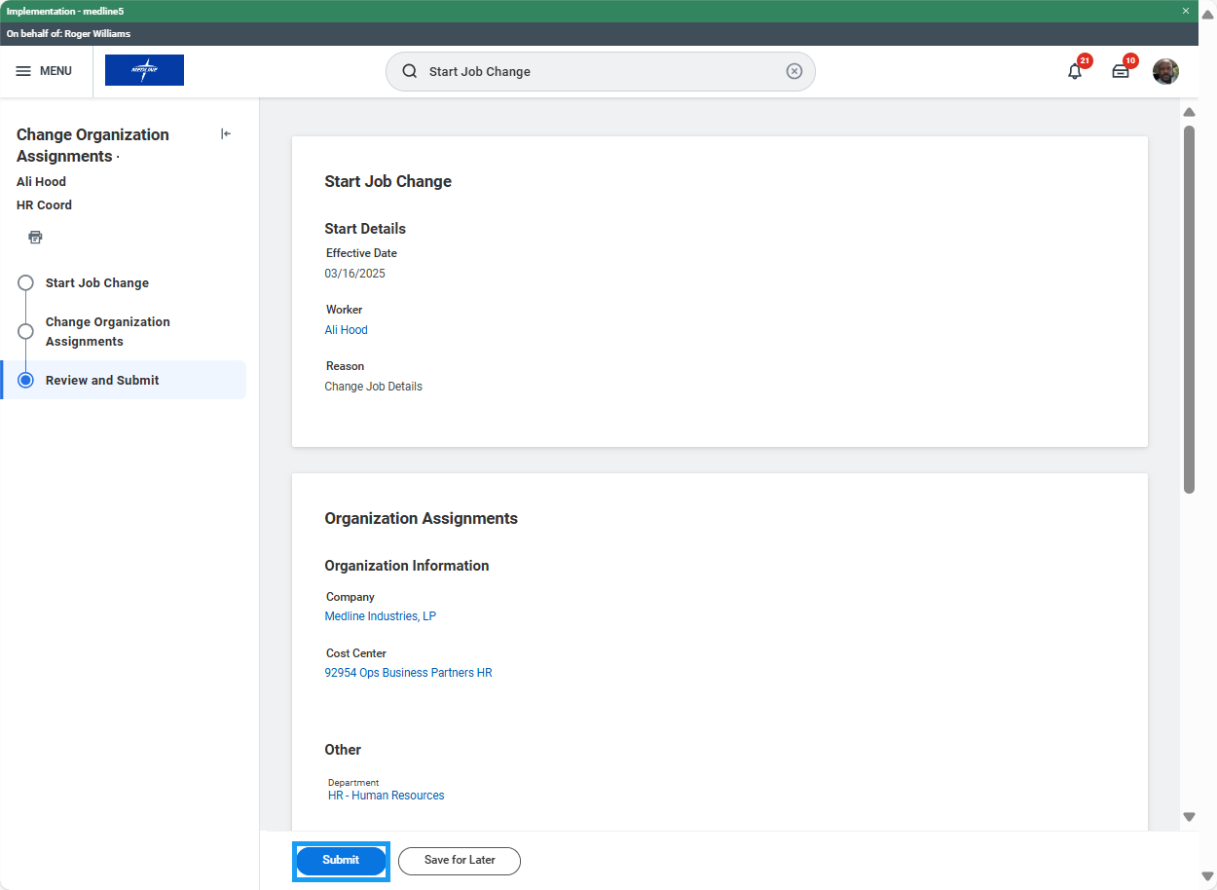
Change Organization Assignment (HR Partner)
- Access the Data Change task in your My Tasks inbox.
- Review the changes submitted by the manager. If edits are required, click the blue “Make Changes” button at the top of the form to enter edit mode.
- Confirm accuracy of the change and click Approve.

