

Performance Improvement Plans (PIPs)
Managers

As a manager, you may need to initiate a Performance Improvement Plan (PIP) for an employee. A PIP is a structured process that provides a set of goals and expectations to an employee who is not meeting performance standards. This process may help the employee improve their performance over a defined period of time. This document will guide you through the following tasks and processes:
Initiating PIPs
How to initiate a PIP for an employee on your team

Conducting a Progress Check
How to conduct a Progress Check to assess the employee's progress and make any adjustments to the PIP at any point(s) after the initial Performance Improvement Plan.

Completing the Evaluation
How to assess whether or not the employee has successfully met the expectations outlined in the plan once the defined date of the Performance Improvement Plan has been reached.

Initiating PIPs
- To get started, click the Team Performance application from the Applications Menu on your Workday Homepage.

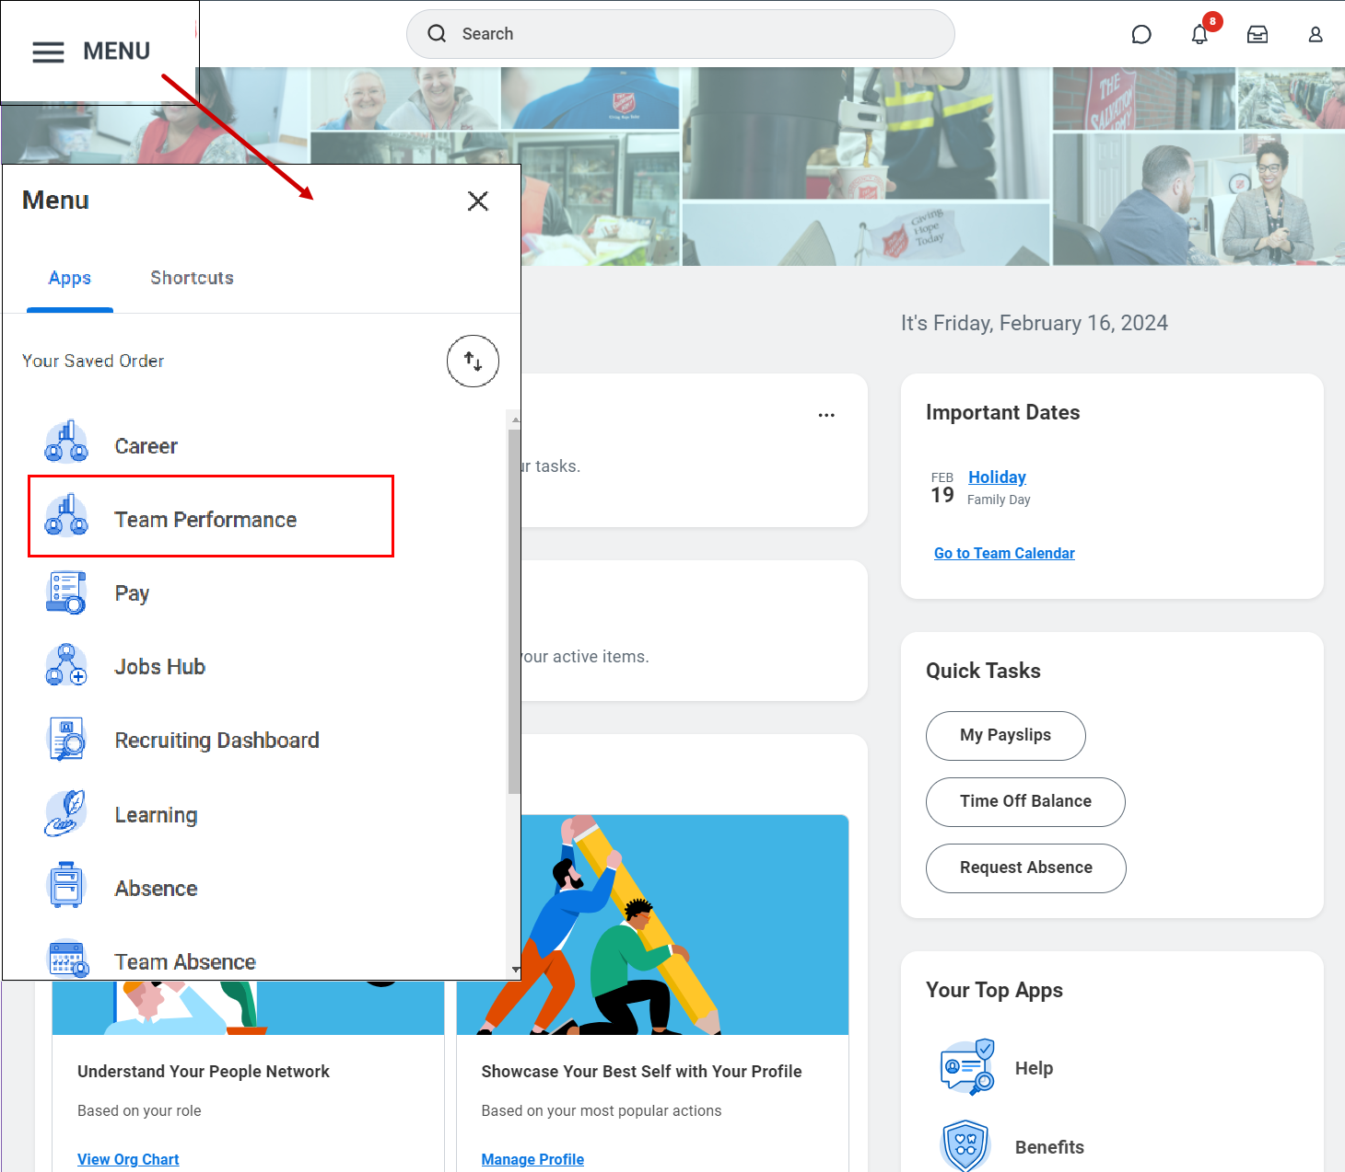

- From the Performance column, click Start Performance Improvement Plan.

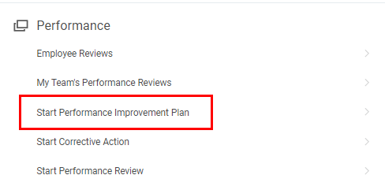

- Fill in the mandatory fields, marked by a red asterisk (*), Then, click Submit.
  - Select the Employee you would like to start the performance improvement plan for
  - Select Initiate: Performance Improvement Plan - Global from the Review Template drop-down menu.
  - Select today’s date for the Period Start Date
  - Select today’s date for the Period End Date

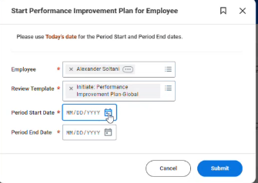

- You will receive a notification. Click Open or navigate to your Inbox to Complete the Manager Evaluation.

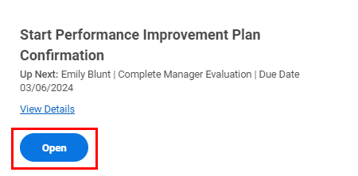

- Then, click Get Started.

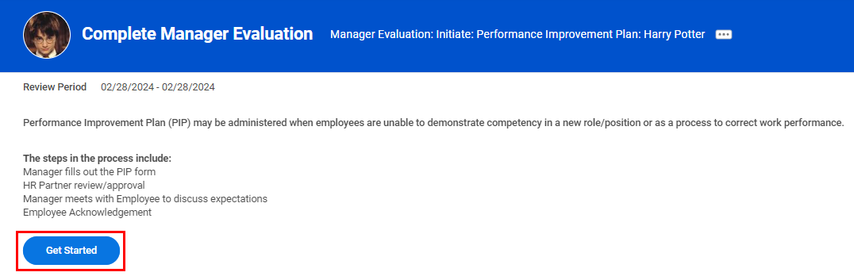

- You will be brought to the PIP Details section of the Performance Improvement Plan. Scroll down to answer the questions, then click Next to continue.
  - Performance Commentary: Provide overall commentary of the employee’s performance. State the role and high-level expectations/ responsibilities of the role that the employee is in, followed by 1-2 sentences stating where the employee may not be meeting these expectations.
  - Specific Performance Concerns: State 2 or 3 categories of performance concerns. Further provide at least 1 recent example of a task or situation where a performance expectation was not met to support each category or concern listed, including any negative impact to the department or business. Highlight any coaching that may have already been provided thus far.

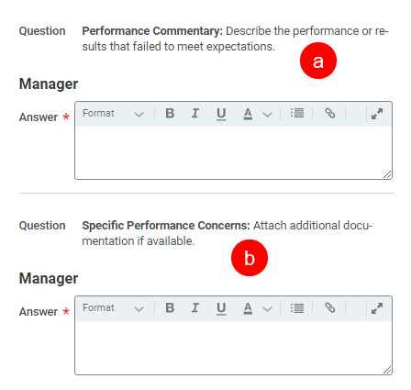

Please note that you can click on Review Example PIP Here at the top of the page for more support.

- You will be brought to the Duration section of the Performance Improvement Plan. Here, Select a time frame (30 days, 60 days, 90 days, N/A), then Answer the corrective action the employee has been asked to take. Click Next to continue.

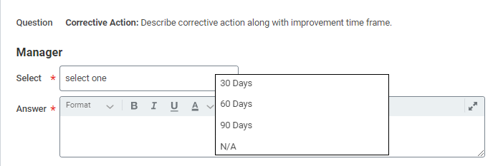
Please note that corrective action categories typically mirror the areas highlighted as part of performance concerns. Include any metrics, deadlines or milestones that you expect the employee to achieve during the PIP period.

- You will be brought to the Supporting Documents section of the Performance Improvement Plan. Here, you can choose to click Select Files to upload any documents here that might support the PIP action. Documents included here will be visible to the employee. Click Next to continue.

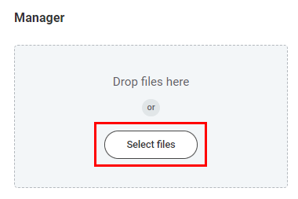

- Next, you can read through the Employee Acknowledgement statement, which will show you what the employee will have to sign upon receiving the PIP. Click Next to continue.

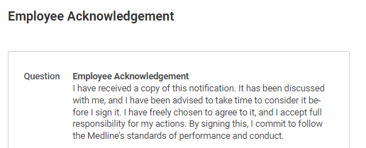

- The Review and Submit page will provide an overview of the information you entered. Review it carefully and make any necessary corrections. To go back, click on a section in the left sidebar. Then, click Submit to advance to the next step.

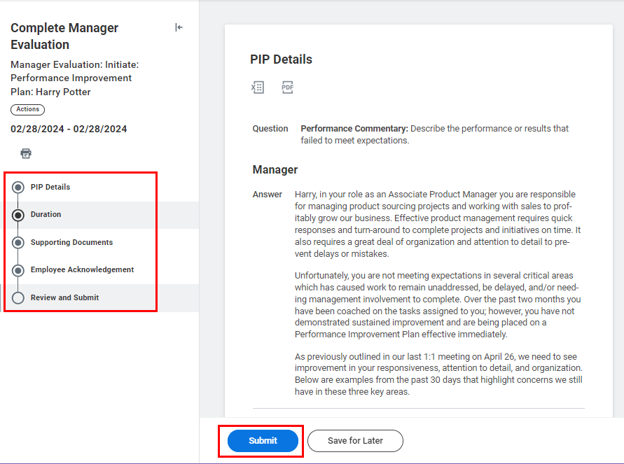

- You will receive a confirmation notification. The task will then be routed to the HR Partner who will review your PIP submission.

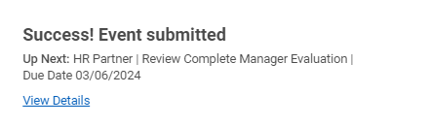

- Once the HR Partner have approved your PIP submission, you will receive a task in your My Tasks Inbox to meet with the employee to discuss their Performance Improvement Plan.
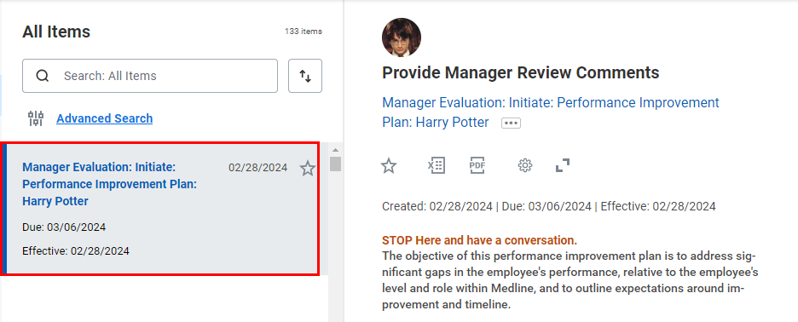

Please note: Do not click “Submit” until the meeting with the colleague has occurred as it will route the task to the colleague within Workday for acknowledgement.

- Click Get Started for a summary of the PIP, which you can reference during your discussion with the employee. Then, click Next.

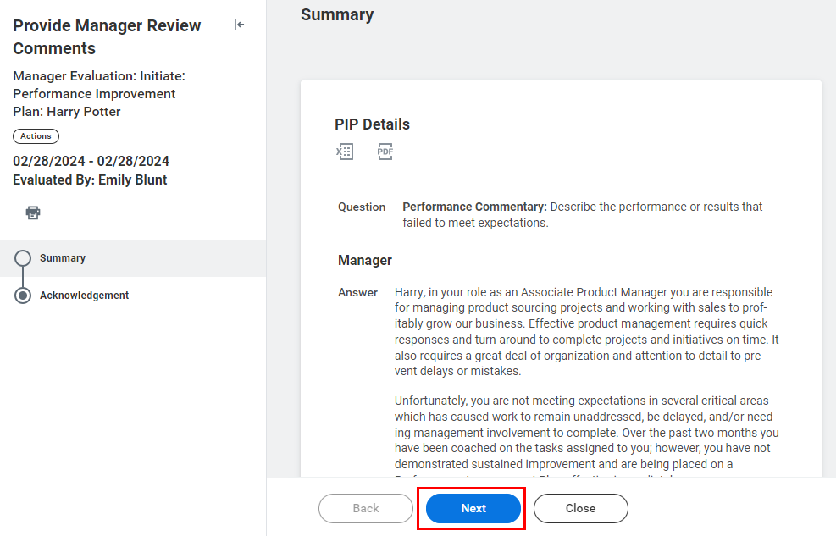

- When the conversation has been completed, select Acknowledge Review Discussion Complete in the Status and add any additional comments as necessary. The

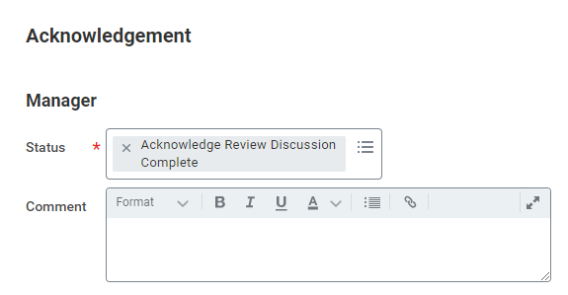

- Once complete, click Submit.



- You will receive a confirmation notification. The task will then be routed to the employee for their acknowledgement of the PIP.



Conducting a Progress Check
At any point(s) after the initial Performance Improvement Plan, you may want to conduct a Progress Check. This allows you to assess the employee's progress and make any adjustments to the plan.
- To track an employee’s progress who is currently on a Performance Improvement Plan, click the Team Performance application from the Applications Menu on your Workday Homepage.

- From the Performance column, click Start Performance Improvement Plan.

- Fill in the mandatory fields, marked by a red asterisk (*), Then, click Submit.
  - Select the Employee who is currently on a PI.
  - Select Progress Check from the Review Template drop-down menu.
  - Select today’s date for the Period Start Date. This should not be the same as the day the PIP was initiated.
  - Select today’s date for the Period End Date. This should not be the same as the day the PIP was initiated.

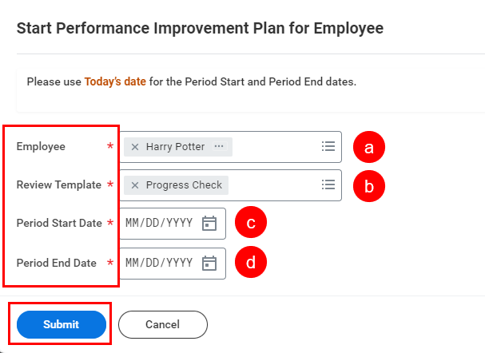

- You will receive a notification to begin the Progress Check process. Click Open or select the task in your Workday My Tasks Inbox titled Manager Evaluation: Progress Check.

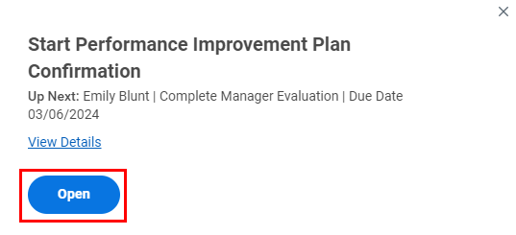

- Then, click Get Started.

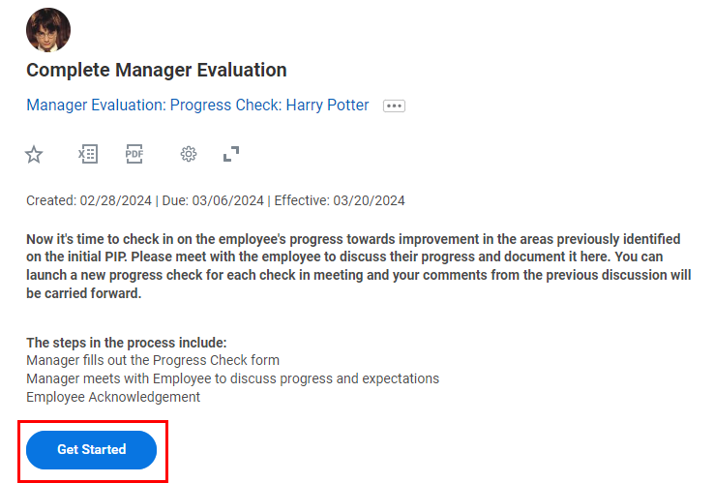

- On the PIP Details page, you will find that the details entered during the PIP Initiation will automatically populate for the employee. Scroll to the bottom of the page and provide a description of the progress the employee is making towards improvement in the blank field. Then, click Next to continue.

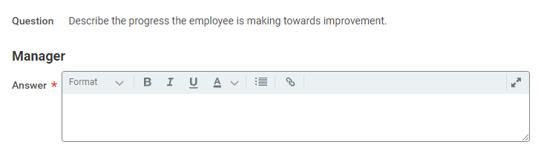

- Skip ahead to the PIP Status page. Choose a Rating from the drop-down list, indicating the current progress of the employee. For a progress check, you will likely want to select either PIP Open – Continue Coaching or PIP Extension. If needed, you can add any comments. Then, click Next to proceed.

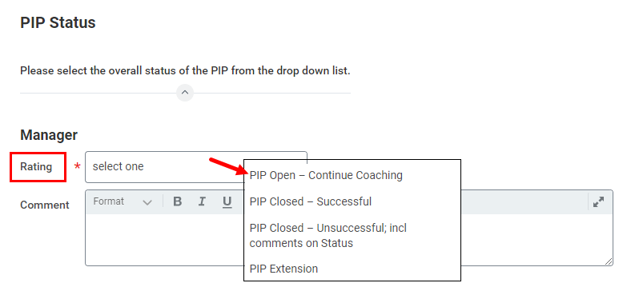

- On the next page, if the PIP is being extended, indicate the length of the extension by selecting the appropriate option from the drop-down menu under Select. Then, add any comments as necessary. Click Next to proceed.

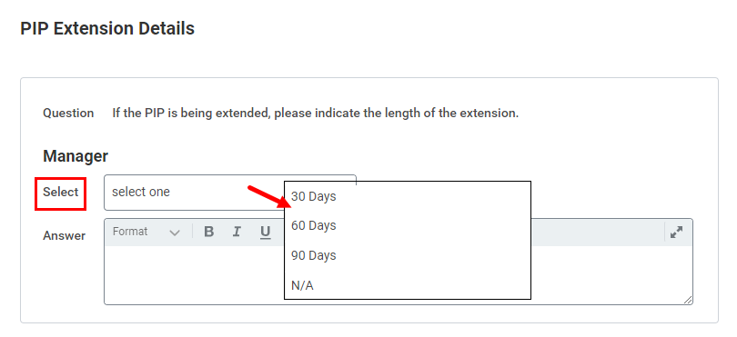
- Once you have finished, proceed to the Review and Submit page. Take the time to carefully review all the information entered. If you need to make any revisions, click on the corresponding section in the left sidebar of the page. Then, click Submit to finalize your entry.

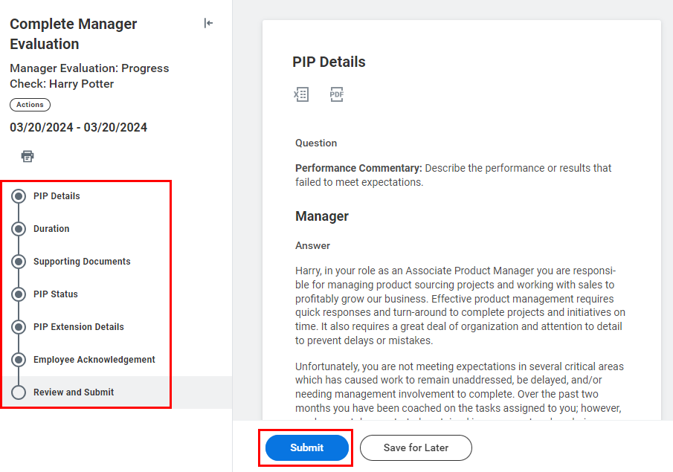

- You will receive a task in your Workday My Tasks Inbox titled Manager Evaluation: Progress Check. This will remind you to set up a meeting with the employee.

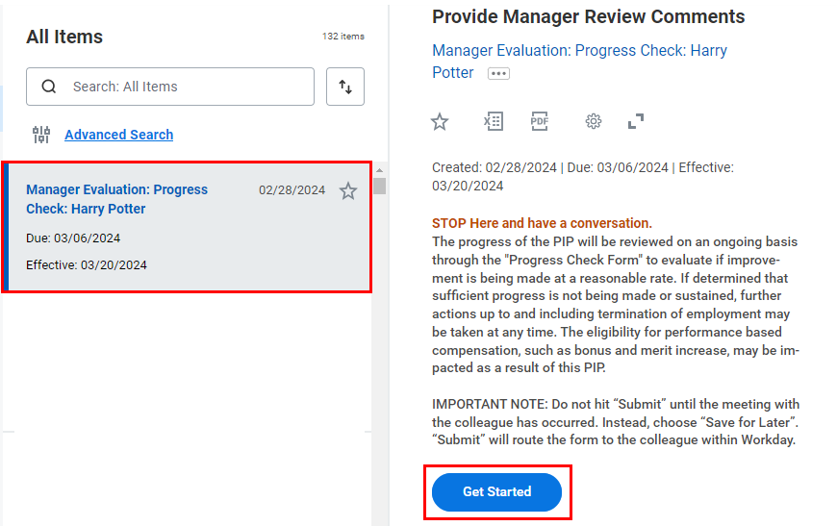

Please note: Do not click “Submit” until the meeting with the colleague has occurred as it will route the task to the colleague within Workday for acknowledgement.

- Click Get Started for a summary of the PIP, which you can reference during your discussion with the employee. Then, click Next.

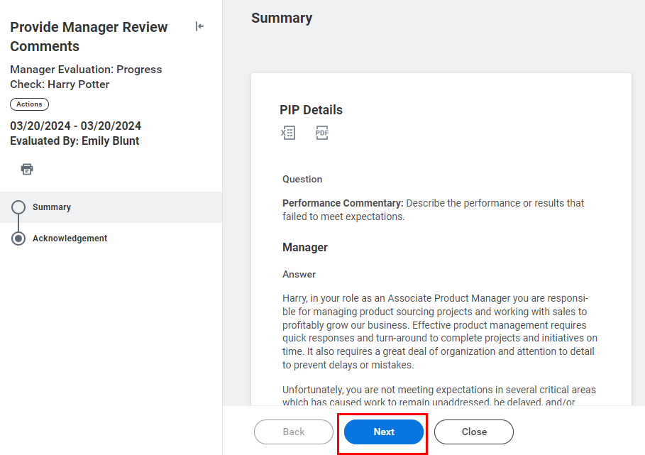

- When the conversation has been completed, select Acknowledge Review Discussion Complete in the Status section and add any additional comments as necessary.

- Once complete, click Submit.

- You will receive a confirmation notification that the progress check has been submitted.



Completing the Evaluation
- Follow Steps 1 – 6 from the section above, Conducting a Progress Check.

On Step 7, PIP Status, you will want to choose either PIP Closed – Successful or PIP Closed – Unsuccessful under the Rating drop-down list. If you chose Unsuccessful, please include a rationale in the comment section below. Click Next to proceed.

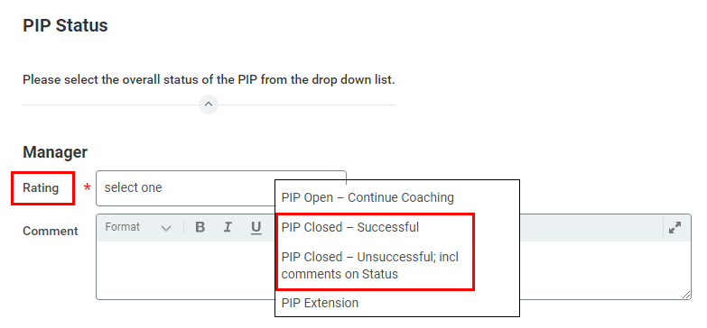

- Once you have finished, proceed to the Review and Submit page. Take the time to carefully review all the information entered. If you need to make any revisions, click on the corresponding section in the left sidebar of the page. Then, click Submit to finalize your entry.

- You will receive a confirmation notification if successfully completed. The task will then be routed to the HR Partner to review the evaluation.

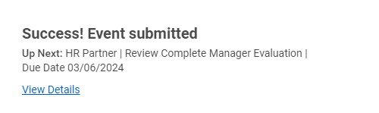

- Once they have approved, you will receive a task in your Workday My Tasks Inbox titled Manager Evaluation: Progress Check. This will remind you to set up a meeting with the employee.

Please note: Do not click “Submit” until the meeting with the colleague has occurred as it will route the task to the colleague within Workday for acknowledgement.

- Click Get Started for a summary of the PIP, which you can reference during your discussion with the employee. Then, click Next.

- When the conversation has been completed, select Acknowledge Review Discussion Complete in the Status section and add any additional comments as necessary.

- Once complete, click Submit.

- You will receive a confirmation notification that the progress check has been submitted. The task will then be routed to the employee for their acknowledgement of the PIP completion conversation.

