

Job Requisitions
Managers

For Managers looking to learn about the job requisition approval and initiation process, this document will guide you through the following tasks and processes:
Initiating Job Requisitions
How to initiate job requisitions if you are hiring for your team.

Approving Job Requisitions
How to view job requisitions that are sent to you for approval by a Hiring Manager on your team.

Initiating Job Requisitions
- As a Hiring Manager, you have the ability to initiate job requisitions in Workday. To get started, click on the Recruiting Dashboard app from the Applications Menu on your Workday Homepage. Alternatively, you can click the Recruiting Dashboard app directly on your Workday Homepage below Your Top Apps if it appears there.

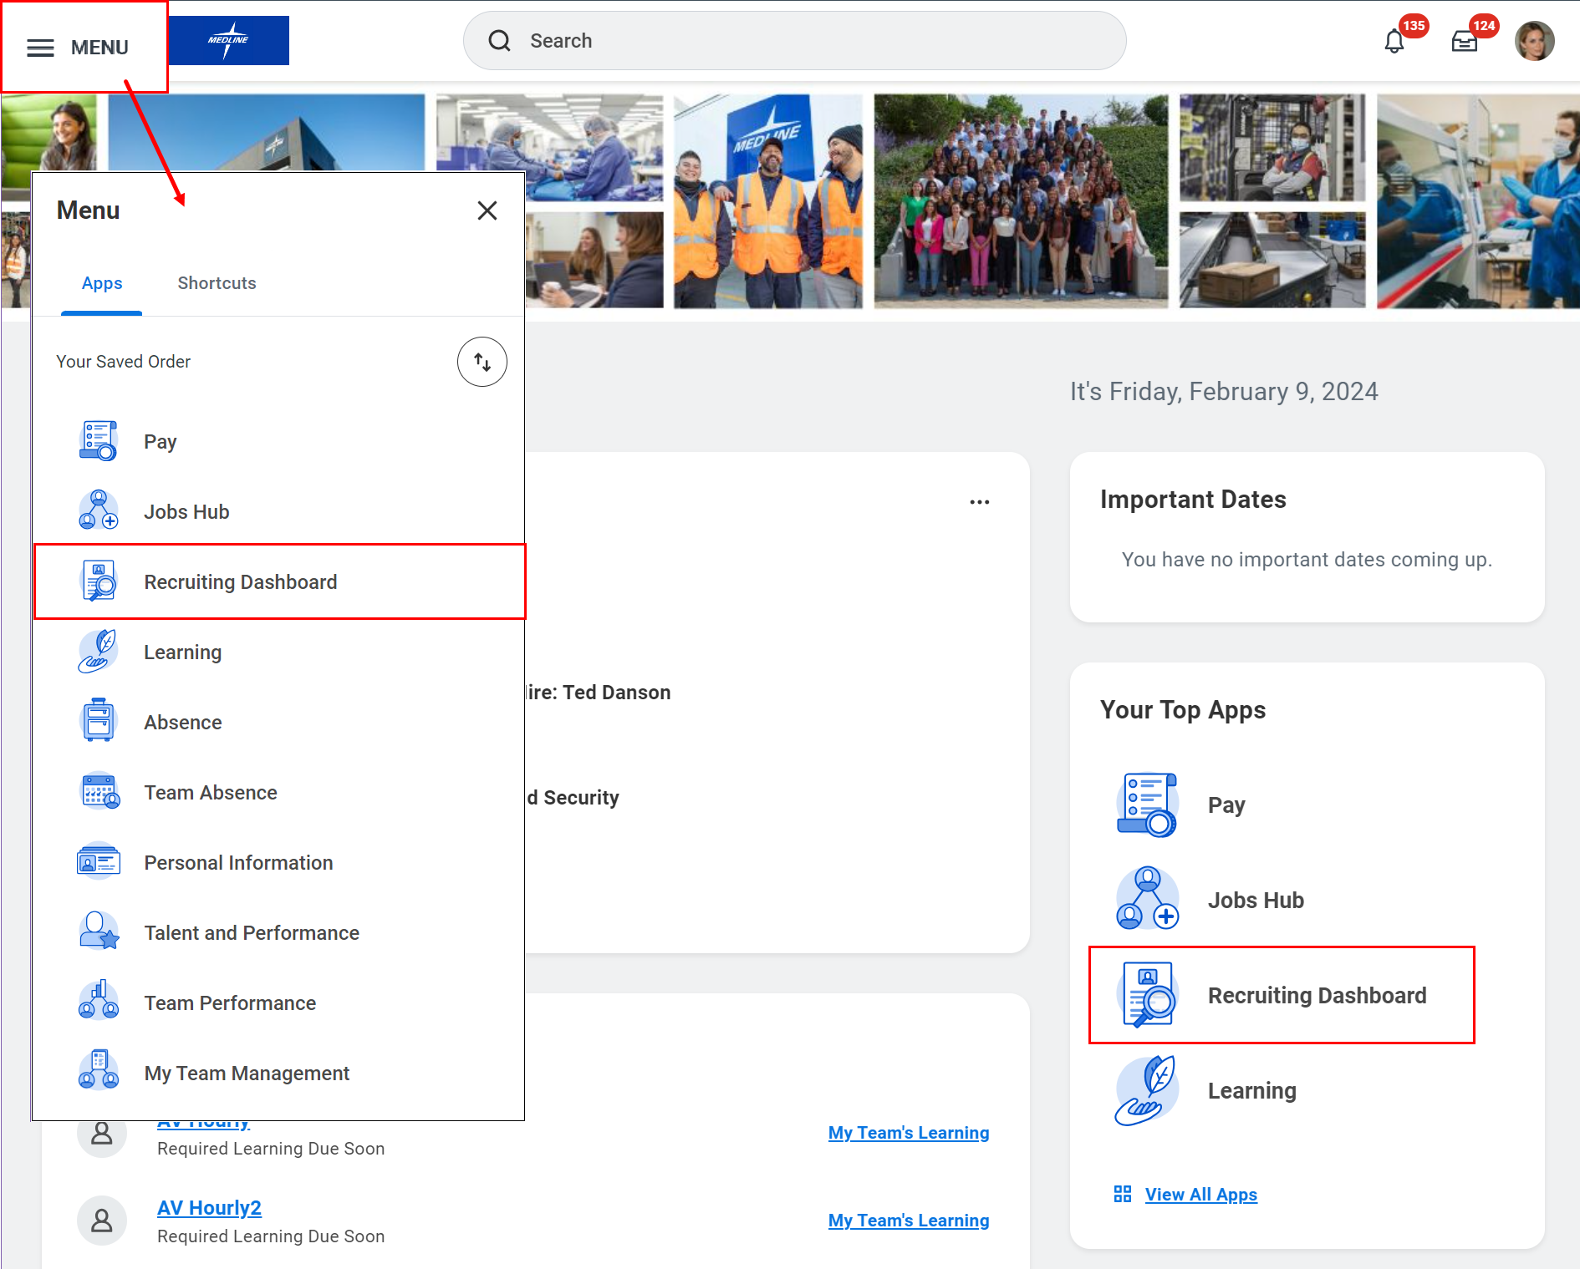

- Under the Actions column, select Start Job Requisition.

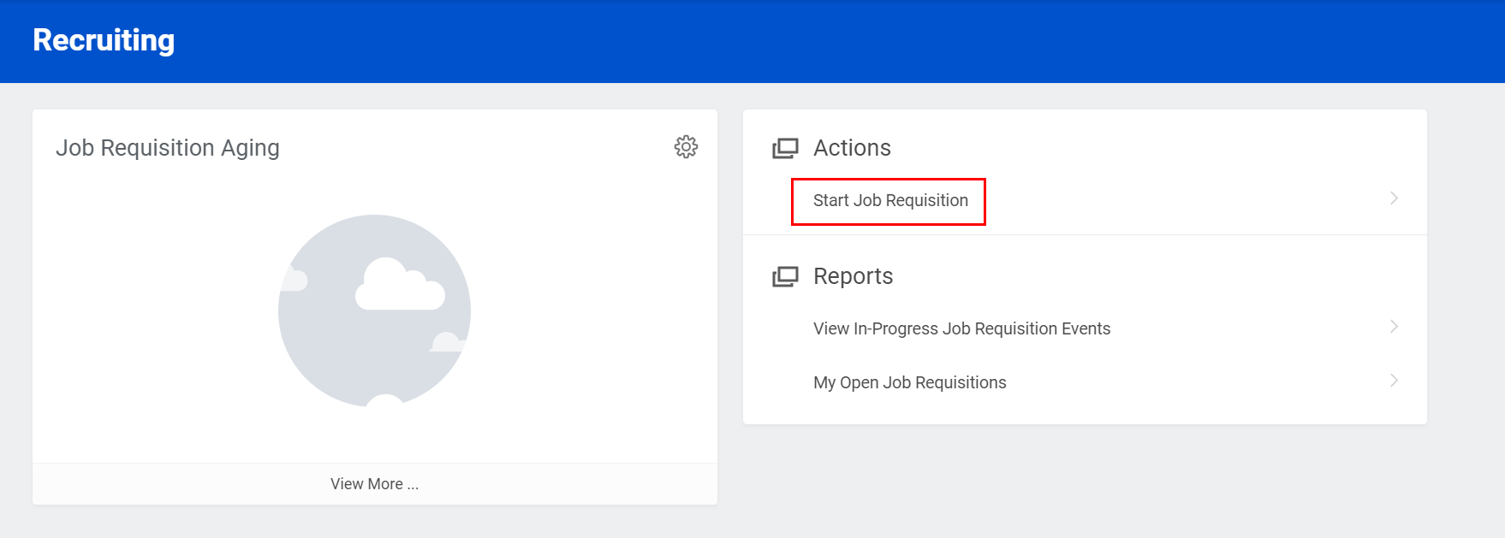

- A form will appear to enter Job Details for your new job requisition. Provide the requested information as described below. Once you have completed the form, click Submit.
  - What supervisory organization is this job for?: This will automatically populate with your name. Note that you can only enter your name and the supervisory organizations of your direct reports.
  - This job will replace a worker or add a worker?: If you select replace a worker, please provide the name of the worker being replaced. If you select add a worker, please indicate if you an existing position for this job already exists. If so, select the existing posting for this job. If no, enter how many openings there are for this job.
  - Select a Job Profile: A list of suggestions based on your team will be displayed, or you may choose one from the drop-down menu.
  - Select a Job Title: Enter the desired title for the position.
  - Is there a remote opportunity for this job: Use the drop-down menu to specify if the role is remote, hybrid, on-site, or outside sales.
  - What location is this job based in: A list of suggestions based on your team will be provided, or you may choose a location from the drop-down menu, or add additional locations below.
  - Are you hiring a new employee or contingent worker: Choose Employee. Then, specify what type of worker you are hiring from the drop-down menu (i.e. seasonal, regular, contract).
  - What is the time type for this job: Choose between full time and part time.
  - (Optional) What are the scheduled weekly hours for this job?: This will automatically populate based on your previous responses, but you can change this. You may also be required to select a work shift from the drop-down menu options.
  - Select a company and select a cost center: Your organization will automatically populate, but you can choose an organization from the drop-down menus to align with the position.
  - When would you like this worker to start?: Choose between as soon as possible and selecting a specific date.
  - (Optional) What recruiting instruction do you have for this job: Choose between this is a campus requisition and this is not a campus requisition.
  - Select a primary location to post this job: This field will automatically populate. You may add an additional location from the drop-down menu if necessary.
  - Why are you creating this job?: Choose between back-fill and new headcount.

Please note that additional questions may appear depending on your responses to the form. All fields marked with a red asterisk (*) are mandatory to complete. You may not initiate this process on behalf of another Manager.

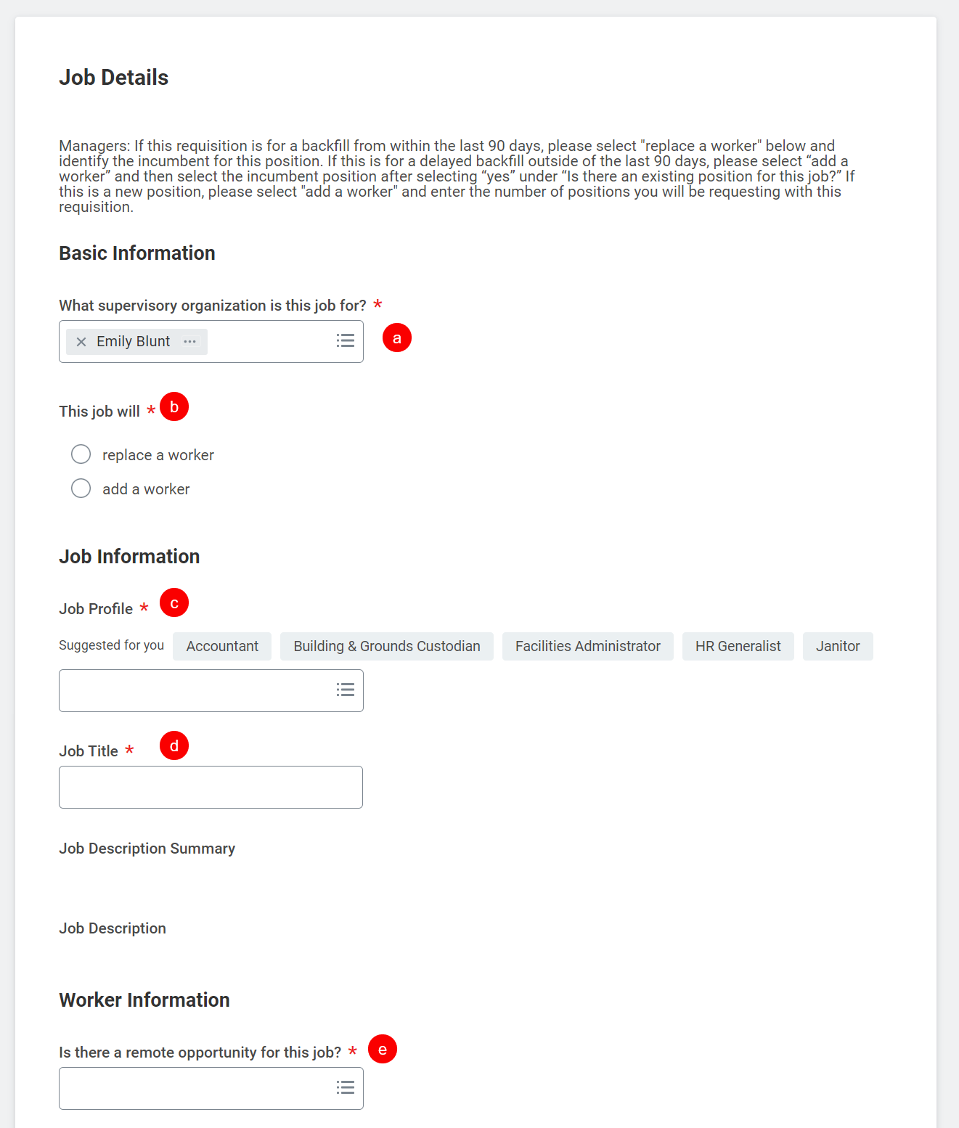
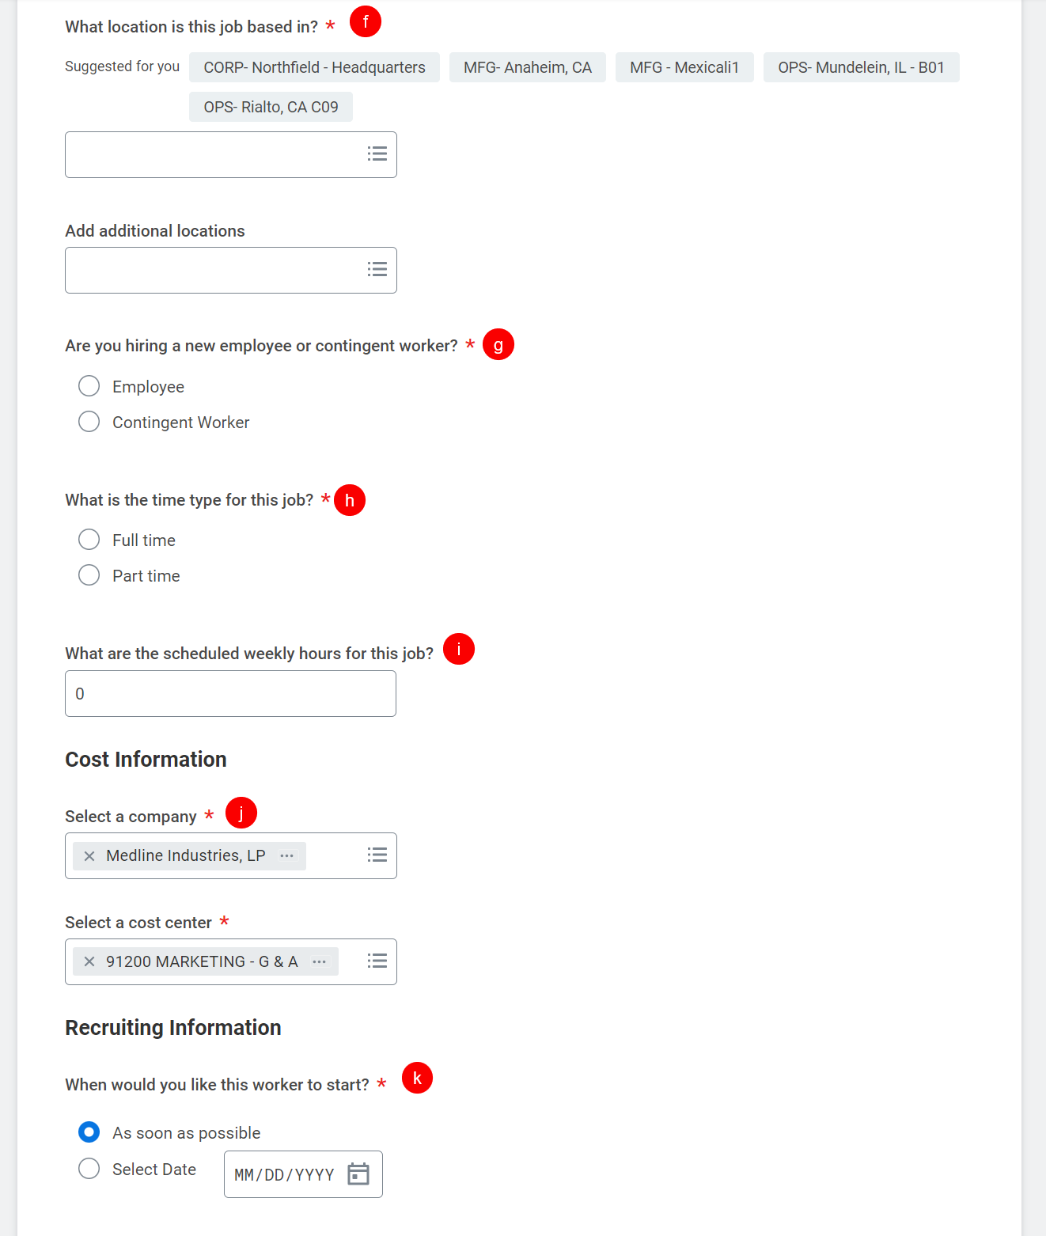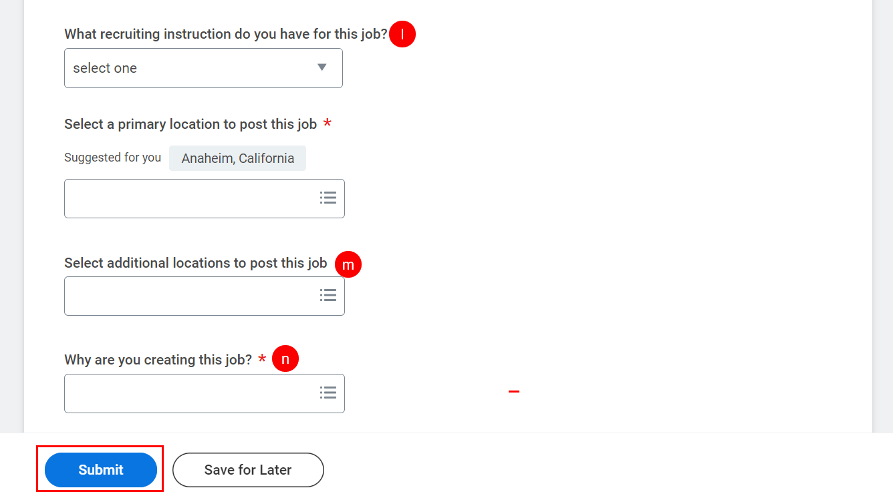

- Upon successful completion, you will receive a confirmation notification along with instructions for next steps. You can either click Open directly on the notification or select the Request Requisition Compensation task in your My Tasks Inbox.

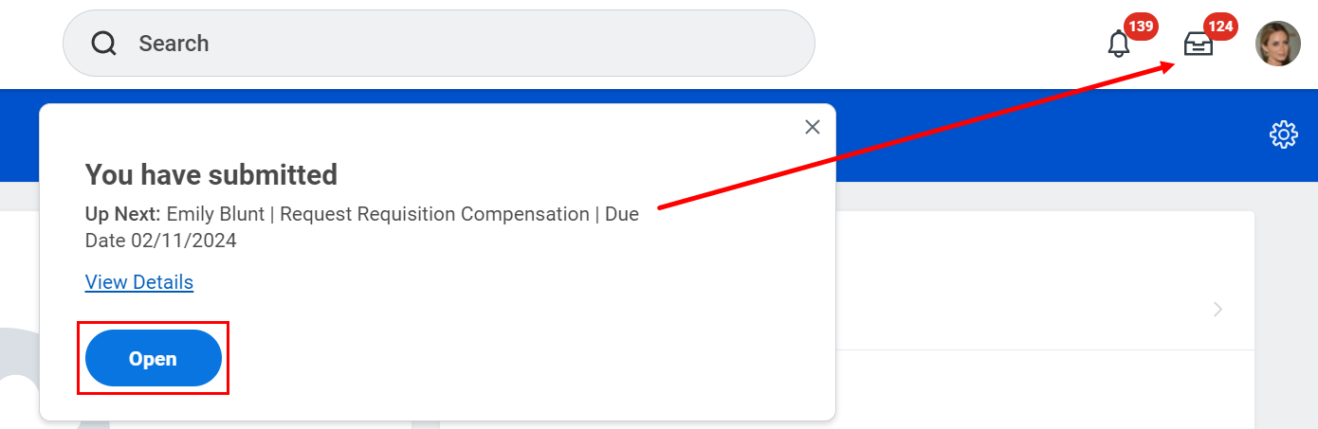

- The Requisition Compensation Change form will appear to enter your target compensation assignment for the requisition. You may make changes to the following fields.
  - Scroll down to view the Guidelines for the Total Base Pay Range. This section provides an appropriate salary band that you should target for the role.
  - Click the Edit icon () to enter your target salary amount for the position. If the role is for an hourly worker, a similar process will fall under the Hourly category. To save, click the Checkmark icon.
  - Then, scroll further down and click the Edit icon () to enter a Bonus structure. Enter an Individual Target % amount and click the checkbox if it is a Guaranteed Minimum. Click the Checkmark icon to save.
  - Once you have finished, click Submit.

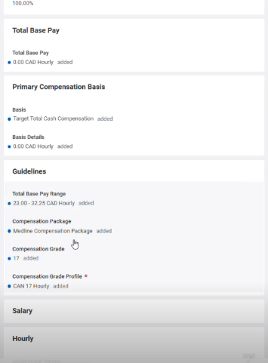

- After submitting your request, you will receive a notification indicating that your request has been routed to the next person in the approval process, typically an HR Partner.



Please note that actual compensation will be assigned to the position at hire based on the approved and accepted offer.

Approving Job Requisitions
- As a People Manager, you may receive a notification in your My Tasks Inbox to approve a request for a job requisition. Look for the task titled Job Requisition and select it for review.

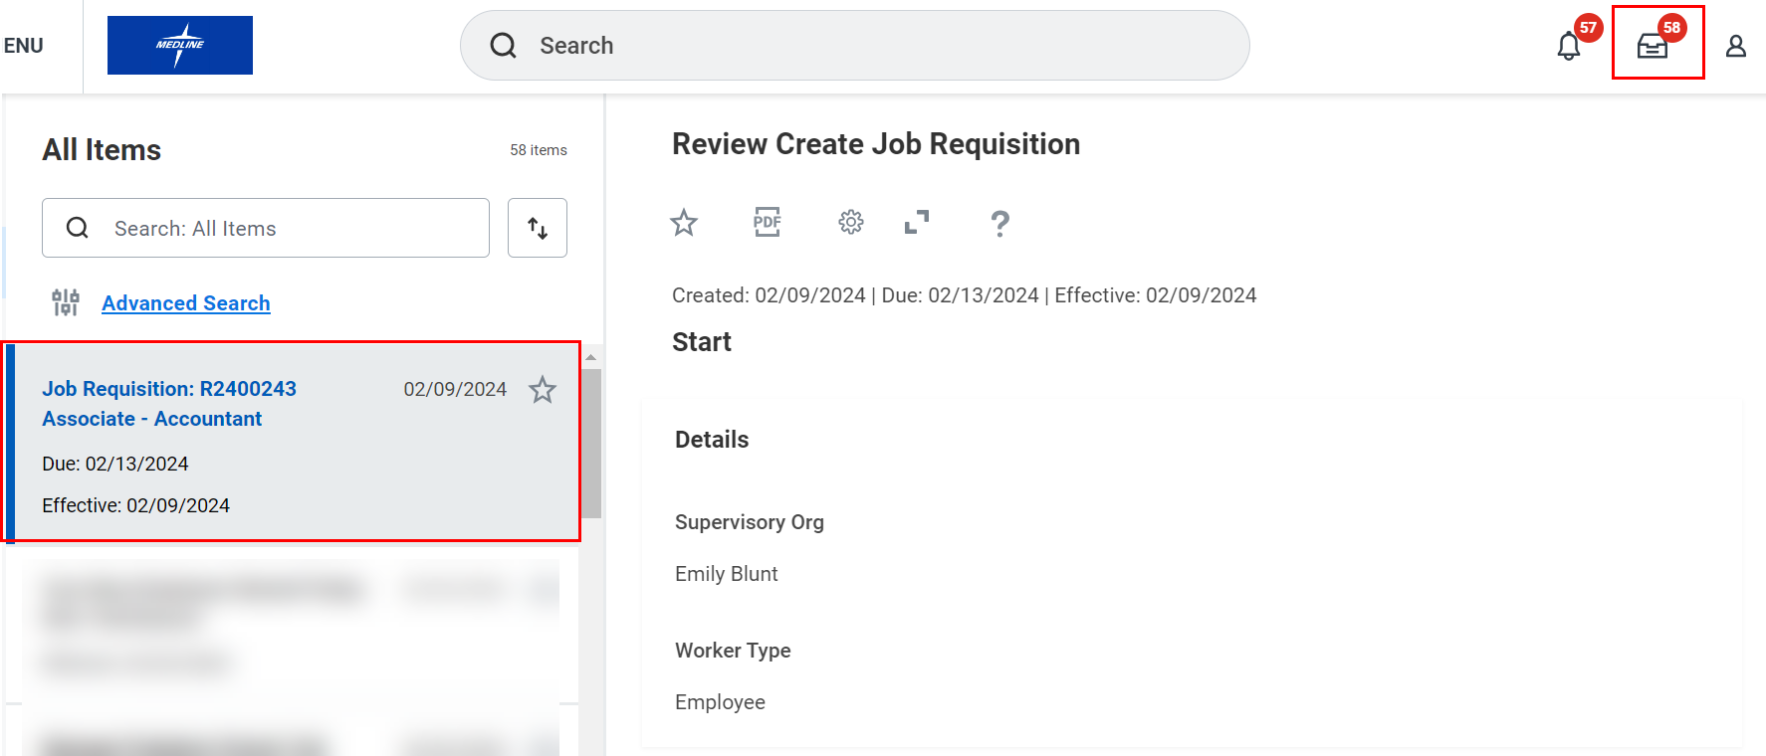

Please note that after an employee has submitted a job requisition request, the second approver in the process is typically the Manager's Manager, following the approval by the HR Partner.

- The details of the job requisition request will open on the right-hand side of the page. Review the job details submitted.

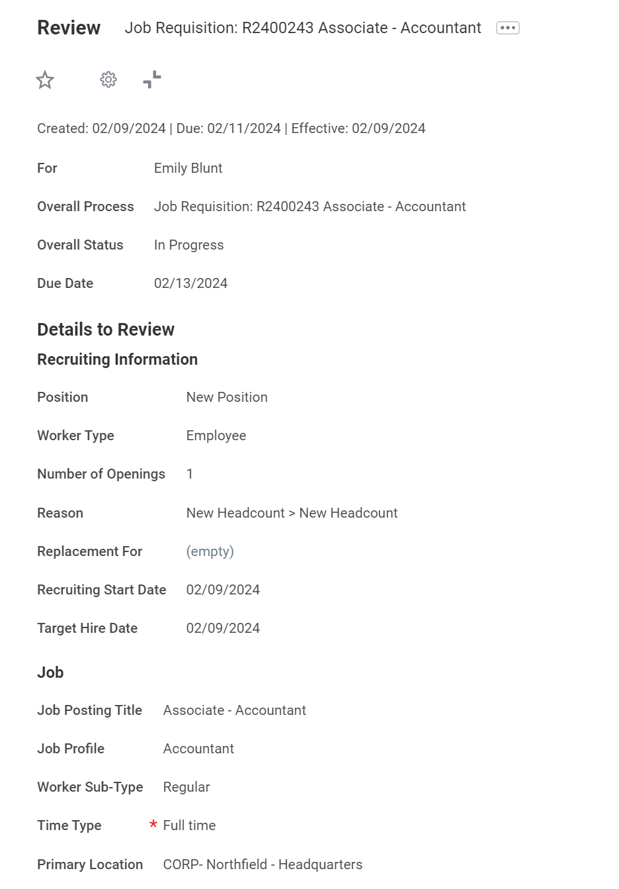

- After reviewing the job requisition, you have two options: Approve or Send Back. If you choose to Send Back the job requisition to the initiator, you can specify whether you would like the initiator to make revisions to the job details or the compensation, or if you would like the HR Partner to review the requisition again. Then, enter your comments in the Reason field to provide clear feedback and click Submit.

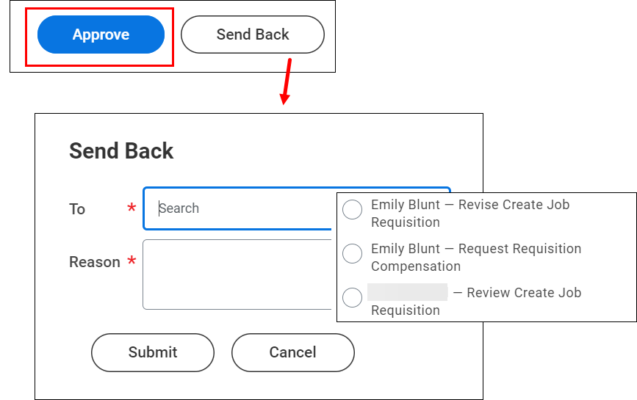

- Once approved, the process will then be routed to several superiors in your organization as part of an approval chain for further review and approval. This chain typically ends with the Recruiting Manager in the Talent Acquisition Department.

