

Corrective Actions
Managers

For Managers looking to initiate a corrective action for one of their employees, this document will guide you through the following tasks and processes:

Initiating a Corrective Action
How to start the corrective action process within Workday and what information is required.

Monitoring a Corrective Action
How to view the status of a corrective action for one of your employees.

Initiating a Corrective Action
As a Manager, you are able to initiate Corrective Actions in Workday. Corrective Actions are used for policy violations, inappropriate behaviors or specific performance deficiencies such as inaccuracies/ errors. Performance Improvement Plans (PIPs) are used when providing a set of goals to an employee so they may improve performance over a defined period of time. Please each out to your HR Representative to confirm what steps you should take based on the situation.

To get started, click on the Menu icon in the top left-hand corner of your Workday Homepage. Then, select the Team Performance application.

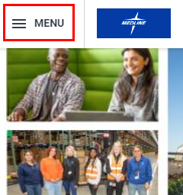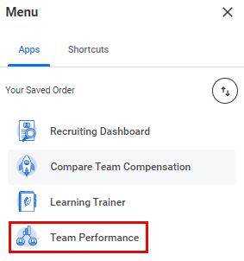

- From the Performance menu on the right-hand side of the screen, select Start Corrective Action.

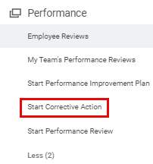

- Next, fill out the details of the corrective action:
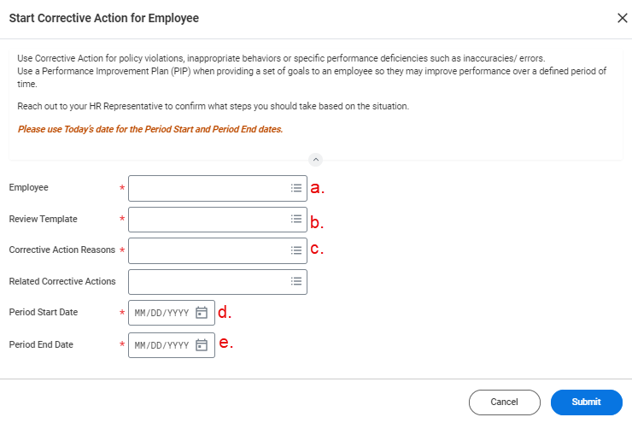
  - Enter the name of the Employee who is receiving the corrective action.
  - From the Review Template drop-down menu, select Corrective Action then Corrective Action Plan-Global.
  - From the Corrective Action Reasons drop-down menu, select Reasons for Employee’s Country, then the employee’s country, then the applicable reason and sub-reason for the corrective action:

Please note that the list of Corrective Action Reasons will differ for employees in Different Countries.

  - Enter today’s date for the Period Start Date.
  - Enter today’s date for the Period End Date.

Please note that if the employee has undergone prior corrective actions, they will be listed in the Related Corrective Actions field. If the current corrective action has been an ongoing issue, it can be linked to a prior corrective action by selecting it here.

- Click Submit when you have entered all the details of the corrective action.

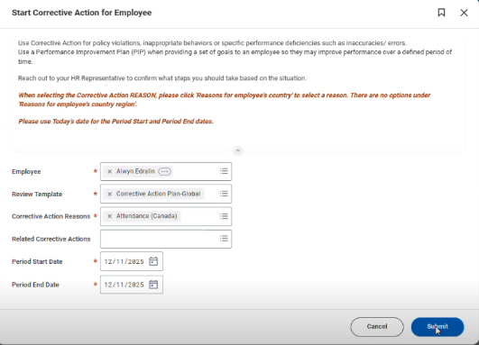

- You will receive a task titled “Manager Evaluation: Corrective Action Plan” in your My Tasks Inbox. Click the task to open its details on the right-hand side of the screen.

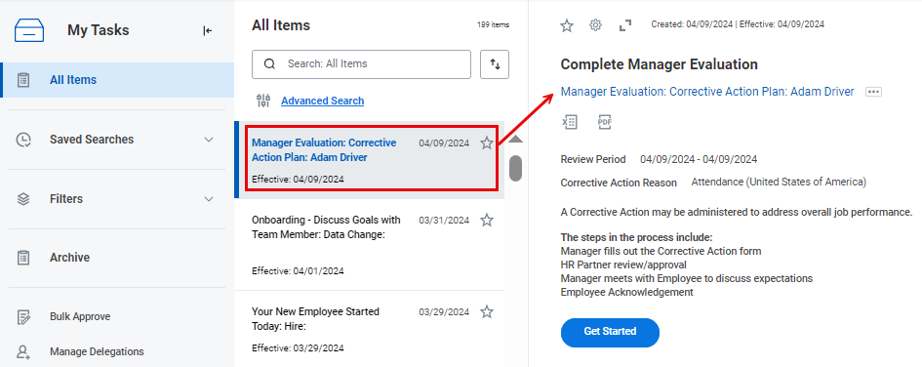

- Click Get Started.

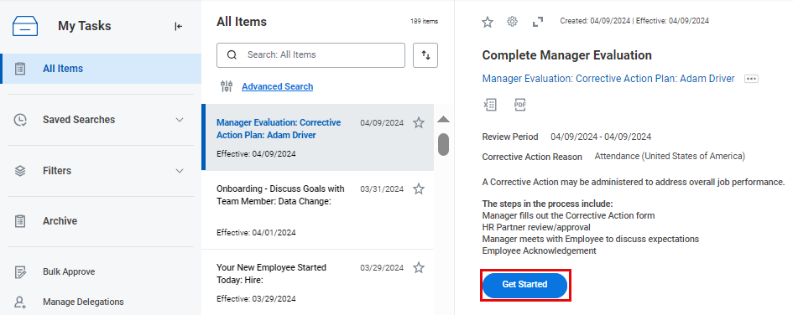

- You will be guided through the steps that are listed on the left-hand side of the screen. Click Next to begin.

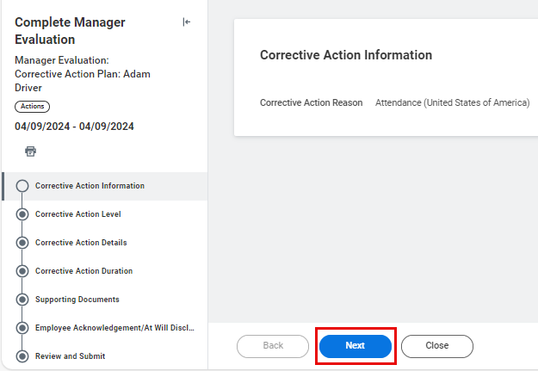

- Select the Corrective Action Level (Coach & Counsel, Written Warning or Final Written Warning). Then, click Next.
Note that only Written Warning and Final Written Warning levels will trigger an employee acknowledgement step at the end of the corrective action process.

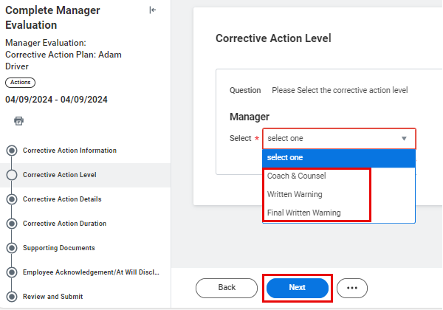

- Enter the Corrective Action Details in the a. and b. Answer fields. Then, click Next.
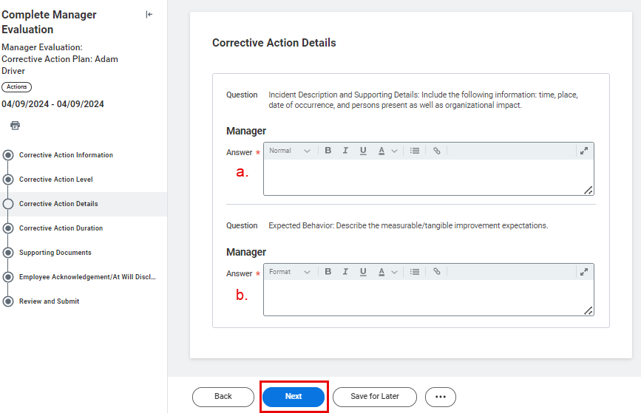

  - Enter the Incident Description and Supporting Details: Include time, place, date of occurrence, and persons present as well as organizational impact.
  - Enter the Expected Behavior: Describe the measurable/tangible improvement expectations.

- Enter the Corrective Action Duration (6 months, 12 months, Permanent, Not Applicable or Other). Then, click Next.

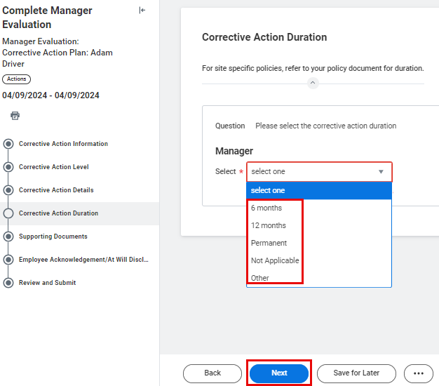

- Upload any Supporting Documents by either clicking Select files then selecting the applicable file, or by dragging and dropping the applicable file into the grey box.
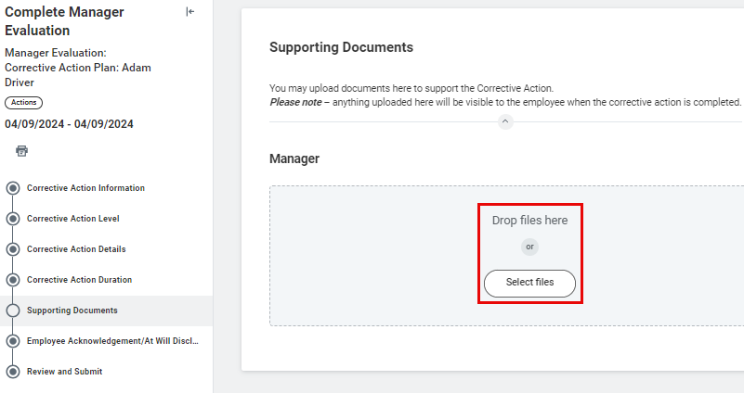
Please note that any documents uploaded here will be visible to the employee at the end of the corrective action process.

- Once the file is uploaded you can leave a supporting Comment if you wish. When you are done, click Next.

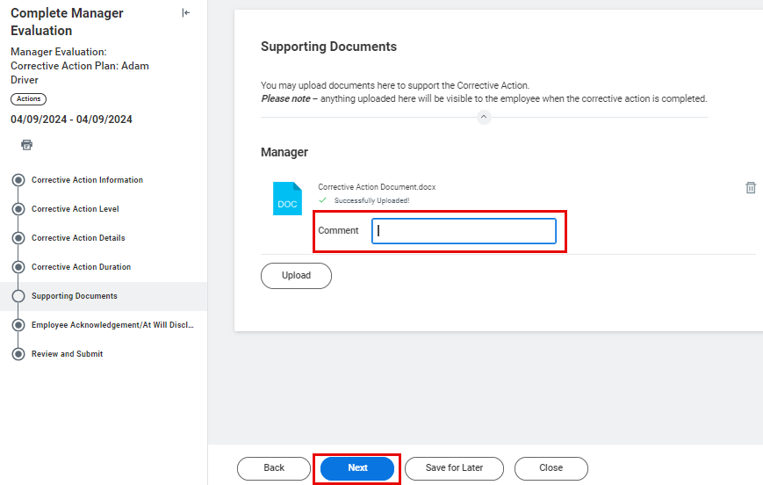

- The Employee Acknowledgement will appear on the following screen. This is what the employee will see at the end of the corrective action process. There is no action needed from you on this step. Click Next.
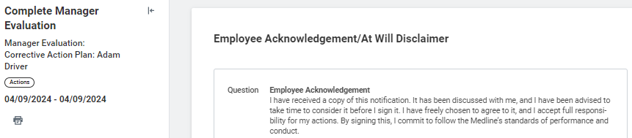
- Review the corrective action information you have just entered, then click Submit.

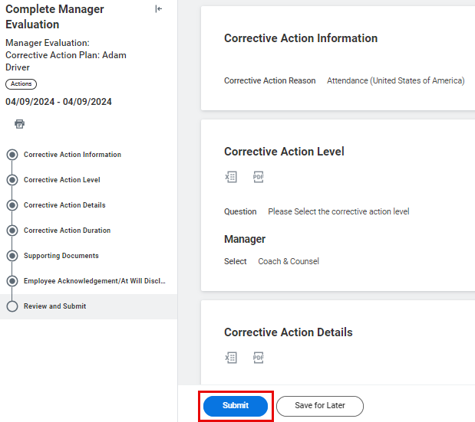
- Next, an HR Partner will review and approve your evaluation. Once that happens, you will receive a task titled “Manager Evaluation: Corrective Action Plan” in your My Tasks Inbox.
Please note that at this point, you must meet with your employee to discuss your expectations before proceeding in Workday.

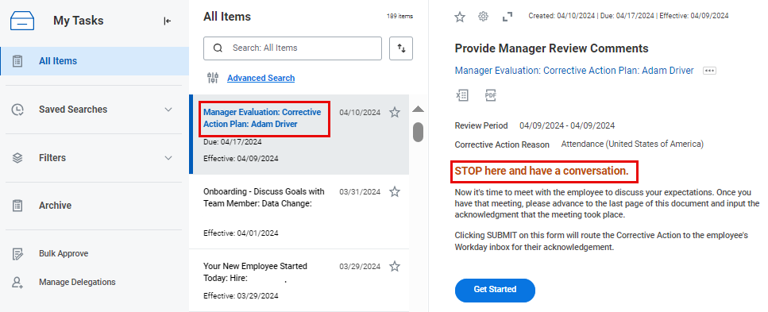

After you have the meeting with your employee, come back to the task and click Get Started.

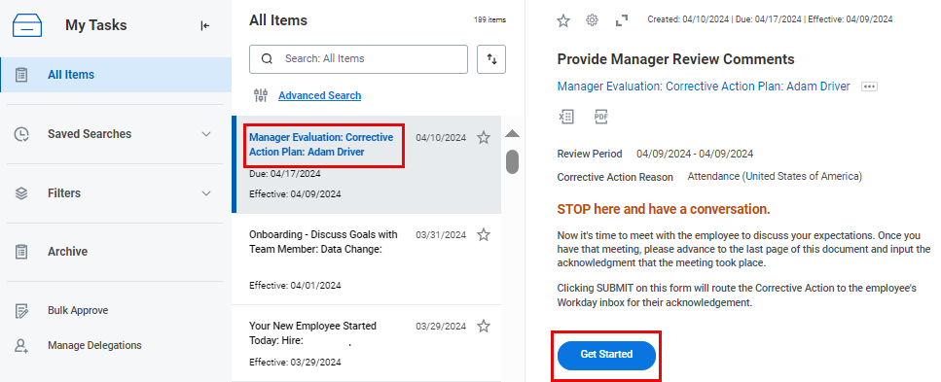

Advance to the Acknowledgement section of the task then change the Status to Acknowledge Review Discussion Complete. Then, click Submit at the bottom of the screen.

Clicking Submit will route the corrective action to the employee's My Tasks Inbox for their acknowledgement.

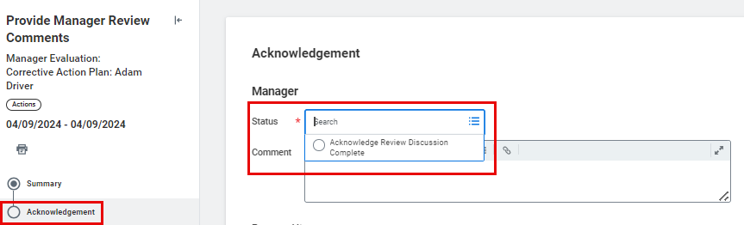

Monitoring a Corrective Action

To get started, click on the Menu icon in the top left-hand corner of your Workday Homepage. Then, select the Team Performance application.

- From the Performance menu on the right-hand side of the screen, select Employee Reviews.

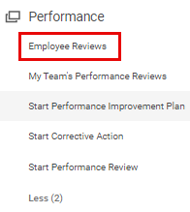

- Next, select your Organization. Then, select Corrective Action Plan-Global from the Review Templates drop-down menu.

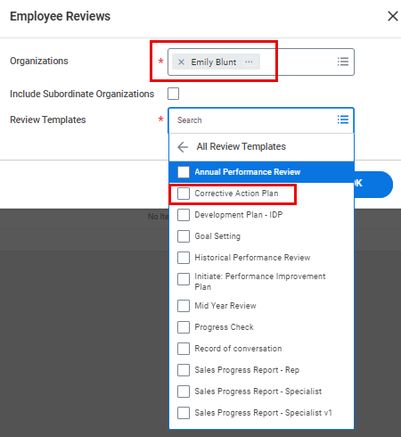

- Click OK to proceed.

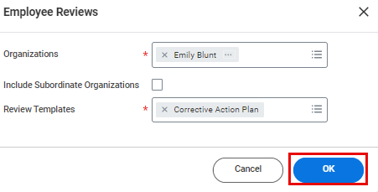

- On the following screen, you will see all In Progress and Completed Corrective Action Plans for your employees. You can toggle between the In Progress and Completed tabs to see the status of the plans.

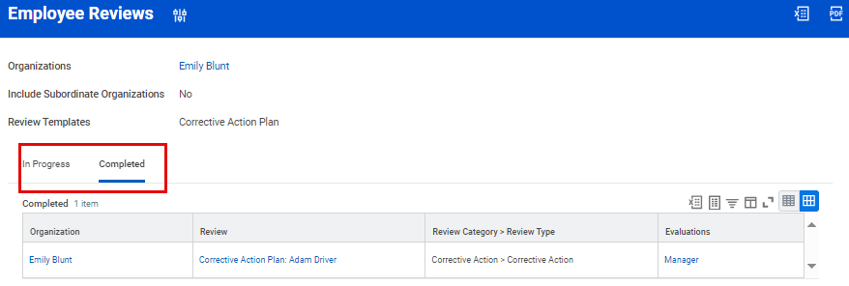

- To review a corrective action process history, click the applicable plan from the Review column.

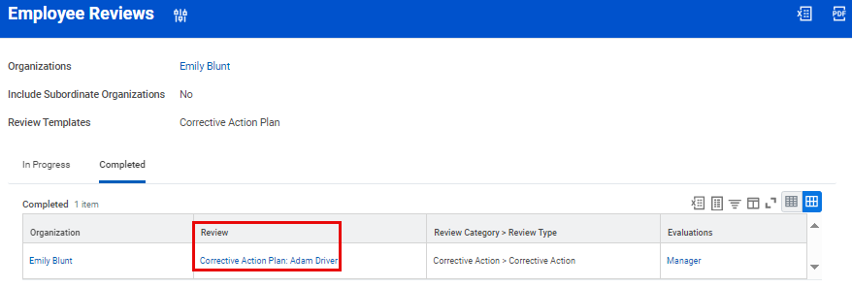

- On the following screen, click any of the steps in the Process column to be directed to additional information about that applicable step.

