HR Zendesk Quick Reference Guide

Welcome to the Medline Human Resources Help Center
This platform allows employees, candidates and former employees access to submit requests and questions directly to the Human Resources team that support the listed categories in the dropdown menus.. Access the HR Zendesk Help Center here: https://medlinehr.zendesk.com/hc/en-us

Sign-In for Employees
For employees with a Medline email account - Please sign in to activate additional tiles and articles, improving your experience.
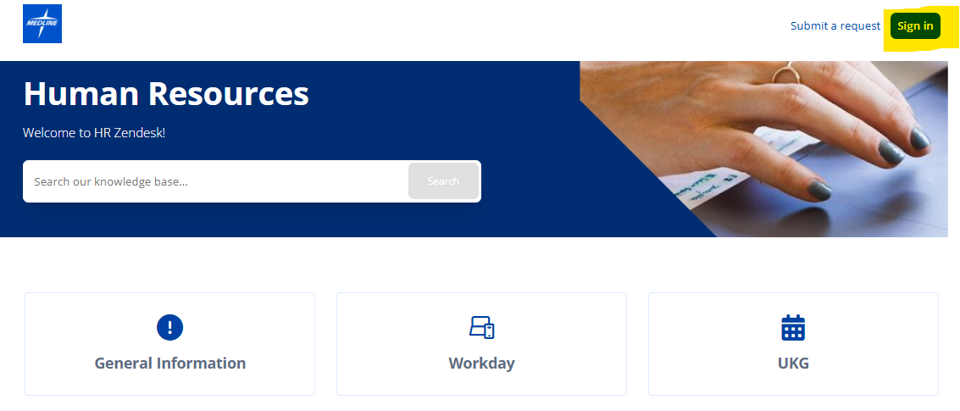

Select “Continue with SSO” if you have a Medline email, or “Sign Up” if you do not and are registering your personal email for the first time.
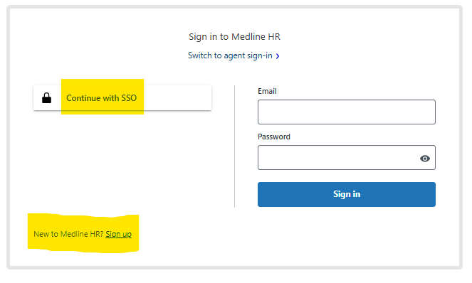

Search for Articles
Use the search bar to find articles using keywords or click on “Submit a request” for assistance.

Submitting a Request
Use the "Submit a request" link on the top right corner of the page.
- Choose the Correct Category: Select the appropriate category such as Workday Support, Global Mobility or UKG Requests.

- Complete the Form: Fill in all required fields accurately, some fields are not required, but helpful with responding to your request.

- Attach Supporting Documents: Upload any required templates or documentation (e.g., EIB templates for mass changes or one-time payments).

- Submit and Track: Click 'Submit'. You will receive a confirmation email with a ticket number. Use the link in the email to track status or add comments.

Tracking a Request
You will receive email updates for your requests, but if you would like to also see a list of pending requests, you can click on your name when signed and select “Requests” to see a complete list and status.
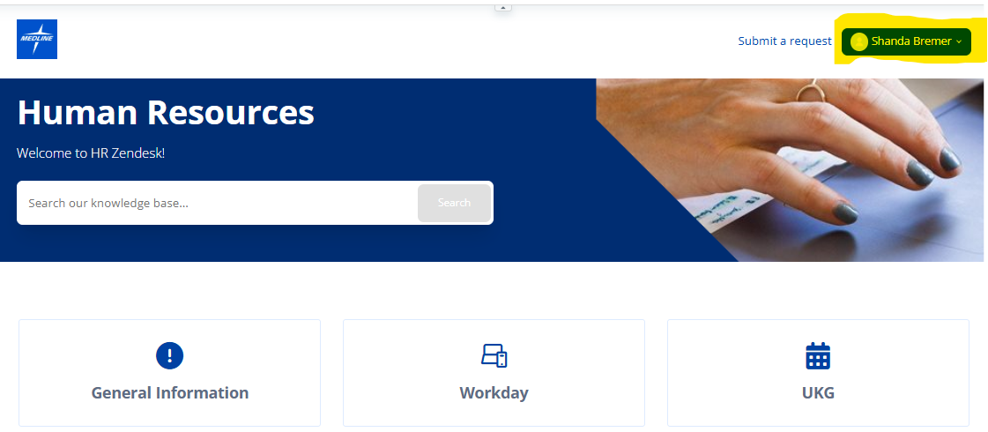
Important Notes:
Do not use IT Helpdesk for HR requests—always submit via HR Zendesk. If you are an employee and cannot log into Workday or UKG, please call the IT Helpdesk for your country to assist.

