


Employees

View My Schedule
You can view your schedule at a glance in the My Schedule tile on the UKG Home Page. You can also review more detailed information about your schedule as well as past and upcoming events.

Navigation: UKG Home Page
- In the My Schedule tile, use the scroll bar to review your scheduled shifts or pay codes and any open shifts for today and the next six days.
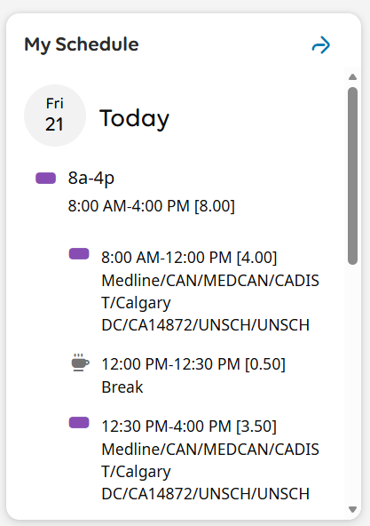
- Select the View My Schedule arrow to open calendar details about your schedule.
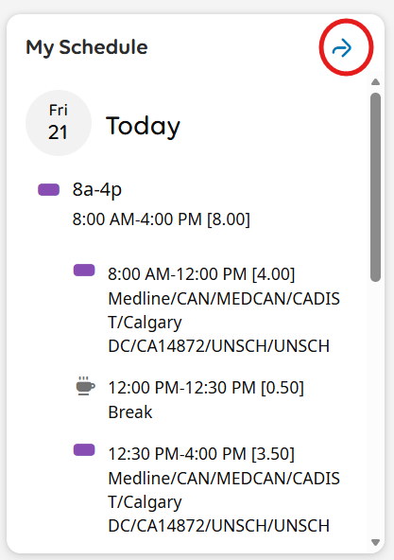
- To review past or upcoming months and days, click on the arrows on the Calendar and select your desired month and date. You can also use the scroll bar on the Schedule to review past and upcoming dates.

