


Employees

Request Time Off
You can request time off for partial or full days using the My Time Off tile on the UKG Home Page.

Navigation: UKG Home Page
- From the My Time Off tile, select Reason for the type of time off.
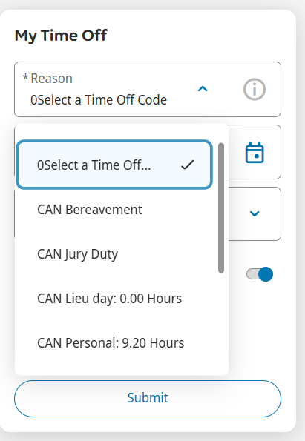
- Select Dates to access the calendar.
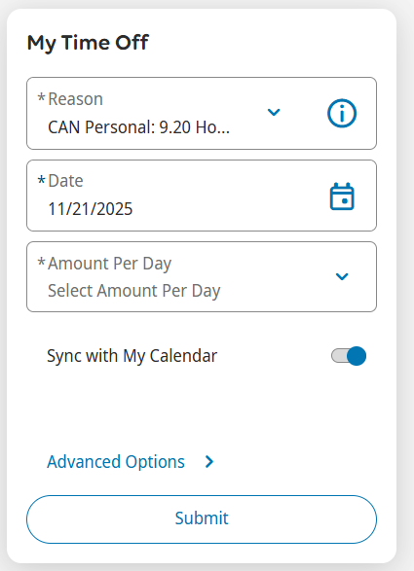
- In the calendar Date Range, input your desired start and end dates. Click Apply.

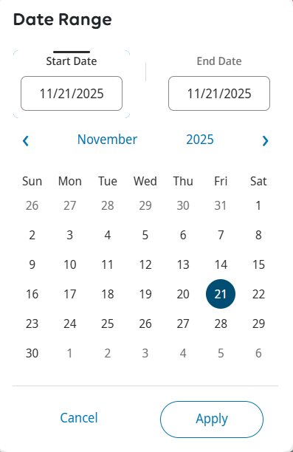

- Select Amount Per Day and in the dropdown options, select Full for a full day off or Hours for a partial day off.

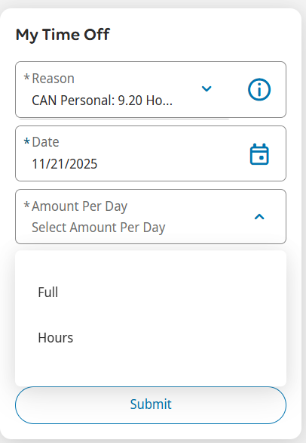

- Input the Start Time and the Duration (formatted as HH.MM), which is the number of hours requested. Review and click Submit.

