


Employees

Cancel an Approved Time-off Request
You can cancel an approved time-off request by accessing the Control Center.

Navigation: UKG Home Page
- On the navigation bar, click the Notifications icon to open the Control Center panel.
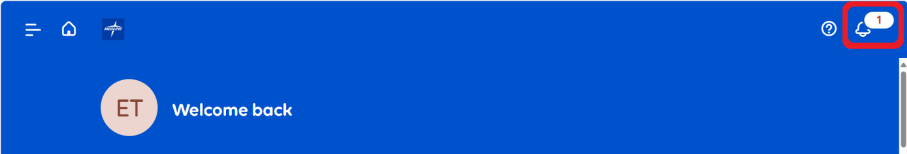
- In the Control Center panel, click on the approved time-off request you want to cancel. It will display on the Control Center page.
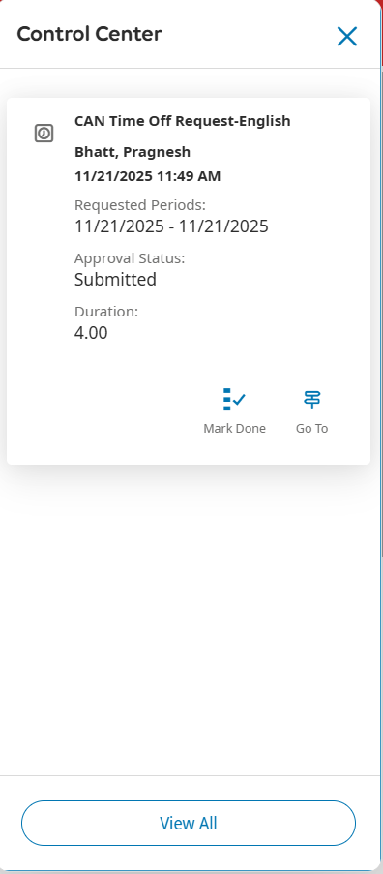
- Select the request you want to cancel. Then click Cancel on the navigation bar.
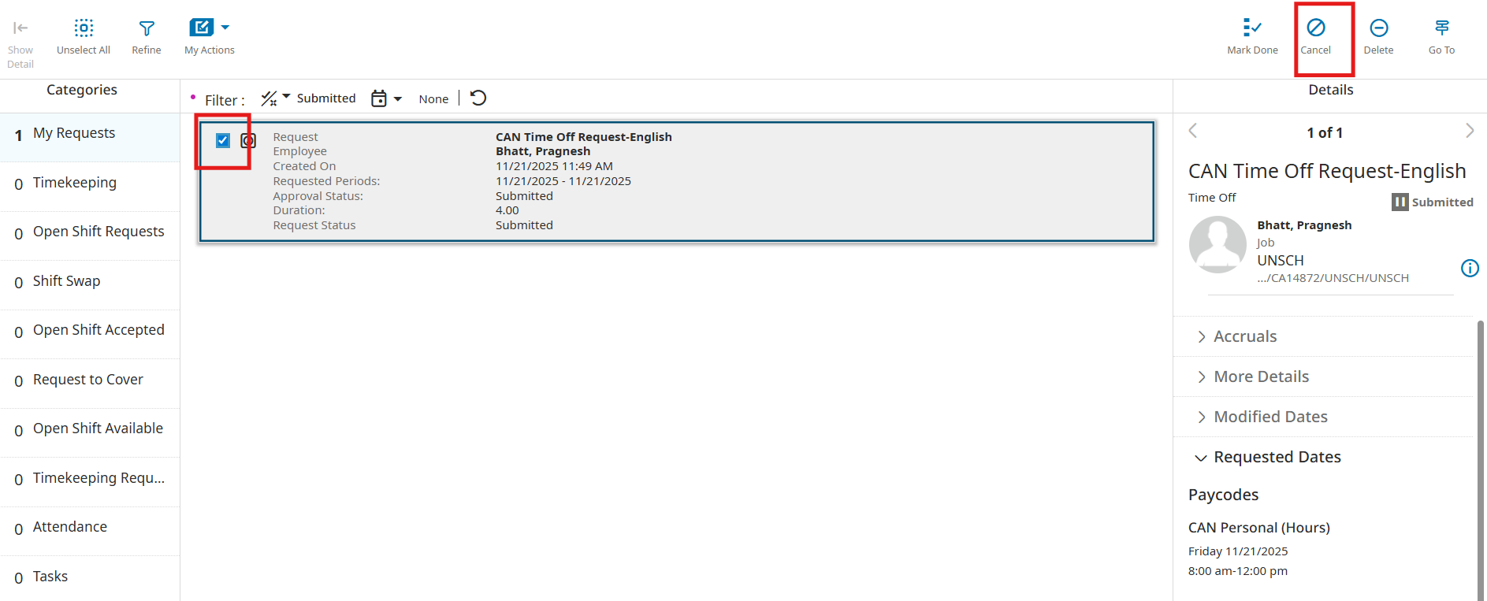
- Select Cancel Request.
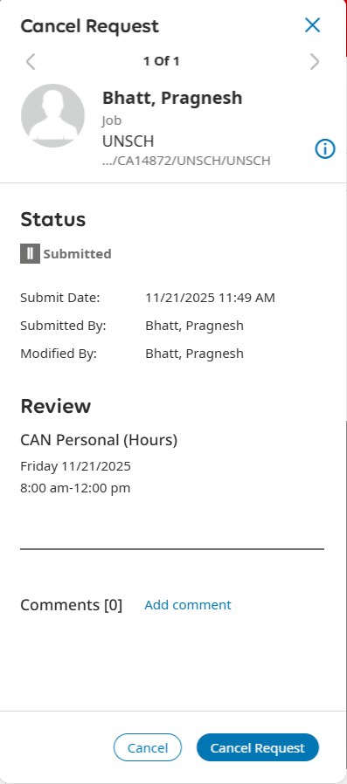
- Click Done.
