

Global Navigation Menu Sidebar
Employees

Introduction
The latest update to the global navigation menu introduces a more streamlined and intuitive user experience. Moving away from the traditional menu button, the new sidebar design places your most-used applications just one click closer, allowing for faster and easier access.

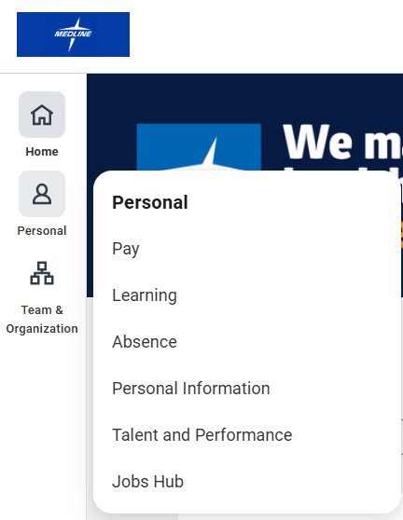

Shortcuts and Customization
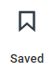
Using the Saved button, employees can navigate to shortcuts they have saved such as commonly used tasks, reports, and external links.

Using the Gear icon, employees can customize their navigation sidebar by rearranging their categories, adding or removing navigation items, and even disabling the sidebar all-together to revert to the original menu user experience.

