

Contract Contingent Worker
Manager Only

Contract Contingent Worker (Manager)
Hiring contingent workers into open positions
If you are a manager and need a contingent worker (contractor) position created for your team, please reach out to your HR Partner for assistance. You can also submit a ticket to the HR Zendesk and select the request type: Workday-Organization & Position Requests. Please be sure to complete all required fields on the form in order for your position request be completed in the requested timeframe.

Once your position has been approved and posted to your team, you can contract the worker in by following the steps below:
- Access the task called Contract Contingent Worker
- If the Contingent Worker (CW) has been at Medline before, you can search for them under Existing Pre-Hire. If they are brand new, select Create a New Pre-Hire.

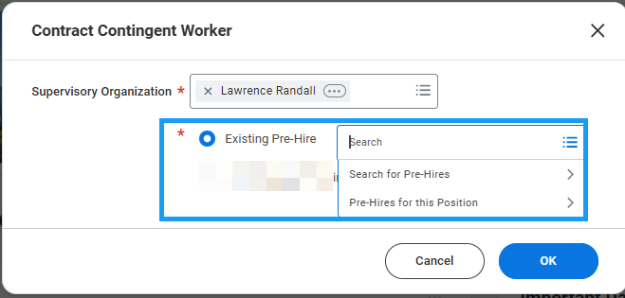
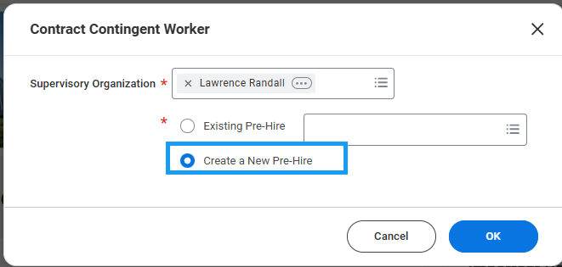

- Enter the CW’s legal name information.

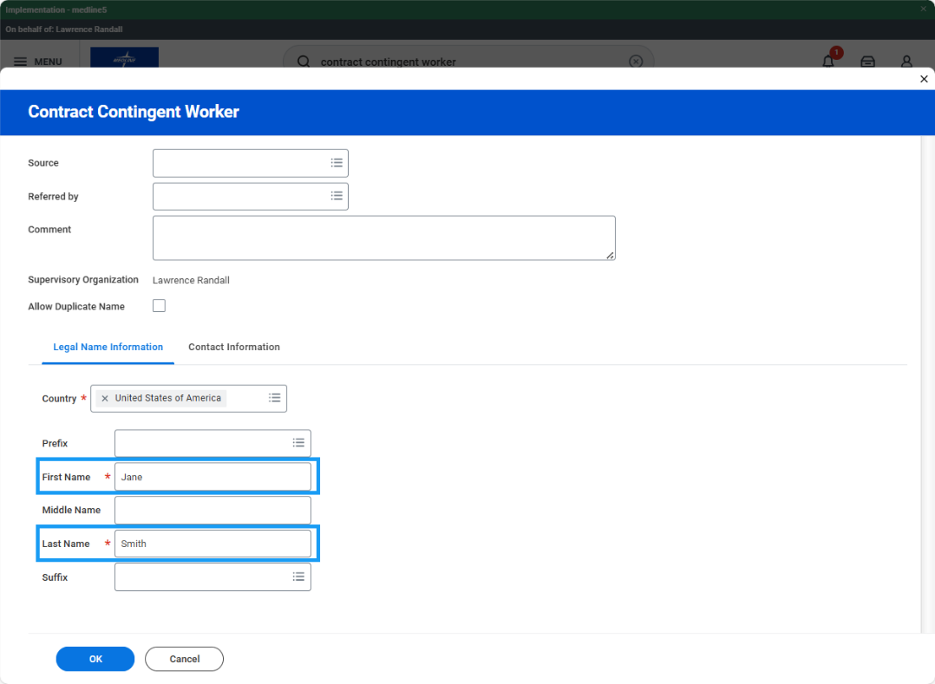

- Click the Contact Information tab and add their contact information. Note: at least 1 piece of contact information is required to proceed. Click Ok.

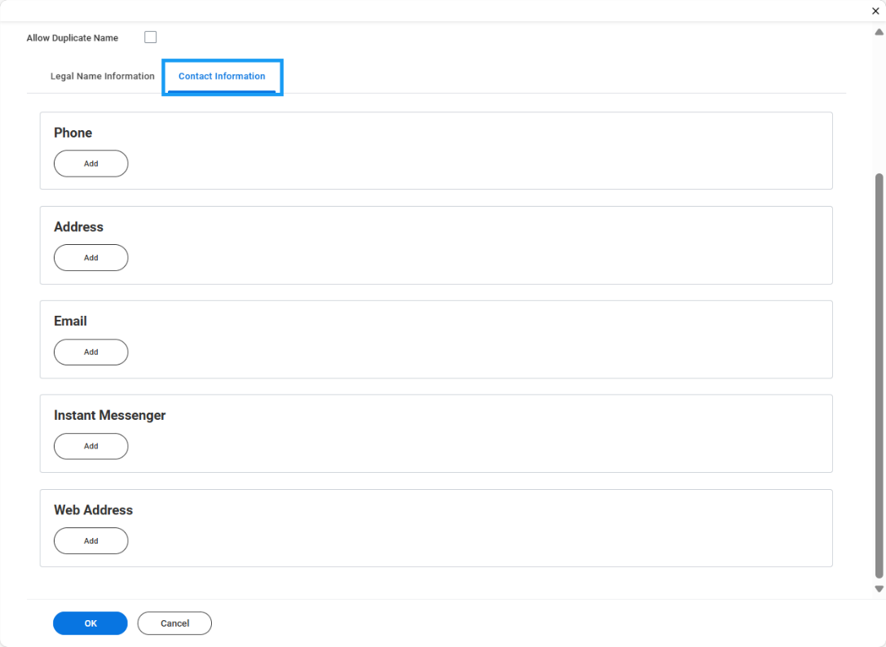
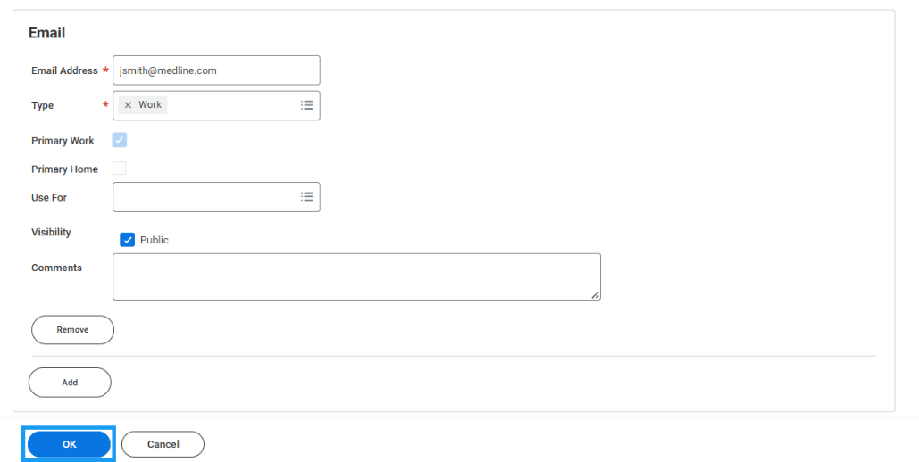

- On the Contract Contingent Worker form, enter the contract start date and reason.

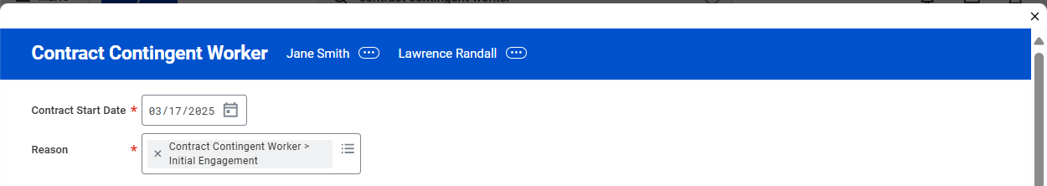
- Under Job Details, select the contingent worker position.
- Confirm that the defaulted information from the position is applicable and change if necessary. Add a location.

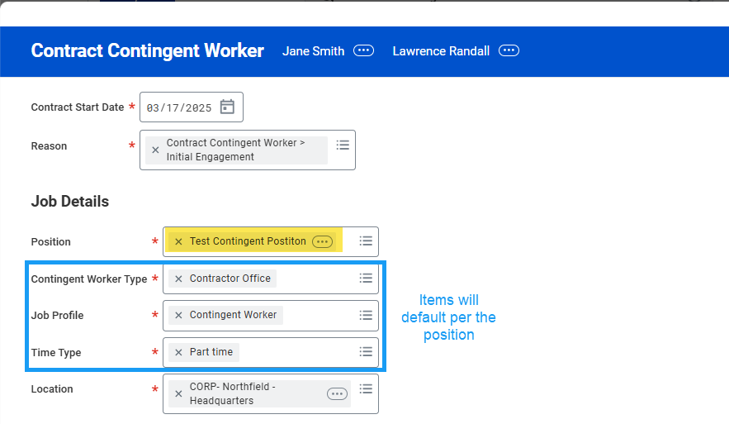
- Supplier is a required field. Enter the name of the organization that provided the contingent worker resource. If the Supplier does not exist, enter a Zendesk ticket to have it created before you proceed.
- The Contract End Date is required and can only be a maximum of 90 days from the Contract Start Date.

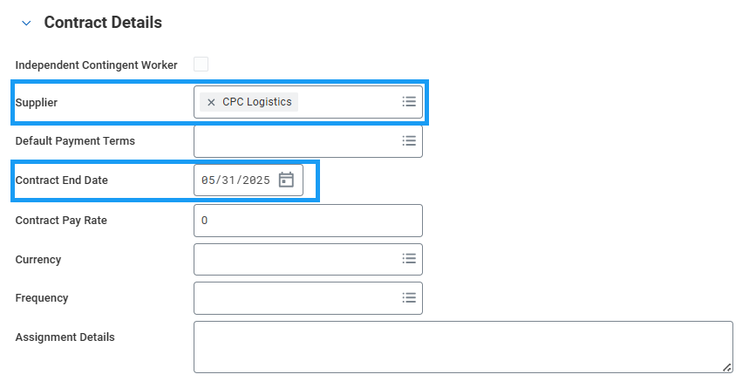

- Enter a Work Shift.

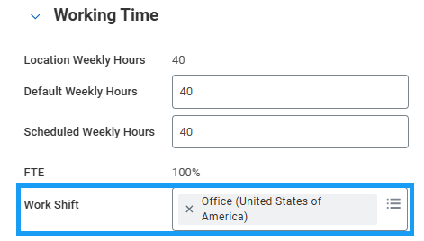

- Expand the Additional Information section. Job Title and Business Title will default to whatever was entered into the Job Profile. Change these fields to whatever the company-facing job title should be. It cannot be Contingent Worker.

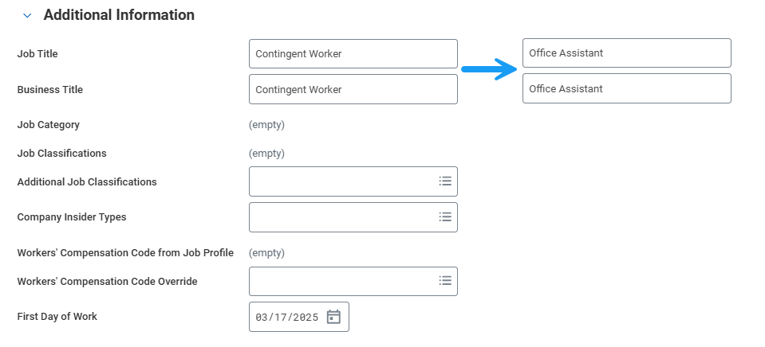

- Click Submit to route for HR Partner approval.

