Workday – Frontline Employee First Time Login

- On your laptop, open your Chrome or Edge browser and go to “https://wd5.myworkday.com/medline/”
- Select Login to Workday
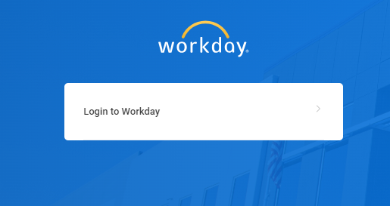
- A new page will load, enter your Workday user ID then click Next.
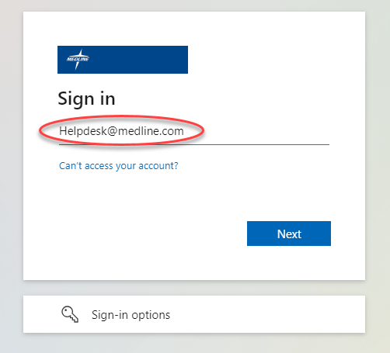
- Enter your Workday password then click Sign in.
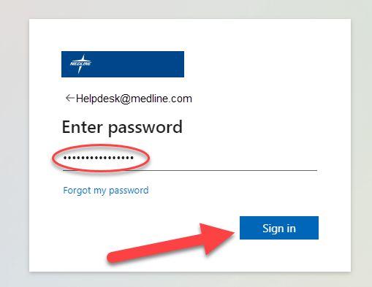
- You’ll be prompted with “Let’s keep your account secure” which will start the process of multifactor authentication (MFA) enrollment. Click next to continue.
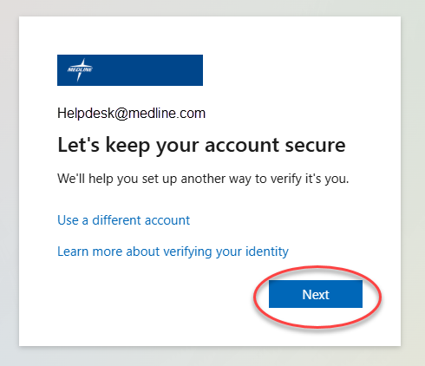
- Click “I want to set up a different method” when prompted to setup Microsoft Authenticator.
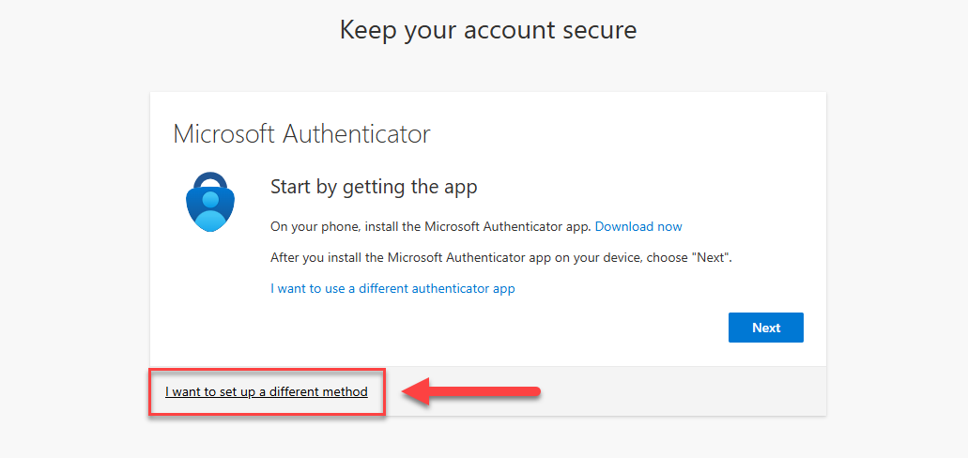
- Select the “Phone” as the authentication method.
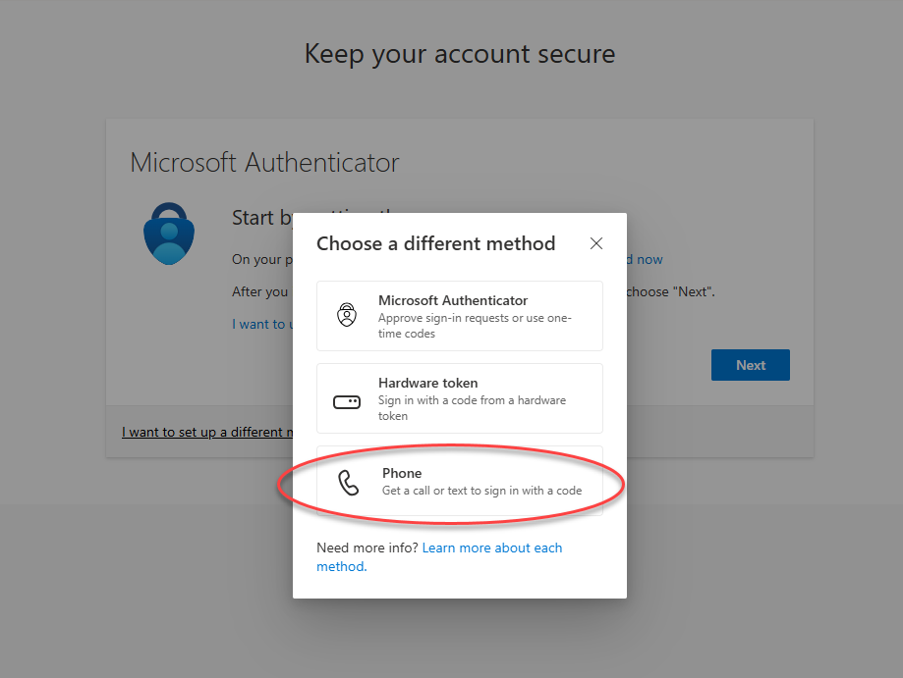
- Enter your phone number to receive the verification code then click Next.
Note: Mexico Employees, change the county field to Mexico.
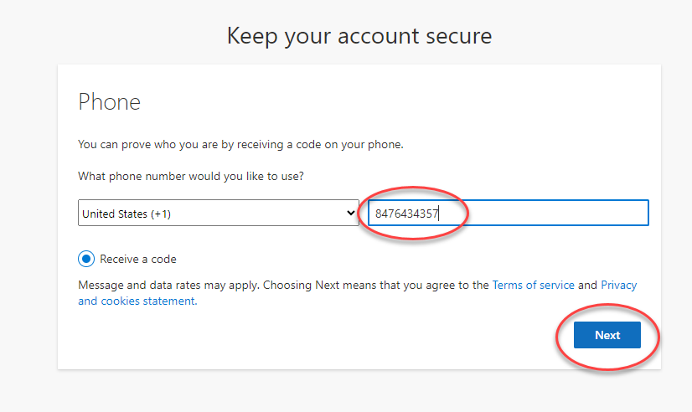
- Enter the 6-digit code sent to your phone number then click next.
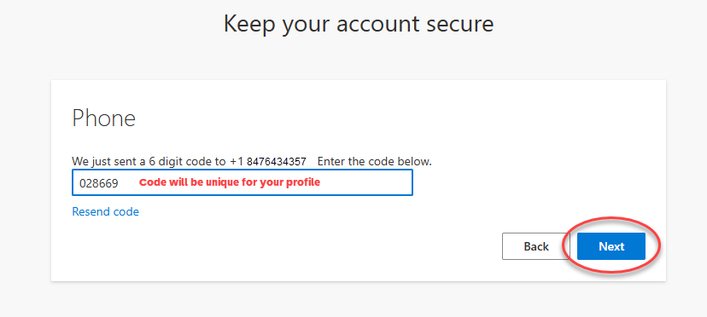
- You’ll receive a message to confirm the code verification is complete, click next to continue.
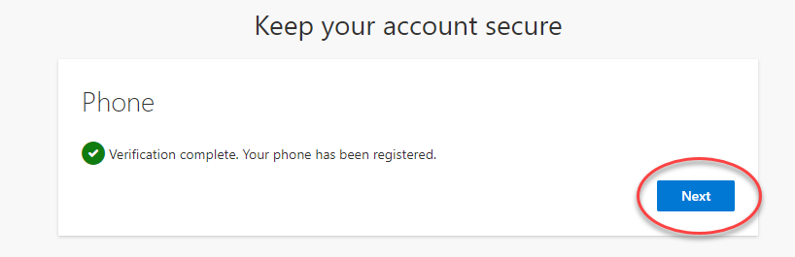
- A second confirmation message will appear showing your enrolled phone number for multifactor authentication (MFA), click done to continue.
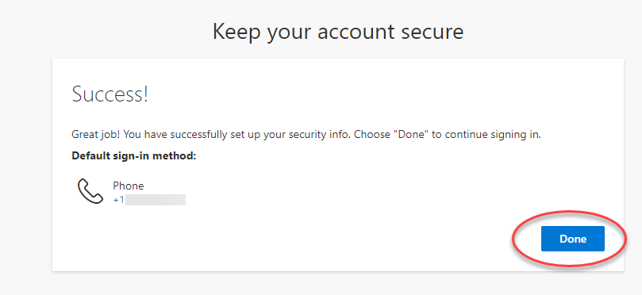
- You’ll be prompted to update your password. In the current password enter the temporary password you were given. In New password, enter a new password that you can remember. The new password must be at least 8 characters or more, contain at least one letter, one, number, and one symbol. It also cannot contain your username. Then confirm your new password and click sign in.
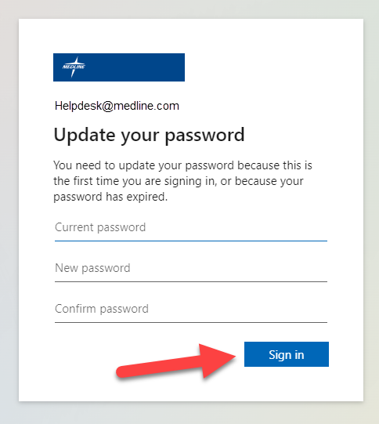
- You have completed the multifactor authentication (MFA) enrollment and updated your password. You will be redirected back to Workday. Optional, if prompted with “Remember Device?” check the box if you’re using a trusted device and submit.
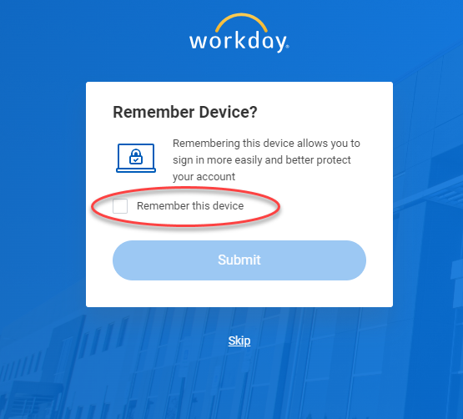
- You have successfully logged into Workday.
