- In workday search for Schedule a report.
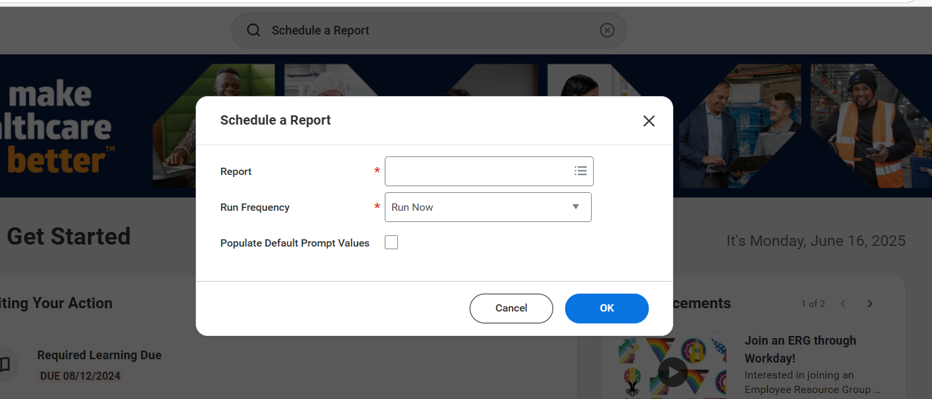

- Enter the name and frequency you want to schedule for the report.
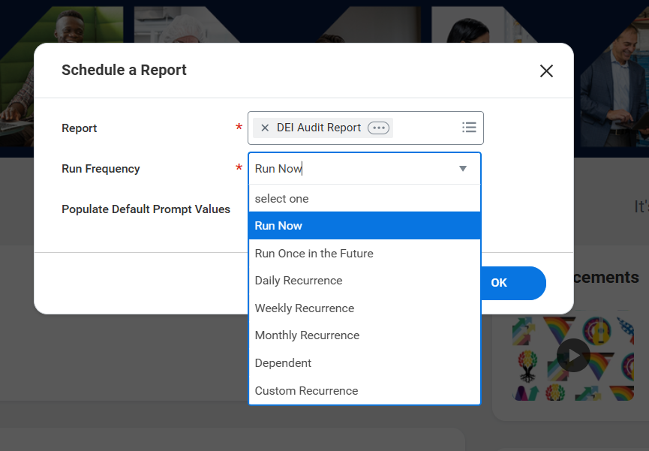
- Select Run Frequency – Weekly Reference then click ok
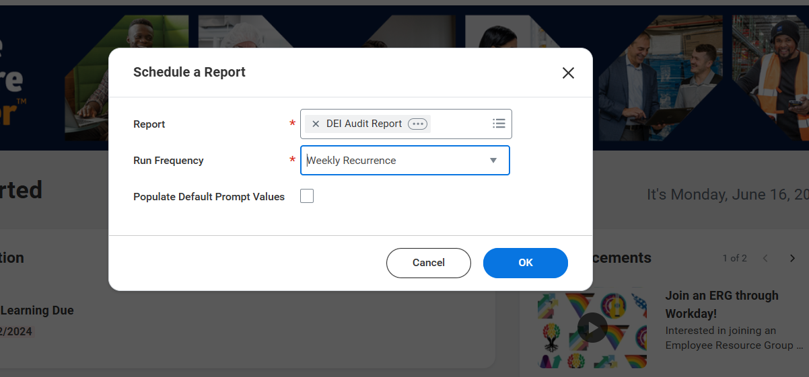

- It will take you to a screen in report criteria, in this example I choose to run it for First day of last week.
- Value type – Is Determine Value at Runtime
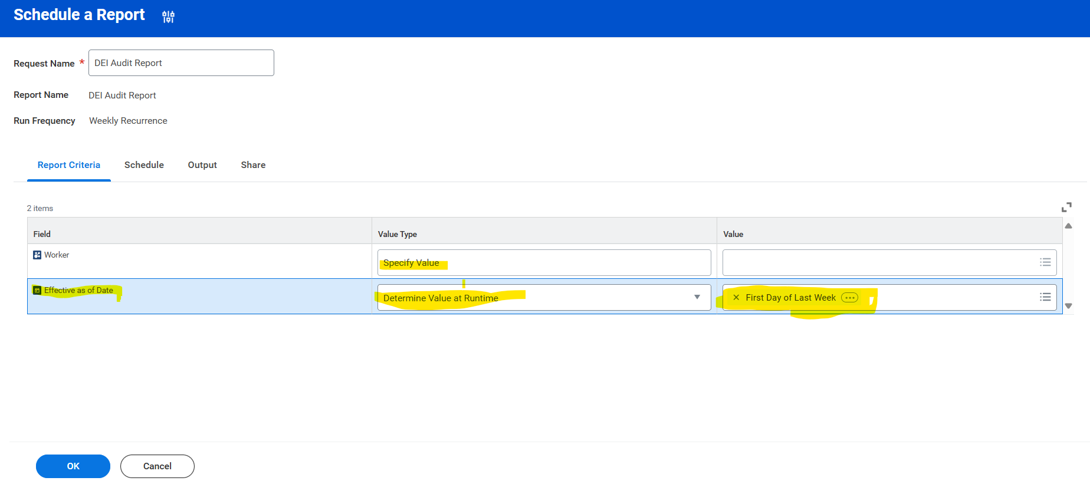

- Enter the details based on how you want to run this report.
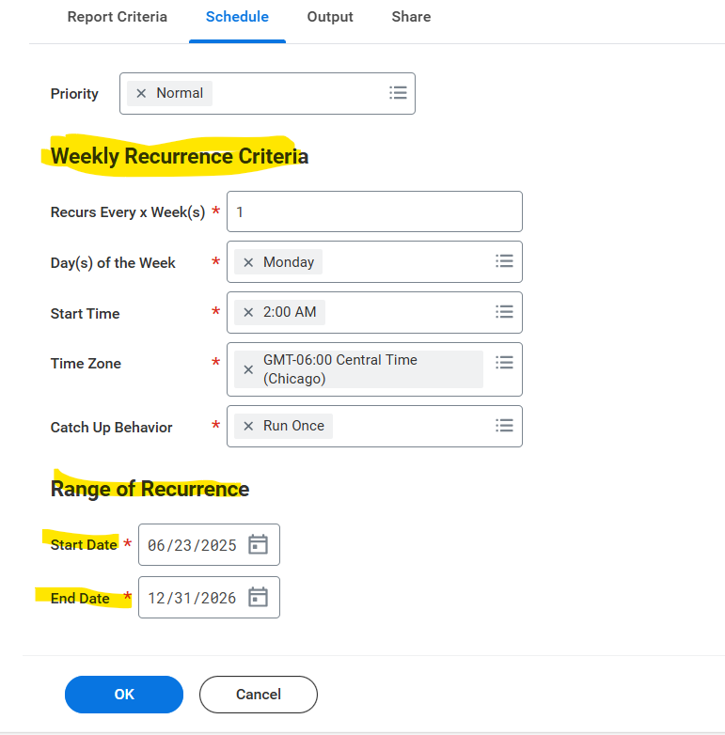

- You can increase the dates when you want this report to be deleted.
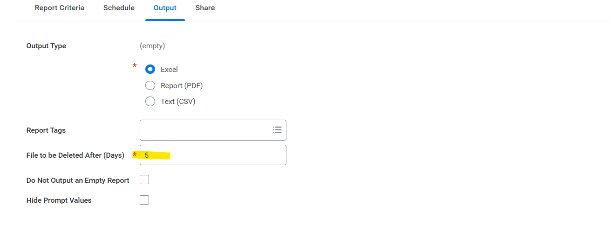

- You can only schedule a report for yourself.

