

Transfer Employee to Another Manager – Plan to Backfill
Managers and HR Partners

Transfer Employee to Another Manager – Plan to Backfill
(Initiating Manager)
- Access the task called Start Job Change
- Select the worker, choose the template called Transfer Employee to Another Manager, and click Ok.

- Choose the desired Effective Date – it must be the beginning of a pay period.

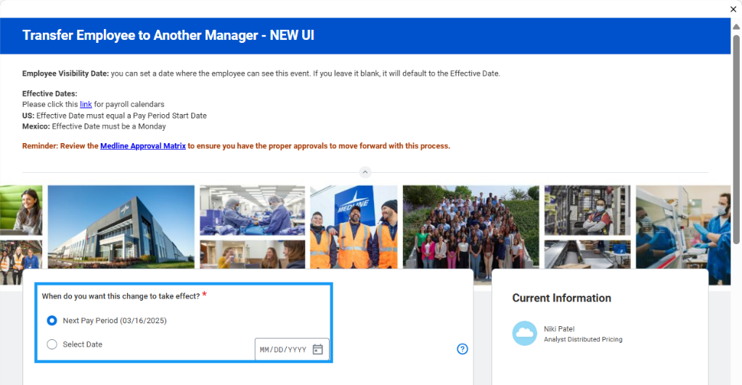
- Select the new manager in the field “Which team will this person be moving to?”
- Ensure that the box next to “Is this person’s position moving with them?” is unchecked.
- Select “Keep open for backfill”
- Select “Should the current position be available for overlap?”
- Click Submit to route to the Receiving Manager for review and approval.

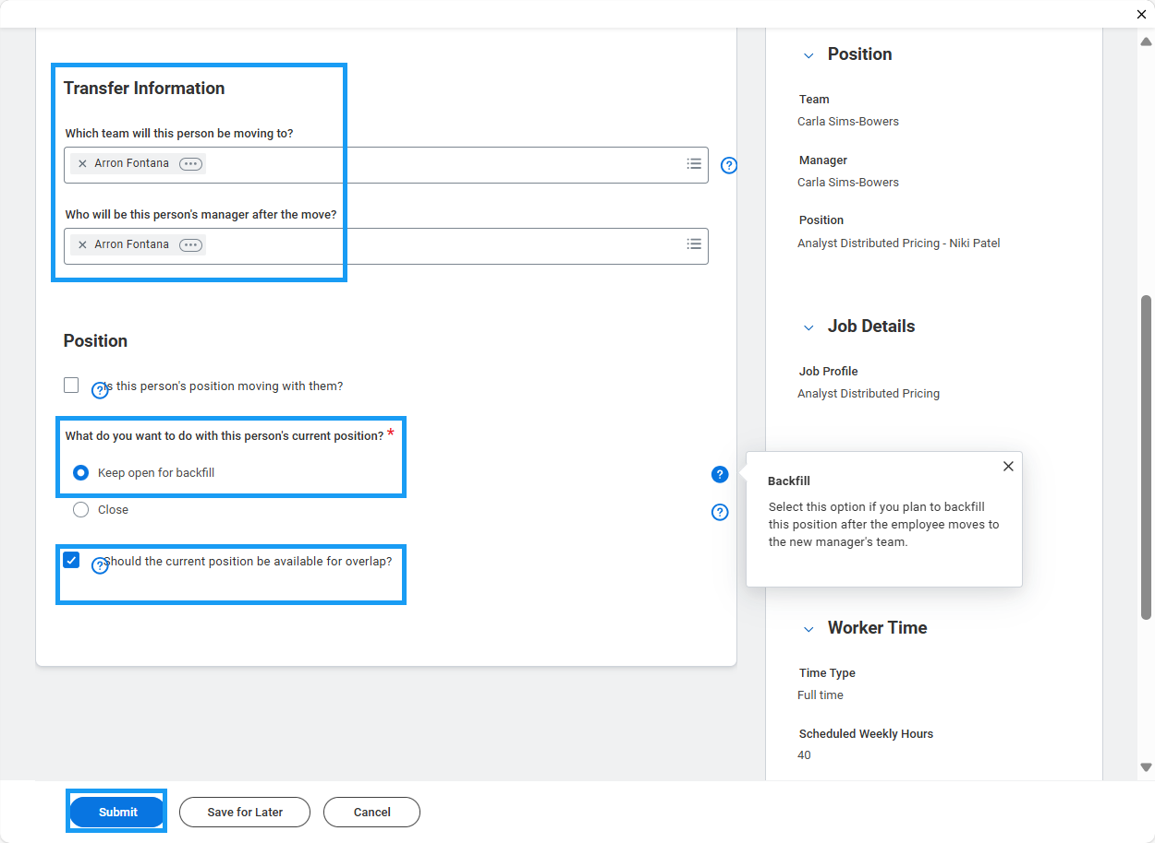

Transfer Employee to Another Manager – Plan to Backfill
(Receiving Manager)
- Access the Transfer task in your My Tasks inbox.
- Review the change submitted by the initiating manager. You will see an “Attention Required” alert at the top of the form. Click the blue “Make Changes” button to enter edit mode.

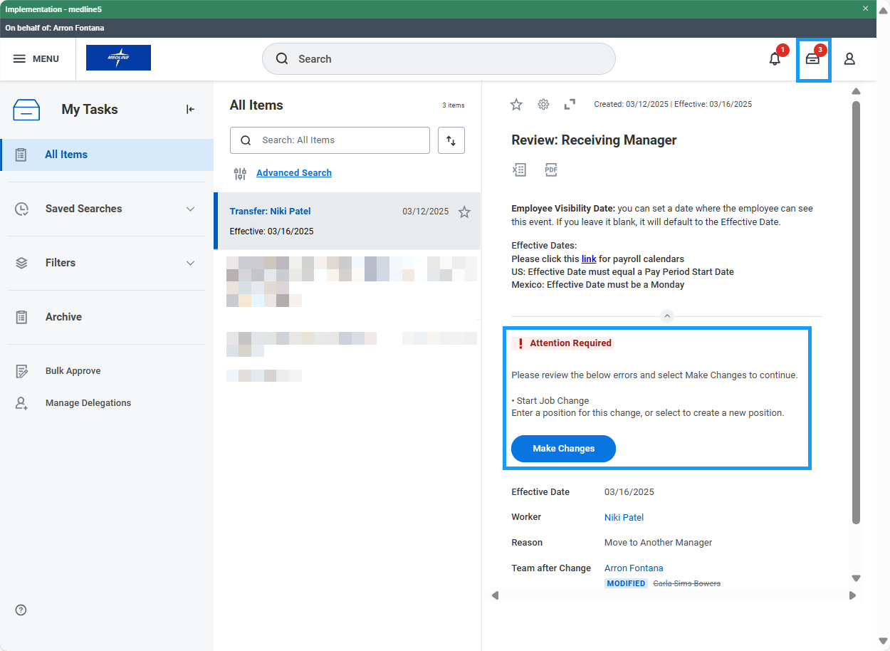

- Choose an open position for the transferring employee. If one is not available, you may check the box that says, “Do you want to create a new position?” Note: you will not be able to choose a position that is tied to an open job requisition.

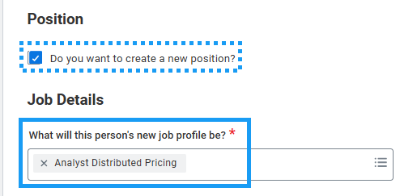

- Edit Job Profile, Work Location, Time Type, Scheduled Weekly Hours and/or Work Shift if necessary. Click Next.

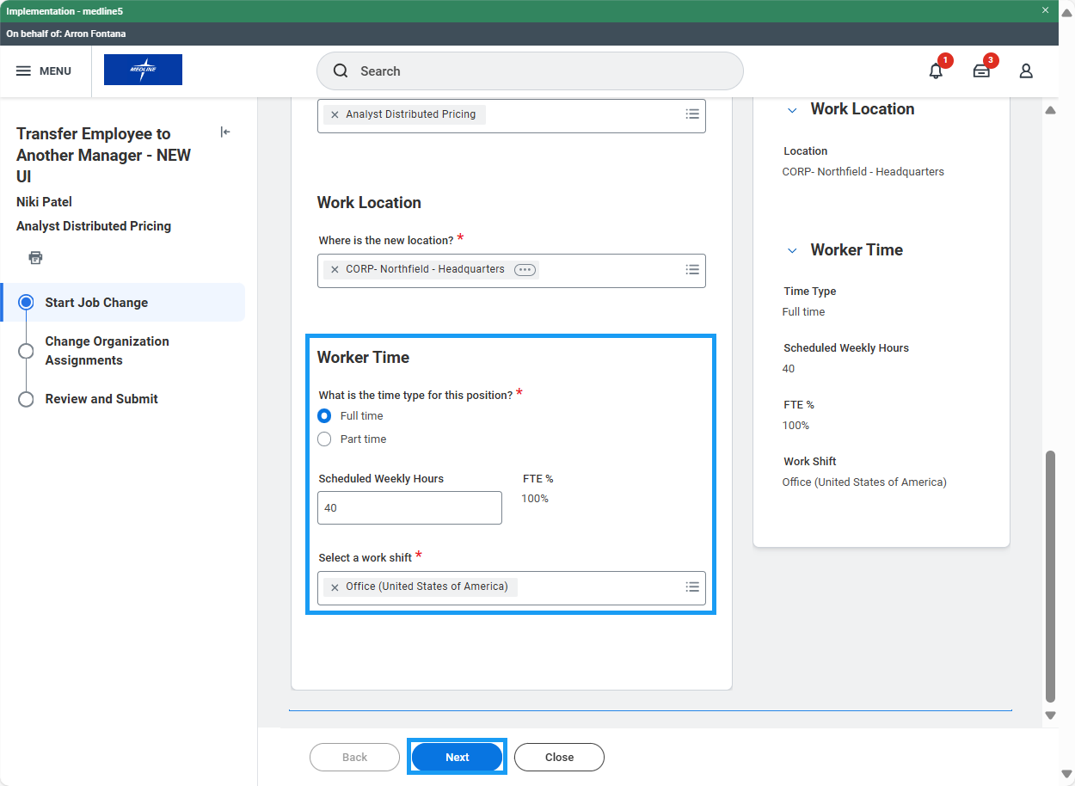

- Edit Company, Cost Center, Department, and other organizations if necessary. Click Next.

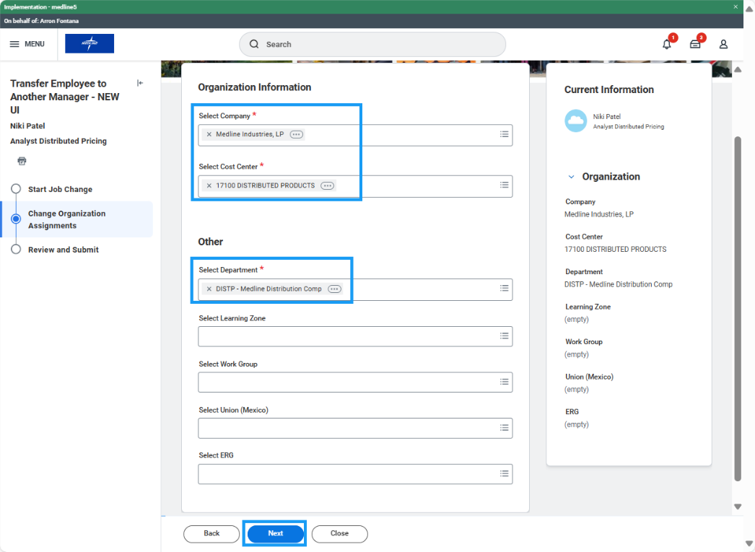
- Review the accuracy of the change and click Approve to route for HR approval.

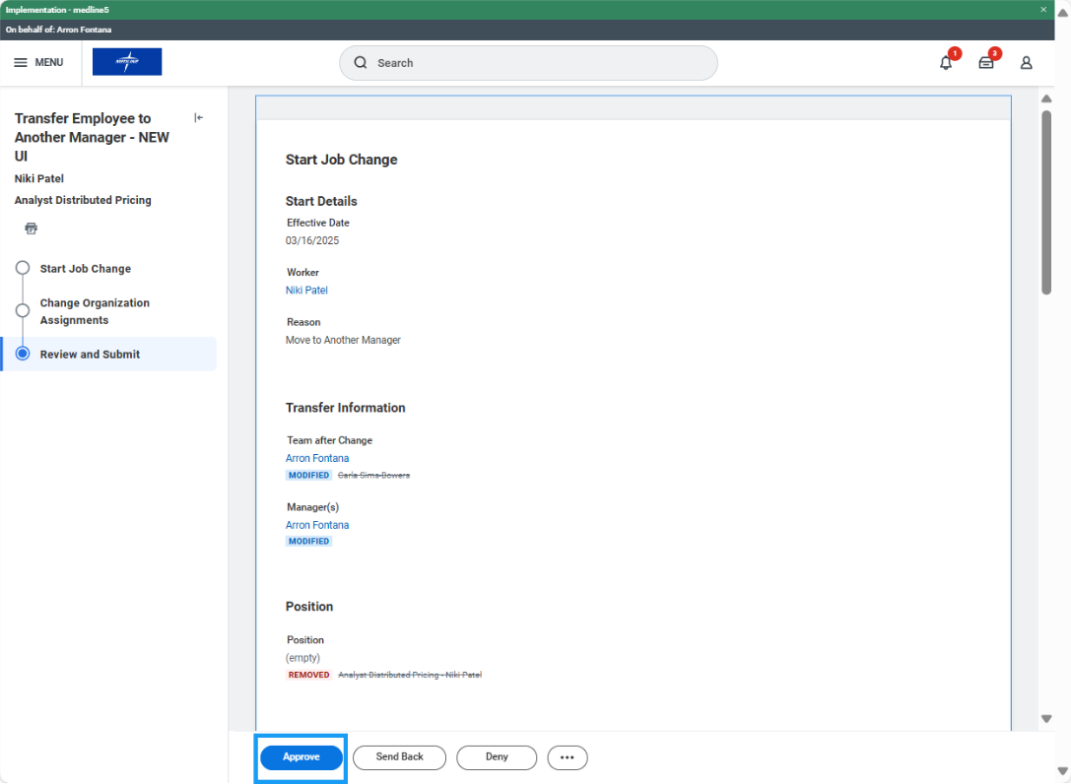

Transfer Employee to Another Manager – Plan to Backfill (HR Partner)
- Access the Transfer task in your My Tasks inbox and review the proposed changes. If edits are needed, click the blue “Make Changes” button at the top of the task to enter edit mode.
- Review accuracy of the change and click Approve.

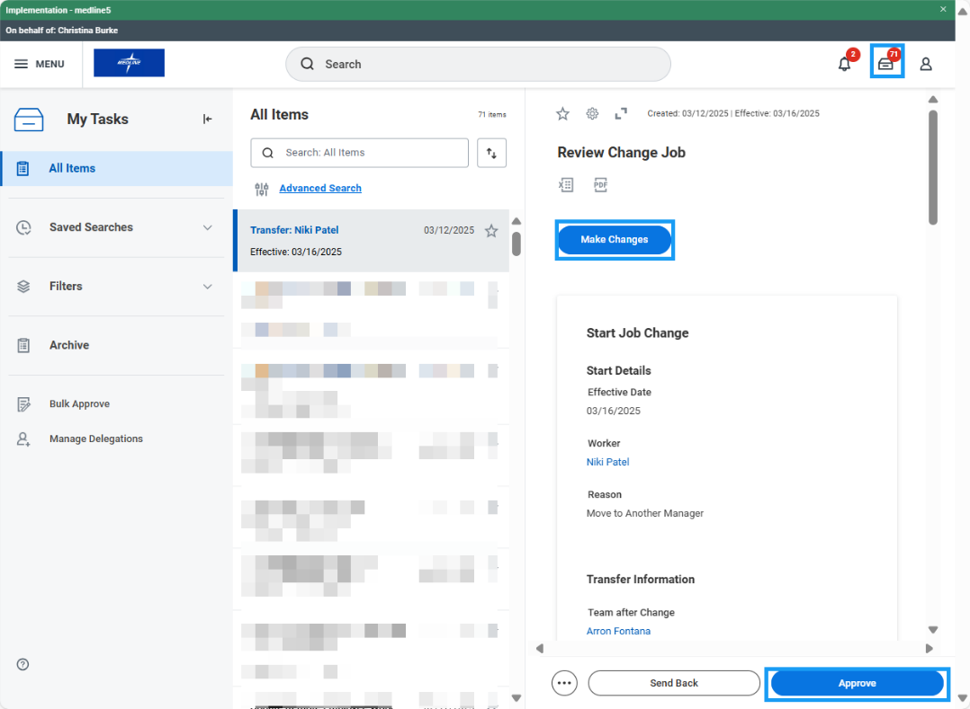

- Approval Chain:

