

Change Contingent Worker Details
Managers and HR Partners

Change Contingent Worker Details (Initiating Manager)
- Access the task called Start Job Change
- Select the worker, choose the template called Change Contingent Worker Details, and click Ok.

- Choose the desired Effective Date.
- Enter the new manager’s name where it says, “Which team will this person be moving to?”
- Select the check box next to “Is this person’s position moving with them?”
- Click Submit to route to the Receiving Manager for review and approval.
Change Contingent Worker Details (Receiving Manager)
- Open the task for the Data Change in your My Tasks inbox.
- Review the change submitted by the initiating manager. You will see an “Attention Required” alert at the top of the form. Click the blue “Make Changes” button to enter edit mode.
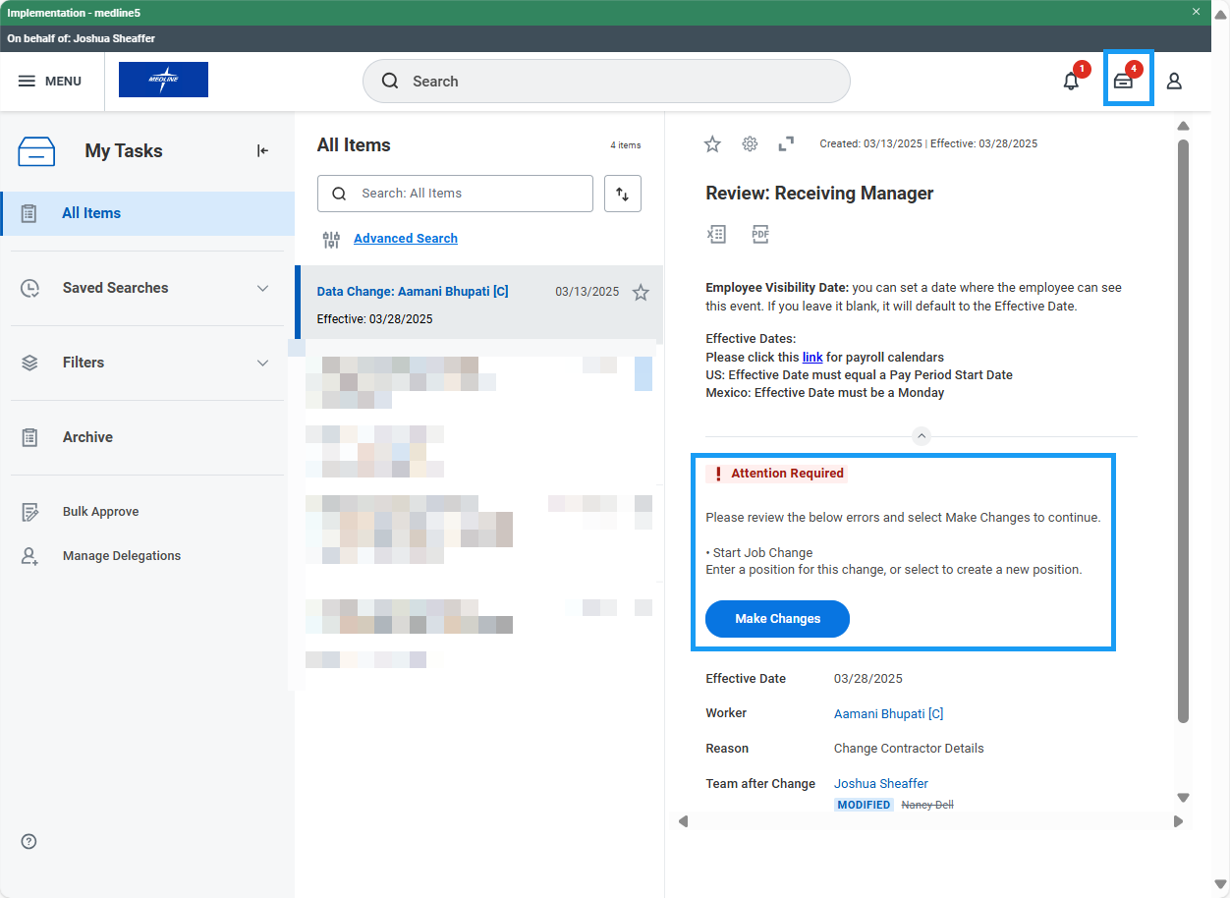

- Under the Position section, choose an open position for the transferring employee. If one is not available, you may check the box that says, “Do you want to create a new position?” Note: you will not be able to choose a position that is tied to an open job requisition.
- Edit Contingent Worker Type, Work Location, Scheduled Weekly Hours and Work Shift, and Contract End Date if necessary. Click Next.
- Edit Company, Cost Center, Department, and other organizations if necessary. Click Next.
- Review the changes and click Approve to route to HR for further approval.

Change Contingent Worker Details (HR Partner)
- Access the Transfer task in your My Tasks inbox and review the proposed changes. If edits are needed, click the blue “Make Changes” button at the top of the task to enter edit mode.
- Review accuracy of the change and click Approve.

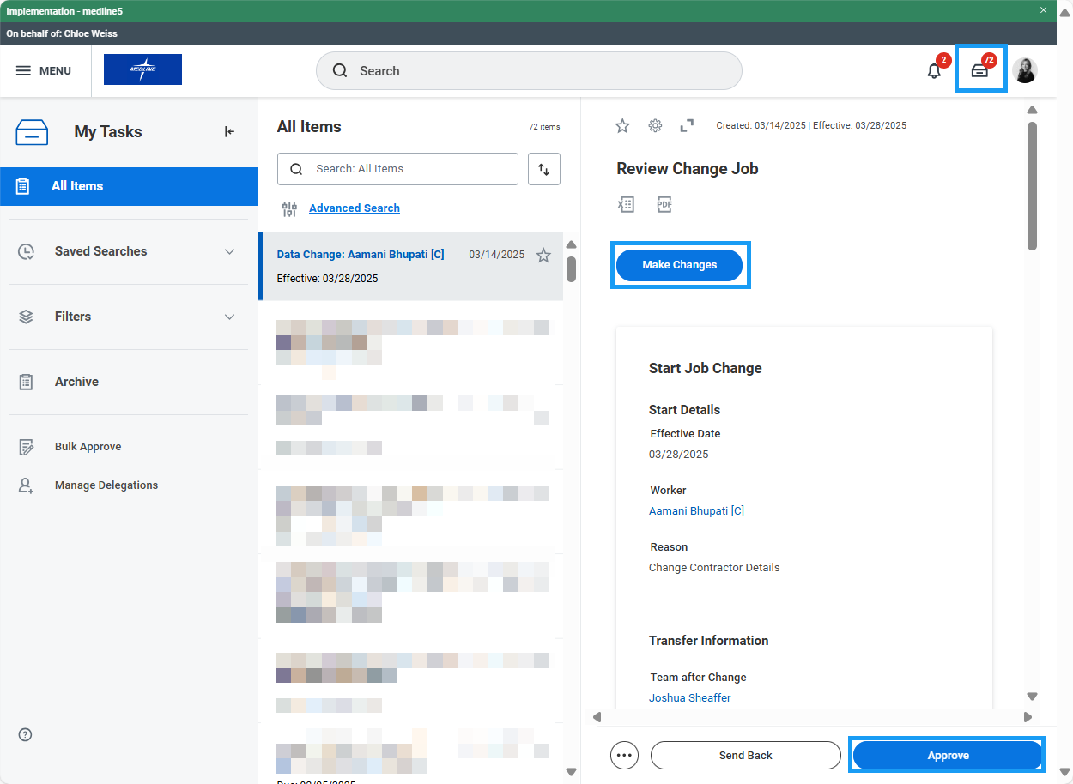

- Approval Chain:
  - Proposed Manager’s Manager:

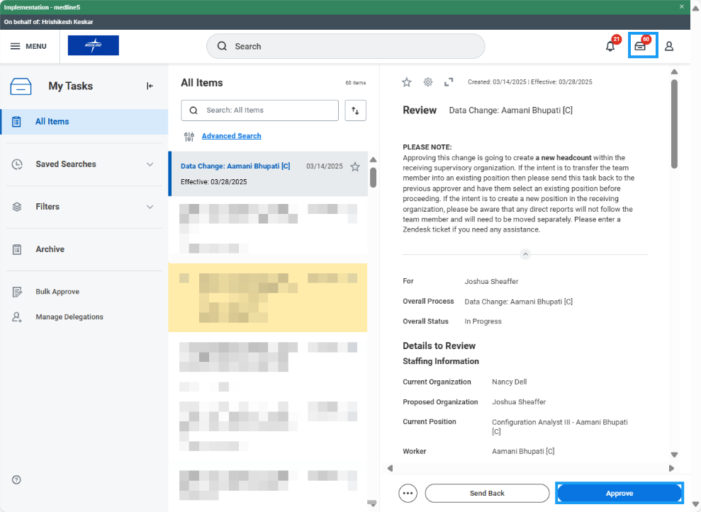

  - Proposed Manager:

