


People Leaders

Create an Open Shift
Creating a new shift is easy. You can do it right from the Schedule Planner.
General Reminders:
- Ensure you have a specific location selected you are looking to post a shift to
- You can change your advanced schedule view from view by employees to view by groups
Navigation: UKG Home Screen
- In the Navigation Bar, select the Control Center. You can also access the Schedule Planner through the Manage Schedule tile.

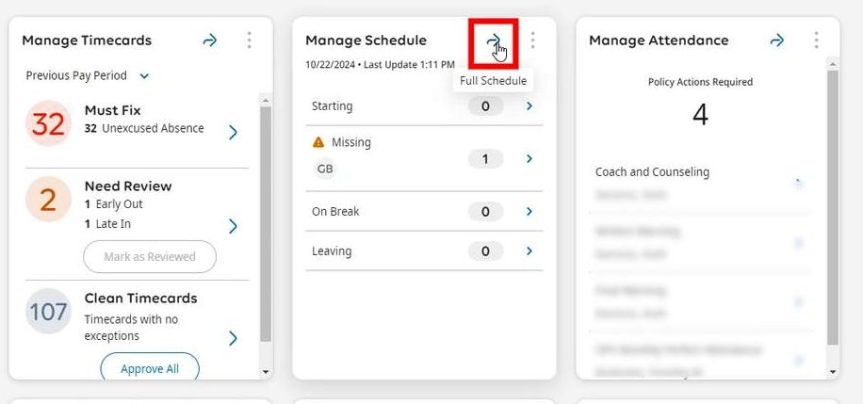
- Right-Click the time slot you want to add a shift to. You can Right-Click in the Open Shift row to create an unassigned shift.
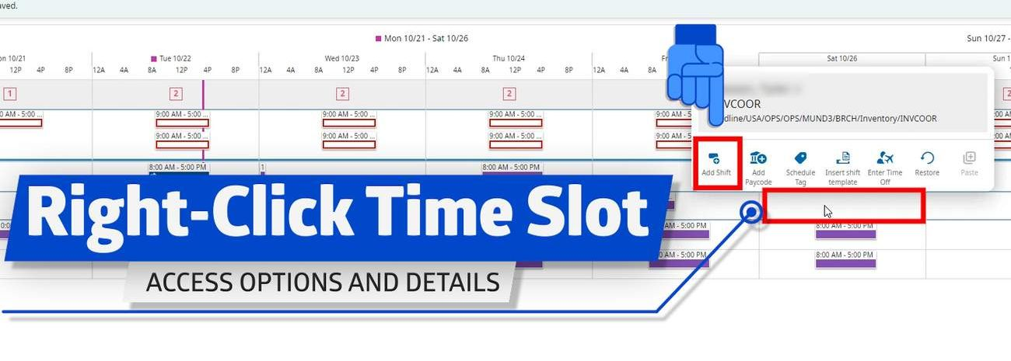

- You can indicate the start and end time of the shift either by dragging the timeline to where you need it to be or by typing in the hours. You can edit the start time in a few different ways. By dragging the timeline, utilizing a template, or entering the start and end time.

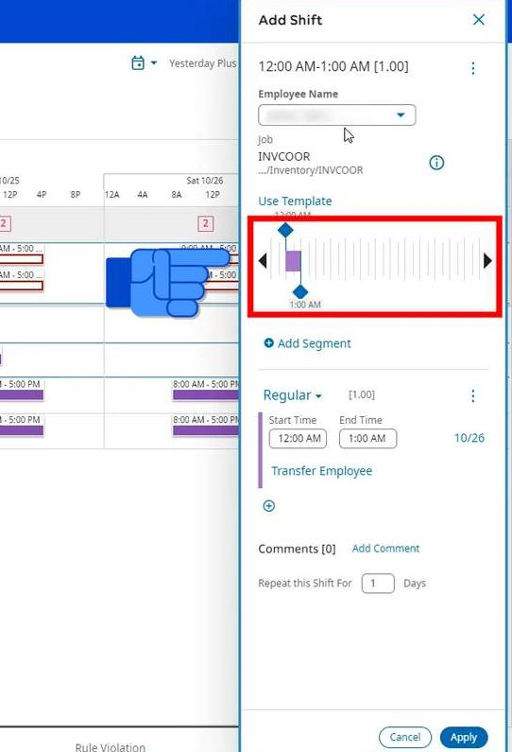
- You can also indicate if you want this shift to repeat more than once.
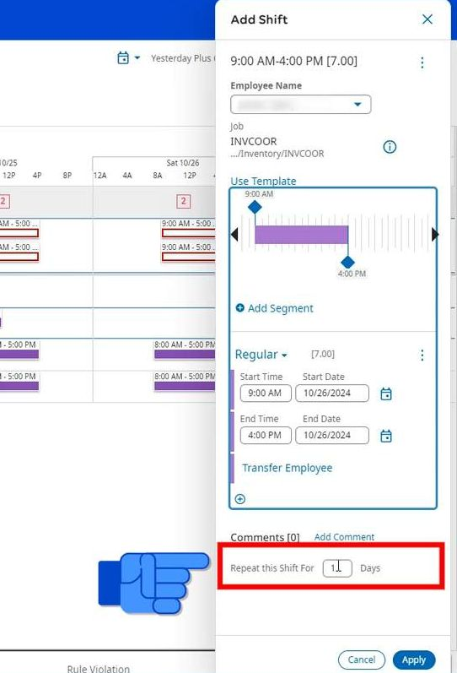

- Select Apply to add the shift to the schedule.
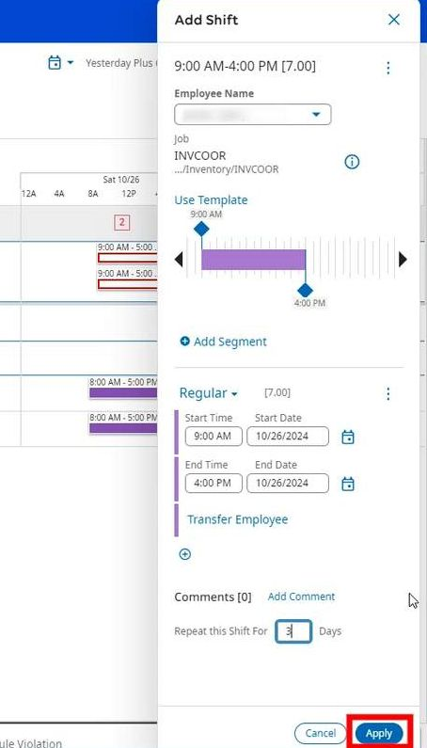
- Once the shift is added to the schedule, don't forget to Save your changes. If you don't the shift will not be added to the schedule permanently.
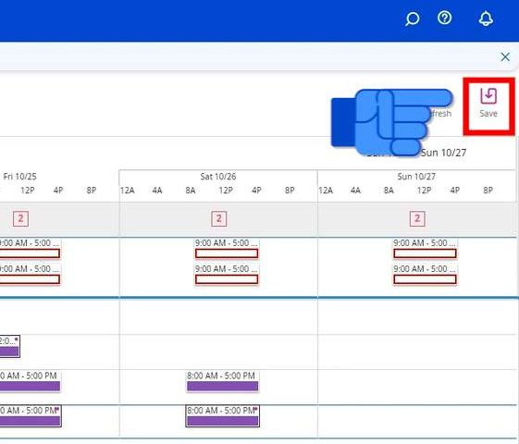

Business Structure
Navigation: Schedule Planner
- From the Schedule Planner, click on Add Shift.
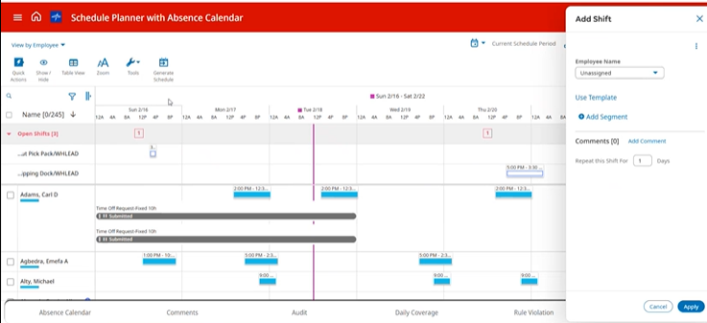
- Click on Transfer. Then Click on Add Business Structure.
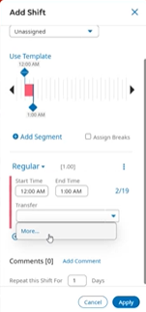
- Click on Browse Entire List. You should then be able to search for the job you want to create a shift for.
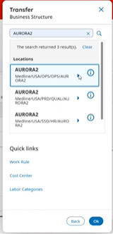
- Click OK when finished and you should see the shift populate. You can search for the location (if you have access to multiple locations) and then select the workgroup in which you want to post an open shift for.

