Removing Holiday Pay
Manual process to remove holiday pay when using MPPTO

When do you need to manually remove holiday pay?

The action of removing holiday pay needs to be manually executed when a team member is not eligible for holiday pay but an excused pay code is being used for pay. Please see your local HR partner to confirm when you need to take this action.

Holiday Removal Process

- Navigate to the team members timecard.
- Holiday pay generates automatically when either punches or excused pay codes are applied on the timecard the scheduled day before and after the holiday.
- On the day in which will disqualify the team member from holiday pay, select the (+) to add a line.
- In the paycode box, enter the paycode called “HOLIDAY”
- In the amount column, enter the hours as “ -8.00”
- This should result in the timecard looking like the below. The day of the holiday should register as “0.00 hours”

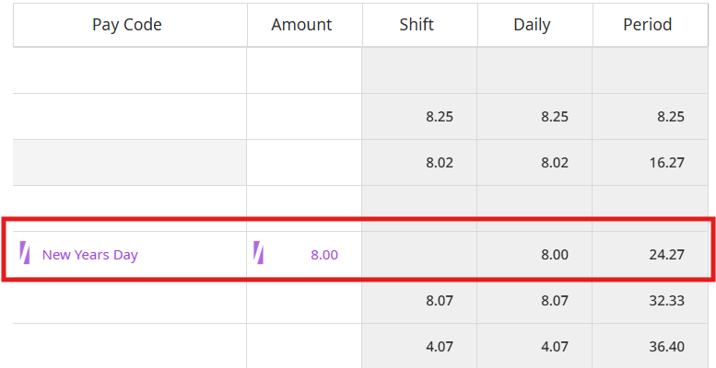
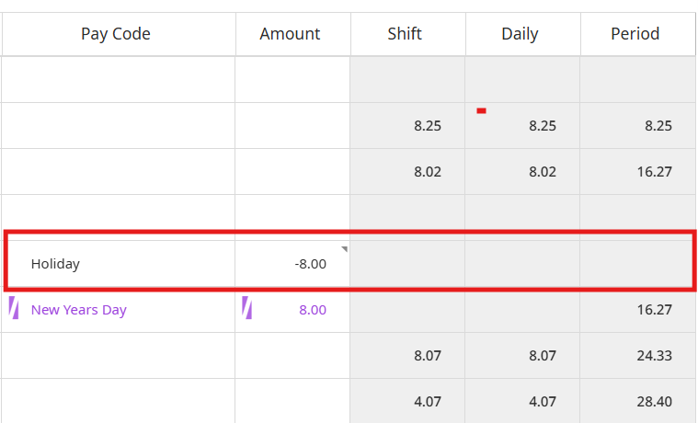
Holiday Removed & Unpaid Holiday Paid

