


People Leaders

Respond to Call-Offs
IMPORTANT: When employees use the Call-Off function in UKG, it will automatically default to “Unpaid Call-Off” to avoid using their accruals. However, you can edit that to whatever paycode your team member requested.

Navigation: Schedule Planner
- From the Schedule Planner, select the event you want to edit. Click “Edit”.
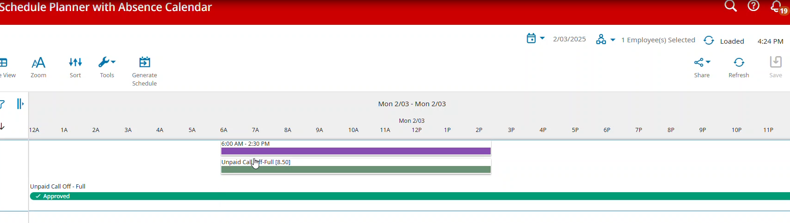
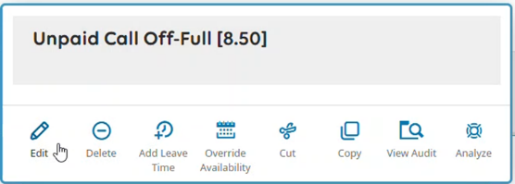
- Select the appropriate Pay Code from the drop-down and then click “Apply”
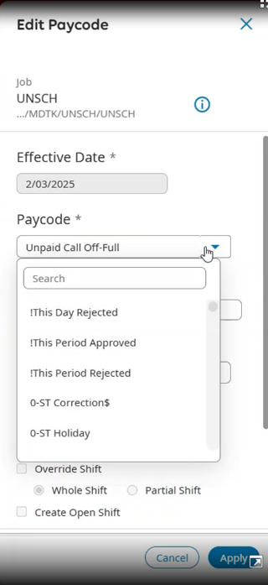
- Click “Save” in the upper right corner.

