


People Managers

Update Corrective Action

- Click on the Manage Attendance Tile.
- Click on “Action Required” to expand the list and see all employees with corrective actions
- Click on a Name to open the Details page
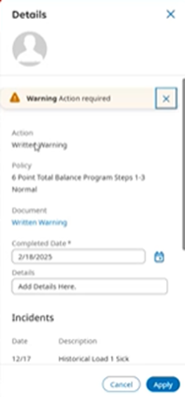
- Enter in the Completion Date and then select Apply.

