Employees

Punch in on a PC

**Navigation: UKG Home Page**

Log in to UKG using your SSO. On the home page, there will be a tile completely dedicated to punching in and out. Simply select Clock In, Meal Out, Meal In, and Clock Out at the appropriate time of day

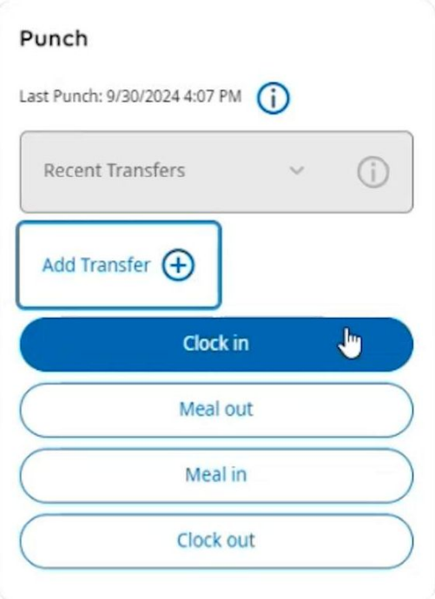

If you need to transfer to a different team, you can do so here as well by selecting Add Transfer and then indicating the Labor Category and Cost Center you're transferring to.

If you think you might have missed a punch you can check your timesheet to be sure that you always have an even number of punches. For example, you should have 1 Clock In and 1 Clock Out for a total of 2 punches, but you should not have only a Clock In or Only a Clock Out. You can fix any missed punches using [these instructions](https://medlinehr.zendesk.com/hc/en-us/articles/32621096757773-Correct-a-Missed-Punch-Corregir-una-marca-faltante).

