


HR Coordinators

Adding an Attendance Event

- From a dataview, select the location where the employee is based. You can also use the Manage Attendance tile.

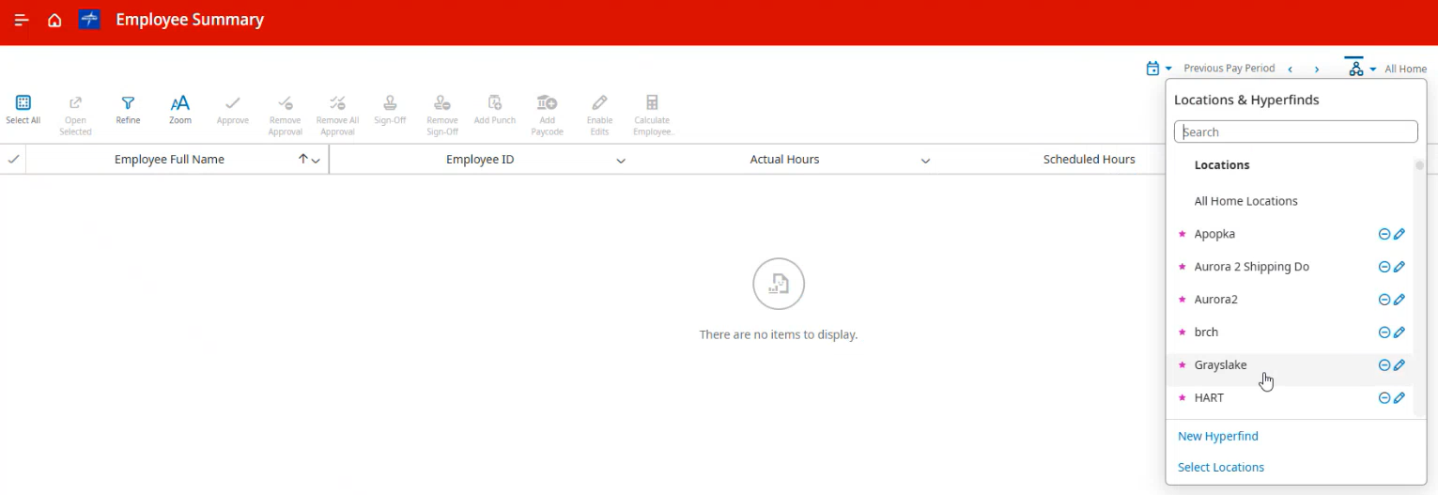
- You will then see a list of all employees in that location. Right-click on an employee, choose “Go To”, and then click on “Attendance Details”.
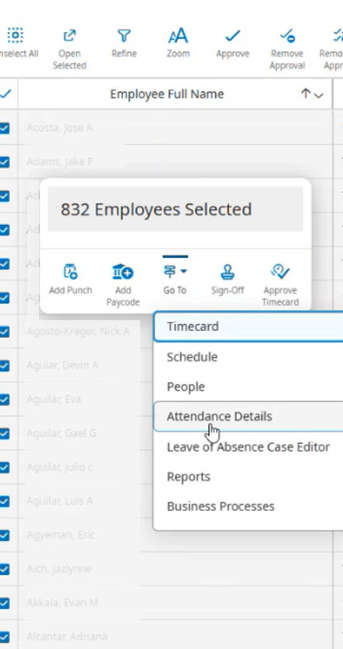
- Expand the time range to include the date for the event you want to add.
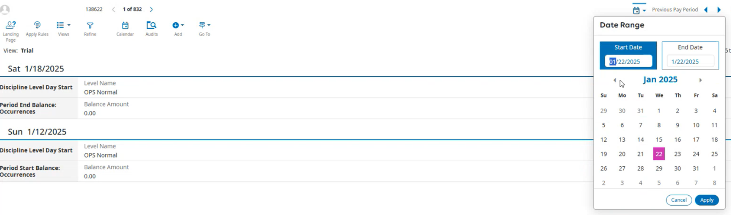
- Click on “Add” and then “Event”
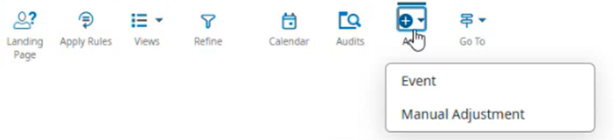
- Fill out the required field and then click “Save and Apply Rules” to finish
