


HR Coordinators

Editing Attendance Points

- From a dataview, select the location where the employee is based. You can also use the Manage Attendance tile.
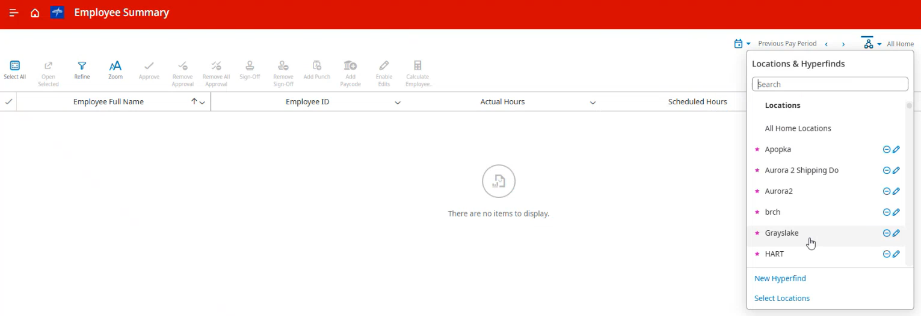
- You will then see a list of all employees in that location. Right-click on an employee, choose “Go To”, and then click on “Attendance Details”.
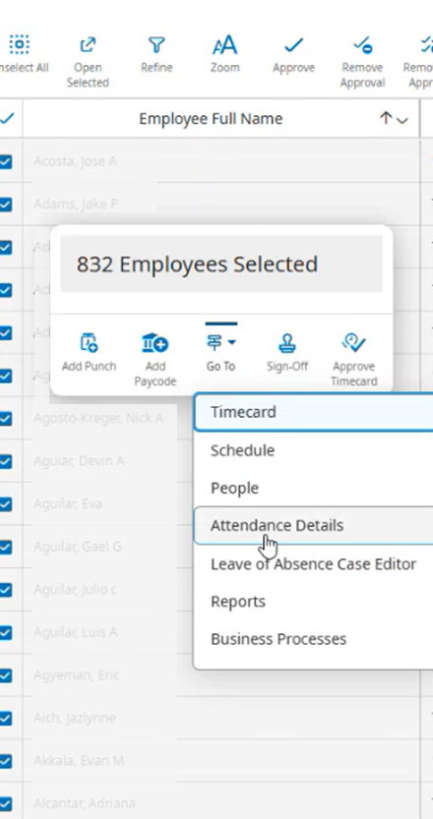
- Expand the time range to include the date for the event you want to correct
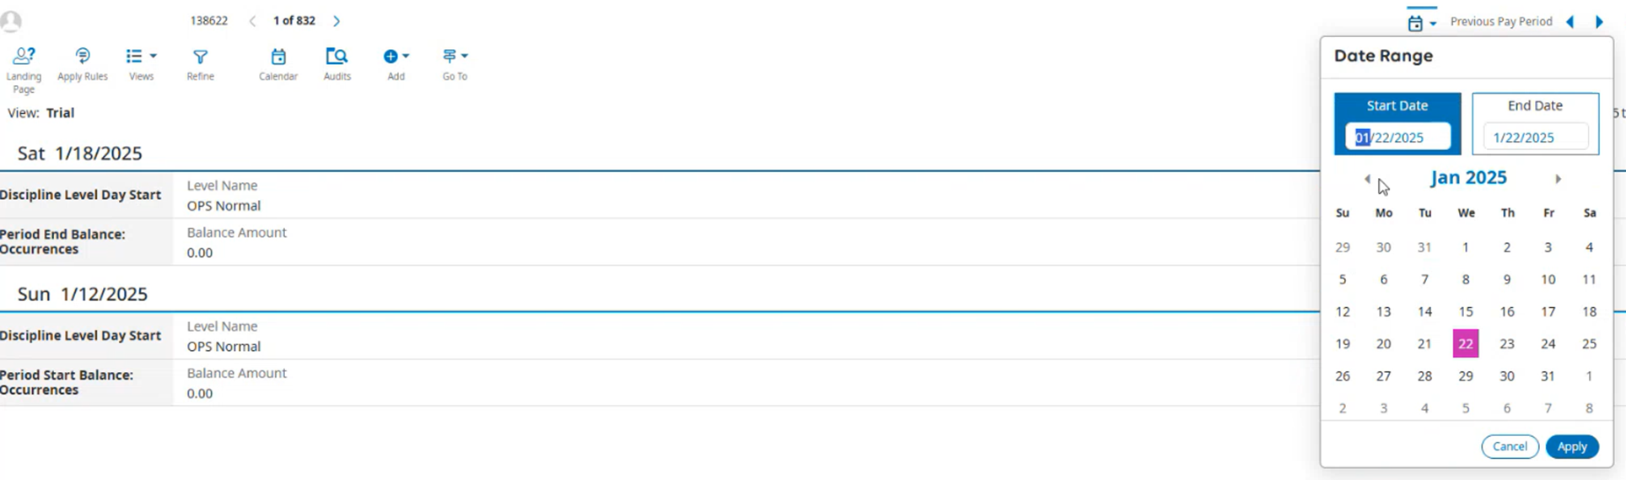
- You can now click on the pencil icon to edit the event. This is the process to use for both Historical Events (events from Kronos that were loaded into UKG) and new Events that occurred after UKG launched.
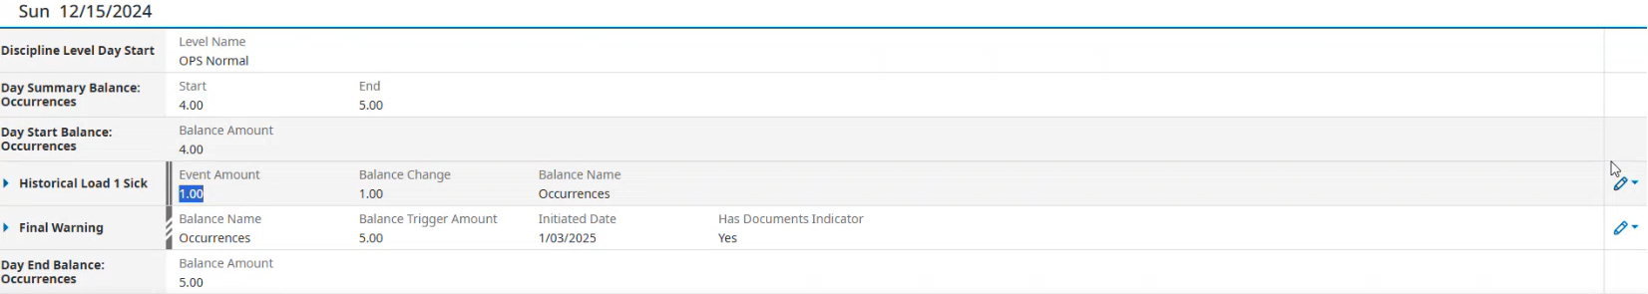
- Change the Event to be the correct code. Then click “Save and Apply Rules” to finish.
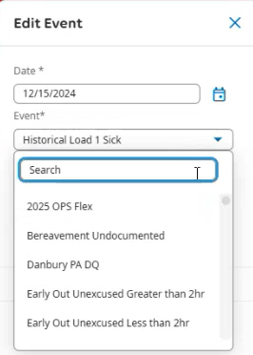
- The point total and event will now be updated.

