


People Leaders

Post an Open Shift Using the Call List
Navigation: UKG Schedule Planner
- Right click on an open shift and select Call List.
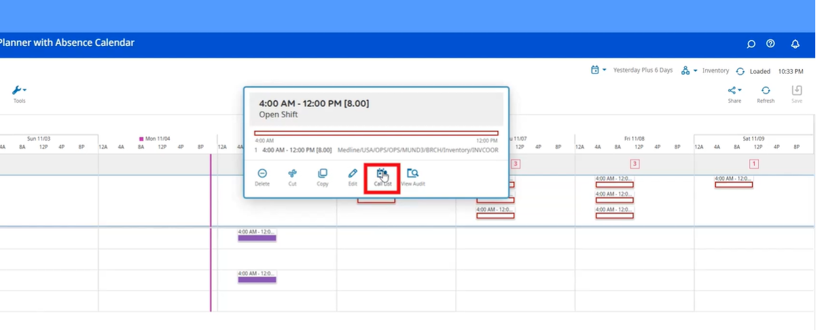

- A list of eligible employees will pop up. You can select specific employees or leave it unchecked to offer to all.
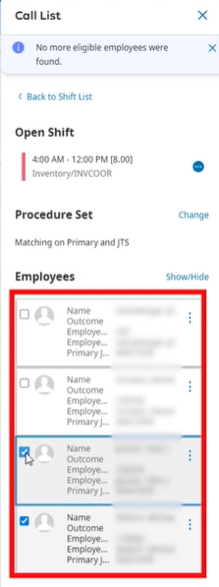
- A message will go out to all eligible employees offering the shift.

- When one employee accepts the shift, the remaining employees will get a message letting them know that shift has been filled.

- The schedule will also be automatically updated to reflect the filled shift.

