Mass Assignments and Mass Updates to the Schedule

**Mass Assignments:**

1. Login to UKG system.
2. Click on the Menu option present on the top left corner of the home page as highlighted in the below screenshot.

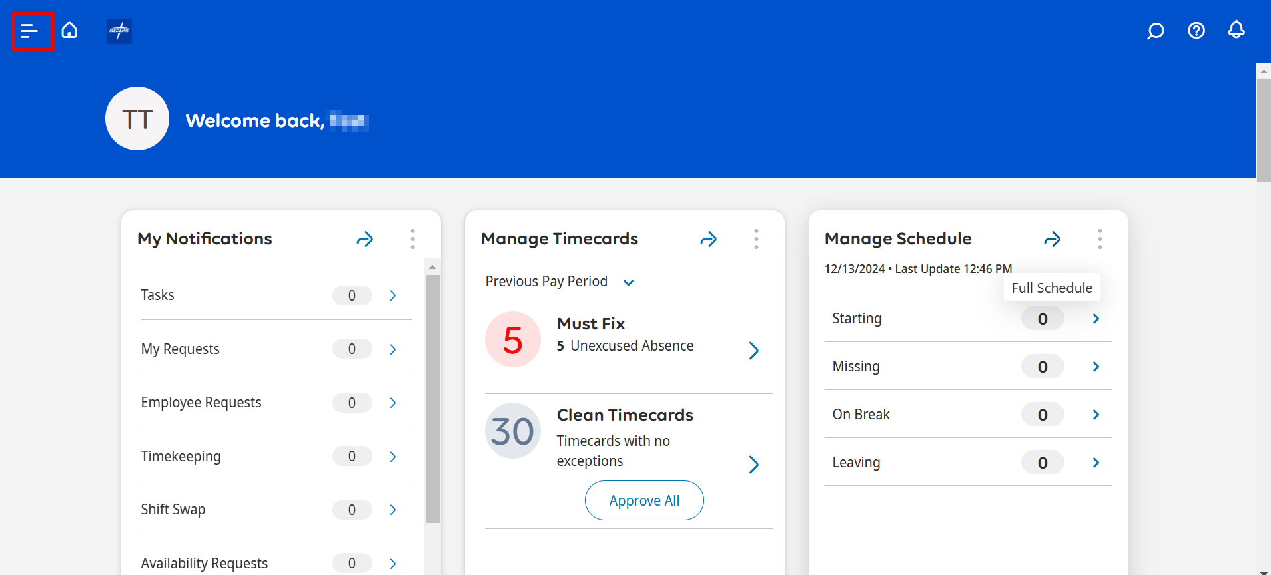

1. Select the Schedule option 🡪 Schedule Planner with Absence Calendar.

1. You will be navigated to the below screen where you can see the list of all employees you have access to.

1. Select the highlighted checkbox if you want to select all the employees or select the specific employees you want to assign the schedule for by checking the checkbox present to the left of the employee’s name.

1. After selecting the employees, right click to see the available options and select Schedule Pattern as highlighted in the below screenshot.

1. Enter the required schedule, rename the pattern template and click on Apply button.
2. Enter the ‘Start Date’ with the date that you want the new Schedule Pattern to start. The start date can be anything on or after 12/29/2024.

1. Click on the save button as shown in the screenshot below to save your changes:

* To view the schedule assigned, the date range should be updated to anything on or after the ‘Start date’ you entered in the previous steps.

**Mass Updates to the existing Schedule:**

To update any existing schedule for a set of employees:

1. Go to Menu 🡪 Schedule 🡪 Schedule Planner with Absence Calendar.
2. Select the employees for whom you want to update the schedule by checking the checkbox present to the left of the employee’s name.

1. Right click to see the available options and select **Schedule Pattern** to update the **.**

1. You will be navigated to the below screen. Click the arrow mark as highlighted in the below screenshot to see the available options. Click Edit button to edit the schedule.

1. Select the Overwrite Pattern option in the pop-up box and click OK.

1. System will allow you to edit the schedule.
2. Edit the schedule, rename the pattern template accordingly and click Apply button.

1. Click the save button to save your changes. The schedule will be updated.

