People Leaders

Add a Missed Punch

You can add missed punches for the shift or lunch break to the employee’s timecard and add a comment or note to a punch. The **Manage Timecards** tile on the **UKG Home Page** indicates any missed punches that must be fixed.

**Navigation: UKG Home Page**

1. In the **Manage Timecards** tile, select **Current Pay Period**. Next to **Must Fix**, select the **View Must Fix in Timecards** arrow.

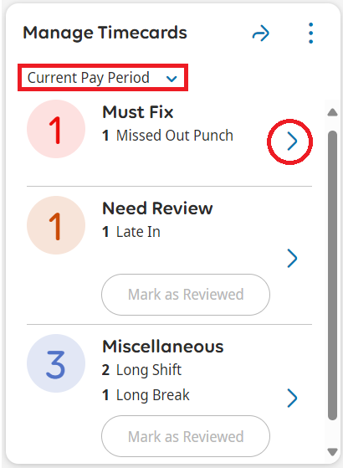

1. Select the plus sign next to the **Date** cell for which you want to add a punch. A new row is added to the timecard.

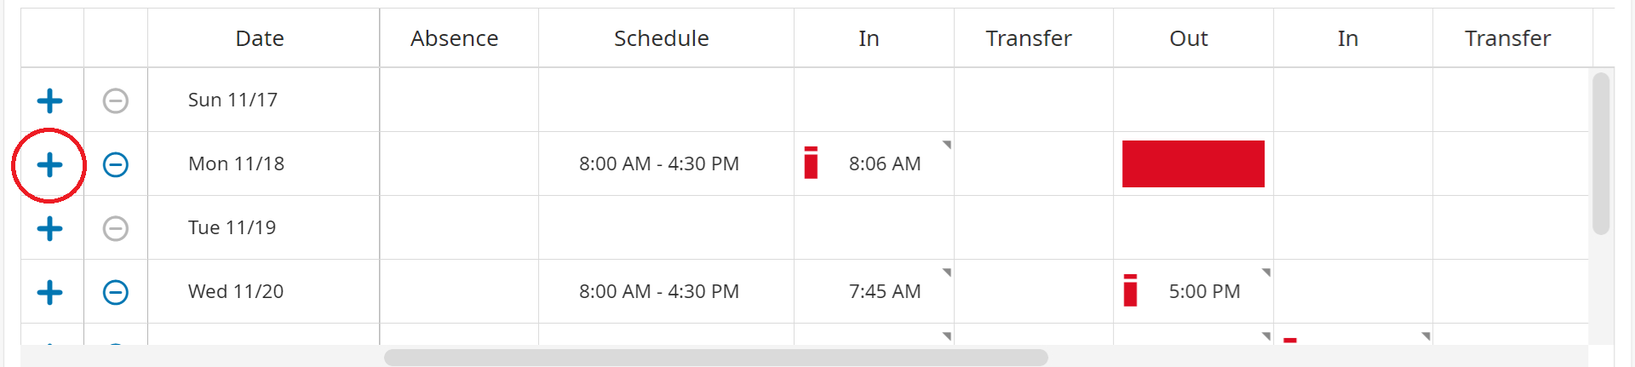

1. Select the **In** cell in the new row to enter a start time for the employee’s shift or break, or select the **Out** cell in the new row to enter an end time for the shift or break.

Enter the time.

1. To add a comment or note, right-click on the punch and select **Comments** from the **Punch Actions** menu.

1. In the **Comments** panel, select an event from the **Comment On** dropdown list.

Select the appropriate comment from the **Select a Comment** dropdown list.

Optionally, enter a note in the **Type a Note** box. Click **Add Another Note** to include more information.

Click **Apply**.

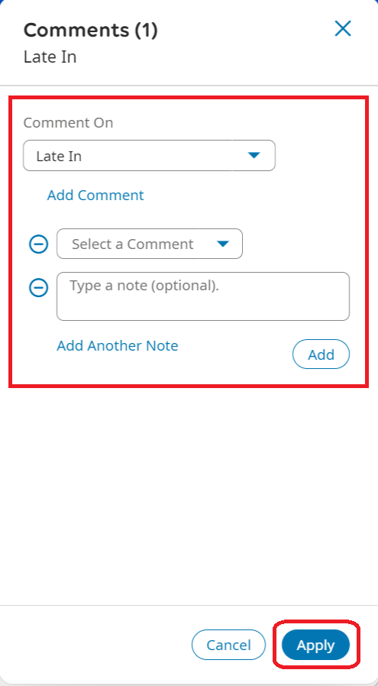

1. Click **Save**. Comments for the punch appear in the timecard as a blue bubble icon. Right-click on the punch to view the comments.

