


People Leaders

Add a Pay Code to an Excused Absence
You can add a pay code in a timecard to excuse an absence. The Manage Timecards tile on the UKG Home Page indicates if there are absences that require attention.

Navigation: UKG Home Page
- In the Manage Timecards tile, select Current Pay Period. Next to Must Fix, select the View Must Fix in Timecards arrow.
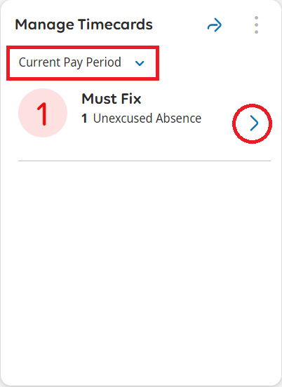
- On the employee’s timecard, click the Pay Code cell in the row with the absence to access the dropdown list of pay codes.
Select the appropriate Pay Code.
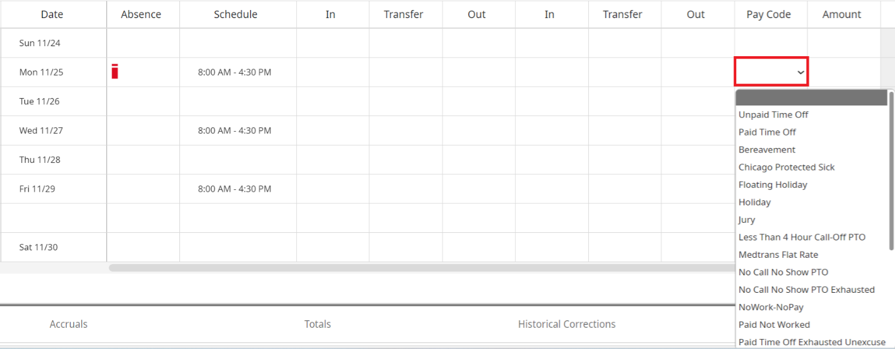

- In the Amount column, enter the length of time.
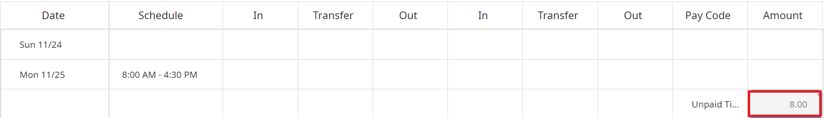
- Click Save.
