


People Leaders

Approve an Individual Employee Timecard
You can approve an individual employee’s timecard at the end of the pay period for payroll processing by accessing the Manage Timecards tile on the UKG Home Page.

Navigation: UKG Home Page
- In the Manage Timecards tile, select Previous Pay Period. Then select the All Timecards arrow.
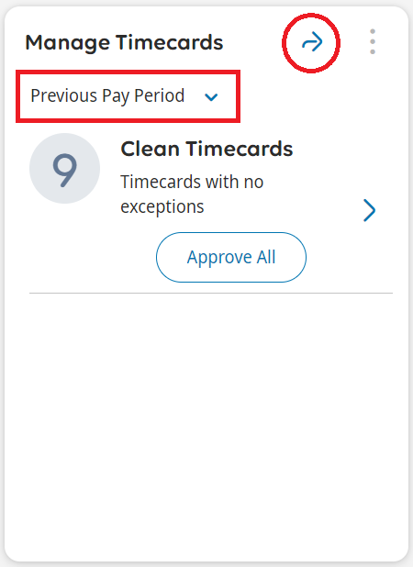
- Select the employee from the dropdown.
Review the timecard for accuracy and resolve any missed punch and unexcused absence exceptions.
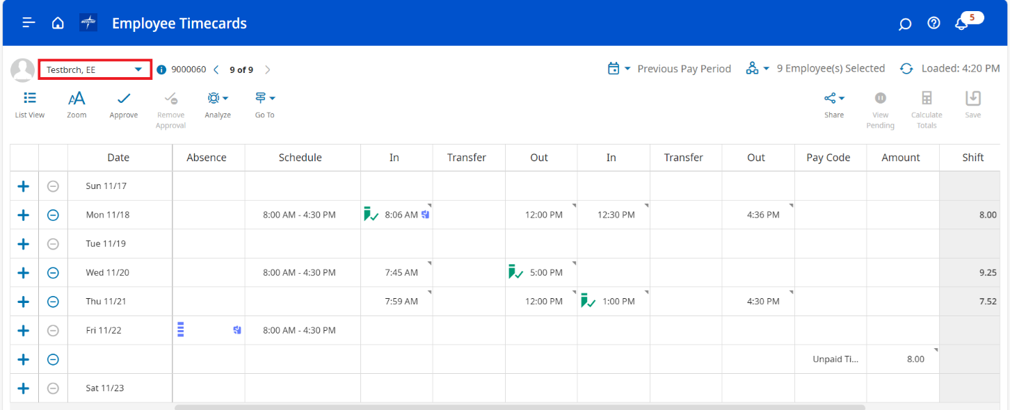
- Select Approve.
